2026年威尼斯雙年展台灣館公布展名「鬱卒的平面」
Taiwan’s Representation at the 61st Venice Biennale 2026: Screen Melancholy

作品圖說Image Description
01  李亦凡，《鬱卒的平面》(影像示意圖)，同展名新作。©李亦凡，圖像由藝術家提供。  Li Yi-Fan, Screen Melancholy (conceptual image for reference only), the exhibition’s eponymous work expected in 2026. © Li Yi-Fan. Courtesy of the artist. | 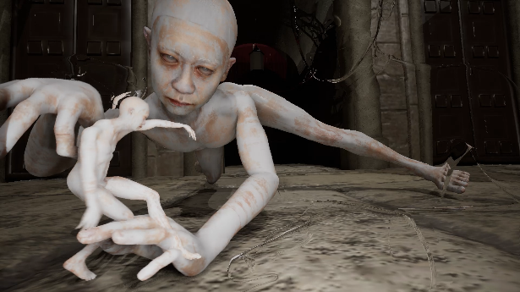
02  李亦凡，《鬱卒的平面》(影像示意圖)，同展名新作。©李亦凡，圖像由藝術家提供。  Li Yi-Fan, Screen Melancholy (conceptual image for reference only), the exhibition’s eponymous work expected in 2026. © Li Yi-Fan. Courtesy of the artist. | 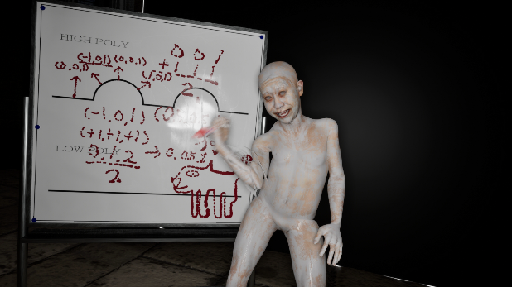
03  李亦凡，《鬱卒的平面》(影像示意圖)，同展名新作。©李亦凡，圖像由藝術家提供。  Li Yi-Fan, Screen Melancholy (conceptual image for reference only), the exhibition’s eponymous work expected in 2026. © Li Yi-Fan. Courtesy of the artist. | 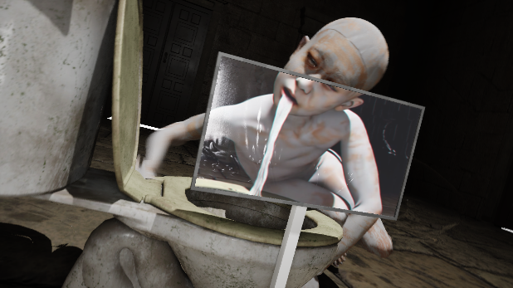
05  藝術家李亦凡（右）與策展人哈法艾爾・馮希卡（左）。圖像由北美館提供。  Artist LI Yi-Fan (right) and curator Raphael Fonseca (left). Courtesy of Taipei Fine Arts Museum. | 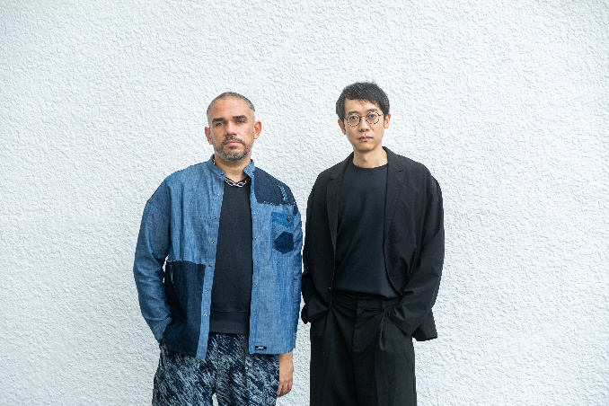  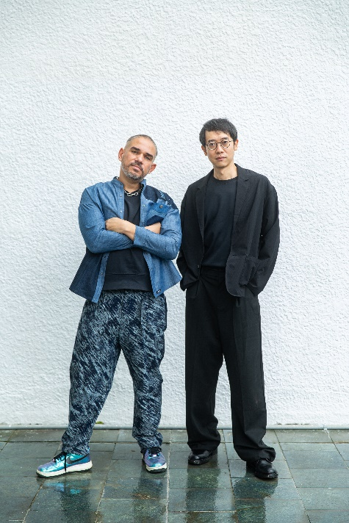
06  2026年威尼斯雙年展台灣館代表藝術家李亦凡。  圖像由北美館提供。  Taiwan’s Representing Artist at the 61st Venice Biennale 2026, LI Yi-Fan. Courtesy of Taipei Fine Arts Museum. | 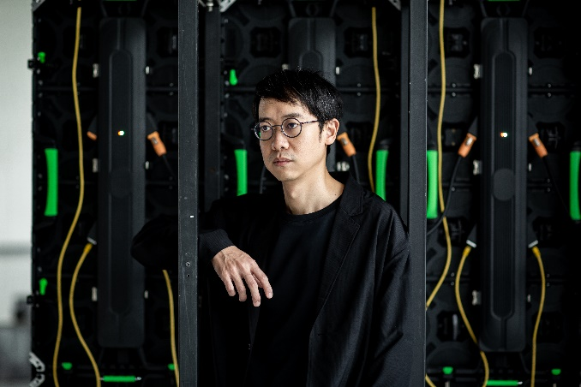  
07  2026年威尼斯雙年展台灣館策展人哈法艾爾・馮希卡。圖像由北美館提供。  Taiwan’s Representing Curator at the 61st Venice Biennale 2026, Raphael Fonseca. Courtesy of Taipei Fine Arts Museum. | 