**Taipei Fine Arts Museum Press Release**

|  |  |
| --- | --- |
| Issued by the Marketing and Public Relations Department | Official Website: <http://www.tfam.museum/> |
| Publishing Date: 2024.04.02 | Facebook Fan Page: Taipei Fine Arts Museum |
| Media Contact: Ethan Yi-Sheng Li 02-2595-7656 ext. 251, [ethan-tfam@gov.taipei](mailto:ethan-tfam@gov.taipei)  Tzu-chin Kao 02-2595-7656 ext. 110, [tckao-tfam@gov.taipei](mailto:tckao-tfam@gov.taipei) | |

**2024 “60th Venice Biennale” Taipei Collateral Event**

Exhibition Period: 20 April – 24 November 2024, Every Tuesday to Sunday 10:00am to 6:00pm

Address: Palazzo delle Prigioni, Venice, Italy

Press Kit

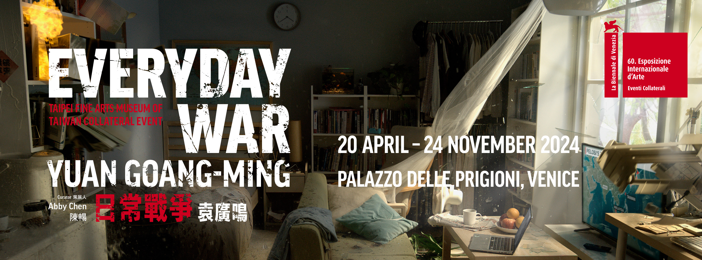

**Taiwan Collateral Event *Yuan Goang-Ming: Everyday War***

**unveiling newly created works, with public events focusing on ‘island-thinking’**

Taipei Fine Arts Museum of Taiwan presents the Collateral Event *Yuan Goang-Ming: Everyday War* at the 60th International Art Exhibition, La Biennale di Venezia, to be held at the Palazzo delle Prigioni. Pre-opening public events will be held in the afternoon of Thursday, 18th April during the opening week of the Biennale Arte 2024. Today, on 2nd April in a press conference in Taipei, artist Yuan Goang-Ming, together with the Taipei Fine Arts Museum team, unveiled brand-new video artworks that will be presented at the Biennale Arte 2024 in two weeks' time.

Within the exhibition space of the Taiwan Collateral Event, there will be a continuous interplay of sirens, explosions, sudden impacts, and a slow-paced recording of the national anthem. These sounds, originating from different artworks, permeate through scenes capturing air defense drills, civil disobedience movements, as well as household scenarios. The exhibition title, *Everyday War*, aims to explore the living conditions of individuals with unpredictable threats of social transformation and unstable situations. From the perspective of the Taiwanese artist, the exhibited works highlight how the places in which we dwell daily are gradually deteriorating as a result of unequal distribution of capitalism, cyber-attacks, climate change, ethnic conflicts, and other conflicts.

The new video work, "**Flat World**”, unveiled during the press conference, is an internet-based video work that utilizes images from Google Street View’s database. Starting from landmark street views of Taiwan, including cities, towns, mountains, the seaside, among others, Yuan Goang-Ming compares this to similar street views from around the world. By filtering and choosing the same center point and perspective through an app, he creates a seamless time-lapse sequence of road images that transcends time and space. In this digital network resembling a new “road movie,” the street views of the entire world within the borderless (globalized) internet, instantly become a “flat world," forming a continuous looping landscape.

The exhibition also includes single-channel video, installation video projections, kinetic installations, and sketches that constantly explore a new medium of language.

**"Everyday Maneuver"** (2018) will be installed at the entrance space, occupying the largest wall space in the venue, where the strong sense of danger it poses sets the tone for the entire exhibition. The exhibition's eponymous piece, **"Everyday War"** (2023), presents the absurd reality in which a home is destroyed by an unexpected bombing attack, yet at the same time, it highlights the possibility of this absurdity in reality. Two early works by Yuan Goang-Ming, **"Dwelling"** (2014) and **"Prophecy"** (2014), reflect the artist's lingering anxieties by displaying domestic settings, reflecting the hidden sense of impending destruction behind the serene façade of reality. The latter generates an intuitive discomfort through sudden loud noises and the collision of cutlery on the table. **"The 561st Hour of Occupation"** (2014) is a documentary by the artist on the scene of the final day of the "Sunflower Student Movement" accompanied by the national anthem playing at a slow-pace in the background, transforming the Legislative Yuan into a democratic sanctuary where students pursue visions of a better tomorrow.

Yuan Goang-Ming's father moved to Taiwan due to political and historical factors, which is why most of his video works revolve around the concept of **"**home**"** and the subconsciousness of mobility and instability. Curator Abby Chen points out, **"like many Taiwanese people born after the 1950s, Yuan Goang-Ming's upbringing is intertwined with his father's painful memories of war and the profound grief of displacement. The imagined violent invasion of a private space reflects the fears that pass through generations. This not only tells the story of Yuan Goang-Ming's personal struggles but also resonates with the shared sense of Taiwan, where the possibility of crisis is always looming".**

"The Warfare Within the Everyday" and the "The Everyday Within Warfare" have not only become universal contexts in contemporary art but also, as emphasized by Abby Chen, a powerful response to the curatorial theme proposed by Adriano Pedrosa, the chief curator of the Biennale Arte 2024, **"Foreigners Everywhere"**. The artists' creations depict skepticism and unease towards this seemingly ideal world and metaphorically reflect the difficulties humans face in a chaotic life, as if suggesting that **“**the ideal place must be elsewhere, not here**".**

On the afternoon of the opening day, **"Public Forum: Thinking Like an Island"**, will be held, highlighting island-thinking as a methodology for survival and touching on what it is to be an island when faced with the reality of rising tides. Artist Yuan Goang-Ming, curator Abby Chen, and three curators from the Asian Art Museum (San Francisco), Tate Modern (UK), and Guggenheim Abu Dhabi Museum will engage in an in-depth discussion on the exhibition. Afterwards, **"Live Performance: Go Tell It to the Mountain"**, will feature Iraqi artist Ali Yass and Palestinian artist and curator Joud Al-Tamimi (both based in Berlin), presenting a communion with past-present yearnings and unfinished political projects.

**(Appendix 1) Introduction to the Pre-opening Public Events**

Time: Thursday, 18 April 2024, 4:00pm to 5:00pm

Address: Palazza delle Prigioni, Venice, Italy

About the Event:

The concept of this public event considers islands as shelters, connecting points, spaces for exchange, and places of transformation. At the same time, they are also considered as areas of conflict and negotiation. Thus, by employing "island-thinking" as a methodology for survival, the aim is to initiate and facilitate dialogue between artists, curators, and exhibition audiences, thereby expanding the discourse and creative context of *Yuan Goang-Ming: Everyday War*. The public forum plans to take the artists' observations and depictions of Taiwan's situation as a starting point to connect curators, performers, and interdisciplinary practitioners from multiple regions to participate together. The forum will focus on the contested relationships between "geopolitics, the everyday within warfare, and warfare within the everyday", in response to the theme of this year's Biennale Arte 2024, "Foreigners Everywhere".

**Public Forum: “Thinking Like an Island”**

Forum speakers:

Yuan Goang-Ming, Exhibiting Artist

Abby Chen, Exhibition Curator

Naz Cuguoğlu, Assistant Curator of Contemporary Art & Programs, Asian Art Museum

Hera Chan, Adjunct Curator, Asia-Pacific, Tate Modern

Birde Tang, Curator, Guggenheim Abu Dhabi Museum

**Live Performance:** **“Go Tell It to The Mountain”**

Joud Al-Tamimi, Artist, Curator

Ali Yass, Artist

**(Appendix 2) Introductions to the artist, curator, and organizer**

**Yuan Goang-Ming**

Yuan Goang-Ming (b. 1965, Taipei) graduated from the Department of Fine Arts, National Taiwan Academy of Arts (now National Taiwan University of Arts) in 1989. In 1993, he was awarded the DAAD Germany Exchange Scholarship, and the next year went on to research media art at the Institute for New Media in Frankfurt, Germany. He received his master’s degree in Media Art from the now Karlsruhe University of Arts and Design (Staatliche Hochschule für Gestaltung, Karlsruhe, Germany) in 1997. Yuan’s active commitment to video art has made him one of the pioneering new media artists in Taiwan since the 1990s. He works across various media, ranging from single-channel videos, computerized interactive installations, installation-based video projections, to prints created with digital media. Through these forms, he has consistently explored and unfolded the possibilities of video and media art.

**Abby Chen**

Abby Chen is the Head of Contemporary Art and Senior Associate Curator at the Asian Art Museum in San Francisco. She took the position in 2019 to curate the museum’s historical expansion project. Her leadership includes positioning the museum with strategy on acquisition, exhibition, and public engagement. She helped build the largest collection of Bernice Bing, and initiated several touring exhibitions in America and beyond. As part of the institutional transformation, she established the Practice Institute, a collaborative model to change museum practices and expedite innovation. Previously, she served for over a decade as the Curator and Artistic Director at the Chinese Culture Foundation and Center of San Francisco. Under her leadership, the Community-based organization was transformed into an internationally recognized open and process-driven platform for contemporary art.

**Taipei Fine Arts Museum**

Founded in 1983, Taipei Fine Arts Museum (TFAM) is Taiwan’s first museum of modern and contemporary art in Taiwan. Venturing into its 40th year, TFAM has dedicated itself to the development of local artists in Taiwan while staying abreast of ongoing trends in international art scenes. It has pioneered the biennial trends for the region and overseen the operations of the Taipei Biennial since 1998, and the participation as Collateral Event at the International Art Exhibition – La Biennale di Venezia since 1995, coloring its visions with stronger overtones of global strategy.

[www.tfam.museum](http://www.tfam.museum)