第13屆台北雙年展圓滿閉幕，館方公布第14屆策展人
Taipei Biennial celebrates another successful edition and announces curators for the 14th edition
媒體圖說Image Description
台北雙年展作品圖檔To download images: https://reurl.cc/krzDZK

- 1-1、1-2  2025台北雙年展策展人山姆．巴塔維爾(右)和提爾．法爾拉特(左)。圖片由臺北市立美術館提供。  Curators of Taipei Biennial 2025, Sam Bardaouil (Right) and Till Fellrath (Left). Image courtesy of Taipei Fine Arts Museum. | 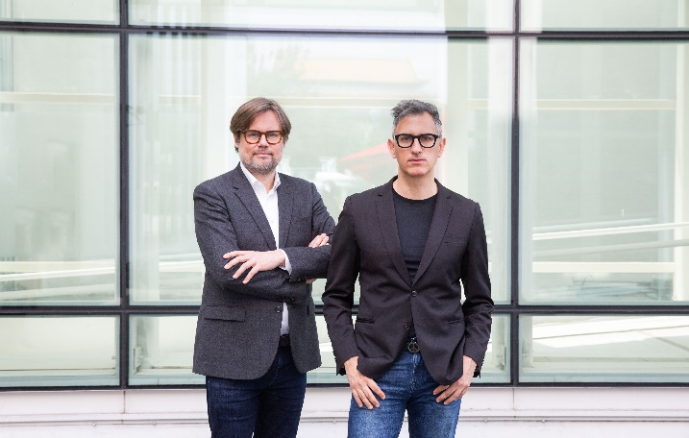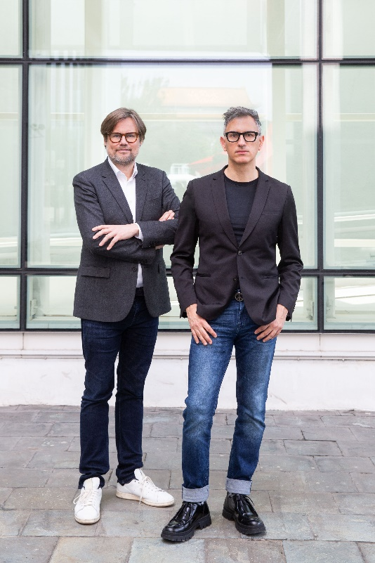
- 「2023台北雙年展：小世界」，害喜影音綜藝《練習一下：我們在講什麼？你們在想什麼？他們在做什麼？》，2023，語音導覽，時間長度不一。圖像由北美館提供，2023台北雙年展委託製作。  Taipei Biennial 2023: Small World, Hide and Seek Audiovisual Art, Practice 01: What are we talking about? What are you thinking about? What are they working on?, 2023, audio guide, duration variable. Image courtesy of Taipei Fine Arts Museum. Commissioned by Taipei Biennial 2023. | 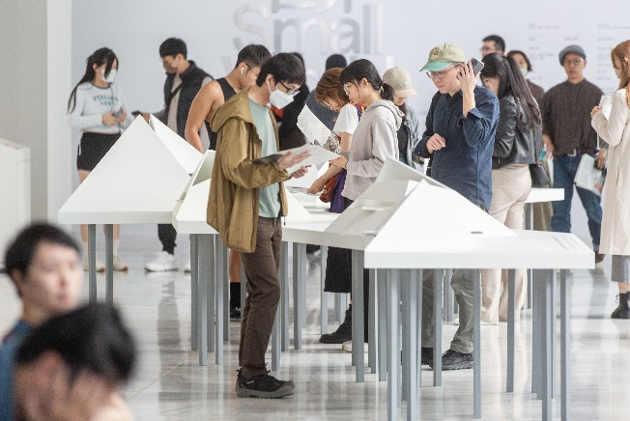
- 「2023台北雙年展：小世界」，李俊陽與神仙老虎狗表演現場。圖像由北美館提供。  Taipei Biennial 2023: Small World, live performance by Li Jiun-Yang and Buddha, Tiger, Dog. Courtesy of Taipei Fine Arts Museum. | 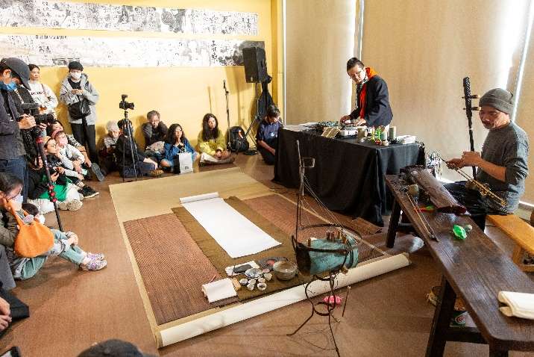
- 「2023台北雙年展：小世界」，「吸膠少年」於Music Room舉辦《音樂無國界》活動現場。圖像由北美館提供。  Taipei Biennial 2023: Small World, Suck Glue Boys, view of "Music No Borders" at Music Room. Courtesy of Taipei Fine Arts Museum. | 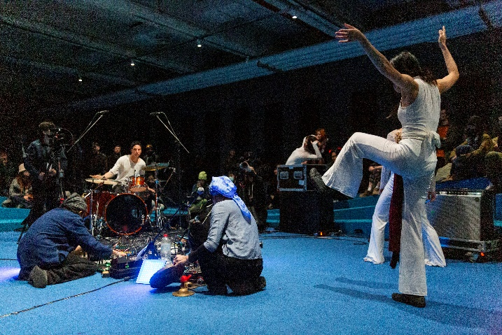
- 「2023台北雙年展：小世界」，「聽說」於Music Room舉辦《交聲響音》: 三人駐活動。圖像由北美館提供。  Taipei Biennial 2023: Small World, Ting Shuo Hear Say, view of "Sound Worlds Rotation- trios in residence" at Music Room. Courtesy of Taipei Fine Arts Museum. | 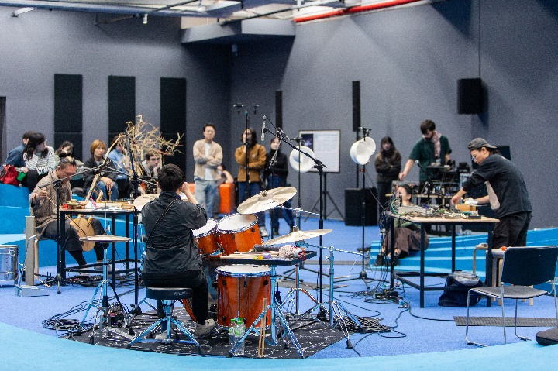
- 6-1、6-2  2023台北雙年展主題網站持續於「小世界線上誌」發佈相關專文(網站截圖)。圖像由北美館提供。  The official website of Taipei Biennial 2023 continuously publishes articles in the "Small World Journal." Courtesy of Taipei Fine Arts Museum.  https://www.taipeibiennial.org/2023/list/smallworldjournal | 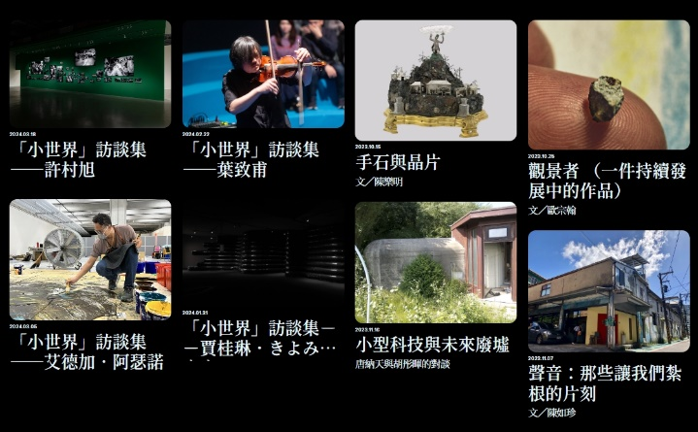  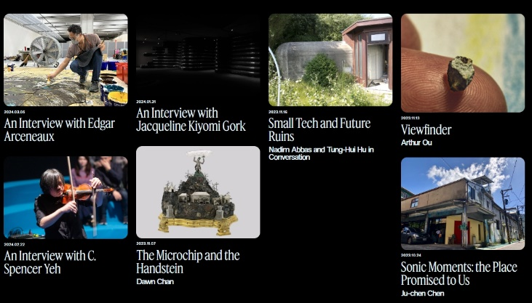
- 2023台北雙年展主題網站完整收錄Music Room精彩活動紀錄。圖像由北美館提供。  The official website of Taipei Biennial 2023 fully documents the highlights of Music Room's exciting programs on website. Courtesy of Taipei Fine Arts Museum.  https://www.taipeibiennial.org/2023/list/musicroom | 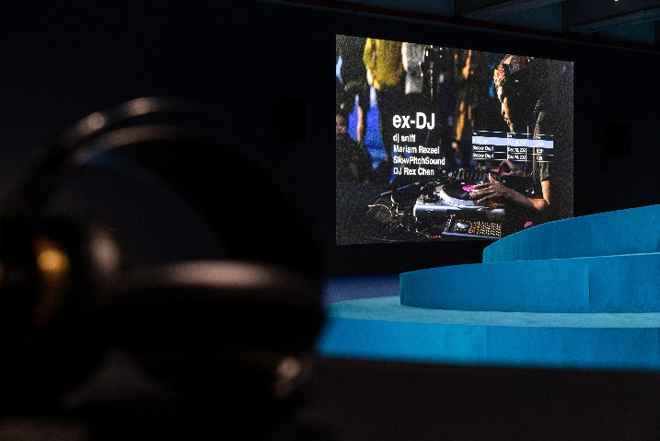
- 「2023台北雙年展：小世界」辦理「育藝深遠 — 藝術欣賞啟蒙方案」校園團體導覽活動，圖像由臺北市立美術館提供。  The “Art Education In-Depth” program for a school group tour of the Taipei Biennial 2023. Courtesy of Taipei Fine Arts Museum. | 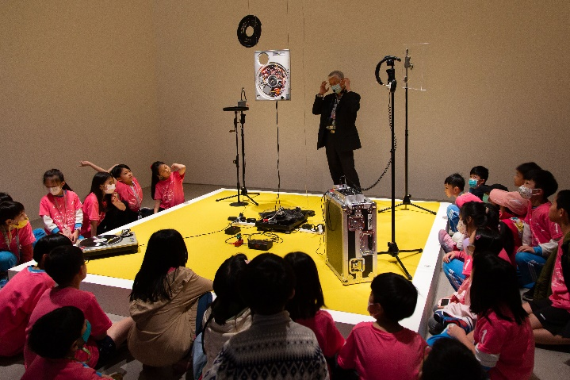
- 「2023台北雙年展：小世界」與主力贊助中國信託文教基金會合作舉辦多場偏鄉及社區孩童的藝術教育活動，圖像由臺北市立美術館提供。  A school group tour of the Taipei Biennial 2023 collaborates with the lead sponsor CTBC Foundation for Arts and Culture. Courtesy of Taipei Fine Arts Museum. | 