2023第13屆台北雙年展呈現豐富公眾計畫
Taipei Biennial 2023 Public Programs

媒體圖說 Image Caption
1-1、1-2、1-3  「2023台北雙年展：小世界」，Music Room《前DJ》《好客幫》《交聲響音》三場公眾計畫主視覺。圖像由北美館提供。  Taipei Biennial 2023: Small World, key visual of the Music Room program: “ex-DJ “ “Hostbuster” and “Sound Worlds Rotation”. Image courtesy of Taipei Fine Arts Museum. | 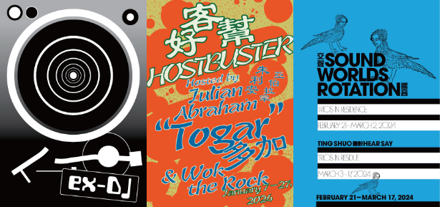
2-1  北美館與紐約雕塑中心（SculptureCenter）聯手推出｢小世界影院（Small World Cinema）｣。圖片由紐約雕塑中心（SculptureCenter）提供。  In collaboration with Taipei Fine Arts Museum, SculptureCenter, New York welcomes “Small World Cinema”. Image courtesy of SculptureCenter, New York. | 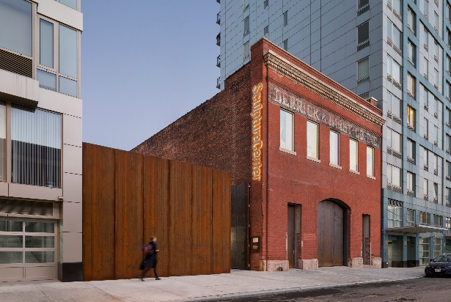
2-2  「2023台北雙年展：小世界」，王雅慧作品《訪客》於放映單元之展出現場。圖像由臺北市立美術館提供。  Taipei Biennial 2023: Small World, Visitor by Wang Ya-Hui is exhibited at the Cinema Program. Image courtesy of Taipei Fine Arts Museum. | 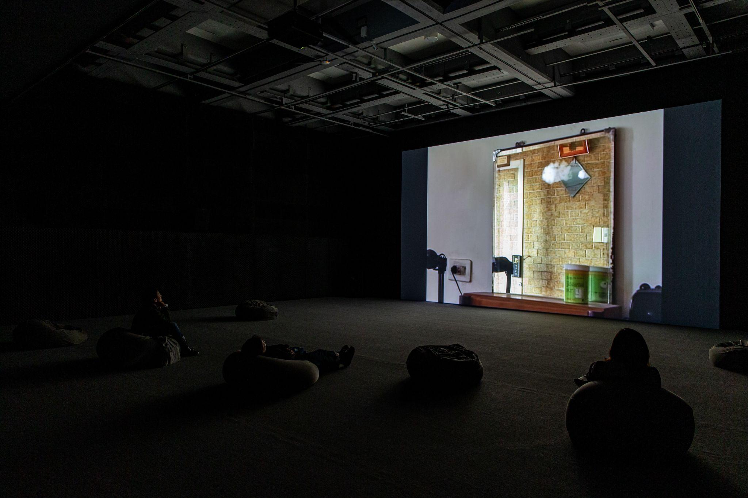
３  「2023台北雙年展：小世界」，Music Room《前DJ》由dj sniff主持之活動現場。圖像由北美館提供。  Taipei Biennial 2023: Small World, site view of Music Room program, “ex-DJ “ hosted by dj sniff. Image courtesy of Taipei Fine Arts Museum. | 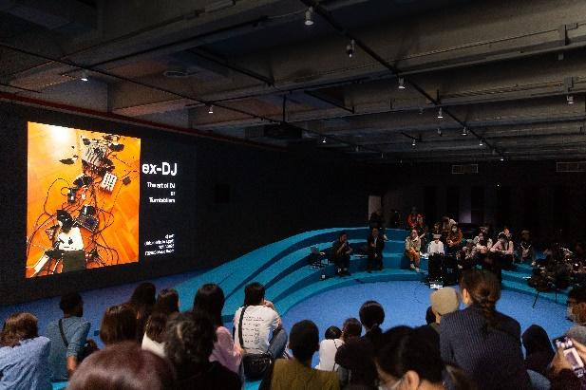

4-2  「2023台北雙年展：小世界」，dj sniff ，Music Room《前DJ》現場演出。圖像由北美館提供。  Taipei Biennial 2023: Small World, site view of Music Room program, “ex-DJ “ by di sniff. Image courtesy of Taipei Fine Arts Museum.  4-3  「2023台北雙年展：小世界」，DJ誠意重，Music Room《前DJ》現場演出。圖像由北美館提供。  Taipei Biennial 2023: Small World, site view of Music Room program, “ex-DJ “ by DJ Rex Chen. Image courtesy of Taipei Fine Arts Museum.  4-4  「2023台北雙年展：小世界」，瑪莉安．雷札伊（Mariam Rezaei），Music Room《前DJ》現場演出。圖像由北美館提供。  Taipei Biennial 2023: Small World, site view of Music Room program, “ex-DJ “ by Mariam Rezaei. Image courtesy of Taipei Fine Arts Museum.  4-5  「2023台北雙年展：小世界」，SlowPitchSound，Music Room《前DJ》現場演出。圖像由北美館提供。  Taipei Biennial 2023: Small World, site view of Music Room program, “ex-DJ “ by SlowPitchSound. Image Image courtesy of Taipei Fine Arts Museum. | 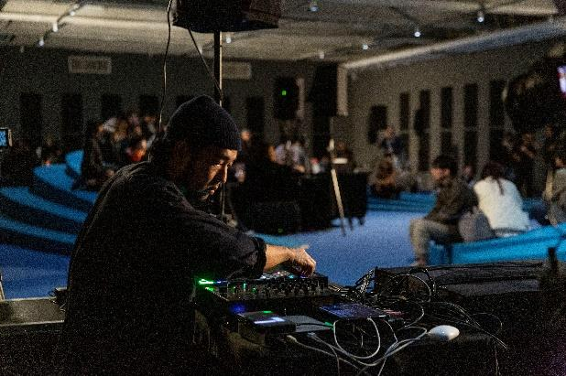  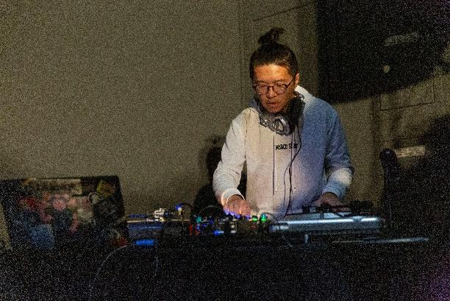  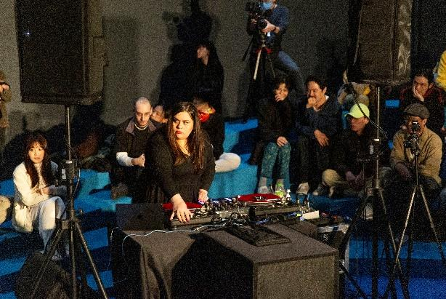  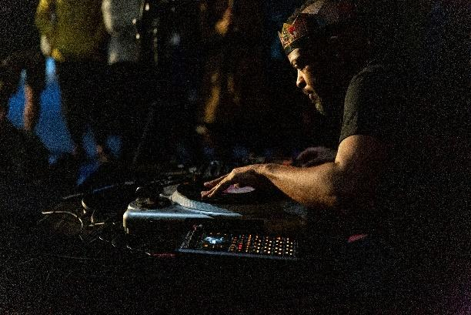
5-1  「2023台北雙年展：小世界」，Music Room《好客幫》由朱利安．亞伯拉罕（「多加」）與Wok the Rock主持之活動現場。圖像由北美館提供。  Taipei Biennial 2023: Small World, site view of Music Room program, “Hostbuster” hosted by Julian Abraham “Togar” & Wok the Rock. Image courtesy of Taipei Fine Arts Museum. | 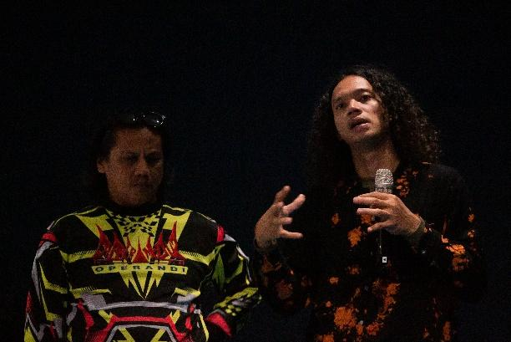
5-2、5-3、5-4  「2023台北雙年展：小世界」，Music Room《好客幫》其一活動邀請印尼台灣流行音樂局舉辦《你看過道明寺嗎》—— 獻給「流星花園」。圖像由北美館提供。  Taipei Biennial 2023: Small World, one of the events of Music Room program “Hostbuster”, "Have You Ever Met Dao Ming Tse?: A Tribute to Meteor Garden" by ID-TW Pop Bureau. Image courtesy of Taipei Fine Arts Museum. | 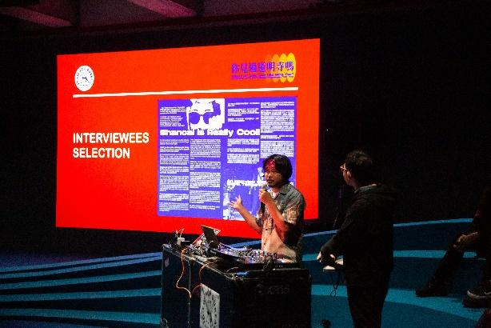  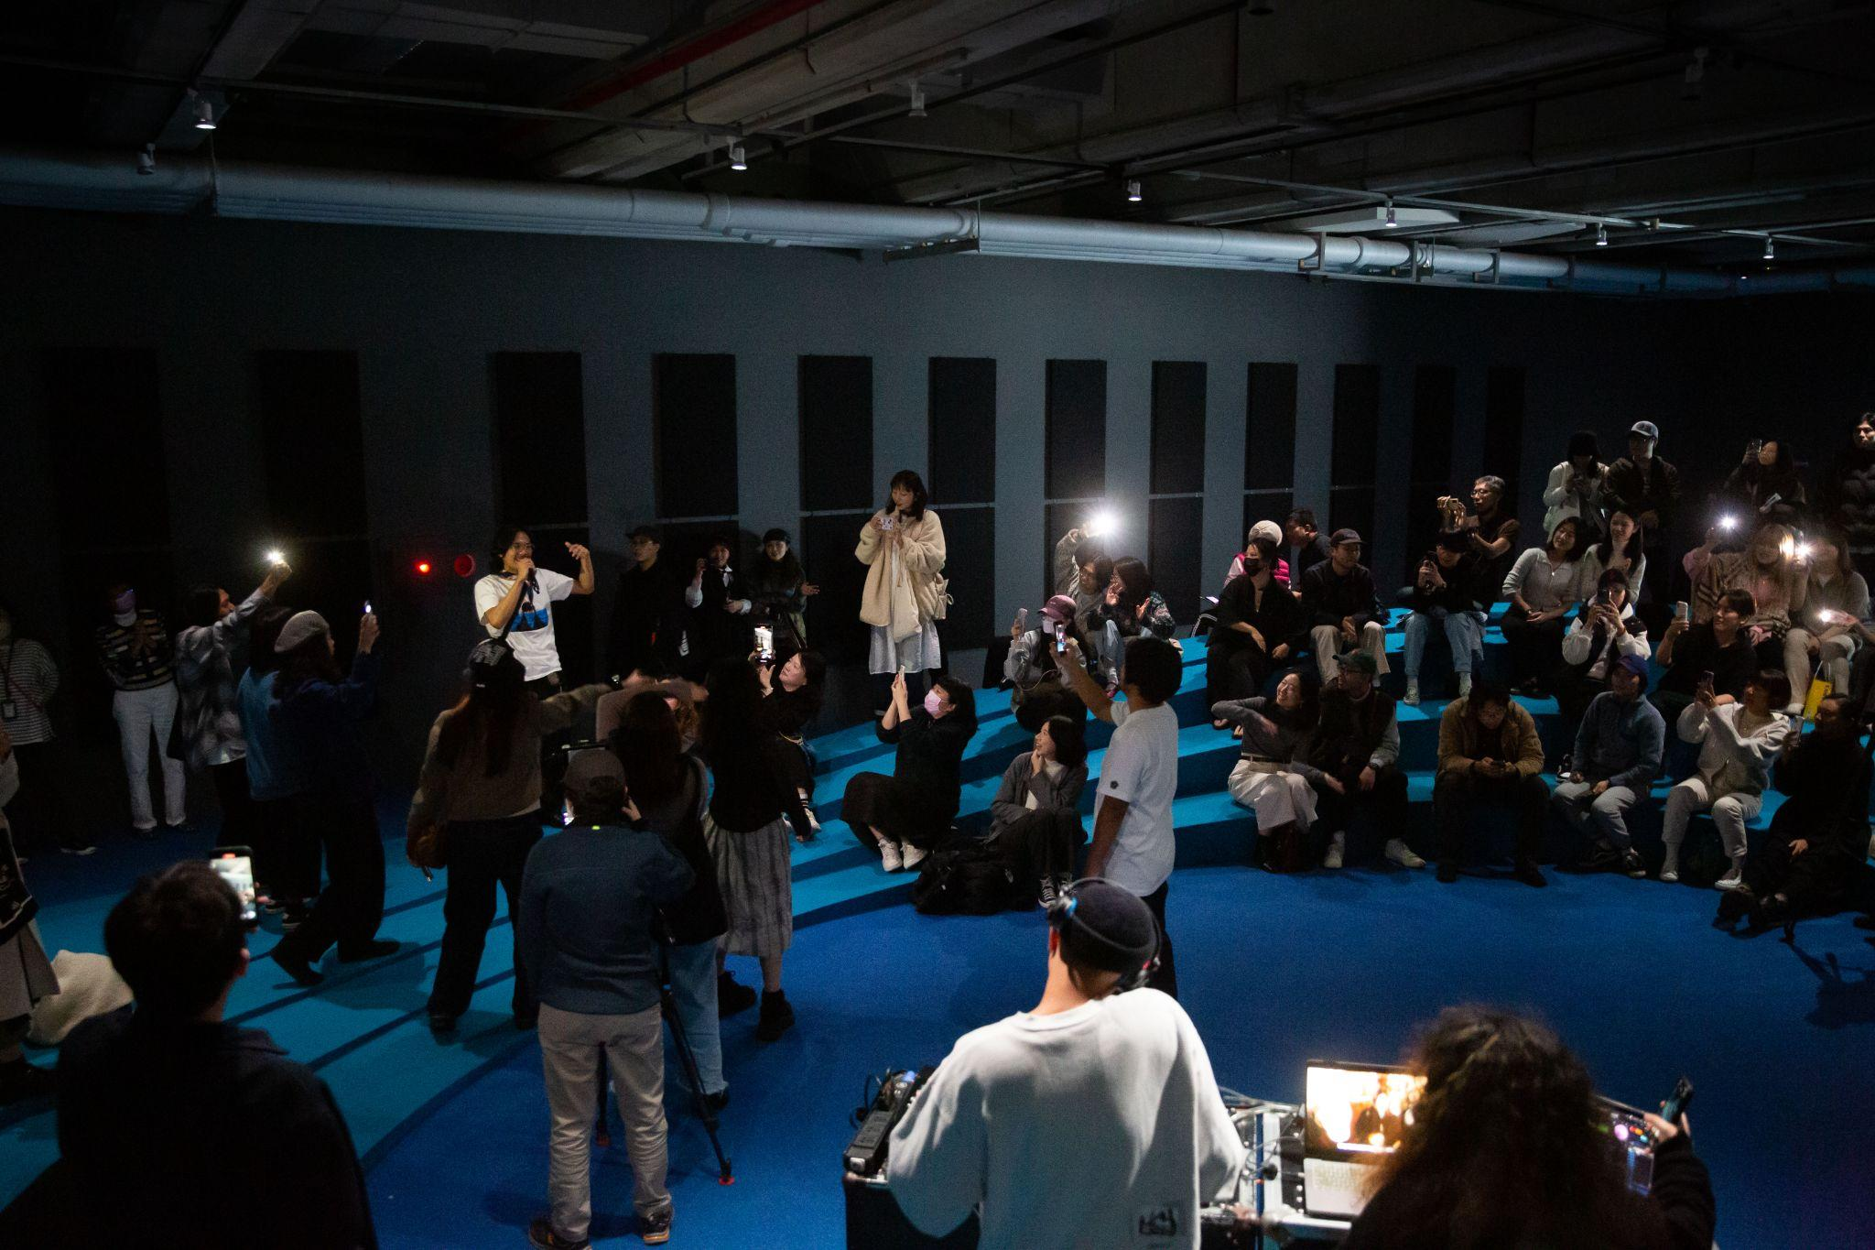  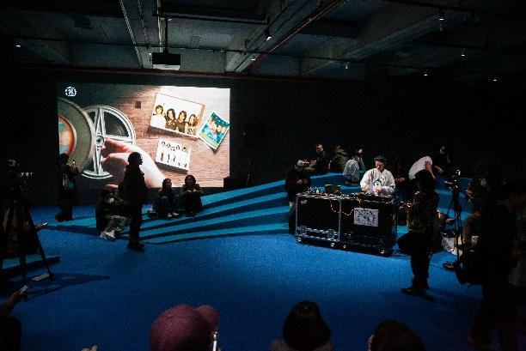
6  2018聽說有表演—貴人散步場。攝影師郭耀正。圖像由藝術家提供。  2018 Ting Shuo Has Performance LUCfest. Photographer Yao-Cheng Kuo. Image courtesy of the artist. | 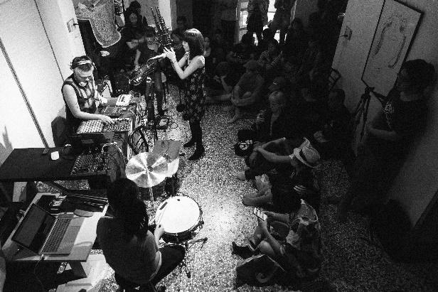
7  賈桂琳．きよみ．寇克，《不完全是(管他何種新音調)》，2017迄今，PVC塑料充氣裝置、離心風機、Arduino微控制器、MIDI及觸發繼電器，尺寸依場地而定。圖像由臺北市立美術館提供。  Jacqueline Kiyomi Gork, Not Exactly (Whatever the New Key Is), 2017 – ongoing, PVC tarpaulin walls, centrifugal blowers, Arduino microcontroller, MIDI and trigger relay, dimensions variable. Image courtesy of Taipei Fine Arts Museum. | 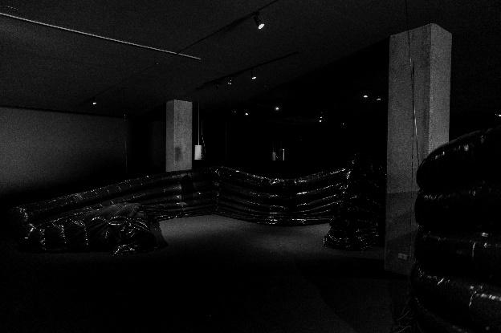  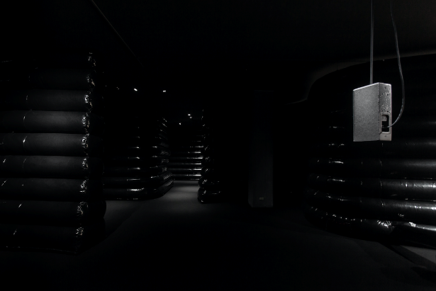
8  尼基塔．蓋爾，《重力獨奏三：超表演》，2022，壓克力盒、擴大器、鍵盤、揚聲器、紅方解石、立體聲，55.9x55.9x30.5公分，循環播放，圖像由北美館提供。  Nikita Gale, GRAVITY SOLO III: HYPERPERFORMANCE, 2022, plexiglass box, amp, keyboard, speakers, red calcite, stereo audio, 55.9×55.9×30.5 cm, loop. Image courtesy of Taipei Fine Arts Museum. | 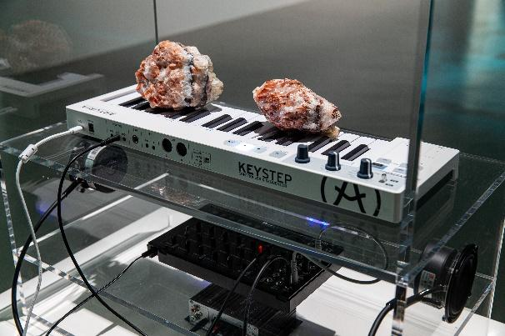  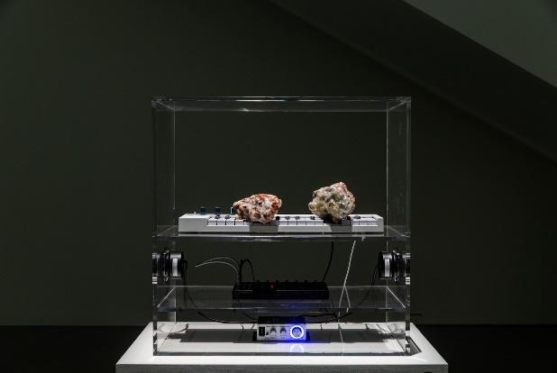
9  派翠西亞．博伊，《操作員（再融資2）》，2017 - 迄今，高畫質錄像投影、彩色、有聲、繪畫、展牆，14分48秒。圖像由北美館提供。紐約壬色列理工學院實驗媒體暨表演藝術中心（EMPAC）共同製作。  Patricia L. Boyd. Operator (Refinanced Il), 2017 – ongoing, HD video, color, sound, drawing, wall, 14 minutes 48 seconds. Image courtesy of Taipei Fine Arts Museum. Produced by Experimental Media and Performing Arts Center (EMPAC) at Rensselaer Polytechnic Institute, New York | 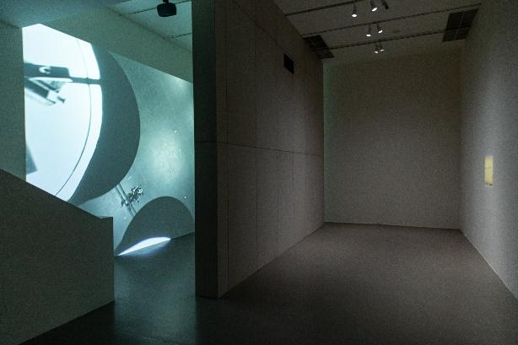
10-1  害喜影音綜藝，《練習一下：我們在講什麼？你們在想什麼？他們在做什麼？》，2023，語音導覽(預計於2月初展出)，時間長度不一。圖像由藝術家、張國耀及北美館提供。2023台北雙年展委託製作。  Hide and Seek Audiovisual Art, Practice 01: What are we talking about? What are you thinking about? What are they working on?, 2023, audio guide, duration variable. Image courtesy of the artists, Chong Kok Yew and Taipei Fine Arts Museum. Commissioned by Taipei Biennial 2023. | 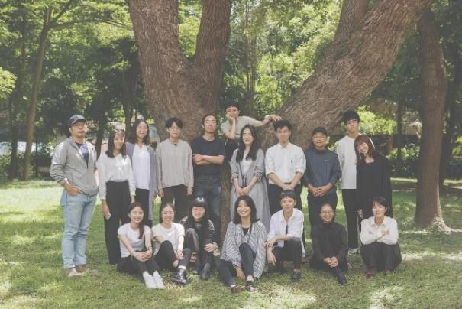
10-2  害喜影音綜藝，雙年展開展前，舉辦的第一次實體工作坊活動紀錄。圖像由藝術家提供。  Hide and Seek Audiovisual Art, the first physical workshop held prior to the Biennial's opening. Image courtesy of the artists. | 