The Taipei Fine Arts Museum Announces the Highlights of 2024 | Image Sheet

圖說 | 影像
1.  TFAM Exhibition Archive 1983-1994 (Still). Courtesy of Taipei Fine Arts Museum.  archives.tfam.museum | 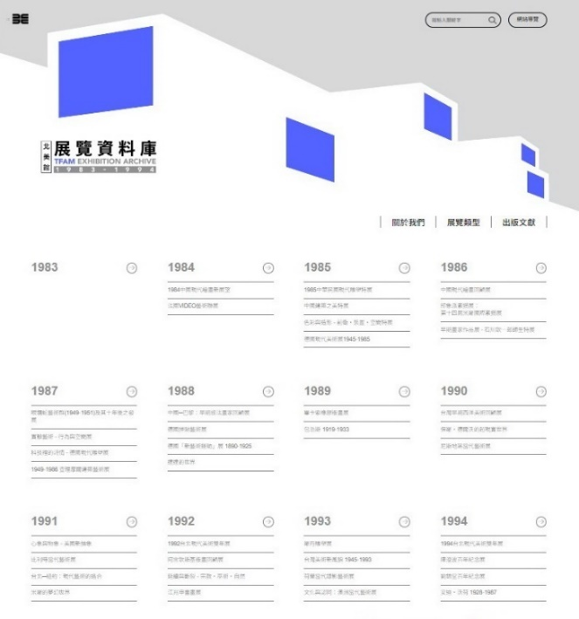
2.  Installation view of Active Archives II: TFAM Exhibition Archive 1983-1994. Courtesy of Taipei Fine Arts Museum. | 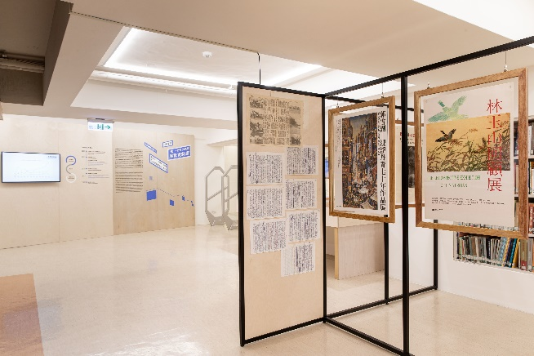
3.  Modern Life: Taiwan Architecture 1949–1983, newly inaugurated Taipei Fine Arts Museum, c. 1983. Courtesy of Taipei Fine Arts Museum. | 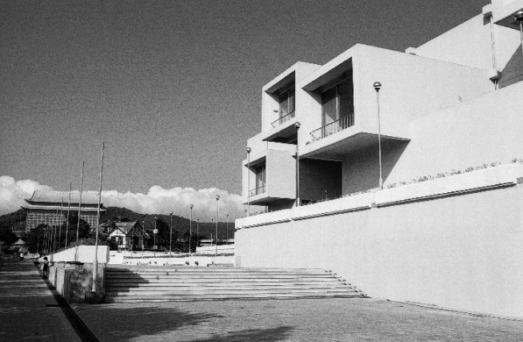
4.  Modern Life: Taiwan Architecture 1949–1983, Lincoln Building and Lin An-Tai Historical House before its relocation, 1978. ©The Ministry of Foreign Affairs. Courtesy of Taipei Fine Arts Museum. | 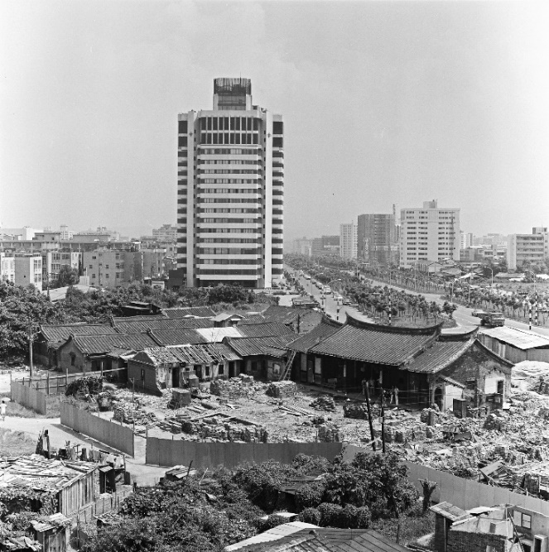
5.  William Kentridge, Mama Put Your Soul Away, 2022, Indian ink and coloured pencil on Phumani handmade paper, mounted on raw canvas, 228.7 × 191.7 cm.  © William Kentridge. Courtesy of the artist and Taipei Fine Arts Museum. | 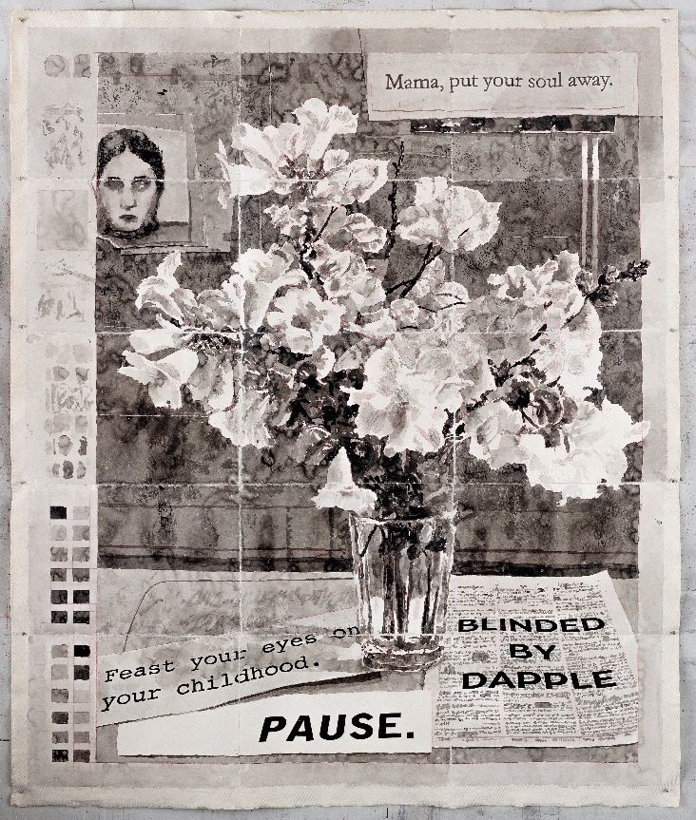
6.  William Kentridge, Notes Towards a Model Opera (still), 2015, three channel HD film installation,11min14sec.  © William Kentridge. Courtesy of the artist and Taipei Fine Arts Museum. | 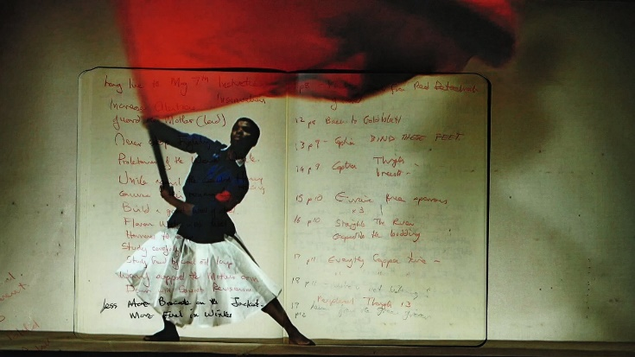
7.  Taiwan Collateral Event of the 60th International Art Exhibition, La Biennale di Venezia, 2024  Yuan Goang-Ming, Everyday War, the exhibition’s eponymous work expected in 2024. © Yuan Goang-Ming. Courtesy of the artist and Taipei Fine Arts Museum. | 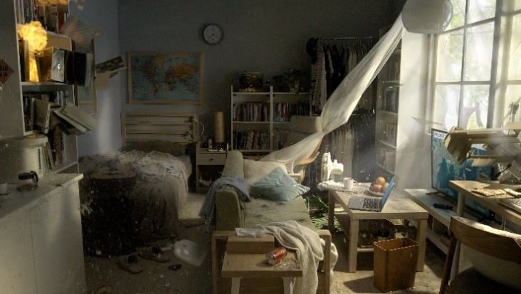
8.  Taiwan Collateral Event of the 60th International Art Exhibition, La Biennale di Venezia, 2024  Yuan Goang-Ming, Everyday Maneuver, 2018. © Yuan Goang-Ming. Courtesy of the artist and Taipei Fine Arts  Museum. | 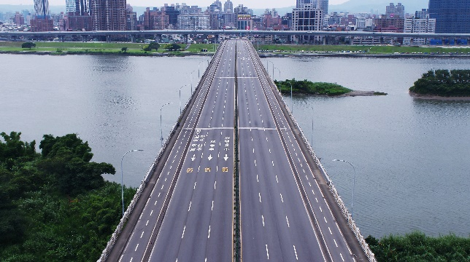
9.  Enclave: A Biography  Lii Jiin-Shiow, Fusion, Reaction and the Song of Rainbow, 2002, Acrylic on canvas, 145 x 90 cm ( x3 ), collection of Taipei Fine Arts Museum. © Taipei Fine Arts Museum.  Courtesy of the artist and Taipei Fine Arts Museum. | 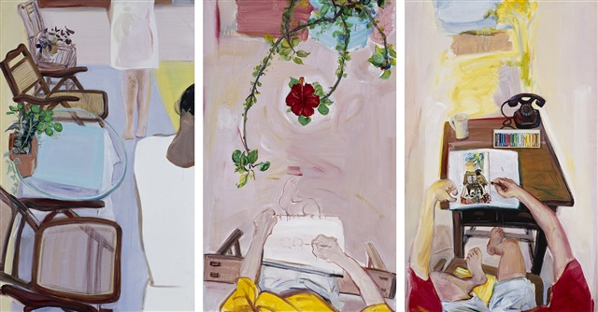
10.  Enclave: A Biography  Chen Hsing-Wan, The Sky Is A Sphere, the Earth Is A Square, 1994, Fabric, ink, collage, 246.5 x 351.5 cm, collection of Taipei Fine Arts Museum. © Taipei Fine Arts Museum. Courtesy of the artist and Taipei Fine Arts Museum. | 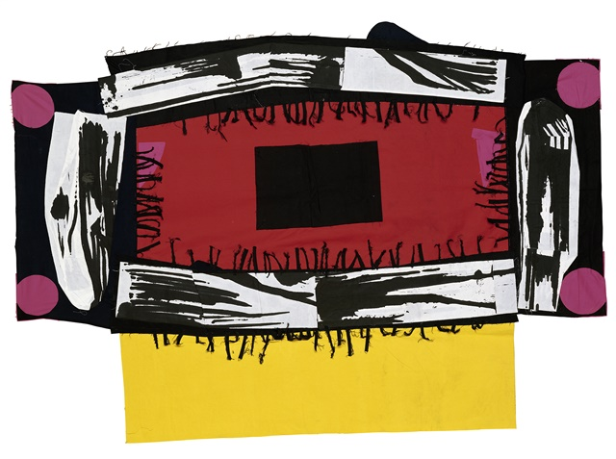
11.  Asian Gouache Painting in Taiwan (tentative)  Huang Ching-Shan, Ship of Southern Country, 1941, Asian gouache on paper, 150 x 328.5 cm, collection of Taipei Fine Arts Museum. © Taipei Fine Arts Museum. Courtesy of the artist and Taipei Fine Arts Museum. | 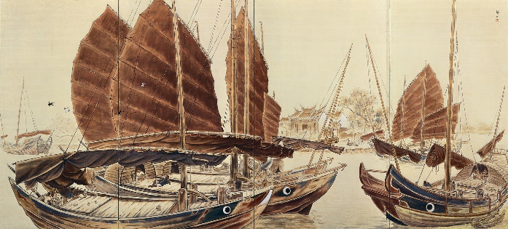
12.  Asian Gouache Painting in Taiwan (tentative)  Lu Yun-Sheng, Pear Espalier, 1934, Asian gouache on silk, 207 x 125.5 cm, collection of Taipei Fine Arts Museum. © Taipei Fine Arts Museum. Courtesy of the artist and Taipei Fine Arts Museum. | 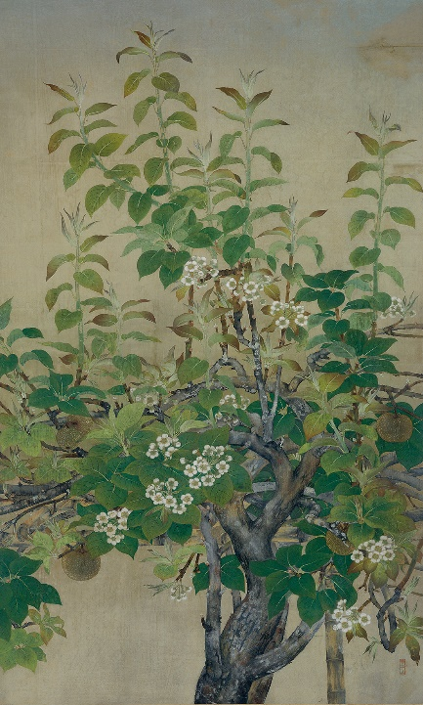
13.  Hsu Yu-Jen: A Retrospective (tentative)  Courtesy of the artist and Taipei Fine Arts Museum. | 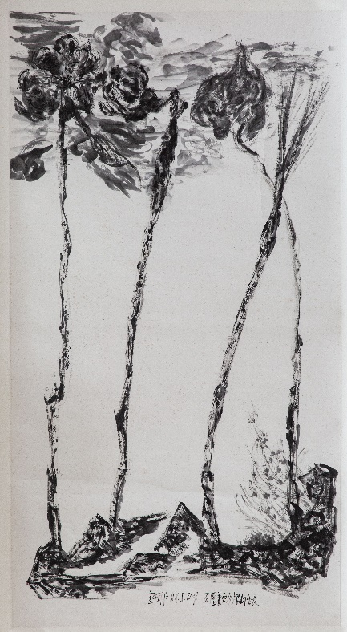
14.  Hsu Yu-Jen: A Retrospective (tentative)  Courtesy of the artist and Taipei Fine Arts Museum. | 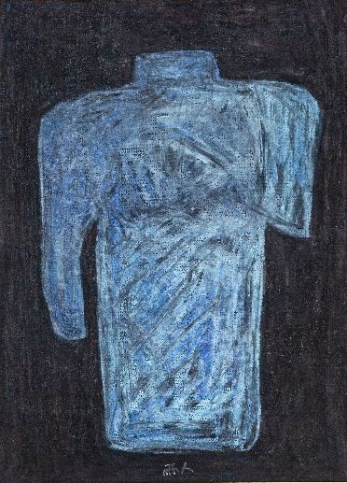
15.  Ni Xiang, Everyone Came to See You, 2022. © Ni Xiang. Courtesy of the artist and Taipei Fine Arts Museum. | 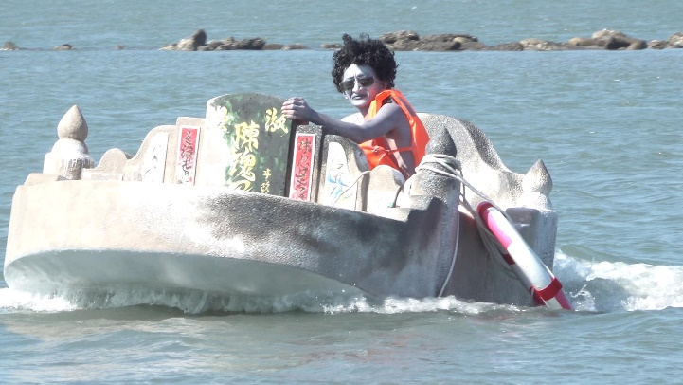
16.  Chen I-Shu, Fake Landscape, 2022. © Chen I-Shu. Courtesy of the artist and Taipei Fine Arts Museum. | 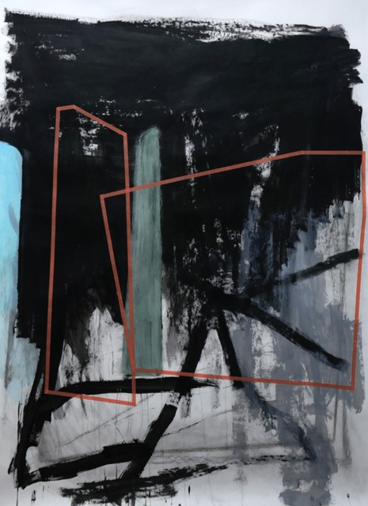
17.  Shyu Ruey-Shiann, Between II, 2023. © Shyu Ruey-Shiann. Courtesy of the artist and Taipei Fine Arts Museum. | 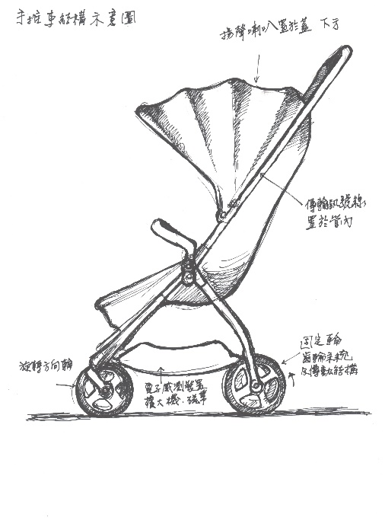
18.  Tsai Pou-Ching, Specimen of Empire, 2023. ©Tsai Pou-ching. Courtesy of the artist and Taipei Fine Arts Museum. | 