Taipei Fine Arts Museum Press Release
FOR IMMEDIATE RELEASE

Media contact:
Daisy Shiou (daisy.s-tfam@gov.taipei)
Jean Tzu-chin Kao (tckao-tfam@gov.taipei)
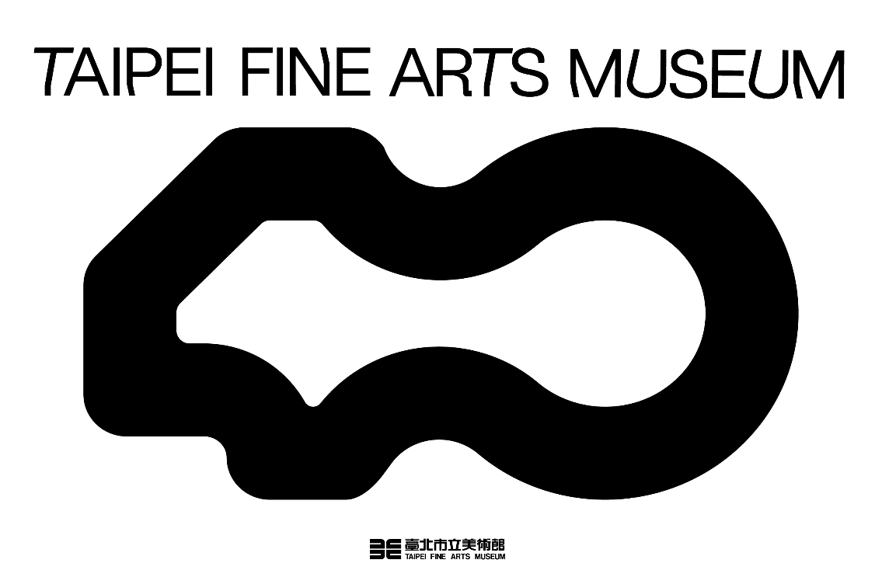
The Taipei Fine Arts Museum Announces the Highlights of 2024

The Taipei Fine Arts Museum (TFAM) is delighted to announce the 2024 highlights, including three flagship exhibitions, six solo exhibitions by Taiwanese artists from various generations, three research-based exhibitions featuring the TFAM collection, and a new online project, continuously fostering the momentum that propels the development of art.

Ushering in the year of 2024, the TFAM continues the exhibition project of the previous year during the first season, attempting to view the world through a new vision at the beginning of the new year. Taipei Biennial 2023: Small World on view in the first-floor, second-floor and basement galleries employs individual life experiences and aesthetic perception to transform the TFAM into a space of listening, gathering, and improvised creative work, guiding the audience to see the big picture through small things. The Taipei Art Awards 2023 on view in the third-floor galleries has announced the winner of the Grand Prize on November 3, and showcases nine works that unveil the creative endeavors of emerging Taiwanese artists, who voice their ideas about the world through dissimilar media.

Since 1983, the TFAM has witnessed the development of Taiwanese art. In 2008, the museum launched an ongoing project to digitize the museum’s archives, and planned the “TFAM Archives” in 2018 to successively gather key historical materials. On the TFAM Day of the museum’s 40th anniversary last month, the “Exhibition Archive 1983-1994” centering on the TFAM’s first decade was open for public use. Moreover, Active Archives II: TFAM Exhibition Archive 1983-1994 was presented at the Library and Archive Center. On view in the archival exhibition are representative exhibition posters, selected exhibition invitations to application exhibitions and the series of avant-garde and experimental exhibitions, as well as the museum archives collated throughout the construction process of the archives. The audience can view long-stored printed materials, digitized photographic images, videos, journal clips, and other archives, which collectively demonstrate the trajectories of the TFAM’s research about its position during the first decade, as well as the ambition and vision to revitalize the museum history for the future.

Three Flagship Exhibitions Explore Global Geographical Awareness through Vocabularies of Contemporary Art
Modern Life: Taiwan Architecture 1949–1983 is a research-based curatorial project by Wu Kwang-Tyng, Wang Chun-Hsiung, and Wang Tseng-Yung. The exhibition focuses on exploring issue events and factors of living culture that had an impact on the developmental context of Taiwanese architecture after the Nationalist government relocated to Taiwan. Diverse and modern architectural features become a window to study the cultural changes in post-war Taiwan. Following the timelines of six subtopics, the exhibition shows how Taiwan gradually stepped out of the shadow of political ideologies and moved towards the modern time of free living.

William Kentridge marks the debut of the artist’s first large-scale solo exhibition in Taiwan, and fully demonstrates the artist’s creative career for 40 years. Co-curated by the TFAM and the Royal Academy of Arts, the exhibition is a reconfigured version of the namesake exhibition held in London 2022. A highly acclaimed contemporary artist, Kentridge is known for his use of multimedia art forms, including drawing, film, sculpture, installation, theatre, literature, and performance. He has created a distinctive and powerful artistic vocabulary delineating the complex themes of race, society and politics in South Africa.

Taiwan Collateral Event at the 60th International Art Exhibition, La Biennale di Venezia 2024 will be officially open at Palazzo delle Prigioni on April 20, 2024. Adopting the theme of “Everyday War,” artist Yuan Goang-Ming and curator Abby Chen focus on the core ideas explored throughout Yuan’s career, and use video art and image language that Yuan is known for, combined with installations, to construct a quasi-domestic “everyday” site. Through metaphors discussing the unstable geopolitics of the island chain on the Pacific rim, the exhibition urges us to open our eyes to real life as well as the troubles and threats lurking in our “dwelling.”

Three TFAM Research-based Curatorial Projects Unfold a Multidimensional Space of Dialogue
The TFAM has consistently focused on research-based endeavors in exhibiting rarely shown works in the collection. At the end of 2024, two thematic exhibitions are planned and curated by the museum staff. Enclave: A Biography appropriates “immanence” in relation to the human geographical idea of “enclave” to portray women artists’ psychological state, and refract their surging inner emotions and rich characteristics. The exhibition extends the common literary style of autobiographic narrative to feature women artists’ multifaceted life experiences, through which the different stages of their creative careers and focuses are unveiled. Meanwhile, the TFAM also looks into the museum collection to curate Asian Gouache Painting in Taiwan(tentative) that investigates the unique role of the art form in the development of Taiwanese art, and features related artists and their works to construct a developmental genealogy of Asian gouache painting in Taiwan. The exhibition inquires into how Taiwanese painters learn from and ruminate over sources inherited from Japan and external stimulations to formulate new interpretations.
To respond to the imagination beyond physical space in the contemporary society of technology, the TFAM launches a new online project to engage our global audience and expand the possibility of their participation. For the first project of the TFAM Net.Open, the TFAM collaborates with Nadim Samman, the curator of the KW Institute of Contemporary Art in Berlin, and commissions Jon Rafman (Canada), Simon Denny (New Zealand), and Cheng Hsien-Yu (Taiwan) to create brand-new works for the project. Meanwhile, an offline public program revolving around the idea of “co-working” will be launched to deepen audience and community engagement and co-creation to generate more dialogues and possibilities.

Six Solo Exhibitions of Taiwanese Artists Display Ample, Intergenerational Momentum of Artistic Creation
Hsu Yu-Jen: A Retrospective (tentative) is the artist’s first large-scale retrospective in his five-decade-long career, which systematically teases out his sketches, drawings, early experimental works, and so on, to show the artist’s creative trajectory and spiritual context. Mentored by Li Chun-Shan, Hsu traveled between the U.S. and Taiwan three times in the 1980s. He works with both ink and oil painting, and used to create stone sculptures as well. However, throughout his career, the exploration of the essence and innovative expression of Eastern ink painting has always been his steadfast and consistent endeavor. The exhibition showcases Hsu’s various series stemming from dissimilar ideas. Having immersed himself in Western cultural impacts several times, Hsu has still insisted on his quest of ink art from a contemporary viewpoint, creating his signature “thin-brush and fragmented lines” that has evolved into a highly individualistic style.

In addition, new-generation artists have been keeping up with the times by responding to contemporary issues with their acute observation and respective context of art. Ni Xiang’s solo exhibition – Everyone Came to See You draws inspiration from his personal experience of being a home care provider, and discusses topics of senility, the physical and mental demand of accompanying patients, as well as the helplessness when facing death through a humorous approach. Chen I-Shu’s solo exhibition – Fake Landscape features a painting series reflecting on issues of the current Russo-Ukrainian War, which prompts the spectator to contemplate on questions about national border/territory and boundary/position. Also drawing inspiration from the situation in Ukraine, Shyu Ruey-Shiann’s solo exhibition – Between II uses the event “Tsina Viyny” (Price of War) as an entry point, and employs readymade and audio recordings to engage the audience in thinking about “how to preserve the positive meanings of life.” Tsai Pou-Ching’s Solo Exhibition – Specimen of Empire investigates specimens from the period of Japanese rule that have been given different values and implications due to historical and environmental changes, offering an alternative way to view the specimens and past events. Featuring the Grand Prize winner of the 2021 Taipei Art Awards, Lin Yen-Chun’s Solo Exhibition is scheduled at the end of the year. The exhibition revolves around the artist’s memories of searching for, studying, and listening to the coexistence between all living beings and the environment in sleep, and utilizes sound, sculpture, and dream to construct a transitional zone between this world and the world beyond.

Highlights of the Taipei Fine Arts Museum in 2024

Note: Following exhibitions are listed in a chronological order. Complete information will be provided before the respective openings.
The 13th Taipei Biennial: Small World 2023 | 2023.11.18-2024.03.24 【Basement, 1F & 2F Galleries】
Co-curated through the approach of collaboration between the independent Taiwanese curator, Freya Chou, the director and curator of Beirut Art Center, Reem Shadid, and the established New York-based writer and editor, Brian Kuan Wood, the exhibition brings together 58 Taiwanese and foreign artists and musicians from more than 20 cities, and features more than 120 works, including 19 brand-new creations and commissioned projects, along with a series of works of sound, moving image, photography, video, painting, sculpture and installation. Through personal life experiences and aesthetic perception, the biennial transforms the TFAM into a space for listening, gathering, and creative improvisation. The biennial also includes a “Cinema Program,” a public outreach program called “Music Room,” and an online Small World Journal, which is a digital platform that offers essays, interviews, and conversations, forming a diverse channel for the audience to extend their reading of the biennial.

Active Archives II: TFAM Exhibition Archive 1983-1994 | 2023.12.20-2024【Library and Archive】
The exhibition is combined with the online platform – the “Exhibition Archive 1983-1994,” and is on view at the Library and Archive, offering an opportunity for the public to see a rich and diverse collection of archives from the first decade of the TFAM. The exhibition not only showcases a selection of representative exhibition posters, including group exhibitions of major Taiwanese artists from an early period, solo exhibitions of established artists, international exchange exhibitions, and the different iterations of the Contemporary Art Trends in R.O.C. and the Taipei Biennial of Contemporary Art (forerunners of the Taipei Biennial), but also features invitations to application exhibitions of mid-career artists as well as the avant-garde and experimental exhibition series, along with precious and rare journal clippings, slides, photo albums, audio tapes, etc. Through the 665 exhibitions presented throughout the first decade of the TFAM, audience can perceive how the museum navigated the initial period after its inauguration by researching about and redefining its position. The exhibition unveils the museum’s journey of transforming itself into “a modern and contemporary art museum,” enriched by the ambition and vision to utilize and revitalize the TFAM history in the future. (archives.tfam.museum)

Modern Life: Taiwan Architecture 1949–1983 | 2024.03.23－2024.06.30【3F 3A & 3B Galleries】
The exhibition a research-based curatorial project by Wu Kwang-Tyng, Wang Chun-Hsiung, and Wang Tseng-Yung, and explores issue events and factors of living culture that had an impact on the developmental context of Taiwan architecture from 1949 to 1983 through six subtopics, namely, “Influence of U.S. Aid,” “Return to Chinese Retro,” “Emergence of Chinese Modern,” “Defining Regional Modernity,” “Outliers,” and “A New Life.” In comparison to the changes of the post-WWII global geopolitics in relation to Taiwan in 1945, the relocation of the Nationalist government from Nanjing to Taiwan indeed had a more profound impact on Taiwan in terms of the new geopolitical role for the island. The mainland Chinese lifestyle ensuing the relocation became mixed with the local lifestyle, and evolved into a diverse new lifestyle informed by modern meanings and implications. While pursuing and longing for modernity, architecture has also become a window for glimpsing into the changing post-war cultural scene on the island. The exhibition points out that the formation of the new living culture was shaped by two policies implemented within the system: the first was the acceptance of the U.S. aid and the import of new modern experiences; and the second was the idea of preserving and further developing the Chinese culture, for which a Chinese retro style was extensively applied to the domain of public architecture. The exhibition timeline reveals how Taiwan gradually stepped out of the shadow of political ideologies and moved towards the modern time of free living.

TFAM Net.Open (Online Platform)｜2024.03.29－2024.12.31【TFAM Website】
TFAM Net.Open (Physical Program)｜2024.04.20－2024.07.14【Basement E & F Galleries】
To respond to the increasing diversifying direction of artistic creation in the future and strengthen the museum’s engagement with audience, the TFAM collaborates with Nadim Samman, the curator of the KW Institute of Contemporary Art in Berlin, and commissions Jon Rafman (Canada), Simon Denny (New Zealand), and Cheng Hsien-Yu (Taiwan) to create brand-new works for the online program of the TFAM Net.Open, as a way to echo the imagination beyond physical space in the contemporary society of technology. Meanwhile, in the B2 E and F Galleries, the TFAM Net.Open also presents an offline public program revolving around the idea of “co-working” with the community that has engaged in the development of technology and art in Taiwan so as to deepen the engagement and co-creation with the audience and the community, endeavoring in opening up more dialogues and possibilities.

Taiwan Collateral Event at the 60th International Art Exhibition, La Biennale di Venezia 2024｜2024.04.20－2024.11.24 【Palazzo delle Prigioni, Venice, Italy】
For the Taiwan Collateral Event at this iteration of the Venice Biennale, artist Yuan Goang-Ming and curator Abby Chen adopt the theme of “Everyday War” to question about the human condition under the constant threat of disasters and catastrophes. The exhibition will feature two brand-new projects and six video and kinetic installations, continuing Yuan’s creative context, including the image vocabularies such as “home,” “dwelling,” and “an uncanny tomorrow” in Dwelling (2014), Tomorrowland, and Everyday Maneuver (both 2018), to reveal the lesser known narratives about everyday life. Yuan’s work centers on metaphors for the unstable geopolitics of the island chain on the Pacific rim to further foreground the lurking fear in individual experiences through the form of recreated nightmares. Meanwhile, the artist also contemplates on the reality inhabited by us as well as the troubles and threats concealed in our “dwelling” through his works.

William Kentridge｜2024.05.04－2024.09.01【1F 1A & 1B Galleries】
South African artist William Kentridge is known for weaving together a variety of artistic forms, including drawing, film, sculpture, installation, theatre, literature, and performance with his distinctive language of arts. His works often use poetic spaces of metaphor and symbol to examine the meaning of power and the history of exploitation, and to explore the justice and freedom in life. A highly acclaimed contemporary artist, Kentridge has unraveled many moving issues of race, society, and politics in South Africa, using his profound insights in aesthetics, history, and philosophy. His work has been featured in major art museums and prominent biennials, such as Documenta and Venice Biennial. This exhibition is a collaboration between the TFAM and the Royal Academy of Arts. It is a reconfiguration of the exhibition of the same name presented in November 2022. It not only features Kentridge’s early drawings and well-known stop-motion films from his drawings, demonstrating how the artist uses monochromatic lines of charcoal and ink to explore the texture of things and the experiment of viewing, but also includes his interdisciplinary endeavor in stage production. The exhibition presents the artist's 40-year creative trajectory for the first time in Taiwan. It is a rare opportunity for the local audience to experience how the artistic creation could transcend the barriers and boundary in a unique socio-political environment. The exhibition offers a chance to witness Kentridge’s dedication to the multifaceted nature of meaning and his believe of art in defense of the uncertain.

Hsu Yu-Jen: A Retrospective (tentative) | 2024.05.18-2024.09.08 【2F 2A & 2B Galleries】
Hsu Yu-Jen (b. 1951-) was born in Jiali, Tainan, and graduated from the Department of National Painting, National Academy of Arts in 1975. He was mentored by Li Chun-Shan, who inspired him to pursue creative freedom and explore the self. After his solo exhibition at the American Cultural Center in 1979, Hsu traveled to the U.S. with the hope of immersing himself in the modern and contemporary art scene and developing the absolute originality in his mind. Having traveled between Taiwan and the U.S. for three times in a decade, Hsu moved his entire family back to Taiwan in 1989. Hsu works with both ink and oil painting, and used to create stone sculptures as well. However, throughout his career, the exploration of the essence and innovative expression of Eastern ink painting has always been his steadfast and consistent endeavor. After 2000, he has published various series stemming from dissimilar concepts, including The Ocean Series, Thin-brush Ink Painting Series, Rough-brush Ink Painting Series, Color Painting Series, and Ink Scribing Series. This exhibition is the artist’s first large-scale retrospective in his five-decade-long career, which systematically teases out his sketches, drawings, early experimental works, and so on, showcasing his creative trajectory and spiritual context.

TFAM 2024 Call for Artists: Ni Xiang, Chen I-Shu, Shyu Ruey-Shiann, Tsai Pou-Ching | 2024.07.27－2024.10.20 【3F 3A & 3B Galleries】
Ni Xiang’s solo exhibition – Everyone Came to See You draws inspiration from his own experience of being a home care provider, and discusses topics of senility, the physical and mental demand of accompanying patients, as well as the helplessness when facing death through a humorous approach, representing the unseen issue of long-term care at different parts of society. Chen I-Shu’s solo exhibition – Fake Landscape reveals compositions comprising layers of stones and objects, embedding the idea of “artificial mountain” in the images. The artist also incorporates the subject of the Russo-Ukrainian War into the series, prompting the spectator to contemplate on questions about national border/territory and boundary/position. Shyu Ruey-Shiann’s solo exhibition – Between II uses the event “Tsina Viyny” (Price of War) as an entry point. The artist gathers more than a hundred strollers from around Taiwan, and utilizes mechanical power to activate audio files to portray and record this historical period, while contemplating on “how to preserve the positive meanings of life.” Tsai Pou-Ching’s solo exhibition – Specimen of Empire investigates specimens from the period of Japanese rule that have been given different values and implications due to historical and environmental changes. His work transforms the vehicles of technology into spirit-summoning technological protheses, offering an alternative way to view the specimens and past events.

Enclave: A Biography│2024.10.05-2024.12.15 【1F 1A & 1B Galleries】
Enclave: A Biography builds upon the TFAM collection, and appropriates “immanence” in relation to the human geographical idea of “enclave” to portray women artists’ psychological state, and refract their surging inner emotions and rich characteristics. The exhibition extends the common literary style of autobiographic narrative and centers on women artists’ multifaceted life experiences, through which the different stages of their creative careers and focuses are unveiled.
Asian Gouache Painting in Taiwan (tentative) │2024.10.12-2025.02.02 【2F 2A & 2B Galleries】
Asian Gouache Painting in Taiwan (tentative) looks into the unique role of gouache painting in the modern development of Taiwanese art. Stemming from Japanese-style gouache painting, gouache paintings by Taiwanese artists have also formed a major direction in terms of the TFAM’s acquisition in order to preserve Taiwanese art history. This exhibition uses the gouache paintings in the TFAM collection as a starting point to uncover related artists and their works on the unfurling timeline. Through this attempt to construct a developmental genealogy of Taiwanese gouache painting, the exhibition unveils the accumulated and growing creative energy in the art scene, and inquires into how Taiwanese painters learn from and ruminate over sources inherited from Japan and external stimulations to formulate new interpretations, demonstrating how the artists inscribe the history of gouache painting in Taiwan with their works.
The 2021 Taipei Art Awards Grand Prize Winner: Yen-Chun Lin│2024.12.07-2025.03.02【Basement E Gallery】
The solo exhibition of Lin Yen-Chun, the Grand Prize winner of the 2021 Taipei Art Awards, revolves around the artist’s memories of searching for, studying, and listening to the coexistence between all living beings and the environment in sleep, and uses sound, sculpture, and dream to construct a transitional zone between this world and the world beyond.

