2024年威尼斯雙年展台灣館公布展名「日常戰爭」
Taiwan’s Representation at the 60th Venice Biennale 2024: Everyday War

作品圖說Image Description
01  袁廣鳴，《日常戰爭》，同展名新作 ©袁廣鳴，藝術家提供。  YUAN Goang-Ming, Everyday War, the exhibition’s eponymous work expected in 2024. © YUAN Goang-Ming. Courtesy of the artist. | 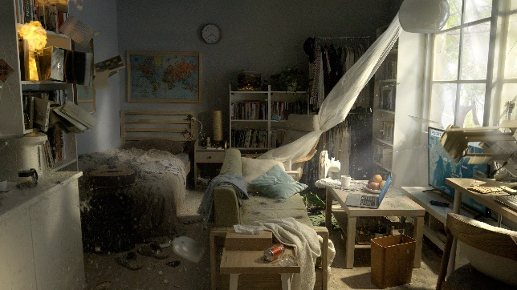
02  袁廣鳴，《日常演習》，2018 ©袁廣鳴，藝術家提供。  YUAN Goang-Ming, Everyday Maneuver, 2018. © YUAN Goang-Ming. Courtesy of the artist. | 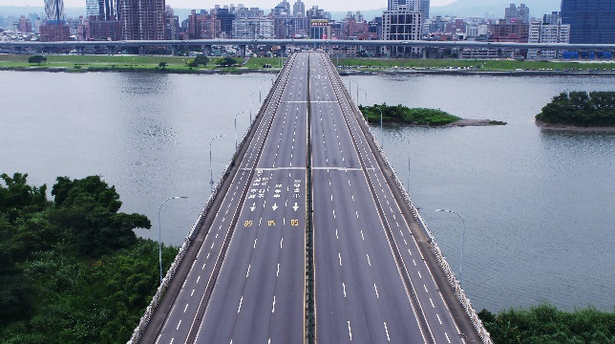
03  袁廣鳴，《棲居如詩》，2014 ©袁廣鳴，藝術家提供。  YUAN Goang-Ming, Dwelling, 2014. © YUAN Goang-Ming. Courtesy of the artist. | 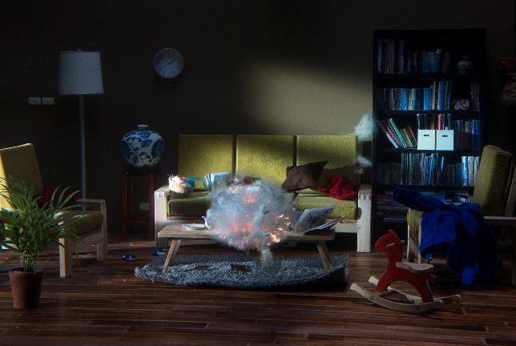
04  袁廣鳴，《佔領第561小時》，2014 ©袁廣鳴，藝術家提供。  YUAN Goang-Ming, The 561st Hour of Occupation, 2014. © YUAN Goang-Ming. Courtesy of the artist. | 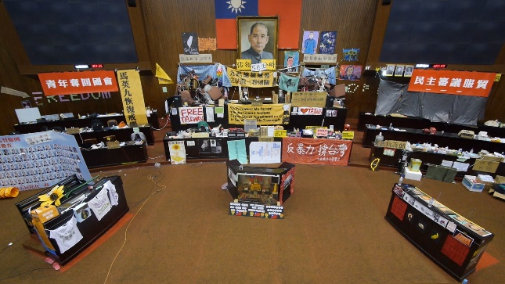
05  藝術家袁廣鳴（右）與策展人陳暢（左）。  Artist YUAN Goang-Ming (right) and curator Abby CHEN (left). Courtesy of the artist and Taipei Fine Arts Museum. | 