2023台北雙年展盛大開幕
Taipei Biennial 2023 Announces the Grand opening
媒體圖說Image Caption
1  「2023台北雙年展：小世界」主視覺。設計：Wkshps（紐約）。圖像由臺北市立美術館提供。  Visual identity of Taipei Biennial 2023: Small World designed by Wkshps (New York). Courtesy of Taipei Fine Arts Museum. | 
2-1、2-2  王衛，《鏡子》，2023，馬賽克磁磚，1600×400×30公分。圖像由藝術家及臺北市立美術館提供。  Wang Wei, Mirror, 2023, mosaic tiles, 1600×400×30 cm. Courtesy of the Artist and Taipei Fine Arts Museum. | 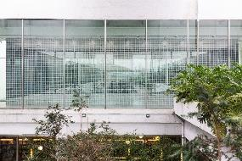  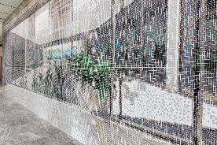
3.  賴志盛，《2B205》，2023，複合媒材裝置，尺寸依場地而定。圖像由藝術家及臺北市立美術館提供。2023台北雙年展委託製作。  Lai Chih-Sheng, 2B205, 2023, mixed media installation, dimensions variable. Courtesy of the Artist and Taipei Fine Arts Museum. Commissioned by Taipei Biennial 2023. | 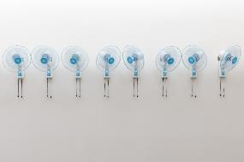  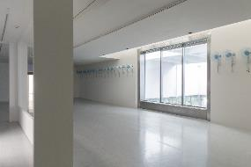
4-1、4-2  唐納天，《漫遊微觀宇宙》，2023，複合媒材裝置：工事用砂、鍍鋅鋼板、顏料染色的水，尺寸依場地而定。圖像由藝術家及臺北市立美術館提供。  Nadim Abbas, Pilgrim in the Microworld, 2023, mixed media installation with construction sand, galvanized steel, pigment dyed water, dimensions variable. Courtesy of the Artist and Taipei Fine Arts Museum. | 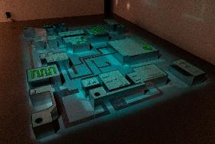  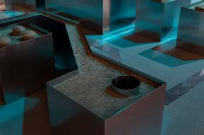
5  保羅．維希留，《碉堡考古學》，1958-1965，微噴輸出，尺寸不一，共25件。圖像由Sophie Virilio及臺北市立美術館提供。  Paul Virilio, Bunker Archeology, 1958-1965, Giclée print, 25 pieces, dimensions variable. Courtesy of Sophie Virilio and Taipei Fine Arts Museum. | 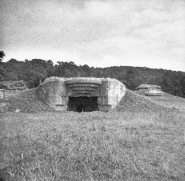
6  皮歐．阿巴德，《詩，第九十七首》，2023，複合媒材裝置、出版品，尺寸依場地而定。圖像由藝術家及臺北市立美術館提供。2023台北雙年展委託製作。  Pio Abad, Laji No.97, 2023, mixed media installation, publication, dimensions variable. Courtesy of the Artist and Taipei Fine Arts Museum. Commissioned by Taipei Biennial 2023. | 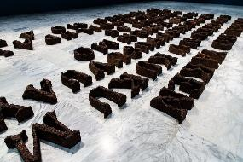
7  依佩．諾兒，《手繪：身體、旅程》，2023，天然顏料、畫布，160×400公分。圖像由藝術家及臺北市立美術館提供。  Ipeh Nur, Manuscript: The Body and Journey, 2023, natural pigment on canvas, 160 x 500cm. Courtesy of the Artist and Taipei Fine Arts Museum. | 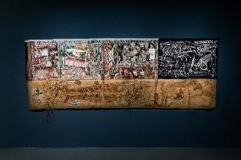  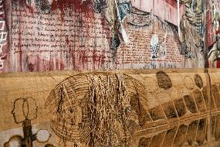
8  艾德加．阿瑟諾，《剝鏡 #59》，2023，硝酸銀、壓克力顏料、紙、鏡子、畫布，274.32×1100×9.52公分。圖像由藝術家及臺北市立美術館提供。  Edgar Arceneaux, Skinning the Mirror #59, 2023, silver nitrate, acrylic paint, glass, and paper on canvas, 274.32×1100×9.52 cm. Courtesy of the Artist and Taipei Fine Arts Museum. | 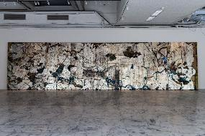  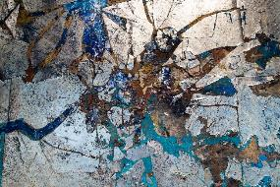
9  娜絲琳．寇德，《分解雕塑》，2019-2023，舊地形圖、軟紙板、玻璃與樹脂、燒陶、剝落顏料、指甲油、馬鈴薯漬，70×50公分。圖像由藝術家及臺北市立美術館提供。  Nesrine Khodr, Sculptured Decompositions, 2019-2023, Aged topographical map, soft cardboard, glass with resin, fired clay, fallen paint, nail polish, potato stain on cardboard, 70×50 cm. Courtesy of the Artist and Taipei Fine Arts Museum. | 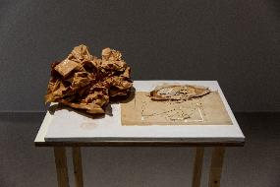
10  伊．古斯提．阿育．卡德可．穆妮阿緒，《與兒嬉戲》，2004，壓克力顏料、畫布，100×100公分。圖像由新加坡Buang S Collection及臺北市立美術館提供。  I Gusti Ayu Kadek Murniasih, Bermain Dengan Anak-Anakku (Playing with My Children), 2004, acrylic on canvas, 100×100 cm. Courtesy of Buang S Collection, Singapore and Taipei Fine Arts Museum. | 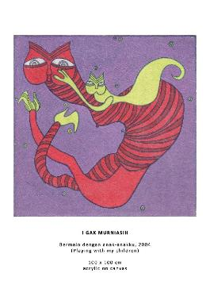
11  尼基塔．蓋爾，《私人舞者》，2020，舞台照明桁架、LED頭燈，尺寸依場地而定。圖像由藝術家及臺北市立美術館提供。  Nikita Gale, PRIVATE DANCER, 2020, lighting truss, moving head LED lights, dimensions variable. Courtesy of the Artist and Taipei Fine Arts Museum. | 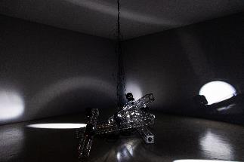
12  約翰．史密斯，《嚼口香糖的女孩》(影像截圖)，1976，16釐米轉高畫質錄像、黑白、有聲，12分鐘。圖像由藝術家、柏林/洛杉磯Tanya Leighton畫廊與倫敦Kate MacGarry畫廊及臺北市立美術館提供。  John Smith, still image from The Girl Chewing Gum(still), 1976, 16 mm film transferred to HD video file, B/W, sound, 12 minutes. Courtesy of the artist, Tanya Leighton, Berlin/ Los Angeles and Kate MacGarry, London and Taipei Fine Arts Museum. | 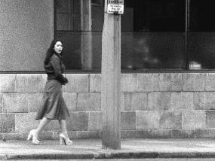
13  阿迪亞．諾瓦立，《亞洲(虛構)房地產計畫》，2023，木材、樹脂、鋁、鋼鐵、銅、壓克力板、布、133個LED三角旋轉盒，380×25×180公分。圖像由藝術家、雅加達ROH畫廊及臺北市立美術館提供。此作品的展出呈現由雅加達ROH畫廊贊助。  Aditya Novali, The Wall-Asian (Un) Real Estate Project, 2023, wood, resin, aluminum, steel, copper, plexiglass, fabric, LEDs on 133 rotatable triangular tubes, 380×25×180 cm. Courtesy of the artist, ROH, Jakarta and Taipei Fine Arts Museum.  The presentation of this work is generously supported by ROH, Jakarta. | 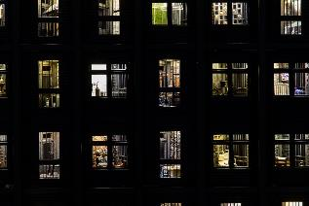
14  陳敬元，《滑言舌誤》，2022，布面油畫，146×110公分。圖像由藝術家、布魯塞爾Foundation Croÿ-Roeulx及臺北市立美術館提供。  Chen Ching-Yuan, Slip of the Tongue, 2022, oil on canvas, 146×110cm. Courtesy of the artist, Foundation Croÿ-Roeulxand and Taipei Fine Arts Museum. | 
15  林真金，《藍盤》，1970，刻蝕版畫，41×41.5公分。圖像由倫敦林真金遺產管理及臺北市立美術館提供。  Kim Lim, Blue Disc, 1970, aquatint, 41×41.5cm. Courtesy of Estate of Kim Lim, London and Taipei Fine Arts Museum. | 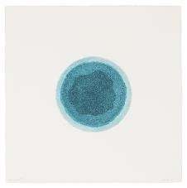
16-1、16-2  蘇詠寶，《書的形狀》，2023，草本植物，尺寸依場地而定。圖像由藝術家及臺北市立美術館提供。  So Wing-Po, The Bookmaking Habits of Select Species, 2023, chewed plant parts, dimensions variable. Courtesy of the artist and Taipei Fine Arts Museum. | 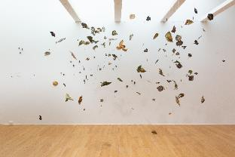  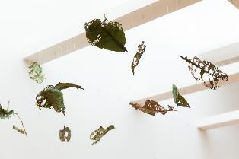
17  李俊陽，《七彩迷魂妙靈儀》，2023，鐵絲、螢光畫作、水墨塗鴉、現成物，尺寸依場地而定。圖像由藝術家及臺北市立美術館提供。  Li Jiun-Yang, The Psychedelic Spiritual Ceremony, 2023, wires, fluorescent pigment, ink graffiti, found and readymade objects, dimensions variable. Courtesy of the artist and Taipei Fine Arts Museum. | 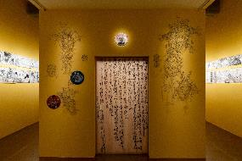
18  李亦凡，《難忘的形狀》(截圖)，2023，單頻道4K高畫質錄像，30分鐘。聲音設計：馮志銘、洪梓倪；建模協助：陳品蓁。圖像由藝術家及臺北市立美術館提供。  Li Yi-Fan, What Is Your Favorite Primitive (Still), 2023, single-channel 4K HD video, 30 minutes. Sound design: Feng Zi-Ming, Hung Tzu-Ni; Modeling assistant: Jeci Chen. Courtesy of the artist and Taipei Fine Arts Museum. | 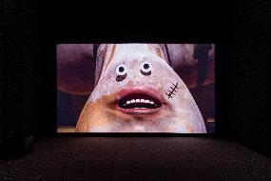
19  楊季涓，《你的淚痕是我未來的眼淚》，2023，聲響裝置、陶瓷、黏土、色粉、釉下彩、不鏽鋼、鍊條、動力設備、動力裝置，尺寸不一，20分鐘。圖像由藝術家及臺北市立美術館提供。2023台北雙年展委託製作。  Yang Chi-Chuan, Your Tears Remind Me to Cry, 2023, sound installation, ceramic, clay, color powder, underglaze color, stainless steel, chain, electronics, dimensions variable, 20 minutes. Courtesy of the artist and Taipei Fine Arts Museum. Commissioned by Taipei Biennial 2023. | 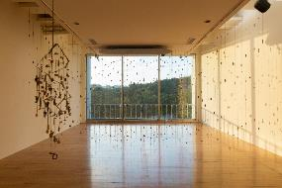  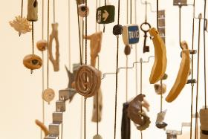
20  娜塔莎．薩德爾．哈吉安，《心．坎》，2023，聲響裝置、PVC雕塑、換能器，尺寸依場地而定，共六件。圖像由藝術家及臺北市立美術館提供。2023台北雙年展委託製作。  Natascha Sadr Haghighian, Watershed, 2023, sound installation, PVC sculptures and transducers, dimensions variable. Courtesy of the artist and Taipei Fine Arts Museum. Commissioned by Taipei Biennial 2023. | 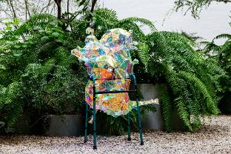
21  賈桂琳．きよみ．寇克，《不完全是(管他何種新音調)》，2017 - 迄今，PVC塑料充氣裝置、離心風機、Arduino微控制器、MIDI及觸發繼電器，尺寸依場地而定。音樂製作 : MNDR Production, Peter Wade Keusch Production and Engineering 歌曲：Carolyn Pennypacker Riggs, Jonathan Mandabach and MNDR圖像由藝術家及臺北市立美術館提供。  Jacqueline Kiyomi Gork, Not Exactly (Whatever the New Key Is), 2017 – ongoing, PVC tarpaulin walls, centrifugal blowers, Arduino microcontroller, MIDI and trigger relay, dimensions variable. Music MNDR Production, Peter Wade Keusch Production and Engineering. Singers: carolyn pennypacker riggs, jonathan Mandabach and MNDRCourtesy of the artist and Taipei Fine Arts Museum. | 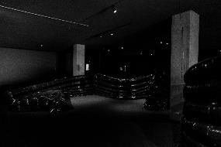
22.  金範，《奇觀》(截圖)，2010，單頻道錄像，1分7秒，循環播放。圖像由藝術家及臺北市立美術館提供。  Kim Beom, Spectacle(Still), 2010, single-channel video, 1 min, 7 sec, loop. Courtesy of the artist and Taipei Fine Arts Museum. | 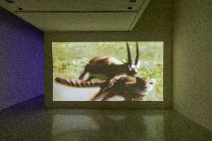
23.  拉哈．塔貝特，《十一個破碎海洋》(局部)，2020，細菌、類比彩色膠捲底片、類比相紙，115x160公分／件，共11件。圖像由藝術家及臺北市立美術館提供。  Lara Tabet, Eleven Fragmented Seas(Partial), 2020, bacteria incubated on analog color film scanned and printed on analog photographic paper.11 pieces, each 115 x 160 cm. Courtesy of the artist and Taipei Fine Arts Museum. | 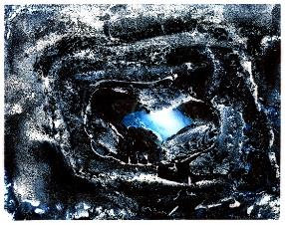
24.  陳瀅如，《財．縫》(影像截圖)，2008，高畫質錄像，7分42秒。圖像由藝術家及臺北市立美術館提供。  Yin-Ju Chen, Transactions(Still), 2008, HD video, 7 min, 42 sec. Courtesy of the artist and Taipei Fine Arts Museum. | 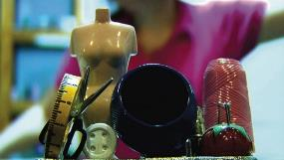
25-1.  蘇郁心，《特殊水，複數》，2023，單頻道錄像裝置，18分35秒。圖像由藝術家及臺北市立美術館提供。  Su Yu-Hsin , Particular Waters, 2023Single-channel video installation, 18 min, 35 sec. Courtesy of the artist and Taipei Fine Arts Museum. | 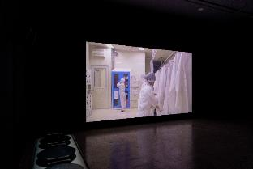
25-2.  蘇郁心，《特殊水，複數》，2023，擋片模型、3D列印支架，35×30×5公分／件，共4件。圖像由藝術家、柏林alexander levy畫廊及臺北市立美術館提供。  Su Yu-Hsin , Particular Waters, 2023, UV Prints on dummy wafers presented with 3D printed holders, 4 pieces, each 35 x 30 x 5 cm. Courtesy of the artist, alexander levy, Berlin and Taipei Fine Arts Museum. | 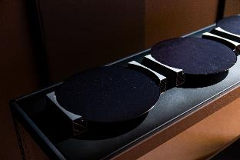
26.  dj sniff，《變形器》，2023，複合媒材，尺寸依場地而定。圖像由藝術家及臺北市立美術館提供。2023台北雙年展委託製作。  dj sniff, Transformer, 2023, mixed media, dimensions variable. Courtesy of the Artist and Taipei Fine Arts Museum. Commissioned by Taipei Biennial 2023. | 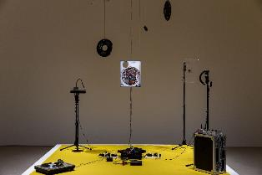
27. 【放映單元 Cinema Program】  王雅慧，《訪客》(影像截圖)，2007，錄像，7分16秒。圖像由臺北市立美術館提供。  Wang Ya-Hui, Visitor(Still), 2007, video, 7 min 16 sec. Courtesy of Taipei Fine Arts Museum. | 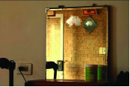
28. 【放映單元 Cinema Program】  葉致甫，《123部奇觀預告片之四》(影像截圖)，2023，錄像，20分29秒。圖像由藝術家及臺北市立美術館提供。  C. Spencer Yeh, 123 Trailers for Spectacle pt.4 (Still), 2023, video, 20 min 29 sec. Courtesy of the artist Taipei Fine Arts Museum. | 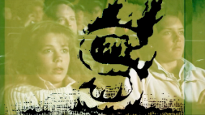
29. 【放映單元 Cinema Program】  巴赫．諾伊扎德，《選擇的自由》(影像截圖)，2023，單頻道錄像，35分51秒。與魯達．巴鮑以及廢紙歌劇院（克拉拉．柯芬、詹姆斯．歐德漢、張哲熙、安娜．帕爾默）共同創作。圖像由藝術家及臺北市立美術館提供。  Bhahr Noorizadeh, Free to Choose(Still), 2023, single-channel video, 35 min 51 sec. In collaboration with Rudá Babau, and Waste Paper Opera (Klara Kofen, James Oldham, Gary Zhexi Zhang, Anna Palmer). Courtesy of the artist Taipei Fine Arts Museum. | 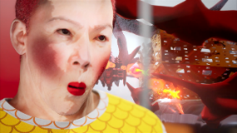
30  「2023台北雙年展：小世界」展區一景。臺北市立美術館提供。  Installation view of “Taipei Biennial 2023:Small World”. Courtesy of Taipei Fine Arts Museum. | 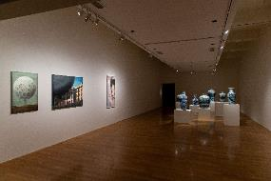
31  「2023台北雙年展：小世界」藝術家許村旭及娜絲琳．寇德展區一景，。臺北市立美術館提供。  Installation view of “Taipei Biennial 2023:Small World” by artist Hsu Tsun-Hsu and Nesrine Khodr,. Courtesy of Taipei Fine Arts Museum. | 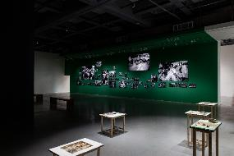
32.  臺北市立美術館館長王俊傑(左二)與2023台北雙年展策展人合影。圖像由臺北市立美術館提供。  (From left to right) Director of Taipei Fine Arts Museum Jun-Jieh Wang and Taipei Biennial 2023 Curators. Courtesy of Taipei Fine Arts Museum. | 