一一重構：楊德昌
A One and A Two: Edward Yang Retrospective

媒體圖說 Image Sheet
1.1  「一一重構：楊德昌」：「時代的童年」展區一景。臺北市立美術館提供。  Installation view of section “Childhood Through the Ages,” A One and A Two Edward Yang Retrospective Exhibition. Courtesy of Taipei Fine Arts Museum. | 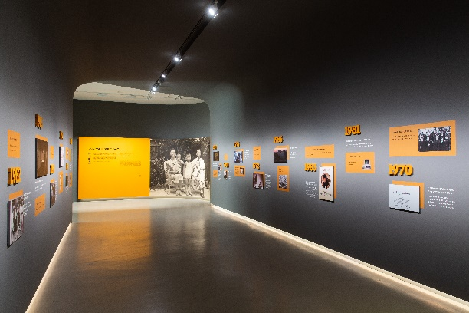
2.1  「一一重構：楊德昌」：「略有志氣的少年」展區一景。臺北市立美術館提供。  Installation view of section “A Somewhat Ambitious Adolescent,” A One and A Two Edward Yang Retrospective Exhibition. Courtesy of Taipei Fine Arts Museum. | 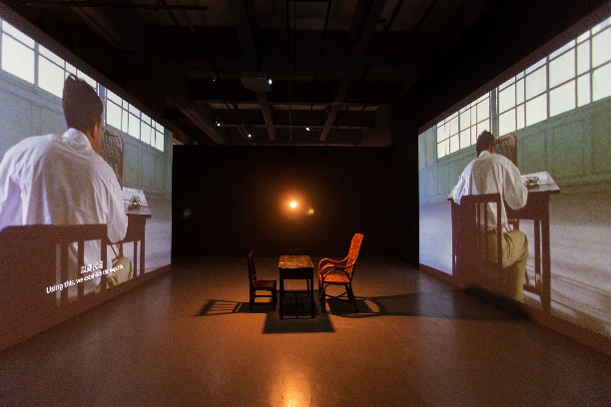
2.2  「一一重構：楊德昌」：「略有志氣的少年」展區一景。臺北市立美術館提供。  Installation view of section “A Somewhat Ambitious Adolescent,” A One and A Two Edward Yang Retrospective Exhibition. Courtesy of Taipei Fine Arts Museum. | 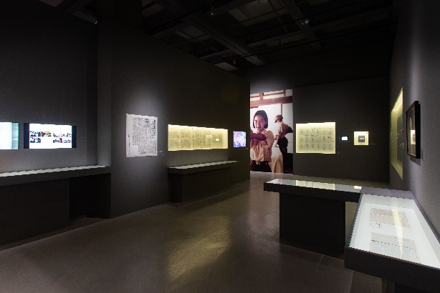
2.3  楊德昌，《牯嶺街少年殺人事件》劇本設定，1989–1991。彭鎧立提供，寄存於國家電影及視聽文化中心。  Edward Yang, A Brighter Summer Day script setting, 1989–1991. Courtesy of Kaili Peng, deposited in Taiwan Film and Audiovisual Institute. | 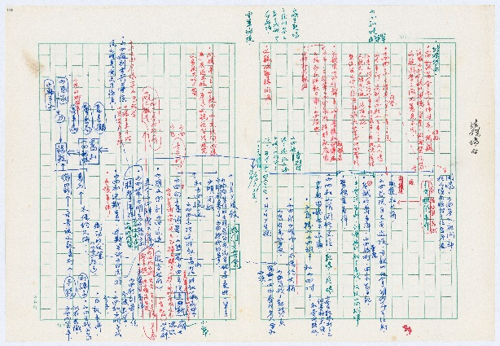
2.4  楊德昌電影公司，《牯嶺街少年殺人事件》工作照，1989–1991。彭鎧立提供，寄存於國家電影及視聽文化中心。  Yang and His Gang, Filmmakers, A Brighter Summer Day production photo,1989–1991. Courtesy of Kaili Peng, deposited in Taiwan Film and Audiovisual Institute. | 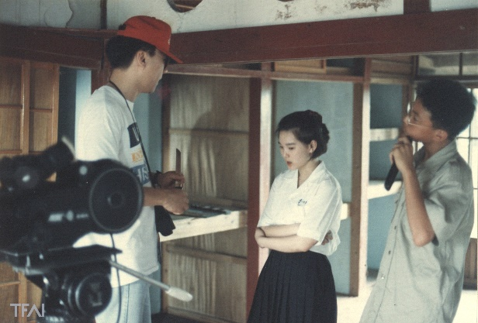
3.1  「一一重構：楊德昌」：「城市探索者」展區一景。臺北市立美術館提供。  Installation view of section “The Urban Explorer,” A One and A Two Edward Yang Retrospective Exhibition. Courtesy of Taipei Fine Arts Museum. | 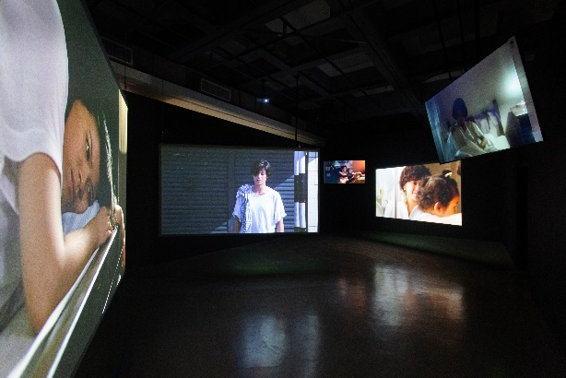
3.2  《恐怖份子》之淑安回眸（數位重製照片），2023。  動力裝置，尺寸視展場空間而定。照片授權及重製：劉振祥；動力裝置：何昆瀚、周柏慶。臺北市立美術館提供。  Image of Shu An looking back from Terrorizers  (digitally restored photo), 2023. Motive installation, dimensions variable. Reproduction of licensed photograph: Chen-Hsiang Liu; motive installation: Kun-Han Ho, Po-Ching Chou. Courtesy of Taipei Fine Arts Museum. | 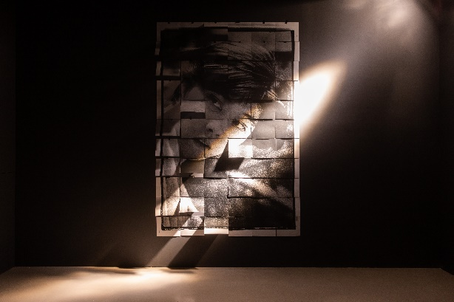
3.3  楊德昌電影公司，《光陰的故事》之《期待》（後更名為《指望》）分鏡圖（影印本），1982。彭鎧立提供，寄存於國家電影及視聽文化中心。  Yang and His Gang, Filmmakers, Expectations storyboard from In Our Time (photocopy), 1982. Courtesy of Kaili Peng, deposited in Taiwan Film and Audiovisual Institute. | 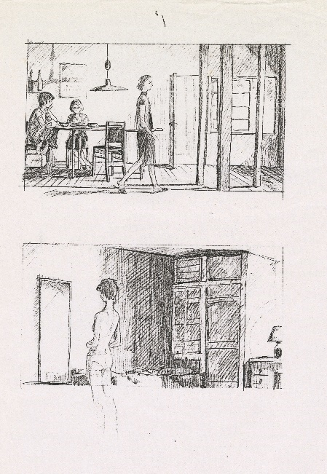
3.4  中央電影公司、新藝城影業有限公司（香港），《海灘的一天》工作照，1983。彭鎧立提供，寄存於國家電影及視聽文化中心。  Central Motion Picture Co., Cinema City Co., Ltd. (Hong Kong), That Day, on the Beach production still, 1983. Courtesy of Kaili Peng, deposited in Taiwan Film and Audiovisual Institute. | 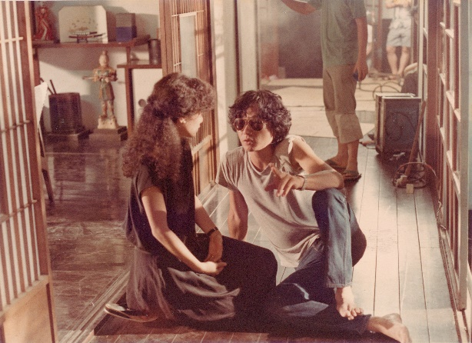
3.5  楊德昌導演於《恐怖份子》拍攝現場，1986。攝影：劉振祥。劉振祥提供。  Edward Yang on the set of Terrorizers, 1986. Photo by Chen-Hsiang Liu. Courtesy of Chen-Hsiang Liu. | 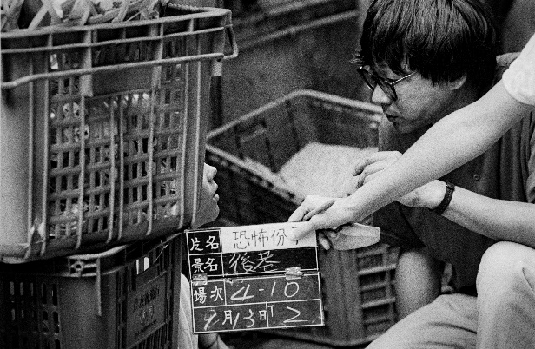
4.1  「一一重構：楊德昌」：「多聲部腹語師」展區一景。臺北市立美術館提供。  Installation view of section “The Polyphonic Practitioner,” A One and A Two Edward Yang Retrospective Exhibition. Courtesy of Taipei Fine Arts Museum. | 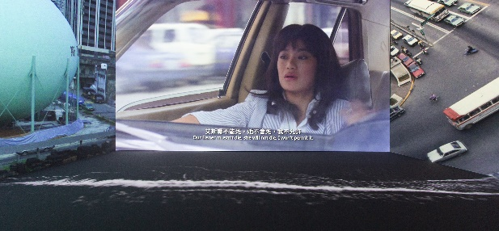
4.2  楊德昌與韋納ㆍ荷索於1995年舊金山國際電影節相見歡。攝影：Pamela Gentile。© Pamela Gentile/SFIFF  Edward Yang and Werner Herzog greeted each other  at the 1995 San Francisco International Film  Festival. Photo by Pamela Gentile. © Pamela Gentile/SFIFF | 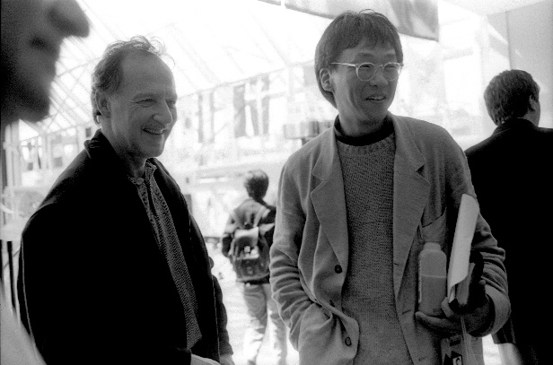
4.3  韋納ㆍ荷索著作《冰雪紀行》（英文版）與楊德昌朗讀該文本之卡帶。彭鎧立與國家電影及視聽文化中心提供。圖像由臺北市立美術館提供。  Werner Herzog's Of Walking in Ice (English version) and a tape of Edward Yang recitation of the book text. Courtesy of Kaili Peng and Taiwan Film and Audiovisual Institute. Image courtesy of Taipei Fine Arts Museum. | 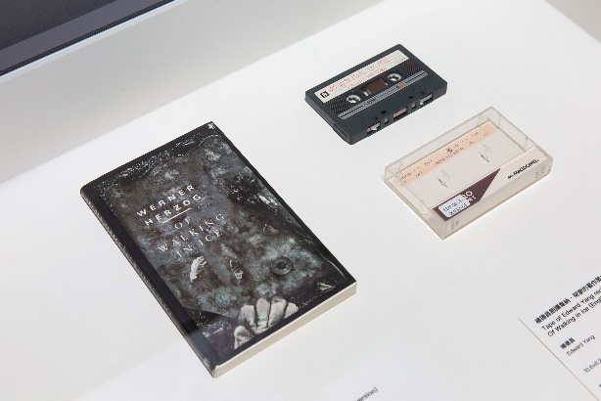
5.1  「一一重構：楊德昌」：「活力喜劇家」展區一景。臺北市立美術館提供。  Installation view of section “The Zesty Satirist,” A One and A Two Edward Yang Retrospective Exhibition. Courtesy of Taipei Fine Arts Museum. | 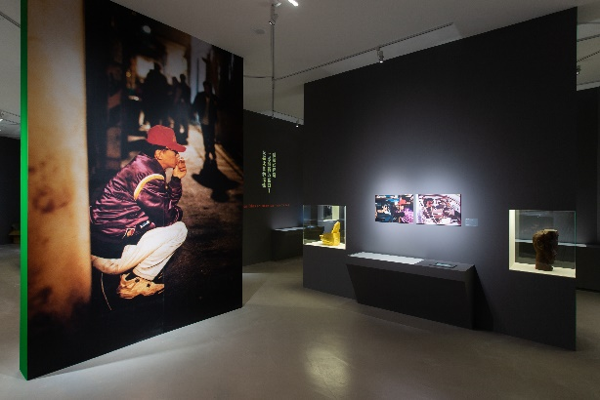
5.2  「一一重構：楊德昌」：「活力喜劇家」展區一景。臺北市立美術館提供。  Installation view of section “The Zesty Satirist,” A One and A Two Edward Yang Retrospective Exhibition. Courtesy of Taipei Fine Arts Museum. | 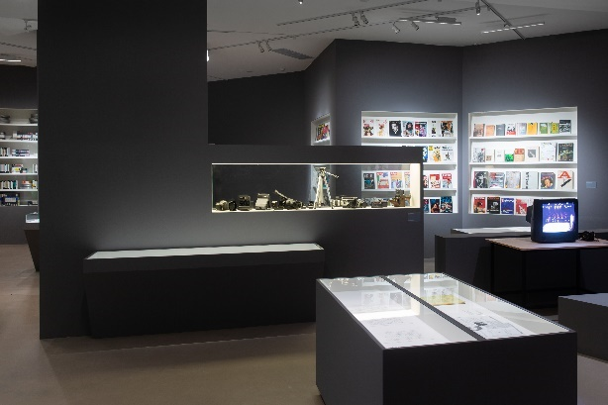
5.3  原子劇場，《成長季節》七幕劇演出劇照，1993。  彭鎧立提供，寄存於國家電影及視聽文化中心。  Atom Theatre, Growth Period seven-act play performance still, 1993. Courtesy of Kaili Peng, deposited in Taiwan Film and Audiovisual Institute. | 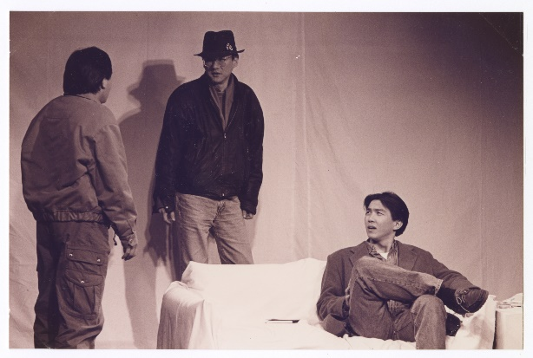
5.4  原子電影，《獨立時代》工作照，1993。彭鎧立提供，寄存於國家電影及視聽文化中心。  Atom Films, A Confucian Confusion production still. Courtesy of Kaili Peng, deposited in Taiwan Film and Audiovisual Institute. | 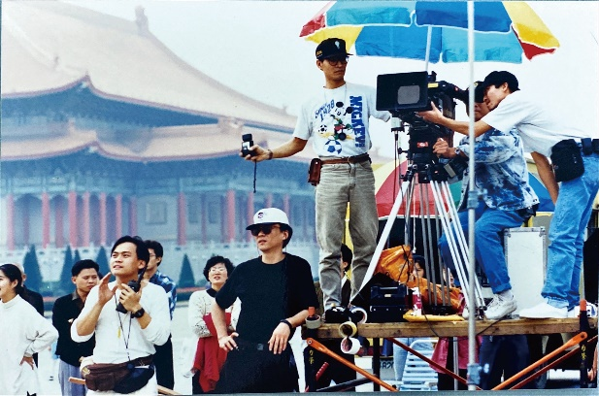
6.1  「一一重構：楊德昌」：「生命沉思者」展區一景。臺北市立美術館提供。  Installation view of section “The Life Ponderer,” A One and A Two Edward Yang Retrospective Exhibition. Courtesy of Taipei Fine Arts Museum. | 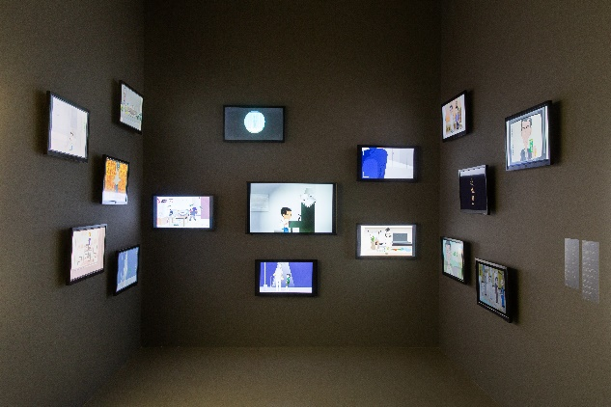
6.2  株式会社ポニーキャニオン、Omega Project Co.Ltd.等，《一一》分鏡設計手繪圖稿（非楊德昌手繪），1999。彭鎧立提供，寄存於國家電影及視聽文化中心。  Pony Canyon Inc., Omega Project Co. Ltd., etc., Yi Yi hand-drawn storyboard design sketches (not drawn by Edward Yang), 1999. Courtesy of Kaili Peng, deposited in Taiwan Film and Audiovisual Institute. | 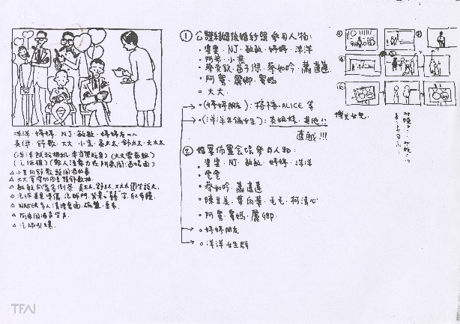
6.3  楊德昌，鎧甲娛樂網路動畫人物手繪稿集錦，2000–2002。彭鎧立提供，寄存於國家電影及視聽文化中心。  Edward Yang, Compilation of Miluku Entertainment’s hand-drawn sketches of online animation characters, 2000–2002. Courtesy of Kaili Peng, deposited in Taiwan Film and Audiovisual Institute | 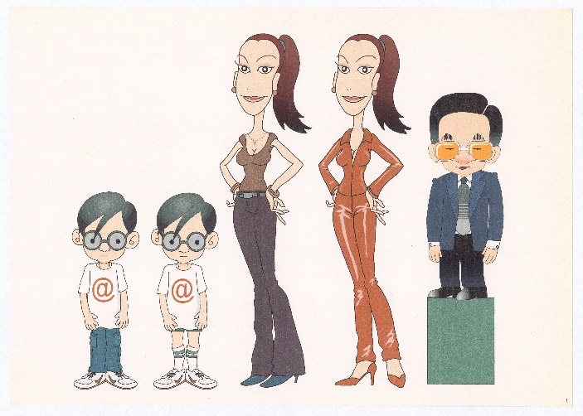
6.4  楊德昌，《追風》分鏡手繪圖稿，2002–2005。彭鎧立提供，寄存於國家電影及視聽文化中心。  Edward Yang, The Wind hand-drawn storyboard sketch, 2002–2005. Courtesy of Kaili Peng, deposited in Taiwan Film and Audiovisual Institute. | 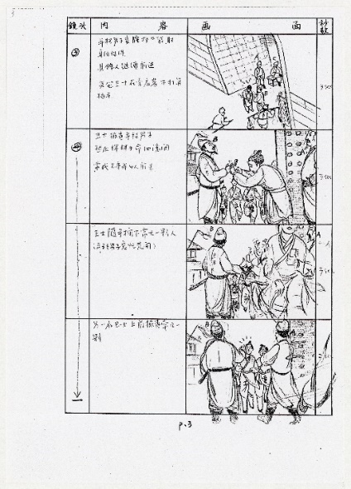
6.5  楊德昌青年時期手繪二戰漫畫，靈感可能來自電影《坦克大決戰》(1965)，約1965–1970。彭鎧立提供，寄存於國家電影及視聽文化中心。  Edward Yang, hand-drawn World War II  comics, possibly inspired by the film Battle of the  Bulge (1965), ca. 1965–1970. Courtesy of Kaili Peng, deposited in Taiwan Film and Audiovisual Institute. | 