2024「威尼斯國際美術雙年展」台灣館邀請藝術家袁廣鳴代表參展
Goang-Ming YUAN to Represent Taiwan at 2024 Venice Biennale

作品圖說Image Description
01  袁廣鳴，《棲居如詩》，2014 ©袁廣鳴，藝術家提供。  Goang-Ming YUAN, Dwelling, 2014. © Goang-Ming YUAN. Courtesy of the artist. | 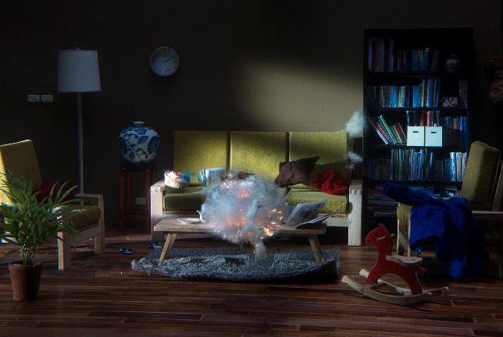
02  袁廣鳴，《佔領第561小時》，2014 ©袁廣鳴，藝術家提供。  Goang-Ming YUAN, The 561st Hour of Occupation, 2014. © Goang-Ming YUAN. Courtesy of the artist. | 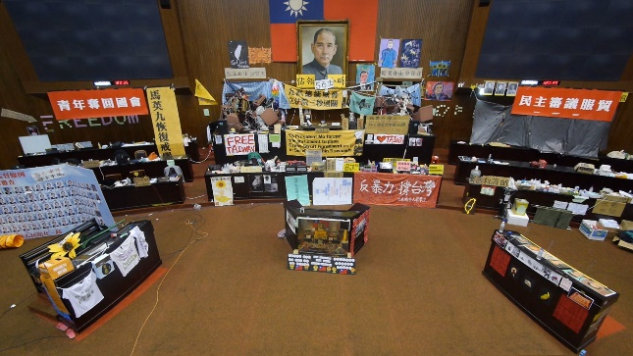
03  袁廣鳴，《日常演習》，2018 ©袁廣鳴，藝術家提供。  Goang-Ming YUAN, Everyday Maneuver, 2018. © Goang-Ming YUAN. Courtesy of the artist. | 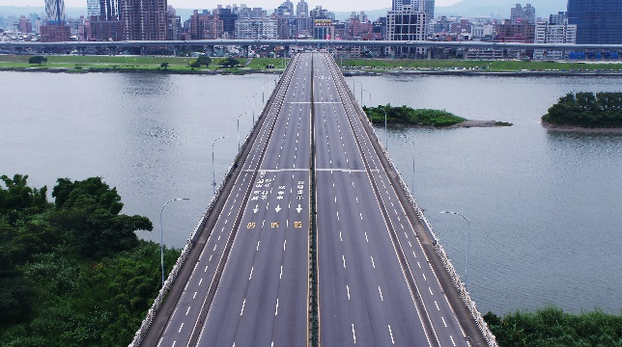
04  藝術家袁廣鳴  Representative Artist  Goang-Ming YUAN  © TEDxTaipei. | 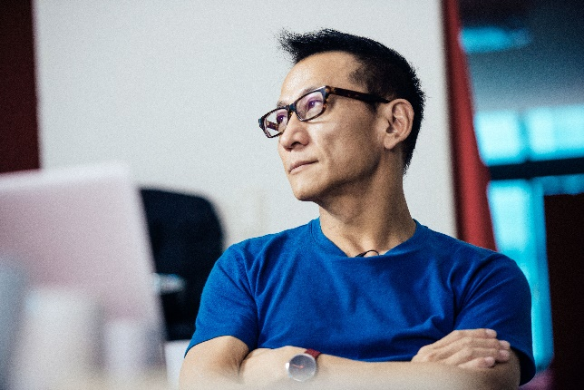
05  策展人  陳暢  Curator  Abby CHEN  © Gao Ling | 