Taipei Fine Arts Museum Press Release  FOR IMMEDIATE RELEASE  Taipei Biennial 2023: Small World  Date: 18 November 2023 – 24 March 2024  Venue: Taipei Fine Arts Museum | Media contact:  Carol Lo, Sutton (carol@suttoncomms.com)  Yu-mei Sung, TFAM (yumei-tfam@gov.taipei)  Jean Tzu-chin Kao, TFAM (tckao-tfam@gov.taipei)
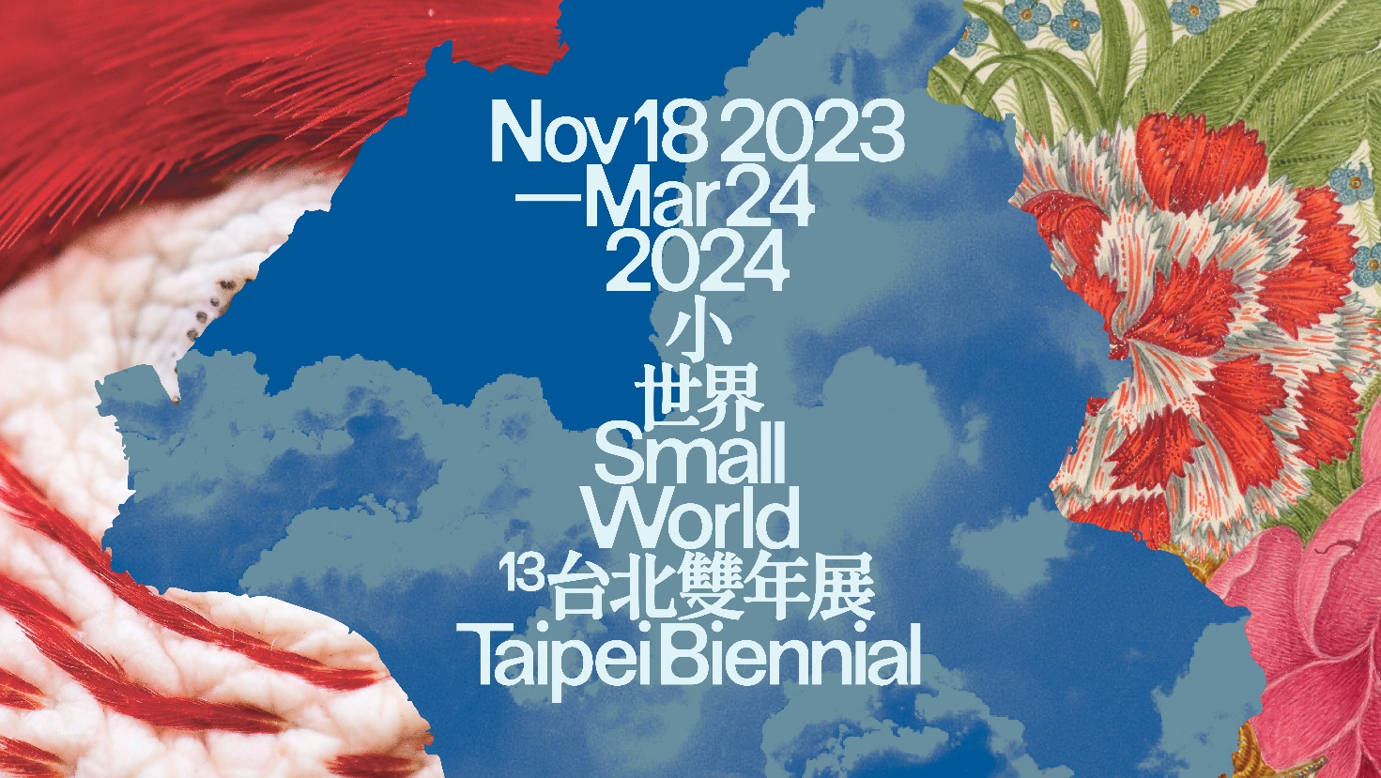

Taipei Biennial 2023 reveals full participating artist list,
exploring new imaginaries in the post-pandemic era

20 June 2023 – Taipei: Taipei Biennial is pleased to unveil the full participating list of artists for its 13th edition, running from 18 November 2023 to 24 March 2024 at the Taipei Fine Arts Museum (TFAM). Curated by curator Freya Chou, writer and editor Brian Kuan Wood, and curator Reem Shadid, this year’s iteration will bring together over 50 international and local artists and musicians, transforming the museum into a space of listening, gathering, improvising, and exploring alternative ways to perceive and apply what we learned from the recent pandemic. Ten new works and commissions will be featured at the Biennial, alongside installations, performances, and musical and cinematic experiences that question promises of the simple and sensual amidst increasing tension and complexity.

The title “Small World” suggests both a promise and a threat: a promise of greater control over one’s own life, and a threat of isolation from a larger community following a global pandemic. Our world can become smaller as we grow closer to one another, but also as we grow apart. This “Small World” takes place within such a suspended state of being unable to join together nor completely separate. Through a series of presentations that comprise sound, music, moving images, photography, video, paintings, sculptures and installations, “Small World” presents audiences with the dilemma faced by us and our societies.

The three curators stated that: “The ‘Small World’ is a lonely and entitled place that we have lost parts of ourselves and our societies to, but it may also be a place that welcomes strange acts of refusing to scale up or down, to amplify, unplug, move, or stay put. It might lure us towards illusions of impossible permanence and simplicity, towards absolute primacies and intoxicating authenticities that surpass all influences, but it also encourages us to betray the need to translate and be understood, to please others for some eventual benefit that never arrives.”

Highlights from Taipei Biennial 2023 includes:

- Pio Abad’s new commission originated in a research trip to Lanyu, an island in Taiwan that is closely related to the Batanes and Babuyan islands of the northern Philippines, a region native to his Ivatan roots. The unexpected intimate familiarity Abad encountered when he arrived in Lanyu amounted to an experience that was psychedelic in its depth and immensity. Abad’s work reflects on the power and ephemerality of both text and soil in a large-scale installation.

- Situated in the courtyard of Taipei Fine Arts Museum, Natascha Sadr Haghighian’s new commission is a multi-channel installation that evokes the sound of disappearance and erasure. Intended as an anti-monument, the work is dedicated to the caretaker—a figure who, in the process of compensating for the frailty of another person, senses their own increasing vulnerability. For Sadr Haghighian, the work is an invitation to cross a threshold beyond the social, entering another realm where distinctions between selves and others dissolve into crueler and yet more abstract forms of relation.

- Taiwanese artist Li Yi Fan will present a new work. Employing a format that stands out from mass animation productions and special effect industries, Li creates video performances that are similar to anti-script, impromptu talk shows with his self-made video tools. He explores the logic and illogic of images in contemporary life with dark humor, and uses the immediacy of the game engine to generate casual and bizarre narratives.

- Artist duo Basel Abbas and Ruanne Abou-Rahme will present an immersive, multichannel sound and moving-image installation that examines how people bear witness to and narrate experiences of violence, loss, displacement, and forced migration through performance. Since the early 2010s, Abbas and Abou-Rahme have collected online recordings of everyday people singing and dancing in communal spaces in Iraq, Palestine, Syria, and Yemen. The work brings digital traces of these performing bodies together with new performances.

- The late Lebanese painter, sculptor, and fashion designer Huguette Caland (1931 – 2019) was known for her erotic abstract paintings and body landscapes challenging traditional conventions of beauty and desire. The Biennial will feature a selection of Caland’s self-portraits from the 1970s after she moved from Beirut to Paris to pursue her own practice and life—a time when she is said to have felt truly liberated at last from the burden of social expectations.

- A major figure of Japan’s 1960s avant-garde, Akasegawa Genpei (1937 – 2014) was a member of influential artist groups Hi-Red Center and Neo-Dada Organizers. Earlier this year, over 40,000 unpublished prints were discovered by Akasegawa’s family, of which the Biennial will present a large selection for the first time in a public museum, reinvigorating Akasegawa’s artistic legacy and reminding us of the power of his observation.

The 13th Taipei Biennial will also transform a gallery within Taipei Fine Arts Museum into a music room designed by Palestinian architects AAU ANASTAS Studio, founded by Elias and Yousef Anastas. Three groups of musicians and sound practitioners, including dj sniff, Julian Abraham (Togar) & Wok the Rock, and Ting Shuo Hear Say, will host public and semi-public programs dedicated to gathering, recording, jamming, and music programming from December 2023 to March 2024.

For the full artist list of the 13th Taipei Biennial, please refer to Appendix 1 below.

APPENDIX 1

The full list of participating artists and musicians in alphabetical order with current location:

Pio Abad (London)
Julian Abraham ‘Togar’ & Wok the Rock (Yogyakarta)
Basel Abbas & Ruanne Abou Rahme (Ramallah/New York)
Nadim Abbas (Hong Kong)
Genpei Akasegawa (1937 – 2014)
Edgar Arceneaux (Los Angeles)
Tekla Aslanishvili (Berlin/Tbilisi)
Huguette Caland (1931 – 2019)
Yin-Ju Chen (Taipei)
Chen Ching-Yuan (Taipei)
dj sniff (Los Angeles/Tokyo)
Nikita Gale (Los Angeles)
Giorgi Gago Gagoshidze (Berlin)
Samia Halaby (New York)
Ting Shuo Hear Say (Tainan)
Hide & Seek Audiovisual Art (Taipei)
Hsu Tsun-Hsu (Taipei)
Takashi Ito (Fukuoka)
Kim Beom (Seoul)
Jacqueline Kiyomi Gork (Los Angeles)
Nesrine Khodr (Beirut)
Patricia L. Boyd (London)
Lai Chih-Sheng (Taipei)
Li Yi-Fan (Taipei)
Kim Lim (1936 – 1997)
Li Jun-Yang (Taichung)
Jen Liu (New York)
Jumana Manna (Berlin)
Basim Magdy (Basel)
Wietske Maas (Berlin)
I Gusti Ayu Kadek Murniasih (1966 – 2006)
Artemio Narro (Mexico City)
Bahar Noorizadeh (London)
Aditya Novali (Surakarta)
Ipeh Nur (Yogyakarta)
Arthur Ou (New York)
Ellen Pau (Hong Kong)
Riar Rizaldi (Yogyakarta)
Natascha Sadr Haghighian (Berlin/Tehran)
Massinissa Selmani (Tours/Tizi-Ouzou)
Seher Shah (Barcelona)
Hema Shironi (Colombo)
John Smith (London)
So Wing-Po (Hong Kong)
Lara Tabet (Beirut/Marseille)
Wang Wei (Beijing)
Raed Yassin (Berlin/Beirut)
Yang Chi-Chuan (Taipei)
Yang Yooyun (Seoul)
C. Spencer Yeh (New York)
Zhou Tao (Guangzhou)

APPENDIX 2

Curators’ biography

Freya Chou
Freya Chou is a curator based in Hong Kong and Taipei. From 2008 – 2014, she was in the curatorial team for the 6th and 7th Taipei Biennial (2008, 2010) and Co-Curator of the 10th Shanghai Biennial (2014). From 2015 – 2019, she worked at Para Site in Hong Kong as the institution’s first Education and Public Programs Curator, during those four years she also curated exhibitions: Ellen Pau: What About Home Affairs? - A Retrospective (2018), Chris Evans, Pak Sheung Chuen: Two Exhibitions (2017), and Afterwork (co-curator, 2016). Recently, Chou has worked with several organizations on research projects, she has also edited and contributed writing to many artist books, magazines, and exhibition catalogues. Chou is a member of the 58th Carnegie International’s Curatorial Council and the Guest Curator of Hong Kong’s participation in the 59th International Art Exhibition of La Biennale di Venezia.

Brian Kuan Wood
Brian Kuan Wood is a writer based in New York, and an editor of e-flux’s book series and monthly journal. He has taught and lectured at the MA Curatorial Practice program at the School of Visual Arts in New York (where he was Director of Research from 2017 to 2022), Ashkal Alwan in Beirut, Moderna Museet in Stockholm, Para Site in Hong Kong, Inside Out Museum in Beijing, and China Art Academy in Hangzhou, among other places. He recently edited Natascha Sadr Haghighian’s relearning bearing witness (2021), Yuk Hui’s Art and Cosmotechnics (2021), as well as the 2017 Sharjah Biennial publication Tamawuj (with Amal Issa, Omar Berrada, and Kaelen Wilson-Goldie), the Taipei Biennial 2012 catalog Modern Monsters: Death and Life of Fiction (with Anselm Franke), and Selected Maria Lind Writing (2010).

Reem Shadid
Reem Shadid is a curator, researcher and cultural organizer who works on the emancipatory possibilities within artistic practice, exploring the ways it intersects with ecological, political and socio-economic forms. Currently, she is the Director of Beirut Art Center in Lebanon and is a co-curator for the second edition of New Visions (2023), the Henie Onstad Kunstsenter triennial for photography and New Media. Shadid is also a contributing editor with Infrasonica, a digital platform of non-western cultures for experimental sound and visual art practices and is the producer and host of Radio Alhara’s show Listening with Reem Shadid; listening sessions with artists and practitioners working at the intersection of sonic, visual and literary productions. Most recently she directed Berlin Biennale (2022) Curator’s workshop, and was the producer and host of Aridity Lines, a podcast on local ecological knowledge and climate change in the south-eastern Mediterranean region commissioned by TBA21 Academy. Previously she was the Deputy Director of Sharjah Art Foundation, where she served in various capacities between 2006 – 2020.

About the exhibition and organizer

Taipei Biennial
Being one of the most long-standing biennials in Asia, the Taipei Biennial held by the Taipei Fine Arts Museum has endeavored in driving Taiwanese contemporary art development since it was launched in 1998, facilitating a platform of interaction and exchange between local and international communities through its vigorous engagement informed by diversely cultural perspectives in Asian and global contemporary art networks. Through the multi-directional communication of exhibition mechanism, the biennial aims to proactively lead in discussions and respond to contemporary issues, encompassing global perspectives and regional individuality. In the recent editions, experts and professionals from various disciplines have been invited to participate in the biennial with the objective to spark and introduce multifacetedness of art, while engendering the energy of different artistic dimensions.

Taipei Fine Arts Museum
Established in 1983 in response to a burgeoning modern art movement, the Taipei Fine Arts Museum (TFAM) is Taiwan’s first museum of modern and contemporary art. Since its inception, the museum has shouldered its mission dedicated to the preservation, research, development and advocacy of modern art in Taiwan, while staying abreast of cultural productions that arise in the context of an expanding global contemporary art scene. TFAM has been participating in Venice Biennale since 1995 and has been hosting the Taipei Biennial since 1998, inviting renowned international and local curators and artists to participate in the exhibition. www.tfam.museum

Lead sponsor

CTBC Foundation for Arts and Culture
In 1996, the CTBC Foundation for Arts and Culture was established to stimulate the art and cultural environment in Taiwan and elevate cultural literacy among the general public. In earlier years, the foundation focused on theater operations. In 2015, it underwent a transformation and initiated a three-pronged approach to promote visual arts, supporting performance arts, and fostering arts and culture education. The foundation organizes the CTBC Arts Festival annually, to promote performance art between global and local communities. It also hosts Dreams Initiatives Project, inviting artists as mentor to conduct workshops at schools in rural areas, bridging the gap by making arts resources accessible to all cities and towns in Taiwan. Starting from 2021, the foundation holds the CTBC Painting Prize biennially, the only award focusing on contemporary painting in Taiwan. It encourages young artists to explore their creativity with contemporary approaches and support unique and innovative voices. Affirming the Biennial’s positive influence on society, CTBC Foundation for Arts and Culture sponsored the Taipei Biennial 2020, and will continue to be the lead sponsor of the Taipei Biennial 2023.

