2023第13屆台北雙年展公佈完整參展藝術家名單
Taipei Biennial 2023 reveals full participating artist list

媒體圖說 Image Caption
1

Pio Abad，《Laji No.97》，2023。
©Pio Abad，圖像由藝術家提供。

Pio Abad, Laji No.97, 2023.
©Pio Abad. Courtesy of the artist.
2  Basel Abbas & Ruanne Abou-Rahme，《願我們永遠記得如何述說》，2022。「Basel Abbas / Ruanne Abou-Rahme：一個深深埋藏卻仍在蕩漾的迴聲」 展覽現場。  ©阿斯楚普費恩利現代藝術博物館，照片拍攝：Christian Øen。  Basel Abbas & Ruanne Abou-Rahme, May amnesia never kiss us on the mouth: only sounds that tremble through us, 2022. Installation view at “Basel Abbas / Ruanne Abou-Rahme: An echo buried deep deep down but calling still”.  © Astrup Fearnley Museet. Photo: Christian Øen. | 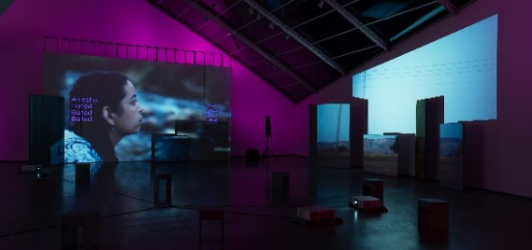
3  Huguette Caland，《自畫像（Bribes de corps） #58》，1973，布面油畫，128.3 x 88.9公分。  圖像由Huguette Caland Estate提供。  Huguette Caland, Self Portrait (Bribes de corps), 1973, oil on linen, 128.3 x 88.9 cm.  Courtesy of Huguette Caland Estate. | 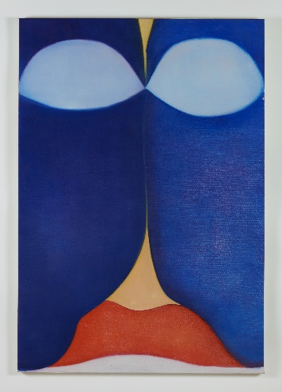
4  赤瀨川原平，《無題》，1987。  ©赤瀨川原平，圖像由 SCAI THE BATH HOUSE提供。  Genpei Akasegawa, Untitled, 1987.  ©Genpei Akasegawa. Courtesy of SCAI THE BATH HOUSE. | 