Taiwan Film and Audiovisual Institute x Taipei Fine Arts Museum | Joint Press Release
FOR IMMEDIATE RELEASE

Media Contact | Yu-mei Sung | yumei-tfam@gov.taipei  Jean Tzu-chin Kao | tckao-tfam@gov.taipei

A One and A Two: Edward Yang Retrospective
Date: 22 July 2023 – 22 October 2023
Venue: Taiwan Film and Audiovisual Institute (film program)
Taipei Fine Arts Museum (exhibition)

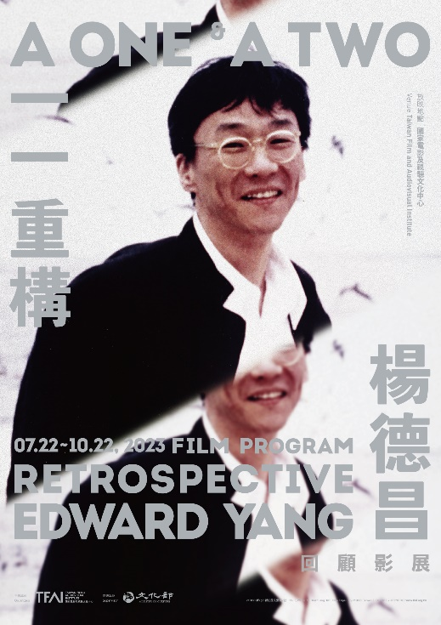
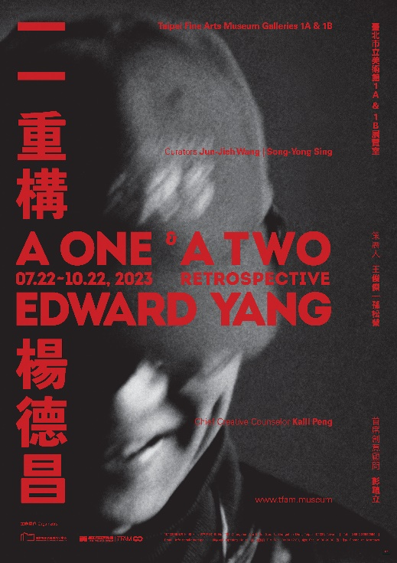

Retrospective of the prominent Taiwan New Wave director Edward Yang opens on July 22

“A One and A Two: Edward Yang Retrospective”, the most comprehensive ever retrospective of the renowned Taiwanese film director Edward Yang co-presented by Taiwan Film and Audiovisual Institute (TFAI) and Taipei Fine Arts Museum (TFAM) opens from July 22 to October 22. Consisting of a film program and an exhibition held respectively at TFAI and TFAM, the retrospective showcases by far the most complete filmography of Yang’s with thematic film screenings, meanwhile leads the audiences into Yang’s cinematic world with an immersive exhibition to uncover his unique creative processes through the archives and audiovisual materials shown to the public for the first time.

This project began in 2019 when Ms. Kaili Peng, Edward Yang’s widow, contacted Taiwan Film and Audiovisual Institute for the digital restoration of A Confucian Confusion and Mahjong as well as the storage of more than ten thousand never-before-seen documents related to Edward Yang’s films. Dated from the time when Yang worked at Central Motion Picture Corporation to the establishment of his own production company, these items include the notes on his films, film project proposals, scripts, correspondence, production papers and audiovisual files, which mark Yang’s uniqueness at every stage of his career. After almost three years of cataloging, digitizing and researching the materials, TFAI started to work with TFAM on this retrospective to pay tribute to the internationally renowned director. With Ms. Peng as the Chief Creative Counselor, the exhibition is curated by the TFAM director Jun-Jieh Wang and film academic Professor Song-Yong Sing, and the film program is put together by TFAI film programmer Wood Lin.

In the 1980s, the Taiwan New Wave signified the beginning of the unique Taiwanese film culture. Edward Yang was one of the directors who not only represented the movement but also won acclaim on the world stage. Working in the era of change under the process of modernity, Yang was concerned with the living conditions and experiences of those dwelling in the urban areas with questions and reflections on universal values echoed with many people. Although the subjects of his films were serious, Yang took a daring, rational yet witty approach for tackling the issues; moreover, his abundant creative energy and unique visual language won him countless awards. They include the 1986 Golden Horse Best Feature Film for The Terrorizers, the 1991 Golden Horse Best Feature and Best Original Screenplay and the Best Film at Asia-Pacific Film Festival 1991 for A Brighter Summer Day, the 1994 Golden Horse Best Original Screenplay for A Confucian Confusion, the 1996 Berlinale Special Jury Prize and Best Director at Singapore International Film Festival 1996 for Mahjong. In 2000, A One and a Two… won Yang Best Director at Cannes, making him the first Taiwanese filmmaker to win the prize. In 2007, Yang received the Golden Horse Lifetime Achievement Award. Moreover, both A Brighter Summer Day and A One and a Two… are included in the BFI Top 100 Greatest Films of All Time.

Featuring important documents and audiovisual files unveiled for the first time, the exhibition at TFAM multifacetedly introduces the context of Edward Yang’s film creations. For instance, from the various versions of the scripts and the character relationship maps, we see how Yang’s ideas evolved and how he depicted the characters; the storyboards, continuity sheets and the behind-the-scenes documentation allow us to imagine how the crew worked on the set. In addition to his works in film and television, Yang wrote and directed several plays. This exhibition showcases the scripts, manuscripts, related documents and recordings of the plays, including Likely Consequence, Growth Period, Jiu Ge and Lao Qi: A 1997 Rhapsody and Experimental Shakespeare: King Lear with Zuni Icosahedron. Furthermore, Yang drew a huge number of comic strips during high school and at the later stage of his career dived into animation production; the hand-drawn drafts of many flash animations and the unfinished animation features, The Wind and Little Kid are also displayed. The exhibition is built upon Yang’s brilliant film legacies, his lesser-known works and many unrealized projects, showing the different aspects of Yang’s career with seven themes. In addition to emphasizing on Yang’s important achievements in the aspects of aesthetics, culture and historical critiques, the exhibition also highlights a dialogue between cinema and contemporary art, with multimedia presentation leading the audiences into an immersive audiovisual world.

The film program held at TFAI not only focuses on Yang’s oeuvre but also includes two screening series, aiming to reconstruct the world of Edward Yang’s films and his creative thinking from different angles. “Edward Yang’s Top 10 Films” features the films Yang submitted to the BFI’s Sight and Sound Greatest Films of All Time poll in 1992, including Aguirre, der Zorn Gottes by Werner Herzog, which greatly inspired Yang to become a filmmaker, My American Uncle by Alain Resnais and Manhattan by Woody Allen, and so on. In “Special Screenings” are When Cinema Reflects the Times: Hou Hsiao-Hsien and Edward Yang, a documentary on Edward Yang by Hirokazu Kore-eda and the animation, Astro Boy by Osamu Tezuka, which echoes with the inspiration and passion for comics Yang had had since he was young.

The screening schedule of Edward Yang’s retrospective film program will be published on the TFAI official website and social media on July 7. The tickets will be available for purchase on OPENTIX from July 12 exclusively for TFAI members and from July 14 for all. On the first weekend of the exhibition (July 22-23), a forum is held at TFAM; international heavyweight filmmakers and academics, including the former Cahiers du Cinéma editor-in-chief and renowned film scholar Jean-Michel Frodon, the Director of Exhibitions at EYE Filmmuseum in Amsterdam Jaap Guldemond, the Tokyo Photographic Art Museum curator Hiroko Tasaka, the M+ Hong Kong Film and Media curator Li Cheuk-to, the Hong Kong senior film critic Shu Kei and the Deputy Director for Curatorial Affairs at MOMI Barbara Miller as well as celebrated Taiwanese scriptwriters, actors and directors are invited to discuss “Film and Art Museums” and “The Film World of Edward Yang”. The forum consists of two keynote speeches and four panel discussions; for more details, please go to https://www.tfam.museum/yiyiey. Registration is scheduled to open at 10 am on July 10. Everyone is welcome to follow the TFAI and TFAM official websites and social media pages to receive the latest updates on the film program, forum and exhibition.

Edward Yang Retrospective Film Program

1. A One: The Rational Soul
The Winter of 1905 (1981, Edward Yang as scriptwriter)
Duckweed (1981, TV movie)
In Our Time (1983, segment “Expectations”)
That Day, on the Beach (1983)
Taipei Story (1985)
Terrorizers (1986)
A Brighter Summer Day (1991)
A Confucian Confusion (1994, opening film of this retrospective, digitally restored by TFAI, voted No. 1 by the audiences at Taipei Golden Horse Film Festival 2022)
Mahjong (1996, TFAI exclusive film version)
Yi Yi: A One and a Two… (2000)
The Wind (2002-2005, test shoot clips)

2. A Two: Edward Yang's Top 10
Aguirre, The Wrath of God (Werner Herzog, 1972)
Blue Velvet (David Lynch, 1986)
A Clockwork Orange (Stanley Kubrick, 1971)
8½ (Federico Fellini, 1963)
Floating Clouds (Mikio Naruse, 1955)
Manhattan (Woody Allen, 1979)
My American Uncle (Alain Resnais, 1980)
Nostalgia (Andrei Tarkovsky, 1983)
Harakiri (Masaki Kobayashi, 1962)
L’Argent (Robert Bresson, 1983)
L’Argent (Marcel L’Herbier, 1928)

3. Special Screenings
When Cinema Reflects the Times: Hou Hsiao-Hsien and Edward Yang (Hirokazu Kore-eda, 1993)
Astro Boy: The Brave in Space (Osamu Tezuka, 1964)

