「生活決定意識：高重黎」媒體圖說對照表
Re-Present: Kao Chung-Li | Image Sheet

圖說 | 影像
1.  「生活決定意識：高重黎」主視覺。  圖像由臺北市立美術館提供。  Re-Present: Kao Chung-Li.  Courtesy of Taipei Fine Arts Museum. | 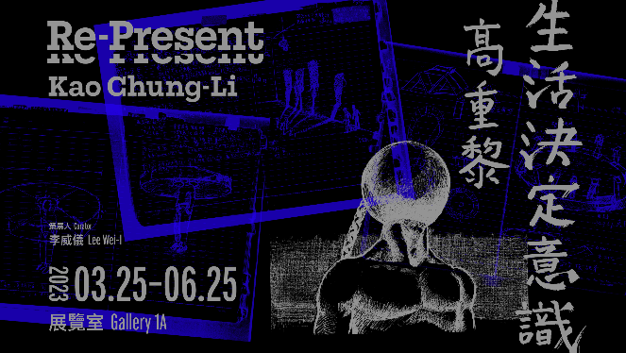
2.  高重黎，《整肅儀容》，1983-2023，75吋螢幕、網路攝影機、深度攝影機，尺寸依場地而定。圖像由藝術家及臺北市立美術館提供。  Kao Chung-Li, Grooming, 1983-2023, 75-inch monitor, webcam, depth camera, dimensions variable. Courtesy of the artist and Taipei Fine Arts Museum. | 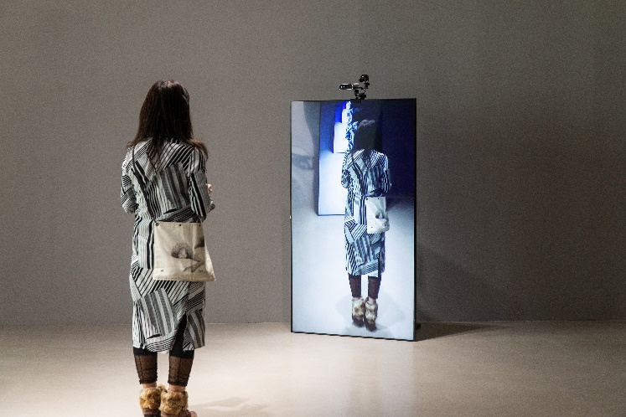
3.  高重黎，《ASA的N次方》，1983，壓克力顏料、X光片、拍立得、義肢、影印物、鏡面壓克力、玻璃纖維，125x245公分。圖像由藝術家及臺北市立美術館提供。  Kao Chung-Li, ASA to the power of N, 1983, acrylic paint, X-ray image, polaroid, prosthesis, photocopying, acrylic mirror sheet, fiber-reinforced plastic (FRP), 125x245 cm. Courtesy of the artist and Taipei Fine Arts Museum. | 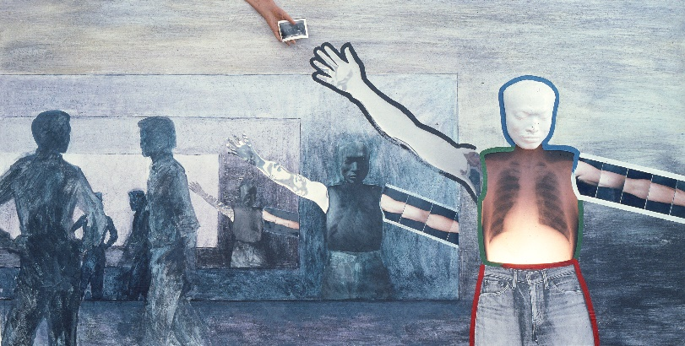
4.  高重黎，《數據⽜仔或遠離烏克蘭》，2023，發泡海綿、機械動力裝置、PC塑膠板、燈，尺寸依場地而定。圖像由藝術家及臺北市立美術館提供。  Kao Chung-Li, Data Cowboy / Loin de l’Ukraine, 2023, expanded polyethylene foam (EPE), mechanical installation, polycarbonate plastic sheet, light, dimensions variable. Courtesy of the artist and Taipei Fine Arts Museum. | 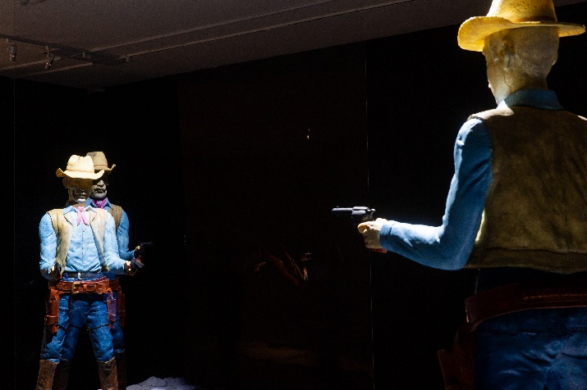
5.  高重黎，《反．美．學 002》，1999，化學機械式活動影像裝置，68x68x115公分。圖像由藝術家及臺北市立美術館提供。  Kao Chung-Li, Anti‧mei‧ology 002, 1999, photochemical-mechanical live image projection device, 68x68x115 cm. Courtesy of the artist and Taipei Fine Arts Museum. | 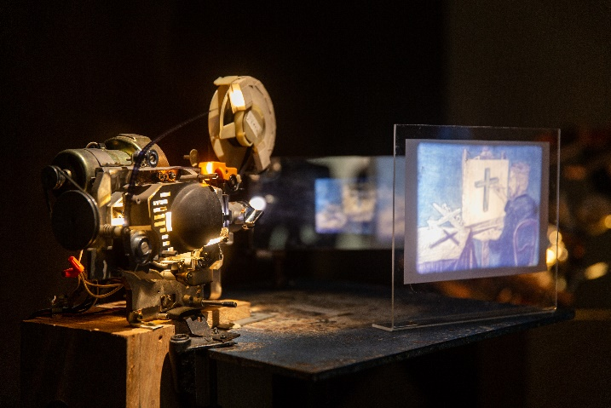
6.  高重黎，《瑪琍有隻小羊羔》，2019，工業時間客體/留聲機、蟲膠曲盤、頭骨模型，50x30公分。圖像由藝術家及臺北市立美術館提供。  Kao Chung-Li, Mary Had A Little Lamb, 2023, industrial temporal objects/phonograph, vinyl, model installation, 50x30 cm. Courtesy of the artist and Taipei Fine Arts Museum. | 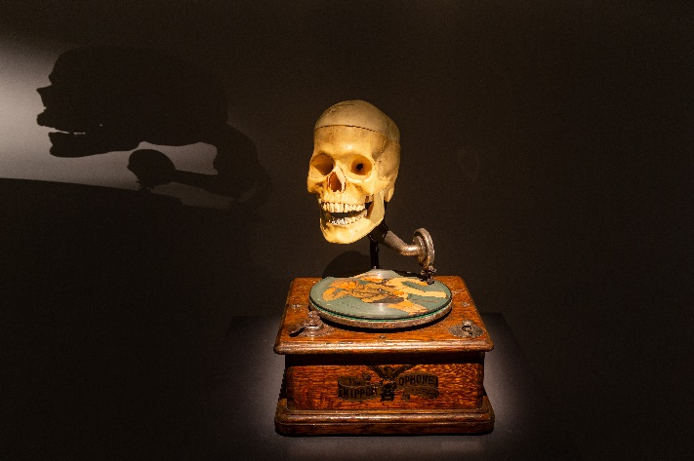
7.  高重黎，《雙目視覺投幣機》，2023，燈片、日本投幣街機，31.5x26x50公分。圖像由藝術家及臺北市立美術館提供。  Kao Chung-Li, Coin-operated Binocular Machine  View-Master, 2023,view-master slide, Japanese coin-operated machine, 31.5x26x50 cm. Courtesy of the artist and Taipei Fine Arts Museum. | 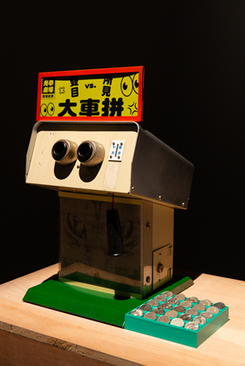
8.  高重黎，「一卡皮箱電影院系列」桌上一景，2006-2015。圖像由藝術家及臺北市立美術館提供。  Kao Chung-Li, Installation view of Cinemas in Suitcases Series, 2006-2015. Courtesy of the artist and Taipei Fine Arts Museum. | 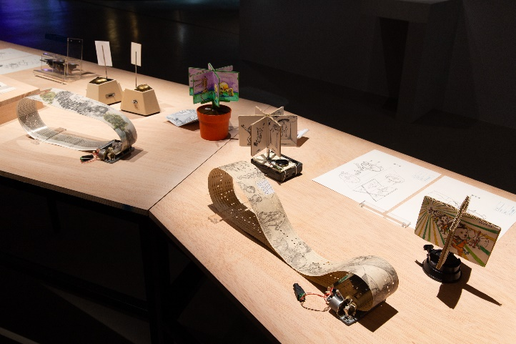
9.  高重黎，《3D活動影像觀視器》，2008，數位輸出、手繪圖、立體攝影、壓克力，21x12x20 cm。圖像由藝術家及臺北市立美術館提供。  Kao Chung-Li, 3D Live Image Display,2008, digital output, freehand drawing, stereoscopic photography, acrylic, 21x12x20 cm. Courtesy of the artist and Taipei Fine Arts Museum. | 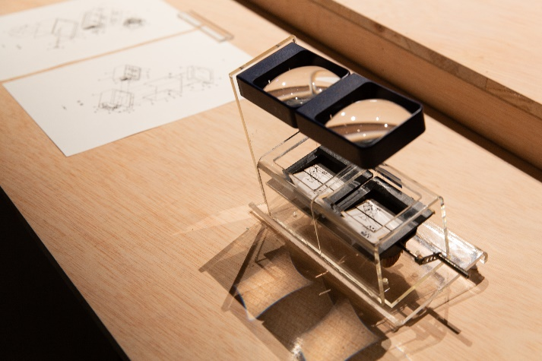
10.  高重黎，《消相與顯相的耳語》，2023，實物投影機、玻璃纖維、動力裝置，120x93.8x127.5公分。圖像由藝術家及臺北市立美術館提供。  Kao Chung-Li, Talking Heads, 2023, episcope, fiber-reinforced plastic (FRP), kinetic installation, 120x93.8x 127.5 cm. Courtesy of the artist and Taipei Fine Arts Museum. | 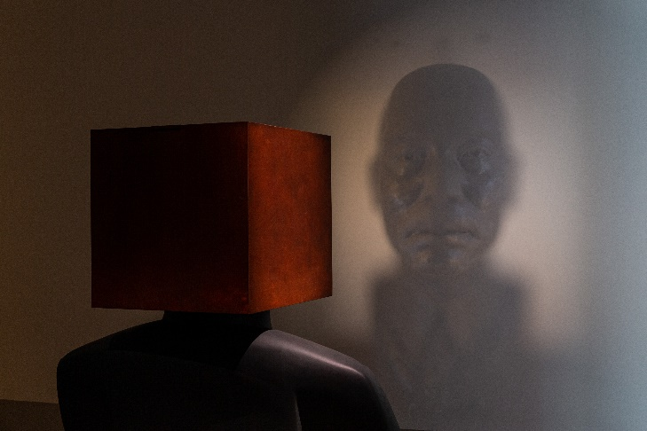
11.  高重黎，《十六小時的情事》，2023，內投有聲幻燈機、電影膠捲、數位程式，尺寸依場地而定。圖像由藝術家及臺北市立美術館提供。  Kao Chung-Li, Hiroshima Mon Amour, 2023, audio slide projector, film, computer program, dimensions variable. Courtesy of the artist and Taipei Fine Arts Museum. | 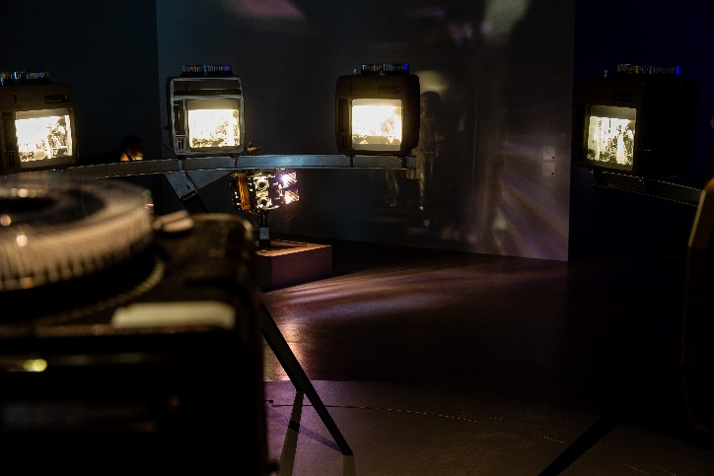
12.  高重黎，《御賜義肢》，2023，工業時間客體、動力裝置，尺寸依場地而定。圖像由藝術家及臺北市立美術館提供。  Kao Chung-Li, Sans Soleil, 2023, industrial temporal objects, kinetic installation, dimensions variable. Courtesy of the artist and Taipei Fine Arts Museum. | 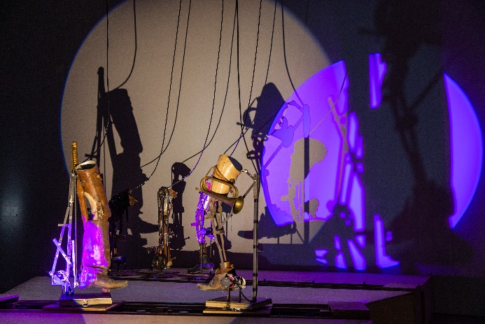
13.  高重黎，《逆旅的三段旅程》場景照，1987-2012，錄像裝置，41分鐘。圖像由藝術家及臺北市立美術館提供。  Kao Chung-Li, Installation view of The Way Station Trilogy,1987-2012, video installation, 41 mins. Courtesy of the artist and Taipei Fine Arts Museum. | 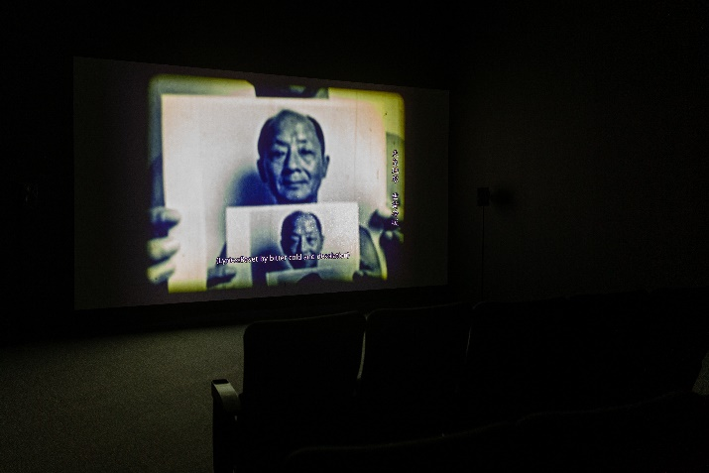
14.  高重黎，《我的陳老師》場景照，2010，單頻錄像，22分27秒。圖像由藝術家及臺北市立美術館提供。  Kao Chung-Li, Installation view of My Mentor, Chen Yingzhen,2010, Single-channel video, 22mins 27secs. Courtesy of the artist and Taipei Fine Arts Museum. | 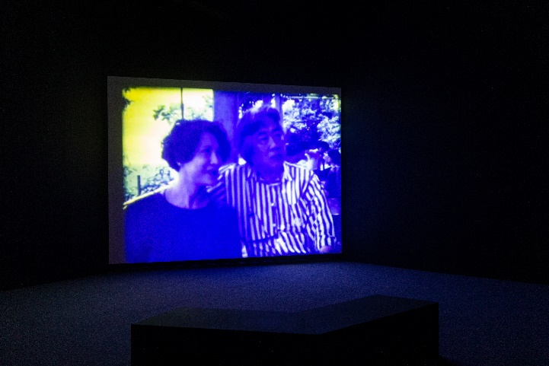
15.  藝術家高重黎。圖像由臺北市立美術館提供。  Artist Kao Chung-Li. Courtesy of Taipei Fine Arts Museum. | 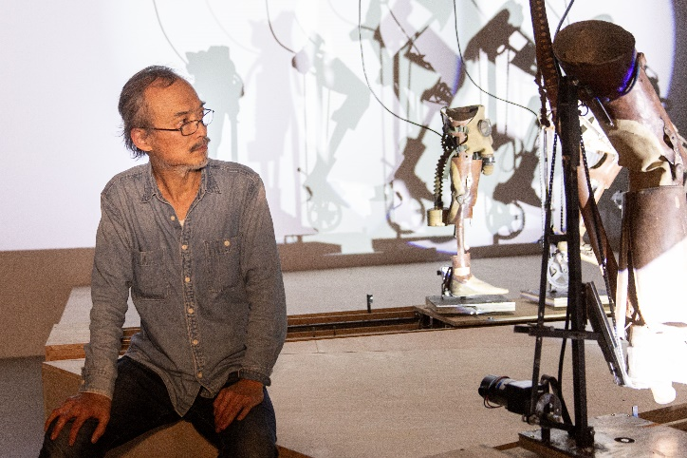
16.  (左至右)策展人李威儀、藝術家高重黎與臺北市立美術館館長王俊傑合影。圖像由臺北市立美術館提供。  (From left to right) Curator Lee Wei I, artist Kao Chung-Li and Director of Taipei Fine Arts Museum Jun-Jieh Wang. Courtesy of Taipei Fine Arts Museum. | 