|  |  |
| --- | --- |
| **Taipei Fine Arts Museum Press Release**  **FOR IMMEDIATE RELEASE**  **Taipei Biennial 2023: *Small World***  Date: 18 November 2023- 24 March 2024  Venue: Taipei Fine Arts Museum | **Media contact:**  Yu-mei Sung ([yumei-tfam@gov.t](mailto:yumei-tfam@gov.t)aipei) Jean Tzu-chin Kao (tckao[-tfam@gov.t](mailto:-tfam@gov.t)aipei) |

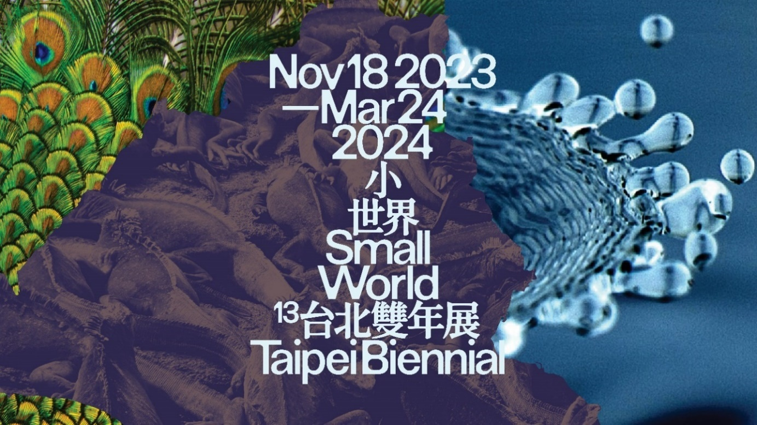

Visual identity of Taipei Biennial 2023 designed by Wkshps (New York). Courtesy of the Taipei Fine Arts Museum.

**Taipei Biennial 2023 announces its title and selected artists**

**13 March 2023 – Taipei:** Taipei Biennial is pleased to announce the curatorial concept for the 13th edition of Taipei Biennial, running from 18 November 2023 to 24 March 2024 at the Taipei Fine Arts Museum (TFAM). Curated by independent curator **Freya Chou**, writer and editor **Brian Kuan Wood**, and curator **Reem Shadid**, this year’s Taipei Biennial is titled *“****Small World****”*. In this iteration, a number of artists are selected to produce or premier new works including **Pio Abad** (London), **Nadim Abbas** (Hong Kong), **Nesrine Khodr** (Beirut), **Jacqueline Kiyomi Gork** (Los Angeles)**, Lai Chi Sheng** (Taipei), **Li Yi Fan** (Taipei), **Jen Liu** (New York), **Natascha Sadr Haghighian** (Berlin/Tehran), **dj sniff**  (Los Angeles/Tokyo), and **Yang Chi Chuan** (Taipei).

On this edition’s curatorial ethos, the three curators say:

*“No matter what hell you have been through these past few years, you have most likely felt and seen endings become beginnings and beginnings abruptly end. You may have run for cover in the nearest enclosure, only to find yourself in a shrinking pod made of cameras and screens feeding your eyeballs and draining your energy. Perhaps it’s time to look under the tangle of pipelines and ask how we might render the menacing drone of automation as music, how to explore the unknown power of the ground just underneath our feet, which might underwrite a possibility for a new and more lyrical kind of life and creation.”*

The 13th edition of Taipei Biennial will transform the Taipei Fine Arts Museum into a space of listening, gathering, improvising and exploring other ways to perceive and navigate recent lessons learned about the life that we really want. The exhibition will unfurl the compressed time of musical and cinematic capture and play back the part of our intimate lives swallowed into a planetary recording apparatus. It’s an invitation to recognize the intimate enclosure and embrace it, to surround your habitat and inhabit your surroundings; an invitation to break open the tensions and invert the scales, values, weights and measures. It’s an appeal to draw out the deathlike fatigue of systems fueled by chronic mistrust and reclaim a sense of clarity on skillfully buried conflicts and calamities that continue to seep into our organs, habits and soils.

As a departure from the 2018 and 2020 editions of Taipei Biennial (*“Post-Nature: A Museum as an Ecosystem”* and *“You and I don’t live on the same planet”,* respectively), which, with an omniscient perspective, tackled ecological issues and engaged in even deeper examination of the interactions, dynamics and diplomatic tactics between human and non-human world, the upcoming edition dives into the sensual experiences and deep tensions of individuals’ everyday life regulated by the changing algorithm of the world, asking whether it holds capacity for new poetics.

Jun-Jieh Wang, Director of TFAM, believes that the 2023 Taipei Biennial is charting another path for the biennial and looks very much forward to its presentation. He adds, “It brings a light touch to the issues we are facing in contemporary society, but at the same time profoundly questions how ones situate themselves when temporal and spatial conditions are constantly re-defined.”

The **CTBC Foundation for Arts and Culture,** continues to be the lead sponsor of the exhibition, following its support to the 2020 edition.

**Curators’ biography**

**Freya Chou**

Freya Chou is a curator based in Hong Kong and Taipei. From 2008 - 2014, she was on the curatorial team for the 6th and 7th Taipei Biennial (2008, 2010) and Co-Curator of the 10th Shanghai Biennial (2014). From 2015 - 2019, she worked at Para Site in Hong Kong as the institution’s first Education and Public Programs Curator, during those four years she also curated exhibitions: *Ellen Pau: What About Home Affairs? - A Retrospective* (2018), *Chris Evans, Pak Sheung Chuen: Two Exhibitions* (2017), and *Afterwork* (co-curator, 2016). Recently, Chou has worked with several organizations on research projects, she has also edited and contributed writing to many artist books, magazines, and exhibition catalogues. Chou is a member of the 58th Carnegie International’s Curatorial Council and the Guest Curator of *Angela Su: Arise, Hong Kong in Venice, Hong Kong* (2022), Hong Kong’s participation in the 59th International Art Exhibition of La Biennale di Venezia.

**Brian Kuan Wood**

Brian Kuan Wood is a writer based in New York, and an editor of e-flux’s book series and monthly journal. Since 2015 he has taught at the MA Curatorial Practice program at the School of Visual Arts in New York, where he was Director of Research from 2017 to 2022. He has taught and lectured at Ashkal Alwan in Beirut, Moderna Museet in Stockholm, Inside Out Museum in Beijing, and China Art Academy in Hangzhou, among other places. He recently edited Natascha Sadr Haghighian’s *relearning bearing witness* (2021), Yuk Hui’s *Art and Cosmotechnics* (2021), as well as the 2017 Sharjah Biennial publication *Tamawuj*(with Amal Issa, Omar Berrada, and Kaelen Wilson-Goldie), the Taipei Biennial 2012 catalog *Modern Monsters: Death and Life of Fiction* (with Anselm Franke), and *Selected Maria Lind Writing* (2010).

**Reem Shadid**

Reem Shadid is a curator, researcher and cultural organizer who works on the emancipatory possibilities within artistic practice, exploring the ways it intersects with ecological, political and socio-economic forms. Currently, she is the Director of Beirut Art Center in Lebanon and is a co-curator for the second edition of *New Visions* (2023), the Henie Onstad Kunstsenter triennial for photography and New Media. Reem is also a contributing editor with Infrasonica, a digital platform of non-western cultures for experimental sound and visual art practices and is the producer and host of Radio Alhara’s show *Listening with Reem Shadid*; listening sessions with artists and practitioners working at the intersection of sonic, visual and literary productions. Most recently she directed Berlin Biennale (2022) Curator’s workshop, and was the producer and host of *Aridity Lines,* a podcast on local ecological knowledge and climate change in the south-eastern Mediterranean region commissioned by TBA21 Academy. Previously she was the Deputy Director of Sharjah Art Foundation, where she served in various capacities between 2006 – 2020.

**About the exhibition and organizer**

**Taipei Biennial**

Being one of the most long-standing biennials in Asia, the Taipei Biennial held by the Taipei Fine Arts Museum has endeavored in driving Taiwanese contemporary art development since it was launched in 1998, facilitating a platform of interaction and exchange between local and international communities through its vigorous engagement informed by diversely cultural perspectives in Asian and global contemporary art networks. Through the multi-directional communication of exhibition mechanism, the biennial aims to proactively lead in discussions and respond to contemporary issues, encompassing global perspectives and regional individuality. In the recent editions, experts and professionals from various disciplines have been invited to participate in the biennial with the objective to spark and introduce multifacetedness of art, while engendering the energy of different artistic dimensions.

**Taipei Fine Arts Museum**

Established in 1983 in response to a burgeoning modern art movement, the Taipei Fine Arts Museum (TFAM) is Taiwan’s first museum of modern and contemporary art. Since its inception, the museum has shouldered its mission dedicated to the preservation, research, development and advocacy of modern art in Taiwan, while staying abreast of cultural productions that arise in the context of an expanding global contemporary art scene. TFAM has been participating in Venice Biennale since 1995 and has been hosting the Taipei Biennial since 1998, inviting renowned international and local curators and artists to participate in the exhibition. [www.tfam.museum](http://www.tfam.museum)

**Lead Sponsor**

**CTBC Foundation for Arts and Culture**

In 1996, the CTBC Foundation for Arts and Culture was established to stimulate the art and cultural environment in Taiwan and elevate cultural literacy among the general public. In earlier years, the foundation focused on theater operations. In 2015, it underwent a transformation and initiated a three-pronged approach to promote visual arts, supporting performance arts, and fostering arts and culture education. The foundation organizes the **CTBC Arts Festival** annually, to promote performance art between global and local communities. It also hosts **Dreams Initiatives Project**, inviting artists as mentor to conduct workshops at schools in rural areas, bridging the gap by making arts resources accessible to all cities and towns in Taiwan. Starting from 2021, the foundation holds the **CTBC Painting Prize** biennially, the only award focusing on contemporary painting in Taiwan. It encourages young artists to explore their creativity with contemporary approaches and support unique and innovative voices. Affirming the Biennial’s positive influence on society, CTBC Foundation for Arts and Culture sponsored the Taipei Biennial 2020, and will continue to be the lead sponsor of the Taipei Biennial 2023.