Taipei Fine Arts Museum announces 2023 & 40th anniversary | Image Sheet

Caption | Image
- Key visual for TFAM’s 40th Anniversary.
- A One and A Two: Edward Yang Retrospective  Behind-the-scene photo: Edward Yang during the filming of That Day, on the Beach, 1982-1983.  Courtesy of Taiwan Film and Audiovisual Institute. | 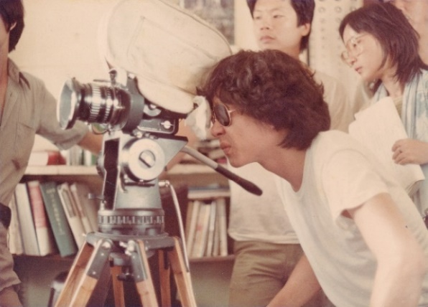
- A One and A Two: Edward Yang Retrospective  Edward Yang’s comic draft (ca. 1960s).  Courtesy of Taiwan Film and Audiovisual Institute. | 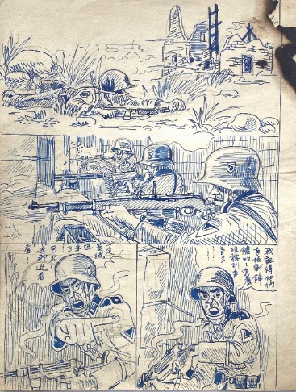
- A One and A Two: Edward Yang Retrospective  Behind-the-scene photo: Edward Yang during the filming of A Confucian Confusion, ca. 1994.  Courtesy of Taiwan Film and Audiovisual Institute. | 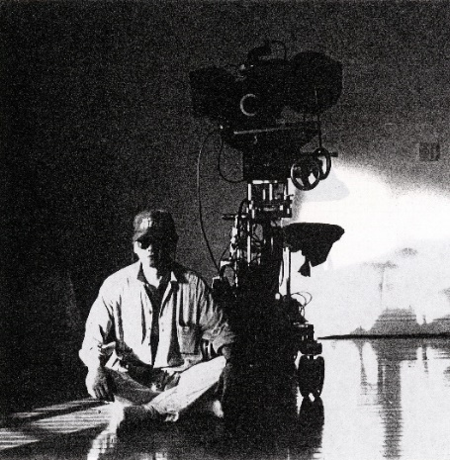
Caption | Image
- Ho Te-Lai: A Retrospective  Ho Te-Lai, Father and Mother, 1959.  Oil on canvas.  130.5 × 194 cm.  Collection of Taipei Fine Arts Museum. | 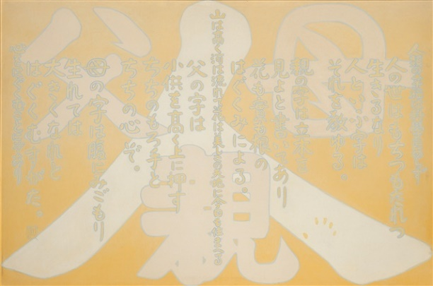
- Ho Te-Lai: A Retrospective  Ho Te-Lai, Post War, 1950.  Oil on canvas.  45.5 × 38 cm.  Collection of Taipei Fine Arts Museum. | 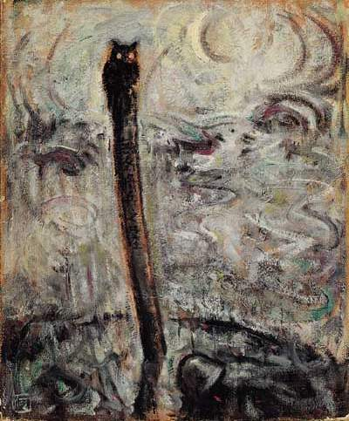
- Re-Present: Kao Chung-Li  Kao Chung-Li, The Man with the Film Projector, 2007. Courtesy of the artist. | 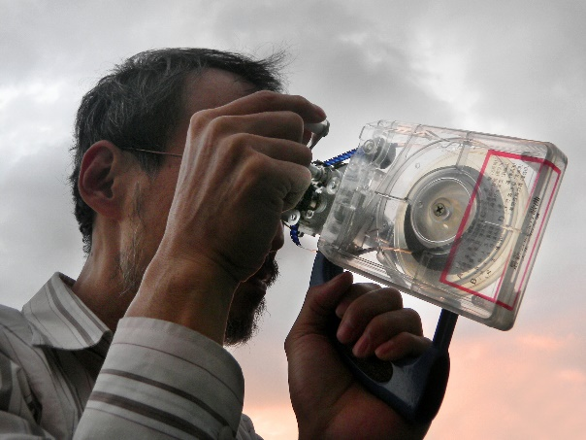
- Re-Present: Kao Chung-Li  Kao Chung-Li, Les Carabiniers, Object Book Series#2, 2018.  Flat-panel display, objects.  55.5 × 43.5 × 15 cm.  Courtesy of the artist. | 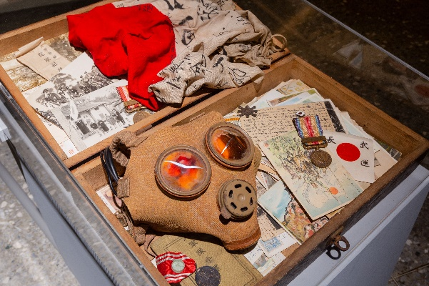
Caption | Image
- BODO: Ting Tong Chang Soli Exhibition  Visual simulation of the exhibition. Courtesy of TTC Studio. | 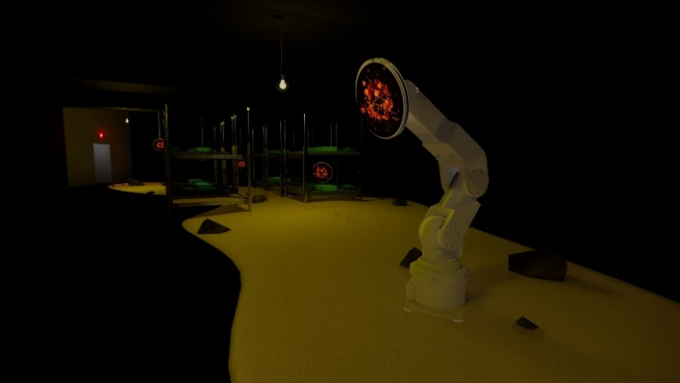
- René Burri · Explosions of Sight  René Burri, Che Guevara, Painted on the invitation card of “Retrospective 2004-2010” which was held in Rotterdam in 2005, after 2015.  © René Burri / Magnum Photos. Fondation René Burri, courtesy Photo Elysée, Lausanne. | 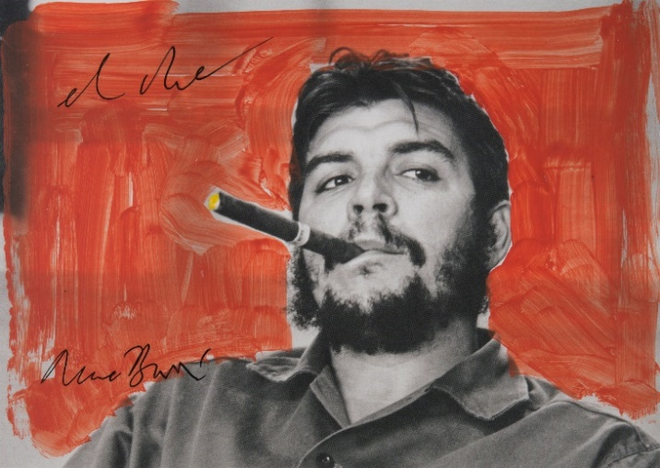
- René Burri · Explosions of Sight  René Burri, A Selfie Portrait, Coronado, New Mexico, United States, 1973-1983.  © René Burri / Magnum Photos. Fondation René Burri, courtesy Photo Elysée, Lausanne. | 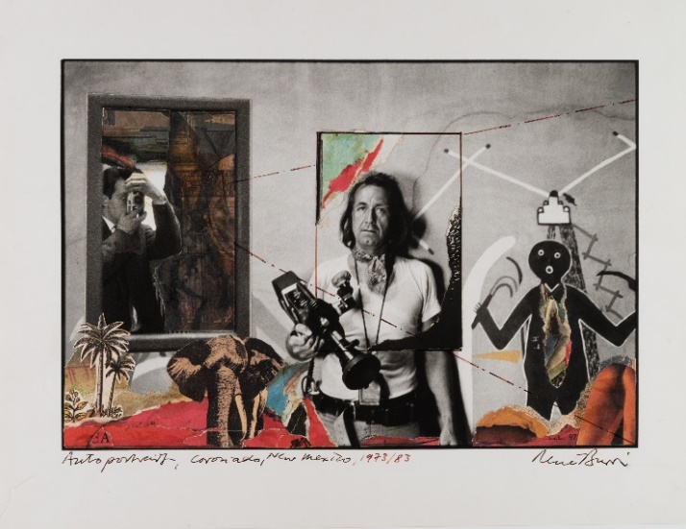
Caption | Image
- David Claerbout Solo Exhibition  David Claerbout, Aircraft (F.A.L.), 2015-2021.  Single channel video projection, black & white, stereo audio.  Courtesy the artist and Esther Schipper, Berlin/Paris/Seoul. | 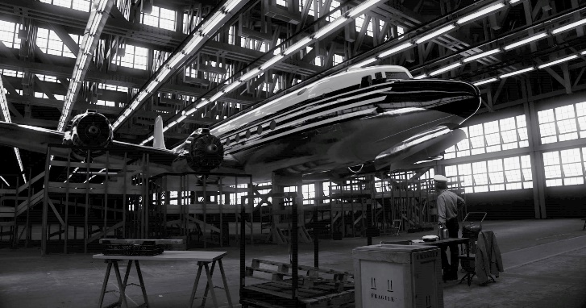
- David Claerbout Solo Exhibition  David Claerbout, The Pure Necessity, 2016.  Single channel projection, 2D animation, stereo sound, 50 min.  Courtesy the artist and Esther Schipper, Berlin/Paris/Seoul. | 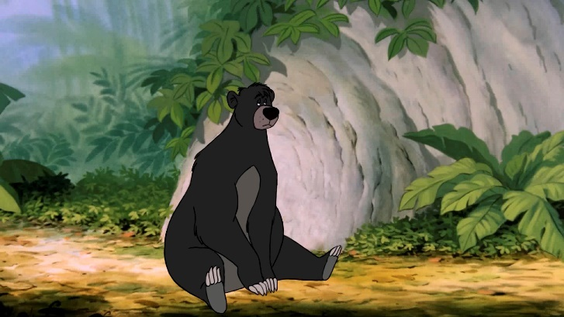
- Supernatual：Sculptural Visions of the Body  Andro Wekua, Untitled, 2014.  Fake hair, silicone, wax, polymer plaster, PU foam, steel, glass, synthetic rope, aluminum cast, fabric, motors, electronics, and mechanics.  212.1 × 101.6 × 68.6 cm.  ©Andro Wekua, VG Bild-Kunst, Bonn 2022.  Private Collection. Photo by Stephen White. | 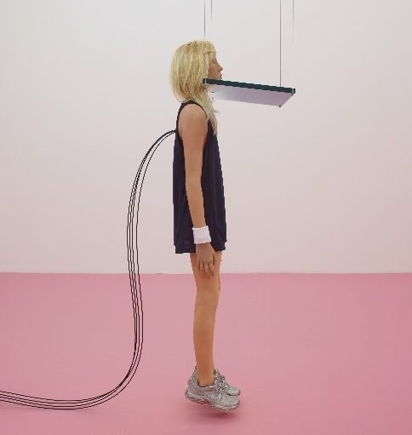
- Supernatual：Sculptural Visions of the Body  Patricia Piccinini, Graham, 2016.  Silicone, fibreglass, human hair, clothing, concrete.  140 × 120 × 170 cm.  ©Patricia Piccinini. Courtesy of the artist and Transport Accident Commission, Australia. | 