Taipei Fine Arts Museum Press Release  FOR IMMEDIATE RELEASE  Taipei Biennial 2023  Date: 18 November 2023- 24 March 2024  Venue: Taipei Fine Arts Museum | Media contact:  Yu-mei Sung (yumei-tfam@mail.taipei.gov.tw)  Jean Tzu-chin Kao (tckao-tfam@mail.taipei.gov.tw)
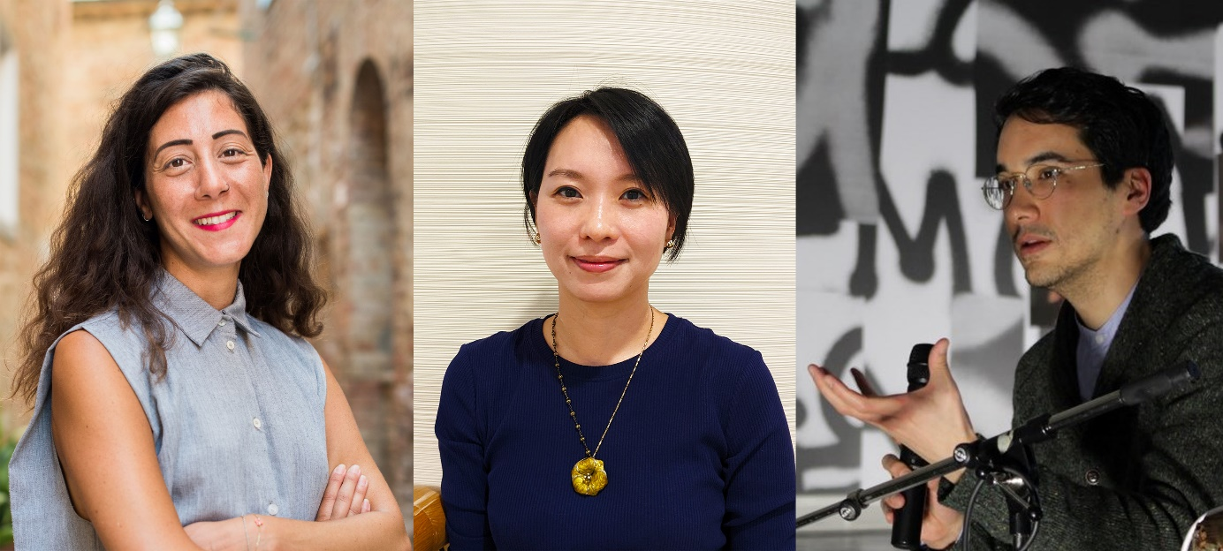

The 13th Taipei Biennial’s curatorial team: Reem Shadid, Freya Chou and Brian Kuan Wood (left to right). Courtesy of the Taipei Fine Arts Museum.

The Taipei Fine Arts Museum Announces the 13th Taipei Biennial’s Curatorial Team

The Taipei Fine Arts Museum (TFAM) is delighted to announce that the 13th Taipei Biennial, opening in November 2023, will be collectively curated by Taiwanese curator Freya Chou; writer, educator, and editor Brian Kuan Wood; and curator Reem Shadid. The team of curators aims to co-produce and co-create a curatorial methodology centering on organic collaboration, which will propel the reiteration and reproduction of knowledge and memory to generate a new momentum for the Taipei Biennial.

Freya Chou is a curator based in Taipei and Hong Kong, she was in the curatorial team of the 6th and 7th Taipei Biennial (2008, 2010), and co-curator of the 10th Shanghai Biennial (2014). From 2015-2019, she worked at Para site in Hong Kong as the institution’s first Education and Public Program Curator. She was the guest curator of Hong Kong’s participation of the 59th Venice Biennale (2022), and a member of the 58th Carnegie International’s Curatorial Council (2022). Brian Kuan Wood is a writer based in New York, and an editor of e-flux’s monthly journal and book series. Since 2015, he has taught at the MA Curatorial Practice program at the School of Visual Arts in New York, where he has been Director of Research. Reem Shadid is a curator based in Beirut, she is a co-curator of the Henie Onstad Kunstsenter New Visions 2023 triennial, most recently she directed the Curator's workshop of the 12th Berlin Biennale (2022). She is the producer and host of a radio show that focuses on the intersection of sonic, visual and literary productions, and is a contributing editor with Infrasonica. She was the Deputy Director of Sharjah Art Foundation that organizes the Sharjah Biennial, where she served in various capacities between 2006 – 2020.Starting from different perspectives, the three curators will explore new ways of connection and channels of dialogue between Taiwan and the world, while collectively moving the development of the biennial forward based on their previous collaborations.

Being one of the most long-standing biennials in Asia, the Taipei Biennial has endeavored in driving Taiwanese contemporary art development since it was launched in 1998, facilitating a platform of interaction and exchange between local and international communities through its active engagement informed by diversely cultural perspectives in Asian and global contemporary art networks. Throughout the previous editions, the biennial has evolved with the times and made dynamic adjustment. In the recent editions, experts and professionals from various disciplinaries have been invited to participate in the biennial with the objective to spark and introduce multifaceted forms of art, while engendering the energy of different artistic dimensions.

With exhibition mechanism and methodology serving as an entry point, the upcoming edition will be grounded by an exhibition, a public program of music, residencies, workshops and various discursive and experiential forms, gradually generated and shaped in the ongoing collaborative and reciprocal process. The 2023 Taipei Biennial explores how the pressures of daily life and survival flip the scales on many hyper-performative modern apparatuses, sending their weights and measures haywire, breaking open stubbornly intimate enclosures in a still-growing world.

Freya Chou
Freya Chou is a curator based in Hong Kong and Taipei. From 2008 - 2014, she was on the curatorial team for the 6th and 7th Taipei Biennial (2008, 2010) and Co-Curator of the 10th Shanghai Biennial (2014). From 2015 - 2019, she worked at Para Site in Hong Kong as the institution’s first Education and Public Programs Curator, during those four years she also curated exhibitions: Ellen Pau: What About Home Affairs? - A Retrospective (2018), Chris Evans, Pak Sheung Chuen: Two Exhibitions (2017), and Afterwork (co-curator, 2016). Recently, Chou has worked with several organizations on research projects, she has also edited and contributed writing to many artist books, magazines, and exhibition catalogues. Chou is a member of the 58th Carnegie International’s Curatorial Council and the Guest Curator of Angela Su: Arise, Hong Kong in Venice, Hong Kong (2022), Hong Kong’s participation in the 59th International Art Exhibition of La Biennale di Venezia.
Brian Kuan Wood
Brian Kuan Wood is a writer based in New York, and an editor of e-flux’s book series and monthly journal. Since 2015 he has taught at the MA Curatorial Practice program at the School of Visual Arts in New York, where he has been Director of Research. He has taught and lectured at Ashkal Alwan in Beirut, Moderna Museet in Stockholm, Inside Out Museum in Beijing, and China Art Academy in Hangzhou, among other places. He recently edited Natascha Sadr Haghighian’s relearning bearing witness (2021), Yuk Hui’s Art and Cosmotechnics (2021), as well as the 2017 Sharjah Biennial publication Tamawuj (with Amal Issa, Omar Berrada, and Kaelen Wilson-Goldie), the Taipei Biennial 2012 catalog Modern Monsters: Death and Life of Fiction (with Anselm Franke), and Selected Maria Lind Writing (2010).

Reem Shadid
Reem Shadid is a curator, researcher and cultural organizer who works on the emancipatory possibilities within artistic practice, exploring the ways it intersects with ecological, political and socio-economic forms. She is the producer and host of Radio Alhara’s show Listening with Reem Shadid; listening sessions with artists and practitioners working at the intersection of sonic, visual and literary productions. She is also co-curator for the second edition of New Visions (2023), the Henie Onstad Kunstsenter triennial for photography and New Media, and a contributing editor with Infrasonica, a digital platform of non-western cultures for experimental sound and visual art practices. Most recently she directed Berlin Biennale (2022) Curator’s workshop, and was the producer and host of Aridity Lines, a podcast on local ecological knowledges and climate change in the south-eastern Mediterranean region commissioned by TBA21 Academy. Previously she was the Deputy Director of Sharjah Art Foundation, where she served in various capacities between 2006 – 2020. She was a resident curator at Ashkal Alwan from April to October 2021.

