Taipei Fine Arts Museum Breaks Ground on the Art Complex Expansion Project

Images
01  The transparent structure allows daylight to stream through the interior areas below. © Ricky Liu & Associates Architects + Planners  Courtesy of Taipei Fine Arts Museum | 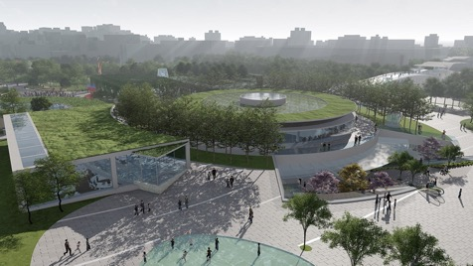
02  Layout of the Taipei Fine Arts Museum, the new building and surrounding facilities. © Ricky Liu & Associates Architects + Planners  Courtesy of Taipei Fine Arts Museum | 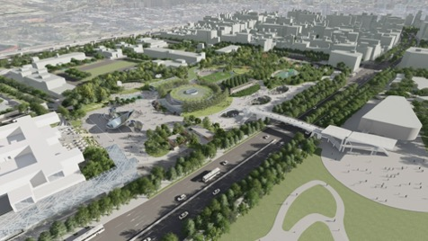
03  An undulating landscape shaped by staggered volumes in the Art Complex. © Ricky Liu & Associates Architects + Planners  Courtesy of Taipei Fine Arts Museum | 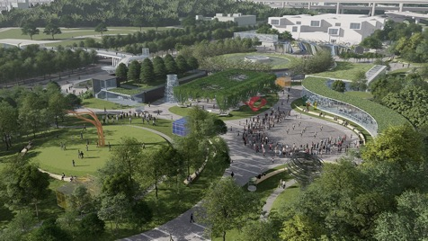
04  A bright concourse with daylight streaming through a glass skylight. © Ricky Liu & Associates Architects + Planners  Courtesy of Taipei Fine Arts Museum | 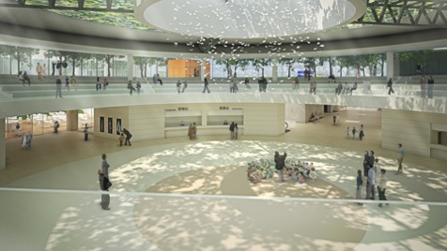
05  The west side of the Art Complex provides a good walking environment. © Ricky Liu & Associates Architects + Planners  Courtesy of Taipei Fine Arts Museum | 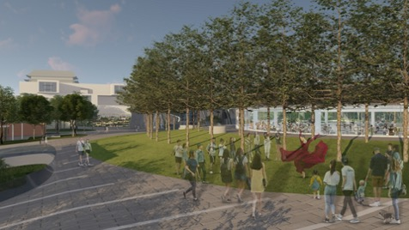
06  Groundbreaking ceremony for the Art Complex Expansion Project of TFAM.  Courtesy of Taipei Fine Arts Museum | 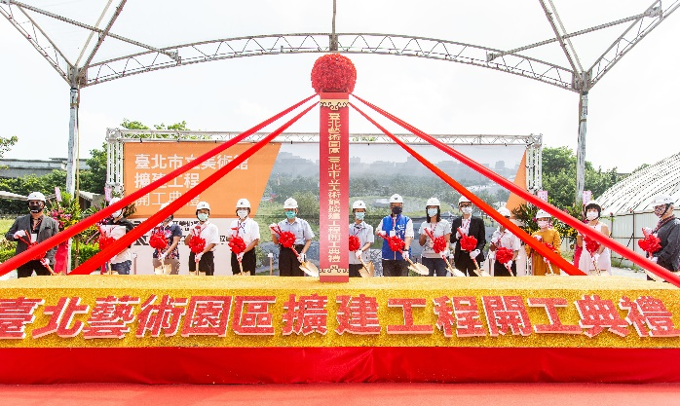
07  Mayor Ko Wen-Je (in the midst), accompanied by Deputy Mayor Pong Cheng-Sheng, Commissioner of Department of Cultural Affairs Li Li-Zhu, and Commissioner of the Public Works Department Lin Chih-Feng, among other guests.  Courtesy of Taipei Fine Arts Museum | 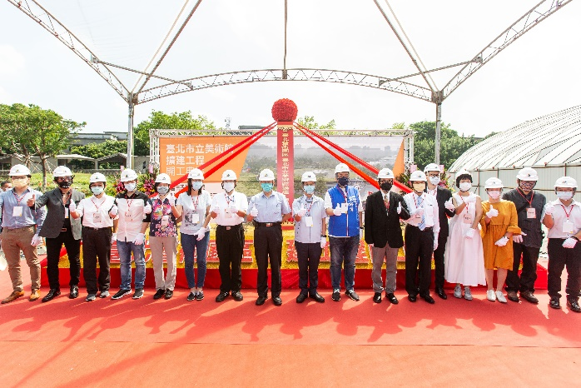
08  Lion Dance at the groundbreaking ceremony for the Art Complex Expansion Project of TFAM  Courtesy of Taipei Fine Arts Museum | 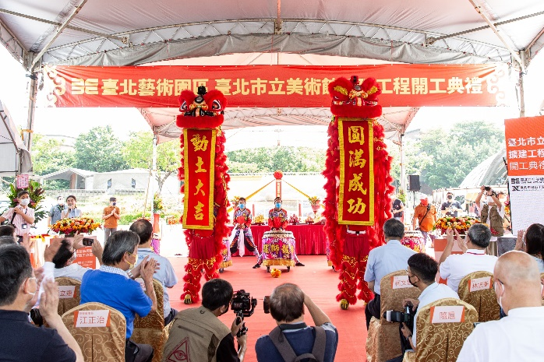
09  Taipei Mayor Ko Wen-Je delivers the opening remarks.  Courtesy of Taipei Fine Arts Museum | 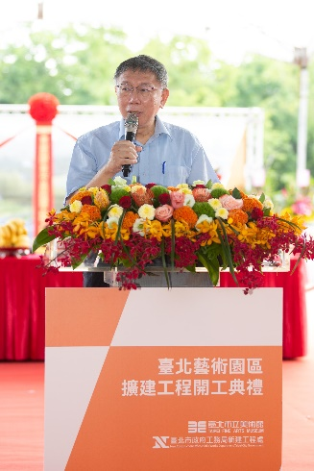
10  Chief Engineer Liu Jia-Ming of the New Construction Preparatory Office reports on the project summary.  Courtesy of Taipei Fine Arts Museum | 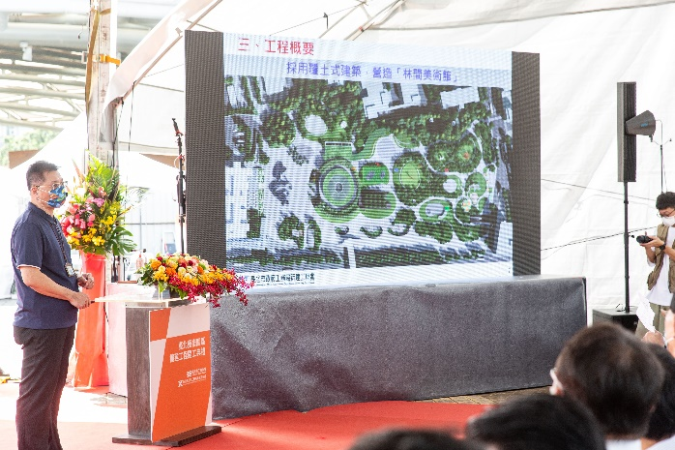
11  TFAM Director Wang Jun-Jieh introduces the reason for expansion and future prospects.  Courtesy of Taipei Fine Arts Museum | 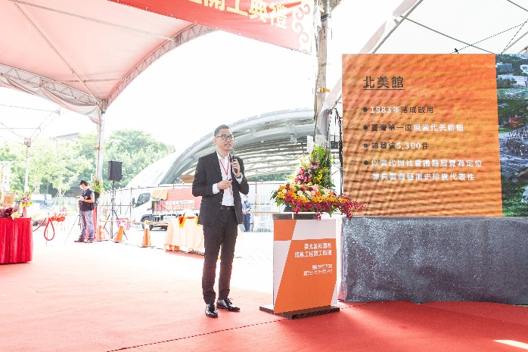
12  Mayor Ko Wen-Je prays for blessings with guests.  Courtesy of Taipei Fine Arts Museum | 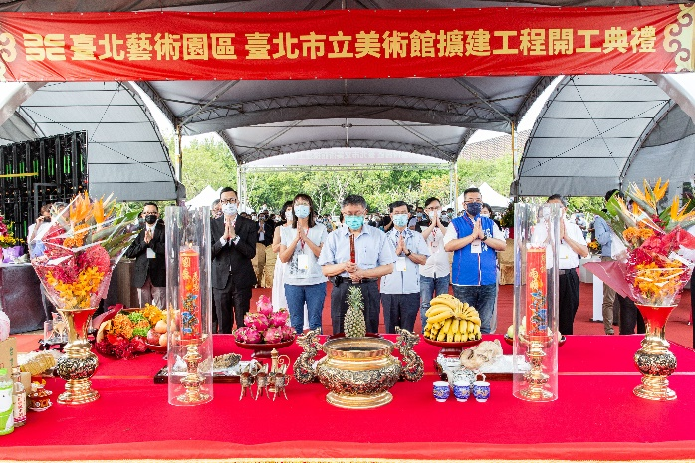
13  Architect Ricky Liu from the selection team explains his expansion design for Mayor Ko Wen-Je  Courtesy of Taipei Fine Arts Museum | 