Taipei Fine Arts Museum Press Release
FOR IMMEDIATE RELEASE
Issued by: TFAM Marketing and Public Relations Department
Date: September 30, 2022
Press Kit
Media Contact | Ethan Yi-Sheng Li (ethan-tfam@mail.taipei.gov.tw)  Tzu-chin Kao (tckao-tfam@mail.taipei.gov.tw)
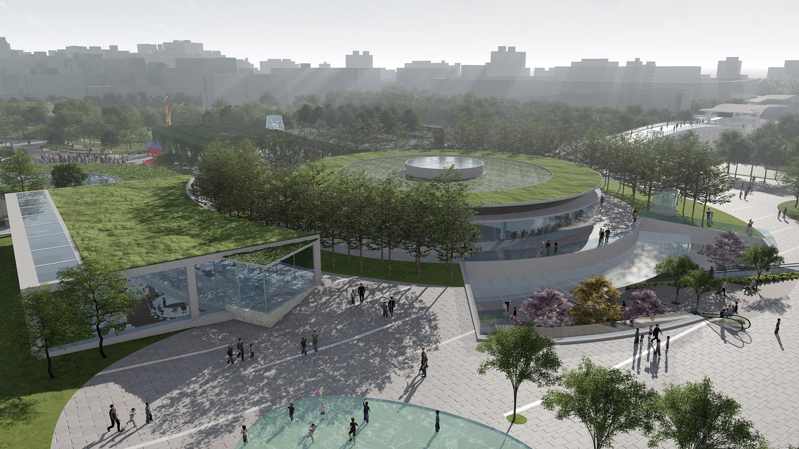
Taipei Fine Arts Museum Breaks Ground on the Art Complex Expansion Project

Longed for over two decades by people in Taipei and the art society, the expansion of Taipei Fine Arts Museum finally kicks off. The groundbreaking ceremony was held on Sep 30, hosted by Mayor Ko Wen-Je, with the attendance of government officials, former TFAM directors, artists, scholars, and curators.
Since its inauguration in 1983, the Taipei Fine Arts Museum has activated the era of art museums in the Taiwanese art history. As the first art museum for modern and contemporary arts in Taiwan, TFAM has taken the lead in elevating and broadening the perspective of its development. Over the past 38 years, the spaces for exhibitions and collections became inadequate for the changing art world, and the need of a new blueprint is pressing. In addition to the continuation of its past achievements, the Museum is eager to catalyze the public’s imagination for the future. An expansion that is comprehensive and foresighted, and that accommodates different dimensions of arts, and interdisciplinary projects becomes a necessary milestone for TFAM.
The new building is located at the Fine Arts Area of Taipei Expo Park adjacent to the TFAM, as the first museum project in the country to adopt earth-sheltered architecture. The construction area is 62,542 square-meters, and total floor area is 44,576 square-meters. Along with the interdisciplinary, experimental and new media projects this building will be engaging, the site with other natural landscaping elements highlights its design concept “Art Nurtured by Nature, Nature Observed in Art,” shaping a green cultural corridor for the northern city of Taipei. Stemmed from Mayor Ko Wen-Je’s promise in 2014, with the aid of TFAM’s museum professionals, as he emphasizes, “the project is to construct an art axis between the Fine Arts Area of Taipei Expo Park and Xinsheng Park.” “By creating a new cultural cityscape, the new building will also serve as a solid foundation for the future development of contemporary art in Taiwan.”
The missions of the future TFAM Art Complex are to incorporate, foster, and envision the next wave regarding modern and contemporary art, with academic profession as well as the public’s everyday aesthetics. Architect Ricky Liu has imagined the possibilities of the Museum by pointing out the significance of this iconic project: the expansion goes beyond the architecture and construction; it further looks into the value of the Museum to Taiwan’s art in the future. Based on the idea that the Museum and the Park as a unity, the design team planned the axis by considering their functions, spatiality, vegetation, and lighting, among many other factors, to provide visitors with an immersive and diversified experience in the cultural context of the environment.
The volume consists of two mergeable white boxes at the basement level 1, and two identical black boxes at the basement level 2, which come to various combinations that can accommodate even more diverse scales or forms of projects. Next to the lobby, a Maker Space provides educational programs to meet the new trend of digital art, and there are also other studios which include facilities for the operation and teaching of virtual reality, acoustics, 3-dimensional printing, and laser cutting, among other tech tools.
Director of TFAM Wang Jun-Jieh expects that, as the modern and contemporary museum with the longest history in Taiwan, the Museum’s art complex expansion marks a crucial timing for the development of Taiwan’s art museums. “The new TFAM building is to present new types of works, interdisciplinary exhibitions and performances, and cultivate experimental projects with publicness and ecology fully considered. It is a big step for the future trends of art.” The new building will serve as a platform for generation, exhibition, research and education of new media art, technology art, live art, among other new types of art, whereas the original building will be dedicated to academic studies and permanent exhibitions for Taiwan’s modern art history. The budget of the expansion is 5.234 billion NTD, and turnkey construction 4.431 billion NTD. Projected date for its opening is 2028.
For more information, please refer to: http://expansion.tfam.museum

