「瑪莉官：時尚革命者」
Mary Quant: Fashion Revolutionary

媒體圖說Image Caption （※版權所有，請務必完整標示）
1  瑪莉官與髮型設計師維達．沙宣，1964年。  © Ronald Dumont/Daily Express/Hulton Archive/Getty Images  Mary Quant and Vidal Sassoon, 1964.  © Ronald Dumont/Daily Express/Hulton Archive/Getty Images | 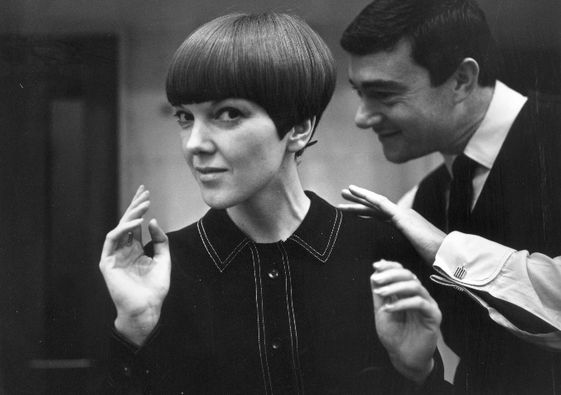
2  英國模特兒、歌手及演員崔姬穿著背心和短褲套裝，1966年。  © Photograph Terence Donovan, courtesy Terence Donovan Archive. The Sunday Times, 23 October 1966  Twiggy modelling waistcoat and shorts ensemble, 1966.  © Photograph Terence Donovan, courtesy Terence Donovan Archive. The Sunday Times, 23 October 1966 | 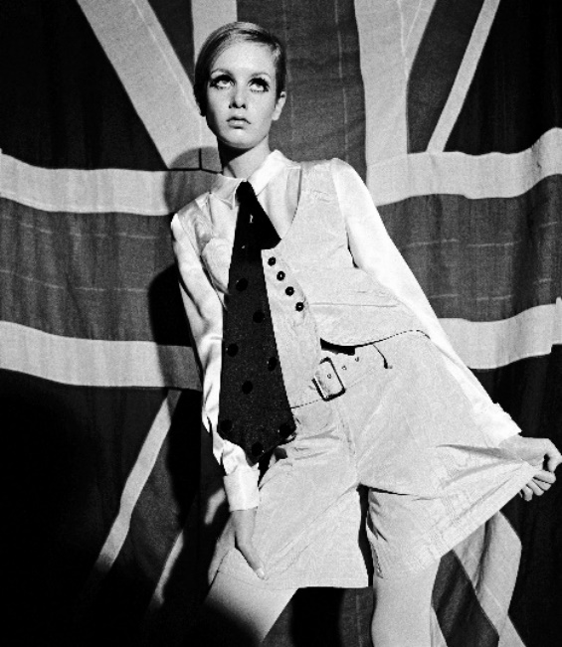
3  瑪莉官與其丈夫兼商業夥伴亞歷山大．普倫凱特．格林，1960年。  Courtesy of Terence Pepper Collection. © John Cowa n Archive  Mary Quant and Alexander Plunket Greene, 1960  Courtesy of Terence Pepper Collection. © John Cowa n Archive | 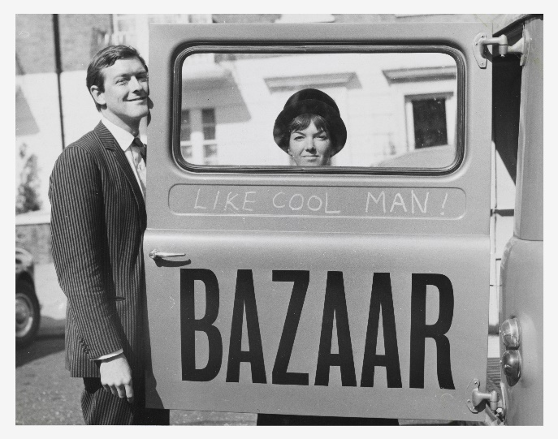
4  瑪莉官坎戈爾貝雷帽廣告，1967年。  Image courtesy of The Advertising Archives  Mary Quant Kangol beret advertisement, 1967.  Image courtesy of The Advertising Archives | 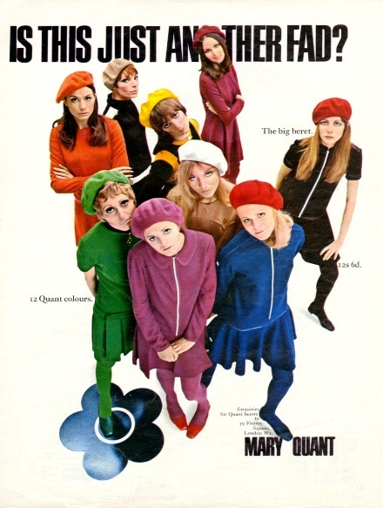
5  《搶先衛兵一步》，1961年。  Photograph by John Cowan  © John Cowan Archive  ‘Stealing a March on the Guards’, 1961.  Photograph by John Cowan  © John Cowan Archive | 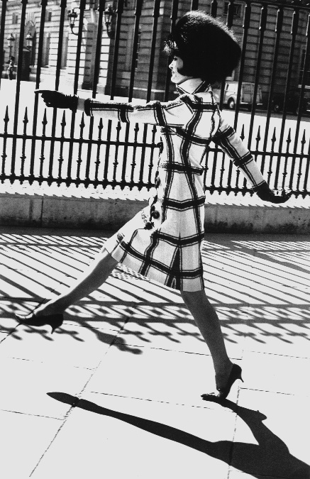
6  模特兒麗絲．丹尼斯穿著瑪莉官的雞尾酒洋裝，約1960年。  Photograph by Woburn Studios  Image courtesy Mary Quant Archive / Victoria and Albert Museum, London  Lieze Denise modelling a Mary Quant cocktail dress, about 1960.  Photograph by Woburn Studios  Image courtesy Mary Quant Archive / Victoria and Albert Museum, London | 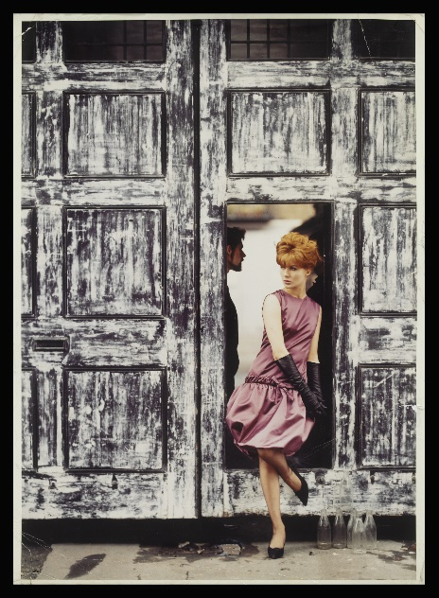
7  模特兒貝蒂．伯伊德穿著《瑪菲特小姐》與滾石樂團合影，1964年。  Photograph by John French  © John French / Victoria and Albert Museum, London  Patti Boyd modelling ‘Miss Muffet’, with the Rolling Stones, 1964.  Photograph by John French  © John French / Victoria and Albert Museum, London | 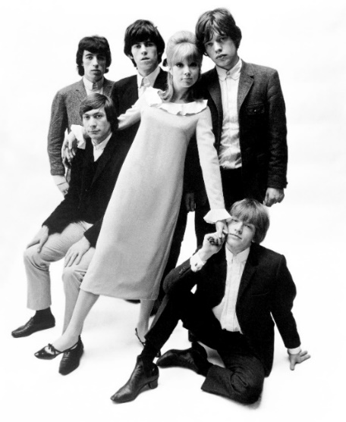
8

模特兒凱莉．威爾遜穿著襯衫裙搭配短褲，1966年。
Photo Duffy © Duffy Archive

Kellie Wilson modelling shirtdress and shorts, 1966.
Photo Duffy © Duffy Archive
9  「瑪莉官：時尚革命者」北美館展出現場。  圖像由臺北市立美術館提供。  Installation view: Mary Quant: Fashion Revolutionary, Taipei Fine Arts Museum.  Courtesy of Taipei Fine Arts Museum | 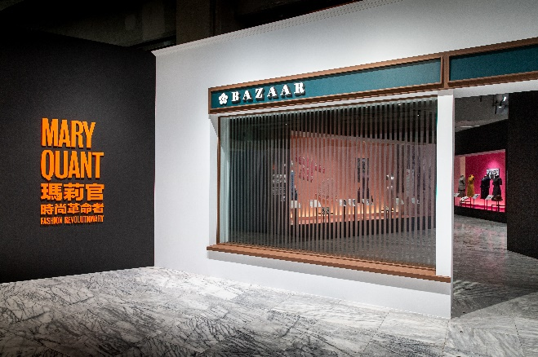
10  「瑪莉官：時尚革命者」北美館展出現場。  圖像由臺北市立美術館提供。  Installation view: Mary Quant: Fashion Revolutionary, Taipei Fine Arts Museum.  Courtesy of Taipei Fine Arts Museum | 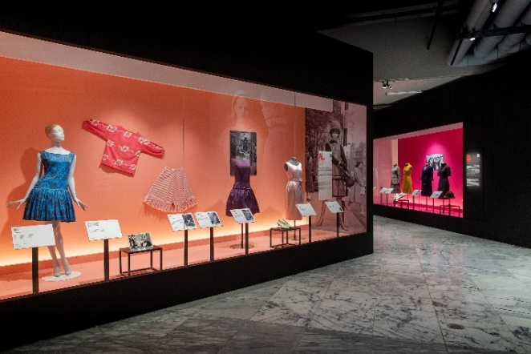
11  1960-63 翻轉男裝：瑪莉官將原本拿來製作紳士西裝或軍裝的剪裁面料，誇大演繹成輕鬆有趣的女裝。  「瑪莉官：時尚革命者」北美館展出現場。  圖像由臺北市立美術館提供。  1960-63 Subverting Menswear: Mary Quant re-interpreted cuts and materials customarily used for tailored suits or military uniforms, and applied them to relaxing, fun clothes for women.  Installation view: Mary Quant: Fashion Revolutionary, Taipei Fine Arts Museum.  Courtesy of Taipei Fine Arts Museum | 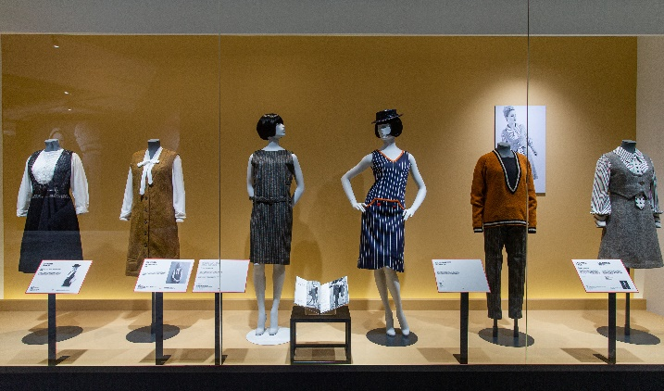
12  「瑪莉官：時尚革命者」北美館展出現場。  圖像由臺北市立美術館提供。  Installation view: Mary Quant: Fashion Revolutionary, Taipei Fine Arts Museum.  Courtesy of Taipei Fine Arts Museum | 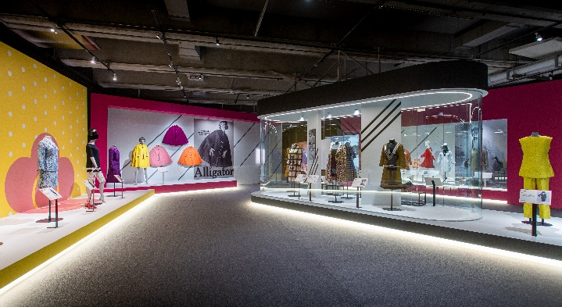
13  1960-64英式怪奇：瑪莉官將維多利亞時代的荷葉邊、立領、燈籠褲和華美印花重新運用，突顯變化的速度和其設計的現代性。而「芭札爾Bazaar」的櫥窗展示帶著假髮、姿勢奇異的假人，搭配如死去的龍蝦等道具，往往使行人駐足。  「瑪莉官：時尚革命者」北美館展出現場。  圖像由臺北市立美術館提供。  1960-64 English Eccentrics: Quant repurposed Victorian frills, stiff collars, bloomers, and florid printed patterns to highlight the pace of change and the modernity of her designs. Her bewigged mannequins strike unusual poses in Bazaar’s window displays, alongside props such as dead lobsters, often made passersby stop to stare.  Installation view: Mary Quant: Fashion Revolutionary, Taipei Fine Arts Museum.  Courtesy of Taipei Fine Arts Museum | 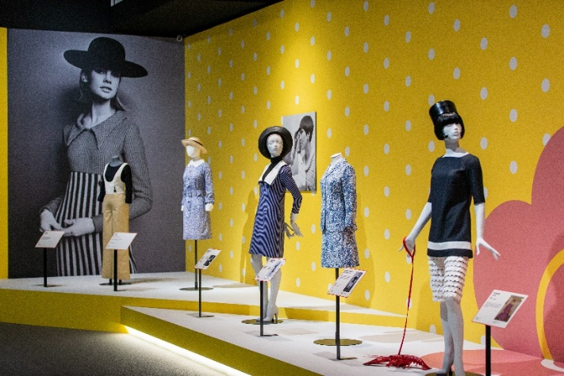
14  1963-67「激進派」品牌線。  「瑪莉官：時尚革命者」北美館展出現場。  圖像由臺北市立美術館提供。  “Ginger Group” (1963-67). Installation view: Mary Quant: Fashion Revolutionary, Taipei Fine Arts Museum.  Courtesy of Taipei Fine Arts Museum | 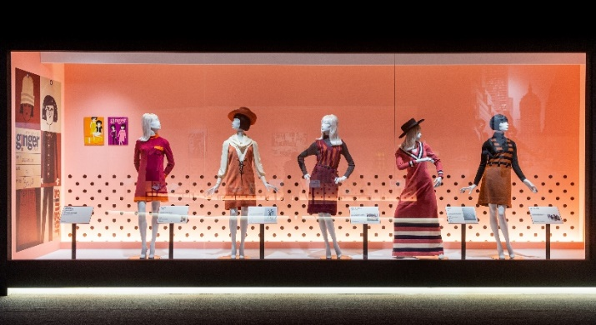
15  「短吻鱷魚牌」雨衣（1965-67）。  「瑪莉官：時尚革命者」北美館展出現場。  圖像由臺北市立美術館提供。  The collection of raincoats (1965-67) created in collaboration with Alligator Rainwear.  Installation view: Mary Quant: Fashion Revolutionary, Taipei Fine Arts Museum.  Courtesy of Taipei Fine Arts Museum. | 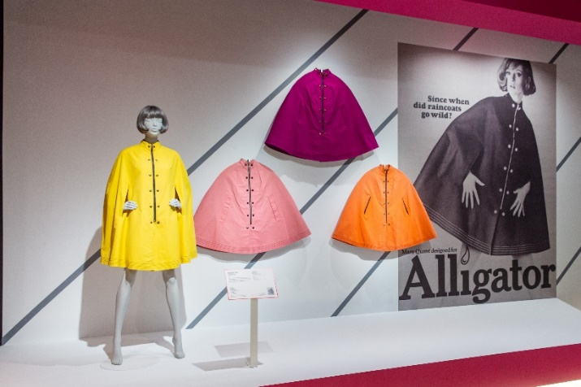
16  1966-67 針織洋裝。  「瑪莉官：時尚革命者」北美館展出現場。  圖像由臺北市立美術館提供。  1966-67 The Jersey Dress. Installation view: Mary Quant: Fashion Revolutionary, Taipei Fine Arts Museum.  Courtesy of Taipei Fine Arts Museum | 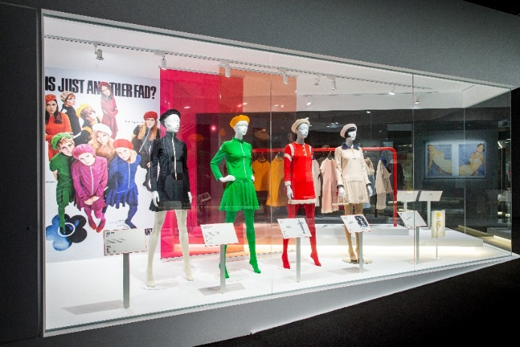
17  「瑪莉官：時尚革命者」北美館展出現場。  圖像由臺北市立美術館提供。  Installation view: Mary Quant: Fashion Revolutionary, Taipei Fine Arts Museum.  Courtesy of Taipei Fine Arts Museum | 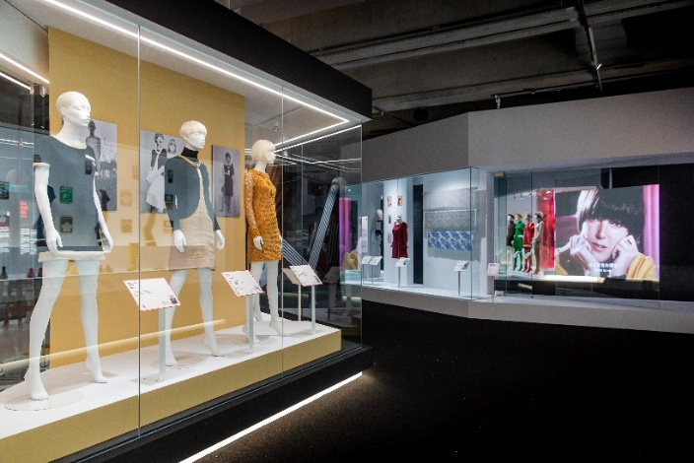
18  「瑪莉官：時尚革命者」北美館展出現場。  圖像由臺北市立美術館提供。  Installation view: Mary Quant: Fashion Revolutionary, Taipei Fine Arts Museum.  Courtesy of Taipei Fine Arts Museum | 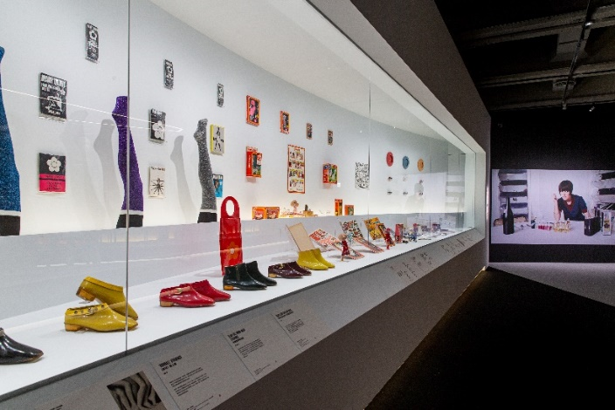
19  黛西娃娃身著迷你版瑪莉官服飾。  「瑪莉官：時尚革命者」北美館展出現場。  圖像由臺北市立美術館提供。  Daisy doll with miniature Quant outfit.  Installation view: Mary Quant: Fashion Revolutionary, Taipei Fine Arts Museum.  Courtesy of Taipei Fine Arts Museum | 