「掘光而行：洪瑞麟」媒體圖說對照表
Unearthing Light: Hung Jui-Lin | Image Sheet

圖說 | 影像
- 「掘光而行：洪瑞麟」主視覺。  洪瑞麟，《煤巷口等出坑》，1957，墨、淡彩、粉蠟筆、紙，40×54.8公分。臺北市立美術館典藏。圖像由臺北市立美術館及家屬洪鈞雄提供。  Unearthing Light: Hung Jui-Lin.  Hung Jui-Lin, Miners Waiting to Exit the Mine , 1957, ink, pigment and pastel on paper , 40×54.8 cm. Taipei Fine Arts Museum Collection. Courtesy of Taipei Fine Arts Museum and Chin C. Houng | 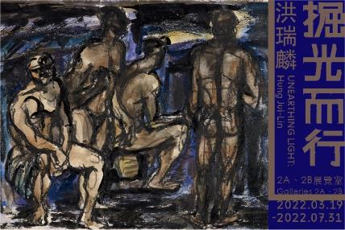
- 洪瑞麟，《自畫像》，1932，油彩、畫布，44.5×36.5公分。臺北市立美術館典藏。圖像由臺北市立美術館及家屬洪鈞雄提供。  Hung Jui-Lin, Portrait of the Artist, 1932, oil on canvas, 44.5×36.5 cm. Taipei Fine Arts Museum Collection. Courtesy of Taipei Fine Arts Museum and Chin C. Houng | 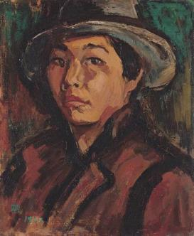
- 洪瑞麟，《父親像》，約1933，油彩、畫布， 39.5×30.5cm公分， June Hung收藏。圖像由臺北市立美術館及家屬洪鈞雄提供。  Hung Jui-Lin, Portrait of Father, c. 1933, oil on canvas, 39.5×30.5 cm. Collection of June Hung. Courtesy of Taipei Fine Arts Museum and Chin C. Houng | 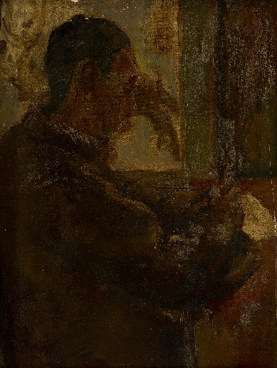
- 洪瑞麟，《日本貧民窟》，1933，油彩、畫布，73×91.5公分，臺北市立美術館典藏。圖像由臺北市立美術館及家屬洪鈞雄提供。  Hung Jui-Lin, Japanese Slum, 1933, oil on canvas, 73×91.5 cm. Taipei Fine Arts Museum Collection. Courtesy of Taipei Fine Arts Museum and Chin C. Houng. | 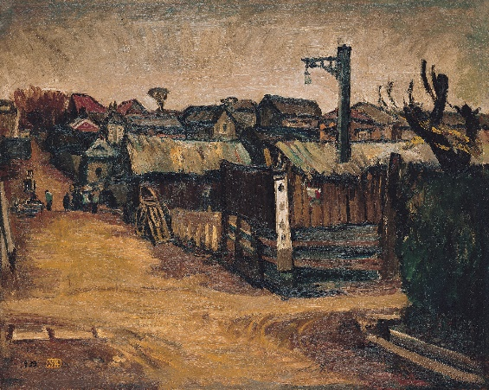
- 洪瑞麟，《山形市集》，1937，油彩、畫布， 120×162 公分，私人收藏。圖像由臺北市立美術館及家屬洪鈞雄提供。  Hung Jui-Lin, Market at Yamagata, 1937, oil on canvas, 120×162 cm. Private Collection. Courtesy of Taipei Fine Arts Museum and Chin C. Houng. | 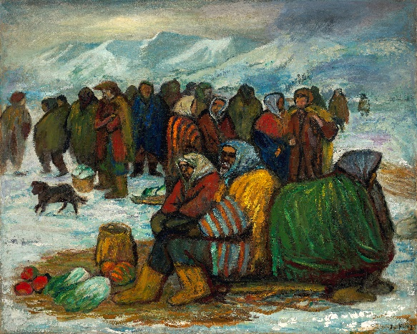
- 洪瑞麟，《臥像》，1934，油彩、畫布， 60.5×80 公分，私人收藏。圖像由臺北市立美術館及家屬洪鈞雄提供。  Hung Jui-Lin, Reclining Figure, 1934, oil on canvas, 60.5×80 cm. Private Collection. Courtesy of Taipei Fine Arts Museum and Chin C. Houng. | 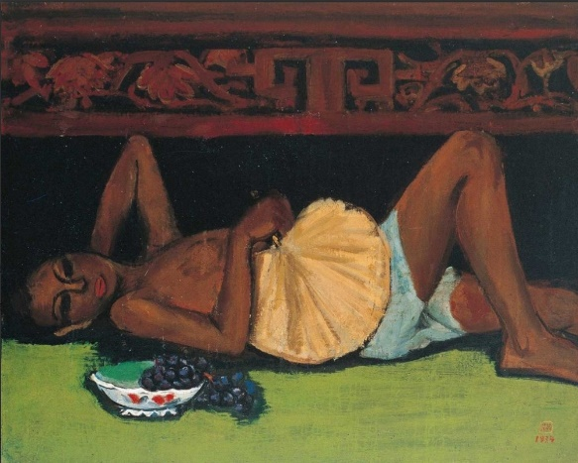
- 洪瑞麟，《坑內工作》，1954，水彩、紙， 27.4×39.2 公分，私人收藏。圖像由臺北市立美術館及家屬洪鈞雄提供。  Hung Jui-Lin, Working Inside the Mine, 1954, watercolor on paper, 27.4×39.2cm. Private Collection. Courtesy of Taipei Fine Arts Museum and Chin C. Houng. | 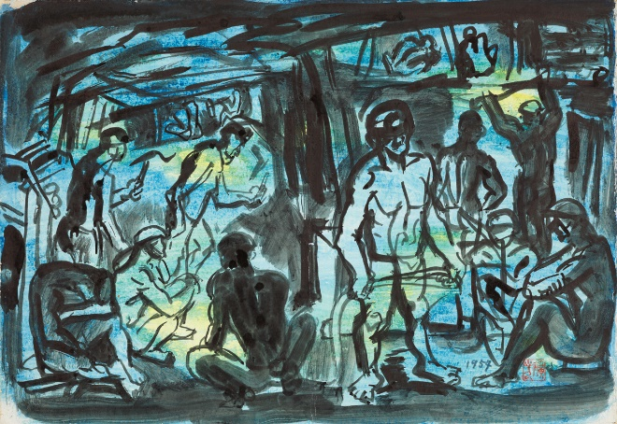
- 洪瑞麟，《長凳上的四位礦工》，1957，墨、淡彩、紙，39.8×55公分，臺北市立美術館典藏。圖像由臺北市立美術館及家屬洪鈞雄提供。  Hung Jui-Lin, Four Miners on a Bench, 1957, ink and pigment on paper, 39.8×55 cm. Taipei Fine Arts Museum Collection. Courtesy of Taipei Fine Arts Museum and Chin C. Houng. | 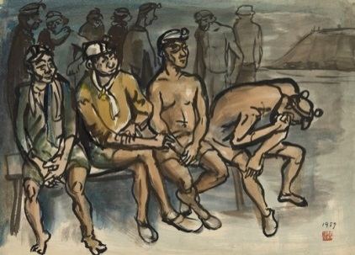
- 洪瑞麟，《敬業勤勞的阿坤伯》，1959，墨、紙， 34×23公分，國史館典藏。圖像由國史館及家屬洪鈞雄提供。  Hung Jui-Lin, Hardworking Uncle Ah-kun, 1959, ink on paper, 34×23cm. Collection of Academia Historica. Courtesy of Academia Historica and Chin C. Houng. | 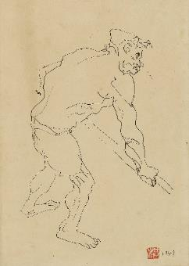
- 洪瑞麟，《坑內工作(地底之光)》，1956，油彩、紙，32×23公分，私人收藏。圖像由臺北市立美術館及家屬洪鈞雄提供。  Hung Jui-Lin, Working in the Pit (Underground Light), 1956, oil on paper, 32×23cm. Private Collection. Courtesy of Taipei Fine Arts Museum and Chin C. Houng. | 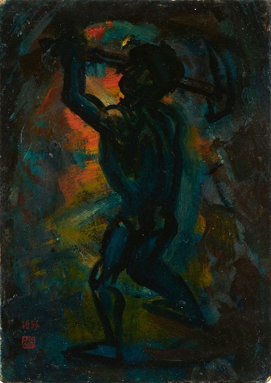
- 洪瑞麟，《礦工頌（坑內坑外）》，1965，油彩、畫布， 63×86 公分，私人收藏。圖像由臺北市立美術館及家屬洪鈞雄提供。  Hung Jui-Lin, Exalting the Miners (Inside and Outside of the Mine), 1965, oil on canvas, 63×86 cm. Private Collection. Courtesy of Taipei Fine Arts Museum and Chin C. Houng. | 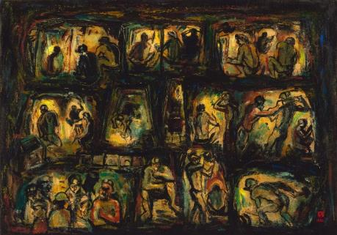
- 洪瑞麟，《畫室》，1975，墨、淡彩、紙，25 × 32公分。臺北市立美術館典藏。圖像由臺北市立美術館及家屬洪鈞雄提供。  Hung Jui-Lin, Artist's Studio, 1975, ink and pigment on paper, 38×45.3 cm. Taipei Fine Arts Museum Collection.. Courtesy of Taipei Fine Arts Museum and Chin C. Houng. | 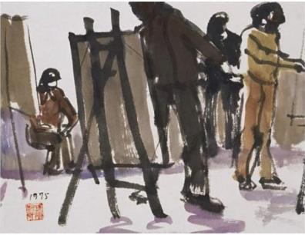
- 洪瑞麟，《原住民婦女》，1972，水彩、紙，32 ×25公分。白省三收藏。圖像由臺北市立美術館及家屬洪鈞雄提供。  Hung Jui-Lin, Indigenous Women, 1972, watercolor on paper, 26.6×38.4cm. Collection of Pai Sing-San. Courtesy of Taipei Fine Arts Museum and Chin C. Houng. | 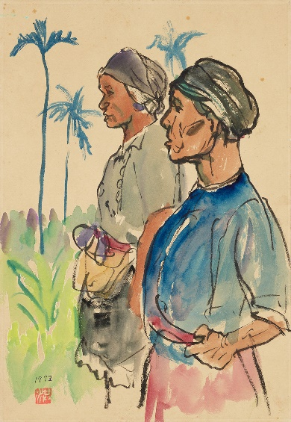
- 洪瑞麟，《彩霞滿天》，1982，油彩、畫布，65×91公分。私人收藏。圖像由臺北市立美術館及家屬洪鈞雄提供。  Hung Jui-Lin, Colorful Clouds, 1982, oil on canvas , 65×91cm. Private Collection. Courtesy of Taipei Fine Arts Museum and Chin C. Houng. | 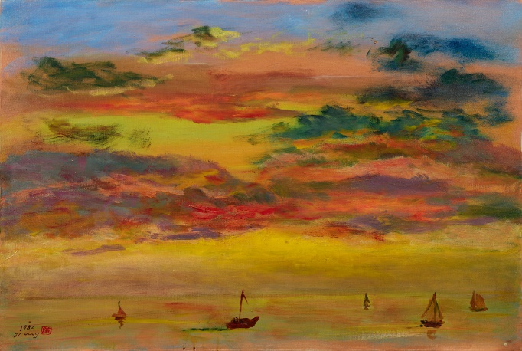
- 1950年代洪瑞麟在坑內為四位礦工畫像。  Hung Jui-Lin painting four miners in the tunnel in the 1950s. | 