「蕭麗虹捐贈記者會」
Margaret Shiu Donation Press Conference

媒體圖說 Image Caption
1  吳學讓，〈群鵝〉，1976，彩墨、紙本，35 × 45 公分，臺北市立美術館典藏。圖像由臺北市立美術館提供。  Wu Hsueh-Jang, A Gaggle of Geese, 1976, ink and pigment on paper, 35 × 45 cm. Taipei Fine Arts Museum Collection. Image courtesy of Taipei Fine Arts Museum. | 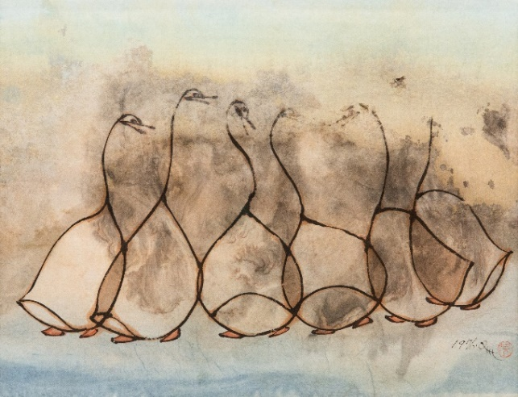
2  董陽孜，〈今人不見古時月 今月曾經照古人〉，1996，墨、紙，39 × 182公分。臺北市立美術館典藏。圖像由臺北市立美術館提供。  Tong Yang-Tze, People Today Cannot See the Moon of Ancient Times, Yet the Moon of Today Once Shone on Ancient People, 1996, ink on paper, 39 × 182 cm. Taipei Fine Arts Museum Collection. Image courtesy of Taipei Fine Arts Museum. | 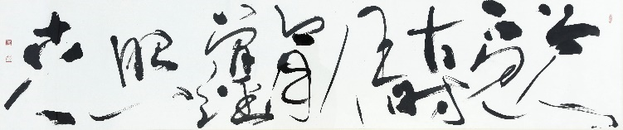
3  陳張莉，〈雲與山的對話〉，1995，油彩、畫布，30 × 30公分，臺北市立美術館典藏。圖像由臺北市立美術館提供。  Jenny Chen, Dialouge Between Clouds and Mountains, 1995, oil on canvas, 30× 30 cm. Taipei Fine Arts Museum Collection. Image courtesy of Taipei Fine Arts Museum. | 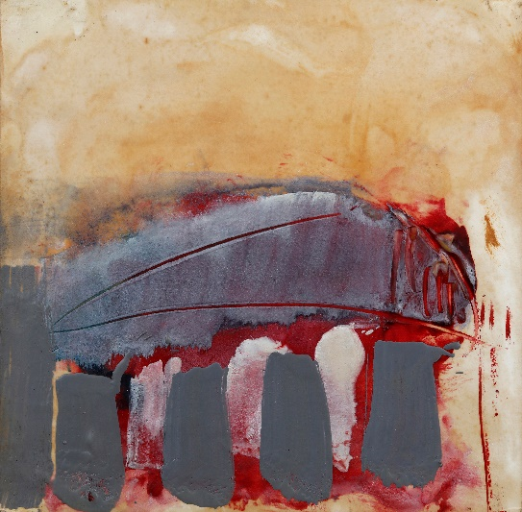
4  莊普，〈水泥中的花朵〉，2010，卡點西德、壓克力顏料、不鏽鋼、石頭，依場地而定，臺北市立美術館典藏。圖像由臺北市立美術館提供。  Tsong Pu, Flowers within Concrete, 2010, vinyl lettering, acrylic paint, stainless steel, stone, dimensions variable. Taipei Fine Arts Museum Collection. Image courtesy of Taipei Fine Arts Museum. | 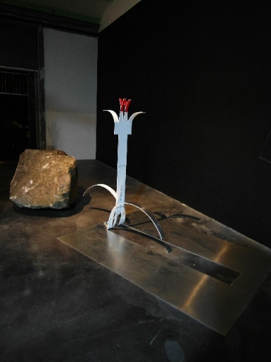
5  賴純純，〈行雲流水篇〉，1991，墨、壓克力顏料、竹紙，79 × 28公分。臺北市立美術館典藏。圖像由臺北市立美術館提供。  Jun T. Lai, Drifting Clouds and Flowing Water, 1991, ink, acrylic paint, bamboo paper, 79 × 28 cm. Taipei Fine Arts Museum Collection. Image courtesy of Taipei Fine Arts Museum. | 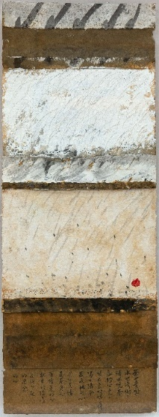
6  陳文祥，〈實物聖母抱嬰#02〉，2010，塑膠袋、金屬夾、紙，57 × 42公分。臺北市立美術館典藏。圖像由臺北市立美術館提供。  Chen Wen-Hsiang, Ready-Made Virgin and Child II, 2010, plastic bag, metal clip, paper, 57 × 42 cm. Taipei Fine Arts Museum Collection. Image courtesy of Taipei Fine Arts Museum. | 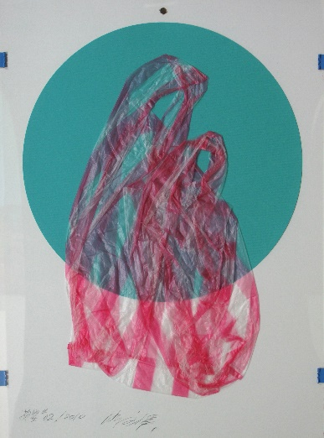
7  吳瑪悧，〈咬文絞字-Pop Art, Art Nouveau〉，1993，壓克力、碎紙，21 × 16 × 10公分，臺北市立美術館典藏。圖像由臺北市立美術館提供。  Wu Mali, Gnawing Texts, Reaming Words, 1993, acrylic, shredded paper, 21 × 16 × 10cm. Taipei Fine Arts Museum Collection. Image courtesy of Taipei Fine Arts Museum. | 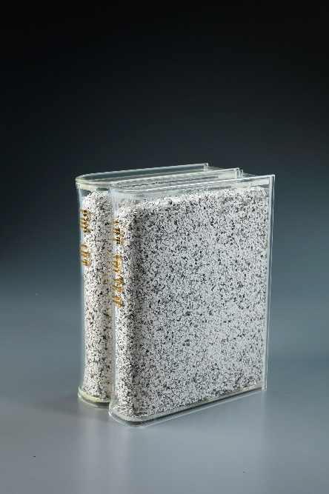
8  陳順築，〈白色的傳統〉，1992，攝影、木框，43 × 30 × 6公分，臺北市立美術館典藏。圖像由臺北市立美術館提供。  Chen Shun-Chu, White Tradition, 1992, acrylic, photograph, wooden frame, 43 × 30 × 6cm. Taipei Fine Arts Museum Collection. Image courtesy of Taipei Fine Arts Museum. | 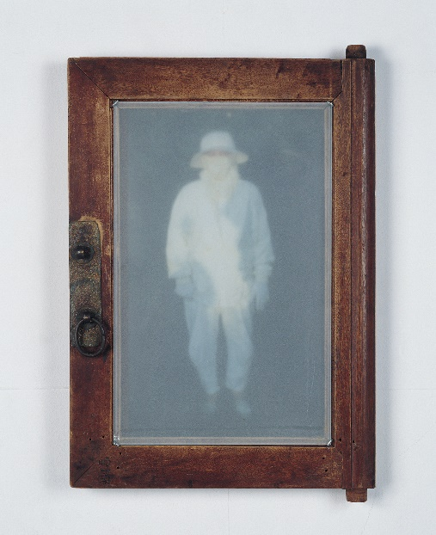
9  石晉華，〈雄獅計劃〉，1993，雜誌、簽字筆，45 × 189 × 7公分，臺北市立美術館典藏。圖像由臺北市立美術館提供。  Shi Jin-Hua, Lion Art Magazine Project, 1993, marker on magazines, 45 × 189 × 7cm. Taipei Fine Arts Museum Collection. Image courtesy of Taipei Fine Arts Museum. | 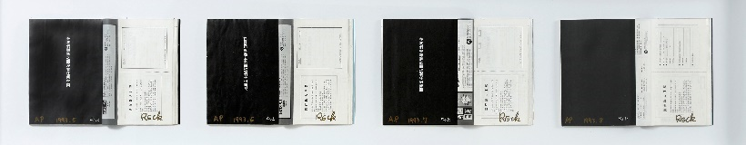
10  陳慧嶠，〈默照〉，1992，針、銀蔥線、樹脂棉，148 × 179 × 7公分，臺北市立美術館典藏。圖像由臺北市立美術館提供。  Chen Hui-Chiao, Silent, 1992, needles, thread, cotton, 148 × 179 × 7cm. Taipei Fine Arts Museum Collection. Image courtesy of Taipei Fine Arts Museum. | 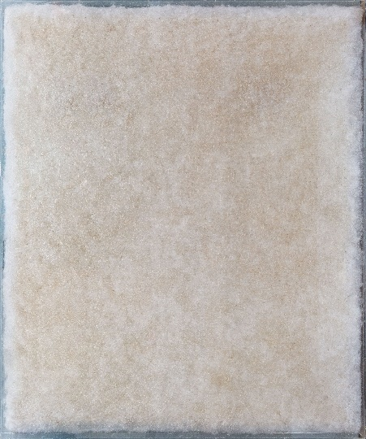
11  姚瑞中，〈兩粒一百（臨 吳彬「羅漢圖」及文徵明「蕉蔭仕女圖」）〉，2007，手工紙本設色、金箔，70 × 100公分，臺北市立美術館典藏。圖像由臺北市立美術館提供。  Yao Jui-Chung, 2 for 100 NTD (Homage to Wu Bin's Portrait of Luohan and Wen Cheng-ming's Lady in the Shade of a Plantain Tree), 1992, handmade paper, ink, gold leaf, 70 × 100cm. Taipei Fine Arts Museum Collection. Image courtesy of Taipei Fine Arts Museum. | 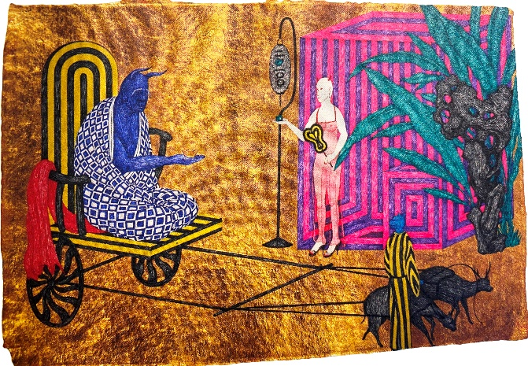
12  王德瑜，〈No. 80-1〉，2015，布料、塑膠氣袋，50 × 50 × 50公分，臺北市立美術館典藏。圖像由臺北市立美術館提供。  Wang Te-Yu, No. 80-1, 2015, fabric and plastic airbag, 50 × 50 × 50cm. Taipei Fine Arts Museum Collection. Image courtesy of Taipei Fine Arts Museum. | 