北美館舉行典藏庫房新建工程動土典禮 預計於2024年啟用
TFAM Breaks Ground for New Collections Vault, Set to Open in 2024

圖說 | 影像
1  鳥瞰本館與新建典藏庫房，模擬示意圖。  臺北市立美術館提供。  Simulation of TFAM and the new collections vault (Aerial view).  Courtesy of Taipei Fine Arts Museum. | 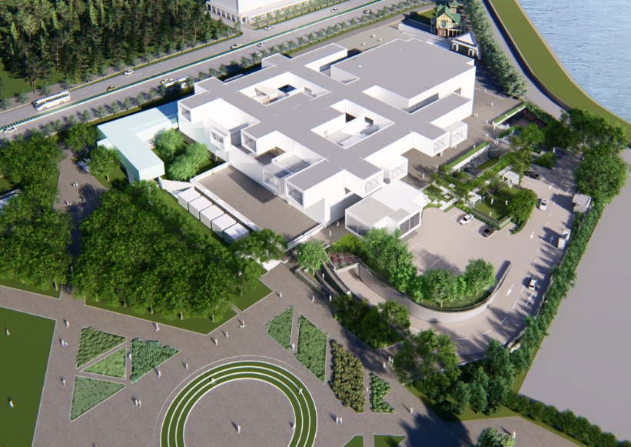
2  臺北市立美術館典藏庫房新建案獲選方案，模擬示意圖（由基隆河方向鳥瞰）  臺北市立美術館提供。  Selected tender of the new collections vault for TFAM. Computer simulation (Aerial view from Keelung River).  Courtesy of Taipei Fine Arts Museum. | 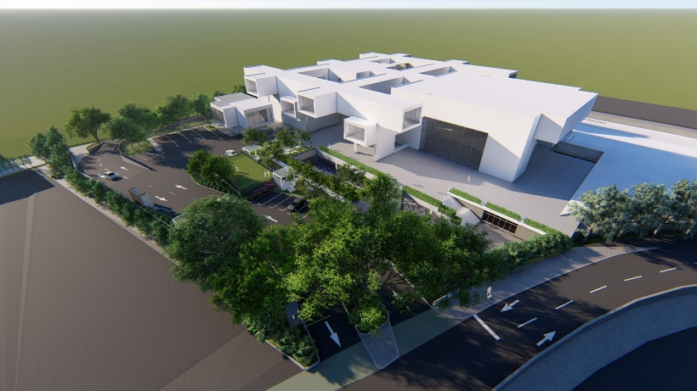
3  臺北市立美術館典藏庫房新建案獲選方案，模擬示意圖（俯視圖）  臺北市立美術館提供。  Selected tender of the new collections vault for TFAM. Computer simulation (Top view).  Courtesy of Taipei Fine Arts Museum | 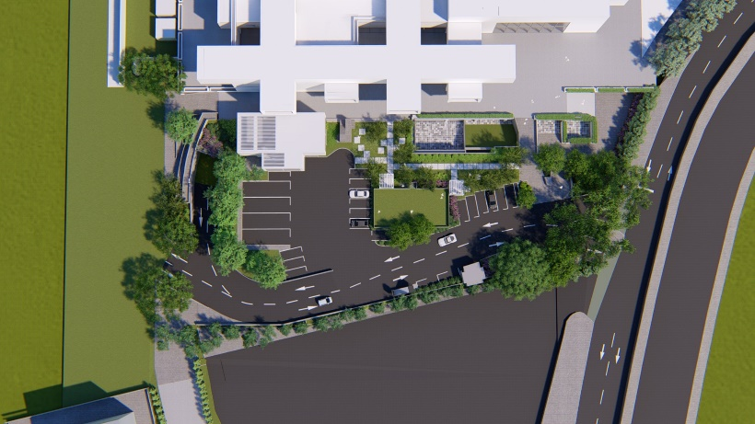
4  臺北市立美術館典藏庫房新建案獲選方案，模擬示意圖（停車場側景色）  臺北市立美術館提供。  Selected tender of the new collections vault for TFAM. Computer simulation (View from the parking lots side)  Courtesy of Taipei Fine Arts Museum | 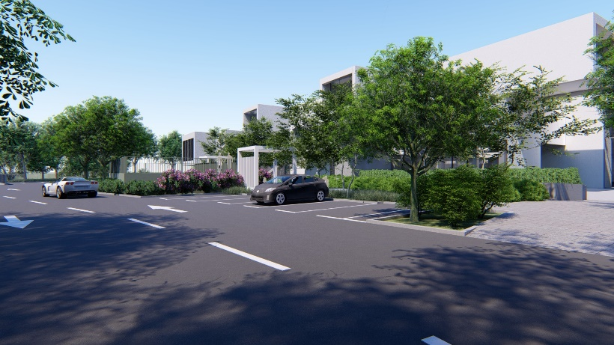
5  臺北市立美術館典藏庫房新建案獲選方案，模擬示意圖（本館入口東側景色）。  臺北市立美術館提供。  Simulation of the green rest areas above the new collections vault (View from the east side of the main museum entrance).  Courtesy of Taipei Fine Arts Museum | 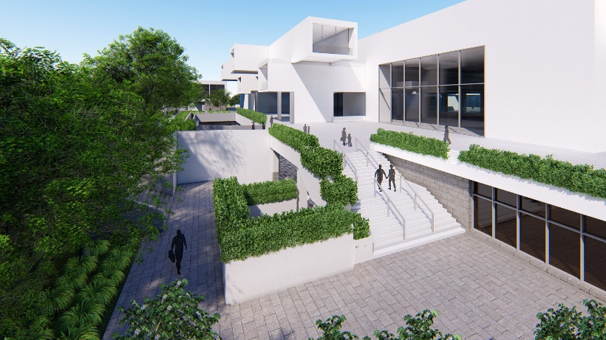
6  新建典藏庫房延伸北美館入口廣場東側空間模擬示意圖。  臺北市立美術館提供。  Simulation of the areas between the east side of the museum plaza and the new collections vault.  Courtesy of Taipei Fine Arts Museum | 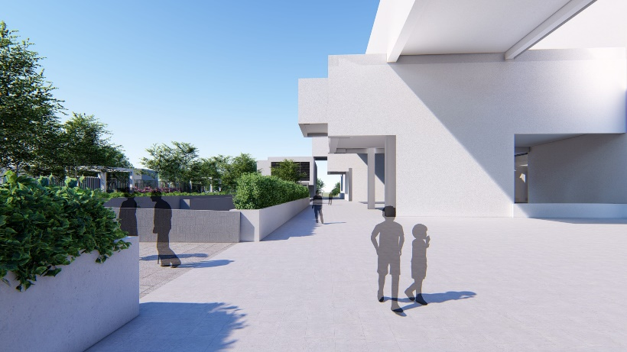
7  新建典藏庫房地面層景觀設計模擬示意圖。  臺北市立美術館提供。  Simulation of the green rest areas above the new collections vault.  Courtesy of Taipei Fine Arts Museum | 