Taipei Fine Arts Museum Press Release
FOR IMMEDIATE RELEASE
Media Contact | Yu-mei Sung (yumei-tfam@mail.taipei.gov.tw)  Tzu-chin Kao (tckao-tfam@mail.taipei.gov.tw )


Art Histories of a Forever War: Modernism between Space and Home
Oct 16, 2021 to Feb 20, 2022
Galleries 2A, 2B, Taipei Fine Arts Museum, Taiwan.

Press kit

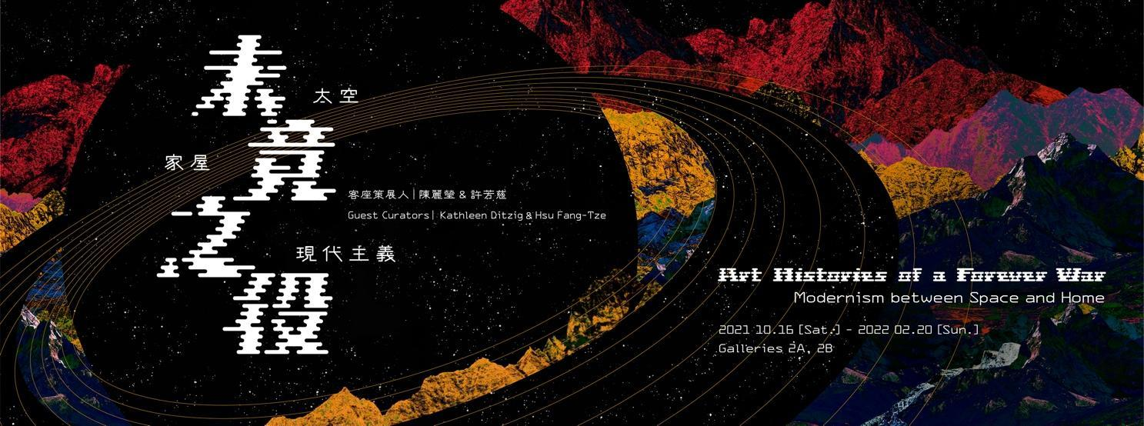

Art Histories of a Forever War: Modernism between Space and Home,
Exploring Relationships between Cold War Histories of Technology and Modern Art from post-war Taiwan

With artworks by CHEN Chi-Kuan, CHEN Ting-Shih, CHIN Sung, CHO Chung-Yung, HAN Hsiang-Ning, HSIA Yan, HSIAO Chin, LEE Shi-Chi, LI Yuan-Chia, LIU Kuo-Sung, LONG Chinsan, MA Shou-Hua, RAN In-Ting, SHAIH Lifa, WANG Da-Hong, YANG Yuyu, YEN Shui-Long;

Contemporary art projects by Erika TAN (Singapore/United Kingdom), Sung TIEU (Vietnam/Germany), Maria TANIGUCHI (Philippines), CHEN Yin-Ju (Taiwan), Prajakta POTNIS (India), Aya RODRIGUEZ-IZUMI (Okinawa/USA), Doris WONG Wai Yin (Hong Kong), YEE I-Lann (Borneo), Writing FACTory (Taiwan) in collaboration with Joy HO (Singapore) and Joanne HO (Singapore).

The Taipei Fine Arts Museum (TFAM) is delighted to present Art Histories of a Forever War: Modernism between Space and Home, which will run from October 16, 2021 to February 20, 2022. Curated by guest curators Kathleen DITZIG (Singapore) and HSU Fang-Tze (Taiwan), the exhibition features modernist classics from TFAM’s permanent collection presented alongside artworks loaned from contemporary artists and archival materials from Taiwan and around the world.

With the Cold War as its analytical point of departure, the exhibition examines the resonances of the Space Race and the idea of Asian modern art and design upon the development of the Chinese Modern Art movement from Taiwan. In addition to exhibiting artworks, the exhibition also showcases different historical materials that together constellate the development of modern art in Taiwan as part of a global history. The exhibition addresses the complex contexts that inform this history through examining the effects of the Space Race, United States Foreign aid projects and aesthetic networks of the Free World.

The exhibition is organized through three interwoven themes – “Cosmotechnics after the Space Race,” “Global Domestic” and “Aesthetic Networks of the Free World.” “Cosmotechnics after the Space Race” focuses on how the moon landing resonated with canonical modern artists – CHIN Sung, HAN Hsiang-Ning, HSIAO Chin, LEE Shi-Chi, LI Yuan-Chia, LIU Kuo-Sung, YANG Yuyu, and architects, CHEN Chi-Kuan and WANG Da-Hong. This section of the exhibition brings together works that not only celebrated the moon landing but also registered a philosophical and perspectival shift in Chinese modern art. Presented in dialogue and thus pointing to an enduring cosmic art historical imagination, Taiwan-based contemporary artist CHEN Yin-Ju’s installation Extrastellar Evaluations (2016) posits a speculative historiography of the 1960s.

“Global Domestic” takes an expanded view of the United States foreign aid projects that seeded an idea of Asian modern art and design. The exhibition explores how Taiwan modern art works and craft found a place in the modern home. It features crystals engraved with ink paintings and calligraphy by Taiwan artists RAN In-Ting, CHO Chung-Yung and MA Shou-Hua and archival materials related to US supported promotion of craft from Taiwan and the region. The exhibition also presents examples of how the Cold War construction of the modern home and its domestic interiors was extrapolated as a motif in the works of modern artists from Taiwan, such as LONG Chinsan, CHEN Chi-Kuan and HSIA Yan.

Presented in dialogue with these works, contemporary artworks such as YEE I-Lann’s The Tinukad Sequence 02 (2021), a large bamboo woven mat by female indigenous weavers from Sabah and Maria TANIGUCHI’s brick paintings and video Untitled (Celestial Motors) (2012), which celebrates the glimmering modern form of the jeepney, raise compelling and critical questions about the insidious neo-colonial underpinnings of modern art and design. Doris WONG Wai Yin’s Being Dead Will Be Our Only Shared Identity (2016), with family portraits of a mother pushing a pram with a gas mask on, extends this inquiry to historical constructions of domesticity and family relations. Erika TAN’s expansive installation Barang-Barang (2021) speculatively imagines a meeting between four female artists: Dora GORDINE, Georgetta CHEN, Kim LIM and her mother, Fay TAN, and reflects upon the enduring historical and personal entanglements between the objects we inherit and the art histories we write.

“Aesthetic Networks of the Free World,” reviews modern artists from Taiwan and their development of an international language of modern Chinese art as they navigated the Cold War aesthetic networks of US-aligned countries. From Harvest (1951 -), a fortnightly magazine focusing on agricultural affairs to the Punto International Art Movement that was co-founded by LI Yuan-Chia and HSIAO Chin and other international artists to artworks by RAN In-Ting, CHEN Chi-Kuan, and YANG Yuyu, the exhibition illustrates the myriad ways in which modern artists from Taiwan evolved their artistic styles between the 1950s and the 1970s as they developed individualistic artistic languages based on traditional Chinese philosophies that critically responded to Western modern aesthetics.

Contemporary artworks and research-based projects in the exhibition reflect upon the persistent ambience of Cold War aesthetic networks today. Prajakta POTNIS’ installation Kitchen Debate (2014- ) captures an anxiety inherent to the everyday and domestic experiences that emerged from the Cold War. Okinawan-American artist Aya RODRIGUEZ-IZUMI’s installation Echoes from the Last Battle (2017- ), inspired by a book illustrated by her father that portrays survivors’ accounts from the Battle of Okinawa, and Sung TIEU’s installations, respectively titled Exposure to Havana Syndrome, Brain Anatomy, Coronal Plane (Sample 1-12) (2021) and Songs for Unattended Items (2018), reveal the psychic traces of wars of the 20th Century in everyday objects and sonic traces that bring history into the contemporary. In Exposure To Havana Syndrome these traces even promise to re-shape the brain.

Responding to the exhibition and the modern artworks it presents, a specially commissioned digital art work in the form of a web-based graphic novel, New Earth No. 3069, by Joy HO, Joanna HO and Writing FACTory, tells the story of an expedition to establish a colony in outer space in a future when the nation state no longer exists and the last resources of the universe are governed by a mega enterprise called ‘The Company’.

Art Histories of a Forever War is as much an inquiry into the interrelations between a global cultural Cold War and Taiwan art history as it is an artistic investigation of the persistent legacies of this longue durée, a forever war that endures in the art histories we write and the objects we populate our lives with. How did modern space technologies rewire modern art and our perspective of the world? What does the trajectory of a modern artist from Taiwan tell us about our shared visions of the world? How much is a personal family history rewritten by the broad strokes of world history? What agency does the artwork have in writing over the lacunas of history? In the face of renewed geopolitical interests in Taiwan, post-human visioning, governance models enabled by planetary computation and a climate crisis that demands a new shared global vision for our future, these questions, while historically rooted, are perhaps more contemporary and urgent than they sound.

