「感性機器：後資本主義時代的自我療癒」媒體圖說對照表
Affect Machine: Self-healing in the Post-Capitalist Era | Image Sheet

圖說 | 影像
- 「感性機器：後資本主義時代的自我療癒」主視覺。臺北市立美術館提供。  Affect Machine: Self-healing in the Post-Capitalist Era  Courtesy of Taipei Fine Arts Museum. | 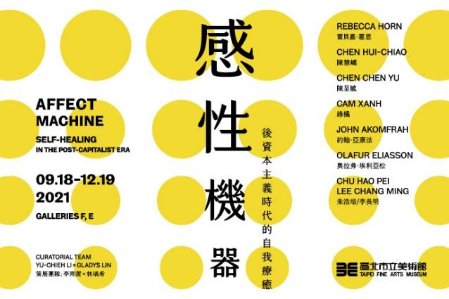
- 雷貝嘉．霍恩，《行為2》行為紀錄影像選段《鉛筆面具》，1972， 16釐米影像轉DVD，彩色，有聲。圖像由藝術家提供。作品鳴謝霍恩藝術家文獻庫。  Rebecca Horn, excerpts from Performances 2: Pencil Mask, 1972, film still from Performances II, 16mm film transferred to video, colour, sound. Courtesy of the artist. ©Archive Rebecca Horn. | 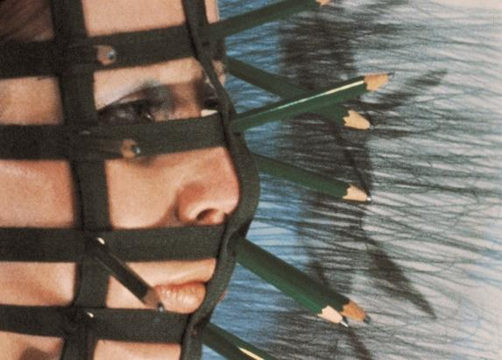
- 雷貝嘉．霍恩，《行為2》行為紀錄影像選段《雞羽毛面具》，1973， 16釐米影像轉DVD，彩色，有聲。英國倫敦泰德現代美術館典藏。圖像由藝術家與臺北市立美術館提供。  Rebecca Horn, excerpts from Performances 2: Cockfeather Mask, 1973, film still from Performances II, 16mm film transferred to video, colour, sound. Collection of Tate Modern in London. Courtesy of the artist and Taipei Fine Arts Museum. | 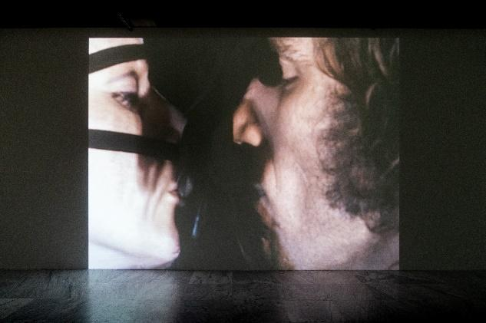
- 雷貝嘉．霍恩，《陽光之嘆》，2006，小提琴、玻璃、馬達、鋼、電器、色粉，68×44×78.5公分。圖像由藝術家與臺北市立美術館提供。  Rebecca Horn, Der Sonnenseufzer  (Sigh of Sun), 2006, violin, glass, motor, steel, electronics, yellow pigment, flame-worked glass. 68×44×78.5 cm. Courtesy of the artist and Taipei Fine Arts Museum. | 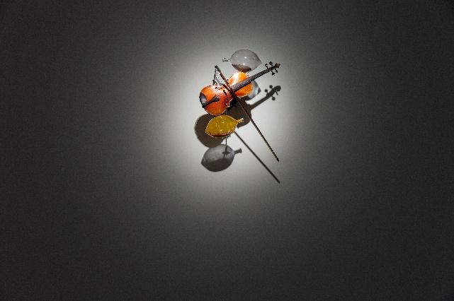
- 5-1  陳慧嶠，《床外的藍天》，2018，混合媒材（針線、行軍床、毛巾電繡、臉盆、鋼杯、牙膏、牙刷、肥皂盒），共16件，每件尺寸為 90×200×140公分。圖像由藝術家與臺北市立美術館提供。  Chen Hui-Chiao, A Room with a View, 2018, mixed mediums (needles, thread, military cots, embroidered towels, basins, toothbrushes, toothpaste, steel cups), 16 Pieces, 90×200×140cm each. Courtesy of the artist and Taipei Fine Arts Museum. | 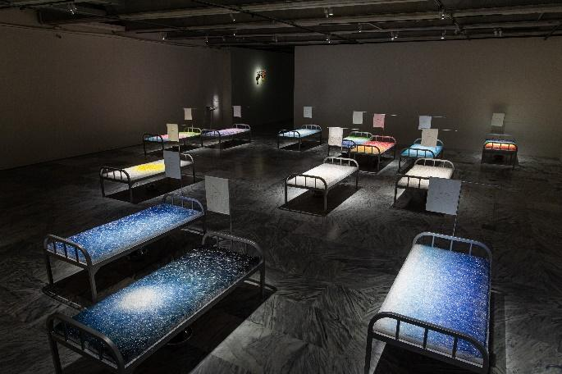
5-2  陳慧嶠，《床外的藍天》（局部），2018，混合媒材（針線、行軍床、毛巾電繡、臉盆、鋼杯、牙膏、牙刷、肥皂盒），共16件，每件尺寸為 90×200×140公分。圖像由藝術家與臺北市立美術館提供。  Chen Hui-Chiao, A Room with a View (partial), 2018, mixed mediums (needles, thread, military cots, embroidered towels, basins, toothbrushes, toothpaste, steel cups), 16 Pieces, 90×200×140cm each. Courtesy of the artist and Taipei Fine Arts Museum. | 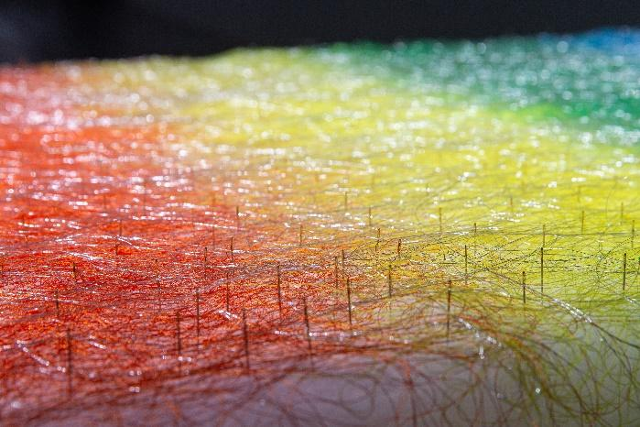
- 6-1、6-2  陳呈毓，《舒緩震盪》，2021，混合媒材（鐵架、鋼管、雕塑、發泡劑、矽膠、樹脂、明膠、羊皮、震動器、織品）、雙頻道錄像，60分鐘，尺寸視空間而定。表演者：LazyMiu.ASMR。圖像由藝術家與臺北市立美術館提供。  Chen Chen Yu, Here Each Vibration Long Away, 2021, mixed mediums (iron structure, sculptures, expanded PU foam, silicone rubber, resin, hide glue, goat skin, exciters, textile), 2-channel video, 60 minutes, dimensions variable. Performer: LazyMiu.ASMR,, Courtesy of the artist and Taipei Fine Arts Museum. | 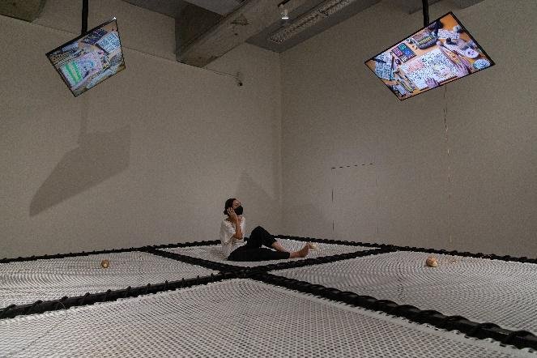  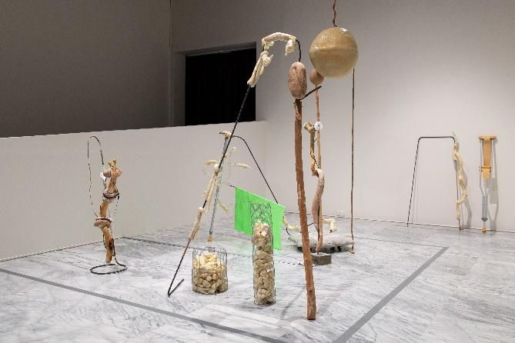
6-3  陳呈毓，《舒緩震盪》（影像截圖），2021，雙頻道錄像，60分鐘。表演者：LazyMiu.ASMR。圖像由藝術家提供。  Chen Chen Yu, Here Each Vibration Long Away (Film still), 2021, 2-channel video, 60 minutes. Performer: LazyMiu.ASMR,  Courtesy of the artist. | 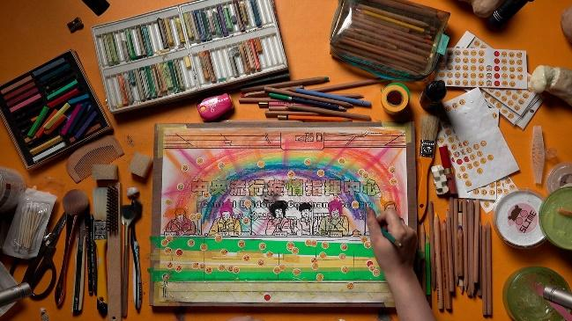
- 7-1  綠橘，《太初有道》（局部），2020-2021，壓克力箱、5000-6000蠶繭，60×60×15公分。  圖像由藝術家與臺北市立美術館提供。  Cam Xanh, In the Beginning Was the Word (partial), 2020-2021, plexiglass box containing 5000-6000 silk cocoons, 60×60×15cm. Courtesy of the artist and Taipei Fine Arts Museum. | 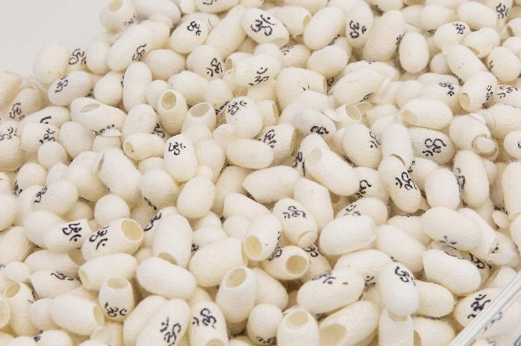
7-2
綠橘，《資訊—人類基因之IXX染色體段落，上帝發布神聖計畫…》（局部），2020-2021，壓克力板浮雕，60×60×3公分。
圖像由藝術家與臺北市立美術館提供。
Cam Xanh, Information — and in the Human Genome, Chromosomes Chapter IXX, the Lord
speaks to us of His divine plan, saying…(partial), 2020-2021,engraved plexiglass, 60×60×3cm. Courtesy of the artist and Taipei Fine Arts Museum.
- 8-1  約翰．亞康法，《機場》，2016，三頻道錄像裝置，7.1聲道，53分鐘。圖像由藝術家與臺北市立美術館提供。  John Akomfrah, The Airport, 2016, three channel HD colour video installation, 7.1 sound, 53 minutes. Courtesy of the artist and Taipei Fine Arts Museum. | 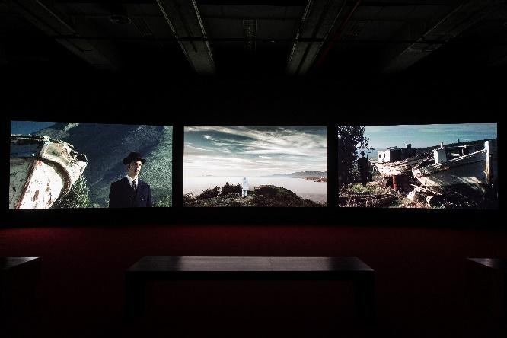
8-  約翰．亞康法，《機場》（影像截圖），2016，三頻道錄像裝置，7.1聲道，53分鐘。© Smoking Dogs Films，圖像由 Smoking Dogs Films和里森畫廊提供。  John Akomfrah, The Airport (Film still), 2016, three channel HD colour video installation, 7.1 sound, 53 minutes.© Smoking Dogs Films; Courtesy of Smoking Dogs Films and Lisson Gallery. | 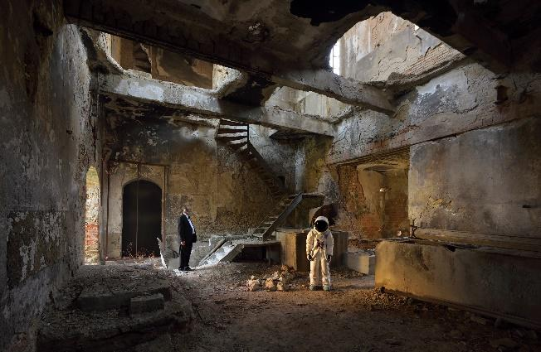
- 9-1、9-2  奧拉弗．埃利亞松，《指北針家族》，2013，不銹鋼、木頭、磁鐵、顏料，共三件（直徑各為61×30公分，193×50.5公分，90公分）。圖像由藝術家與臺北市立美術館提供。  Olafur Eliasson, Compass family, 2013, Stainless steel, wood, magnets, paint, 61×30cm, 193×50.5cm, 90cm in diameter. Courtesy of the artist and Taipei Fine Arts Museum. | 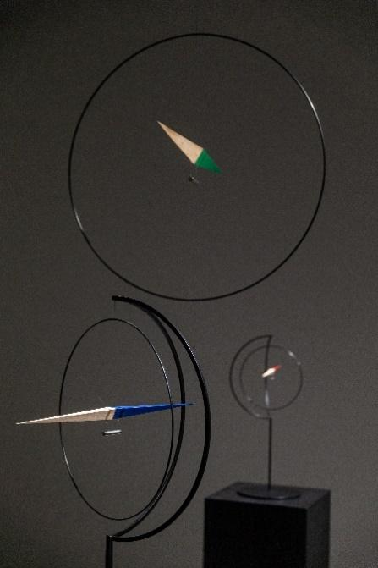  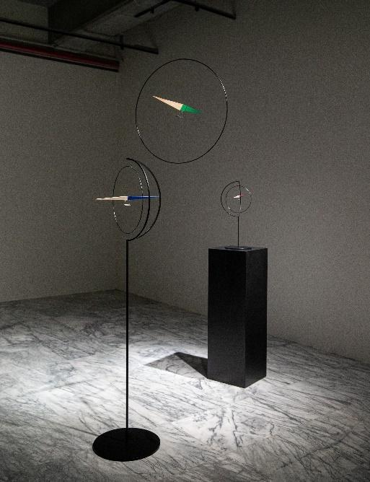
- 10-1  朱浩培/李長明，《菩提與榕之下》，2018，混合媒材（過期膠卷及數位輸出、壓克力板、鋁板、文件），尺寸視空間而定。圖像由藝術家與臺北市立美術館提供。  Chu Hao Pei and Lee Chang Ming, Beneath the Bodhi and Banyan, 2018, mixed mediums (expired film stock, digital prints, acrylic and aluminium boards, documents), dimensions variable. Courtesy of the artist and Taipei Fine Arts Museum. | 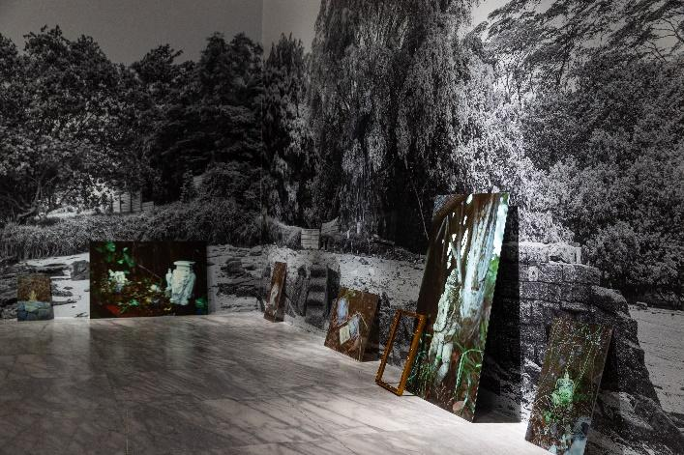
10-2  朱浩培/李長明，《菩提與榕之下》（局部），2018，混合媒材（過期膠卷及數位輸出、壓克力板、鋁板、文件），尺寸視空間而定。圖像由藝術家提供。  Chu Hao Pei and Lee Chang Ming, Beneath the Bodhi and Banyan (partial), 2018, mixed mediums (expired film stock, digital prints, acrylic and aluminium boards, documents), dimensions variable. Courtesy of the artist. | 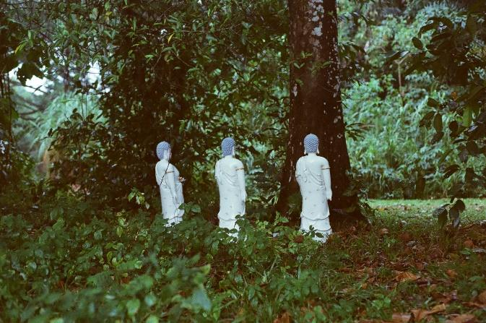
- 「感性機器：後資本主義時代的自我療癒」展場，2021，圖像由臺北市立美術館提供。  Affect Machine: Self-healing in the Post-Capitalist Era, 2021. Courtesy of Taipei Fine Arts Museum. | 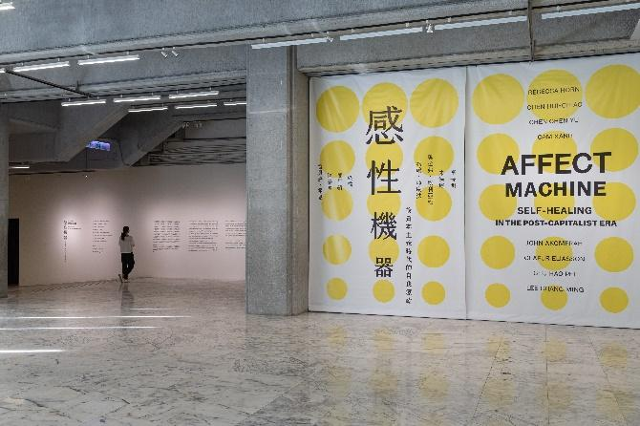
- 策展團隊林瑀希(左)、臺北市立美術館館長王俊傑(中)、李雨潔(右)合影。©臺北市立美術館  Curatorial team Gladys Lin (M), Director of Taipei Fine Arts Museum Wang Jun-Jieh (L) and Curatorial team Yu-Chieh Li (R). Courtesy of Taipei Fine Arts Museum. | 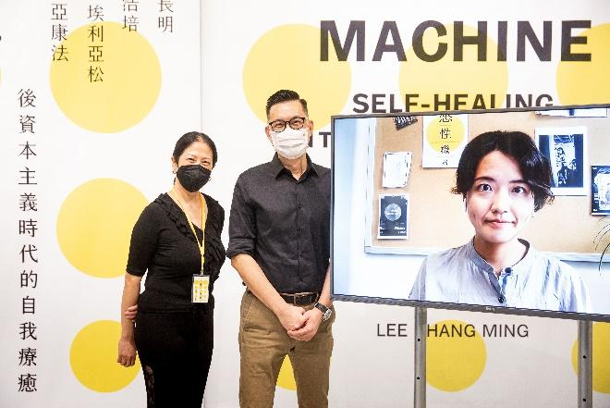
- 藝術家陳呈毓、藝術家陳慧嶠、臺北市立美術館館長王俊傑、策展團隊林瑀希、李雨潔(左至右)合影。©臺北市立美術館  Artist Chen Chen Yu and Chen Hui-Chiao, Director of Taipei Fine Arts Museum Wang Jun-Jieh, Curatorial team Gladys Lin and Yu-Chieh Li (from L to R). Courtesy of Taipei Fine Arts Museum. | 