Taipei Fine Arts Museum Press Release
FOR IMMEDIATE RELEASE
Media Contact | Yu-mei Sung (yumei@tfam.gov.tw)  Tzu-chin Kao (tckao@tfam.gov.tw)


Shiota Chiharu: The Soul Trembles
Curated by Mami Kataoka
May 1 to August 29, 2021
Galleries 1A, 1B, Taipei Fine Arts Museum, Taiwan. Press kit
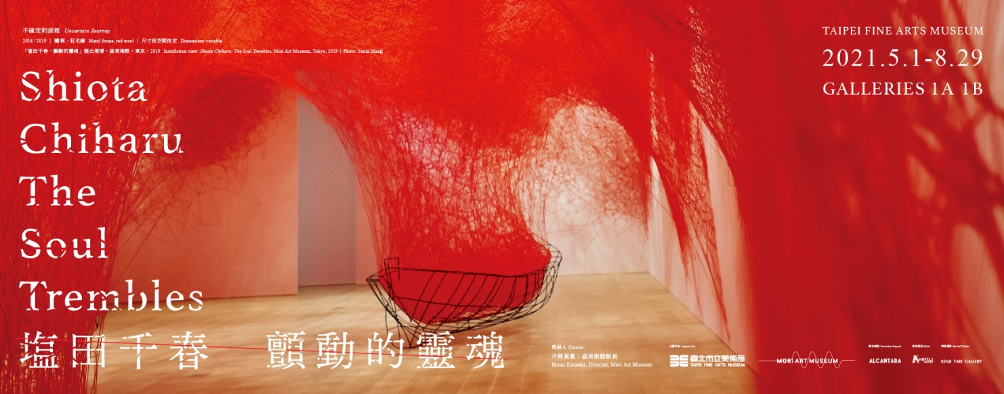
International Art Star Shiota Chiharu's Largest Retrospective Exhibition
—Causing a Sensation at TFAM
Shiota Chiharu: The Soul Trembles will be presented at the Taipei Fine Arts Museum from May 1 to August 29, 2021. Curated by the director of Tokyo's Mori Art Museum, Mami Kataoka, the exhibition is the largest and most comprehensive retrospective of the internationally celebrated artist Shiota Chiharu's career, and includes several large-scale installations, sculpture, as well as performance art videos, photographs, drawings, and documentary materials related to her stage design projects. The public is invited to come to the Museum and experience firsthand over one-hundred of the artist's resonant works spanning twenty-five years of her career.
Shiota Chiharu's artworks are well known for reifying memories, anxiety, dreams, and silence, and by posing universal questions regarding identity, boundaries, and existence, she stirs the depths of human emotions and captivates audiences the world over.
The exhibition presents her best known, large-scale installations, which are composed of countless threads entangled with spaces or objects, and serve as a nexus leading viewers into a complex network of ideas and on an indescribable journey of body, mind, and soul. In Where are We Going? (2017, 2021), boats woven out of white yarn are suspended in mid-air and serve as a prelude to the audience's journey of exploration. Uncertain Journey (2016, 2021) occupies three-hundred square meters of the venue and is composed of entangled red threads that express intricate relationships between people and reflect the artist's inner world. In Silence (2002, 2021) refers to the artist's childhood memory of an upright piano that had been charred in a fire, and includes countless black threads that weave together the artist’s clear memories and quiet feelings. In Accumulation-Searching for the Destination (2014, 2021), a river of suitcases suspended by red threads beg the question, Why do people move so far from home to pursue their dreams?
A chronology of Shiota's career is presented at the beginning of the exhibition with documentary photographs and video that highlight her use of different media, such as paint, performance and installation, and culminate in her status as a multi-faceted artist. When she went to the Australian National University School of Art in Canberra as an exchange student, she liberated herself from strict adherence to technique and used her own body in a work for the first time. This can be seen in her performance Becoming Painting (1994), in which she wraps her body in canvas and then soaks it in red enamel paint. The performance installation piece From DNA to DNA (1994) was Shiota's first attempt at using thread and freed her from two-dimensional space—a turning point that gave rise to feelings of transformation and rebirth. After arriving in Germany for study, Shiota experimented with various forms of performative body art, such as her Try and Go Home (1997), in which she climbed into a hole dug on the side of a small hill while naked, rolled down the slope, and then climbed back up again. Thinking of her distant hometown and her predicament of not being able to return, Shiota projected the uncertain status of her existence onto this work. Bathroom (1999), her first video performance work, presents the artist in a bathtub filled with mud and expresses, in her words, “the memory of my own skin, which cannot be entirely wiped away even by washing.”
Shiota's artistic practice has always been closely linked with her own life experiences. She captures subtle relationships between her physical perceptions and mental state, and wanders among different artistic media in reaction to her delicate perceptual experiences. During her third year in Germany, Shiota started using skin as a symbol for her identity, and later developed several artworks in which she compared clothing to a second skin. This can be seen in Reflection of Space and Time (2018), for which she created dense networks of black thread around two white dresses and placed a double sided mirror between them. For Inside Outside (2008, 2021), she gathered discarded windows from construction sites and stacked them to create a wall to comment on changes in Berlin's human landscape after the fall of the Berlin Wall. The work also echoed her idea that walls, doors and windows are all metaphorically a third layer of skin. In 2017, while Shiota was preparing for this exhibition’s debut in Tokyo, she learned that her cancer had returned, and during the period that followed, started paying more attention to propositions of body and soul, and life and death. For Out of My Body (2019, 2021), she wove a net with red leather, which seems to emanate from hands and feet cast in bronze to create a dialog expressing the notion of being tied to a broken body and mind. In her video About the Soul (2019), the artist posed the questions What is a soul? Where do you think it is? What color is it? Do animals also have souls? Does the soul disappear if someone dies? to a group of German schoolchildren, thus prompting us to consider the profound meaning of existence.
In addition to her visual artworks, Shiota has served as stage designer for performing arts projects including nine different operas and theatrical productions. The exhibition presents documentary films, models, and drawings to show connections between her three-dimensional artworks and stage designs. For Shiota, the contextual framework of the stage is entirely different from that of the museum gallery, as she attaches special importance to the energetic relationship between performers and her work. For a 2011 operatic production of Matsukaze at the Théâtre Royal de la Monnaie in Brussels, for example, Shiota built a fourteen-meter-wide, ten-meter-high installation out of black netting to provide a structure on which dancers could move horizontally and vertically. This type of stage design work brings together the viewpoints of directors, performers, and choreographers while injecting more possibility into their creations.
This exhibition can be said to epitomize Shiota's career-long proposition of presence in absence. Here, she constantly reveals those things and energies that are intangible yet animate everything, and even the exhibition subtitle—The Soul Trembles—refers to the artist's desire to convey her ineffable emotional stirrings. The resonant characteristics of Shiota's works, and their profound associations with universal concepts, empower us to explore the world and accompany us on our journeys of self-discovery. Along with the exhibition, the Museum has planned several workshops aimed at different age groups. For further information about the exhibition and visiting the Museum, please visit the exhibition website: https://reurl.cc/dVb13V.

Curator Biography
Mami Kataoka has been the director of Mori Art Museum, Tokyo, since 2020, previously serving as Chief Curator and curating numerous exhibitions including the Asian artists’ mid-career retrospectives Ai Weiwei: According to What? (2009/US Tour 2012-13), Lee Bul: From Me, Belongs to You Only (2012), Makoto Aida: Monument for Nothing (2012), and Lee Ming-wei and His Relations (2014-15). She was also international curator at the Hayward Gallery, London (2007-2009); co-artistic director for the 9th Gwangju Biennale, South Korea (2012); artistic director of the 21st Biennale of Sydney (2018); and artistic director of Aichi Triennale (2022). She has been a board member of the International Committee for Museums and Collections of Modern Art since 2014, and the president of CIMAM since 2020. She also served as an adjunct professor at Kyoto University of the Arts Graduate School; adjunct professor in the Graduate School of Fine Arts at Tokyo University of the Arts. Kataoka frequently writes and lectures about contemporary art, and serves on juries in Japan, Asia and beyond.

