Taipei Fine Arts Museum Press Release
FOR IMMEDIATE RELEASE
Media Contact | Daisy Shiou (daisy.s@tfam.gov.tw)  Tzu-chin Kao (tckao@tfam.gov.tw)

Great Migrations: Lu Ming-Te
April 17 to July 18, 2021
Galleries 2A & 2B, Taipei Fine Arts Museum
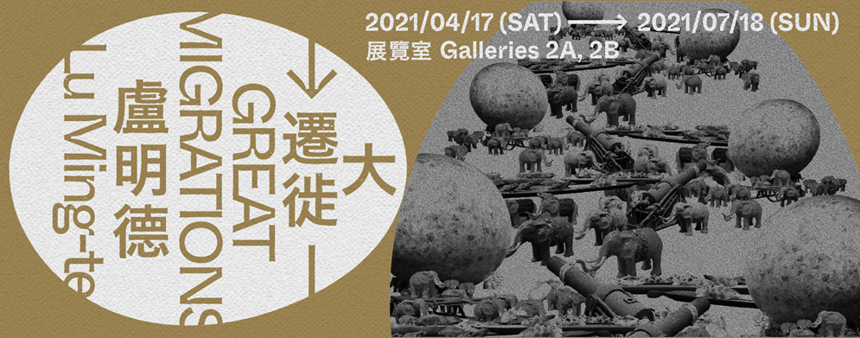

Great Migrations: Lu Ming-Te
Looking Back on Over Half a Century of Art,
Beyond the Ark toward the Freedom of Media Liberation

“Great Migrations: Lu Ming-Te” officially opens on April 17 at Taipei Fine Arts Museum (TFAM). This large-scale retrospective solo exhibition explores the many stages of Lu Ming-Te’s career in art, from the 1970s to today, featuring more than 100 exceptional works, from two-dimensional paintings to video installations, three-dimensional sculptures, spatial installations, readymades, and manuscripts.

In preparation for the exhibition, Lu invited a consultative team of Tsong Pu, Hsu Yuan-Ta, Chiang Po-Shin and Cheng Nai-Ming to research and organize the presentation of the artist’s career spanning more than 50 years. Riverbed Theater artistic director Craig Quintero was also specially invited to act as the spatial design coordinator, as an interpretative space from a theatrical perspective, creating an immersive sensorial experience through such elements as visuals, lighting, and sound.

A migration is a large-scale, long-distance movement to a new living space by either animals or people for the sake of survival. Throughout eight exhibition spaces, Lu Ming-Te references the spirit of “Great Migrations” and “Media Liberation” to ponder three different dimensions: his own personal creative history, observations of the pulse of various artistic eras, and the relationship between humankind and nature. The entrance to the exhibition employs a huge container as an initiatory image, not only alluding to the artist’s early life in the industrial port of Kaohsiung, but also symbolizing the Ark where all life originated, as an invitation to follow in the footsteps of the animals into the memory of different eras of southern Taiwan.

The exhibition also features the first theatrical interpretation of Lu Ming-Te’s art, a large-scale ball projection of the work Vagus Flora, using the concept of vagus nerve connections to explore codified memories, while expressing the harmonious coexistence of plants, insects, birds and beasts, as an encapsulation of the trajectory of Lu’s art over the years. The exhibition visually represents the distinctive characteristics of the artist’s conceptual approaches during different stages of his career, using a panoply of media and materials to reflect his artistic process and demonstrate its impact.

Lu Ming-Te was born in 1950 in Kaohsiung, Taiwan. He enrolled in the fine arts department of National Taiwan Normal University in 1970. Studying under Taiwan’s painting masters of the previous generation such as Liao Chi-Chun, Lee Shih-Chiao, and Liao Shiou-Ping, etc., he pursued “a purely painting-oriented language” with an abstract expressionist technique, surrealist subject matter and a distinctive use of symbols. Then, in a graduate program in plastic arts at the University of Tsukuba in Japan, he came into contact with a wide array of contemporary art forms and the possibilities present in composite materials. Greatly influenced by Marshall McLuhan’s “the medium is the message,” Yamaguchi Katsuhiro’s division of media into different eras, and Joseph Beuys’s concept of social sculpture, Lu turned from his early “pure symbolic painting” toward an expression of “material language.” Developing his “mixed media art theory,” he discovered a higher order of freedom, in which “everything is media” with significance for the times in which it appears. Thus began the most important “Great Migration” of his artistic career.

After returning to Taiwan in 1985, Lu Ming-Te became one of Taiwan’s major pioneers in mixed media art, introducing interdisciplinary, intermedia works and avant-garde ideas and perspectives. With the rise of Taiwanese contemporary art, the nascence of art museums and alternative art spaces, and a wave of overseas students returning to the island with newfound ideas, Lu predicted that art would progress toward a diversity of media and incorporate environments, performance and subject matter centered on symbols and signs. As a professor, his courses on mixed media art were a revolutionary breakthrough in Taiwanese fine arts education. Excelling at the techniques of collage and appropriation and the selection of readymades as vehicles for conveying conceptual messages, he embarked on a long succession of novel art media. His series Evolution and Apocalypse pondered both the progress and annihilation of humankind, and how to remain humble and tolerant toward nature. Lu’s Takao series revealed his memories of growing up, using numerous objects that conveyed a variety of messages, as well as rare historical photos of Kaohsiung.

According to Lu, his concept of interdisciplinary art comes from the European idea of Gesamtkunstwerk (“total work of art”), and he was particularly influenced by the Bauhaus perspective of art, which led him to break down the barriers between disciplines and liberate art from material constraints. The current exhibition features Lu’s classic work Media Is Everything (1986), a neon sign declaring the dawn of the age of media and signaling a shift in his own creative approach, from two-dimensional compositions to an era of media liberation.

In 2006, Lu established Taiwan’s first graduate institute of interdisciplinary art at National Kaohsiung Normal University, expanding the creative concept of mixed media to the realm of transdisciplinary thinking, and putting into practice the concept of collision, dialogue and exchange between art and other disciplines and communities. Lu Ming-Te’s art has always been closely connected to contemporary social issues and cross-disciplinary cooperation and exchanges, as he has experimented with the juxtaposition of different species and eras, and even collaborated with ecologists, geologists and other scientists and scholars in conversations that transcend their respective specializations.

Beginning in 2010, Lu Ming-Te’s art shifted toward animal and plant symbols hand-painted with delicate lines, expressing the “Great Migration” back to the essence of humanity and to nature. With linear drawings similar to those in illustrated botanical books, he has depicted various flora and fauna, serving as symbols to intimate present-day behavior on social media and the internet. And with the completely new series If Ecology were no Longer Symbols? he embarks on a journey of self-questioning and reflection through a new shift in artistic media. His “Great Migration” has ultimately returned to the warmth of humanity, and the “Great Migration” of life has ultimately returned to nature.

“Great Migrations: Lu Ming-Te” also features an Archive Room in Gallery 209, named “Hon An Ya,” as an expansion and extension of the formation, transformation and trajectory of Lu Ming-Te’s artistic ideas. It is divided into three parts: objects, documents, and a timeline, elaborating on the artist’s shifting process of constant border-crossing and migration. The exhibition will feature an “Artist’s Talk,” which takes place at 3:30pm on April 17 (Sat.) in the 2nd floor of Taipei Fine Arts Museum. Everyone is invited to stroll through the galleries with Lu Ming-Te and enter the world of Great Migrations. For details about the event, please visit the official Taipei Fine Arts Museum website (www.tfam.museum) or follow the official TFAM Facebook page (“Taipei Fine Arts Museum”).

