2020台北雙年展呈獻豐富公眾計畫
Taipei Biennial 2020 Public Programs
媒體圖說Image Caption
1  「協商劇場：離岸風電進行式」。圖像由臺北市立美術館提供。  Theater of Negotiations: Offshore Wind Power in Progress. Courtesy of Taipei Fine Arts Museum. | 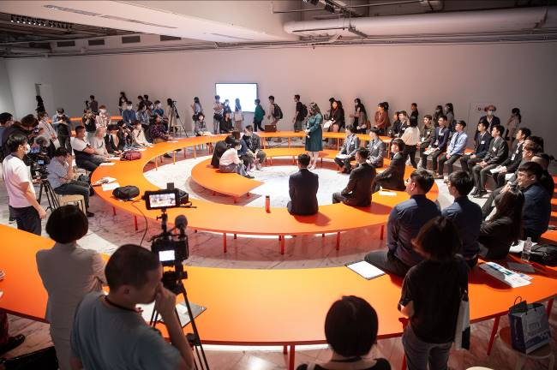
2  「協商劇場：治理助孕科技」。圖像由臺北市立美術館提供。  Theater of Negotiations: Anticipating Reproduction.  Courtesy of Taipei Fine Arts Museum. | 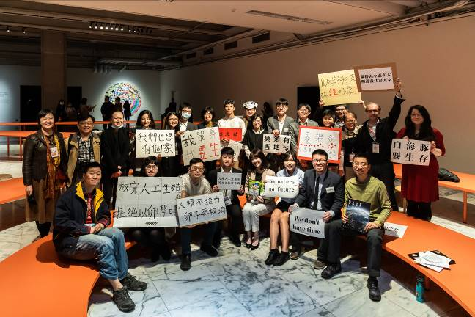
3  「協商劇場：塑化劑爭議」。圖像由臺北市立美術館提供。  Theater of Negotiations: Revisiting Plasticizer Food.  Courtesy of Taipei Fine Arts Museum. | 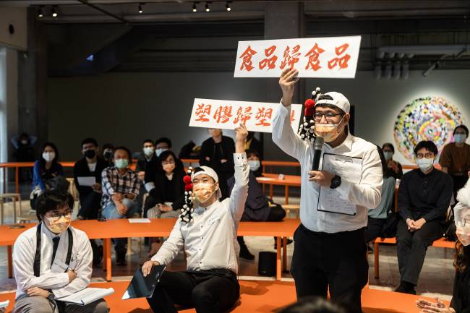
4  「協商劇場：核廢的未知數」。圖像由臺北市立美術館提供。  Theater of Negotiations: The Pending Future of Nuclear Waste. Courtesy of Taipei Fine Arts Museum. | 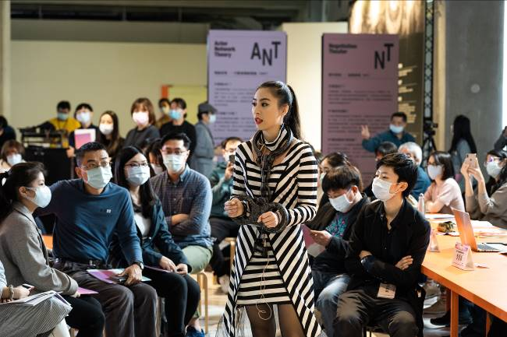
5  「月亮鹽巴：科幻寫作工作坊」。參與者進行投影影像創作並朗讀分享寫作練習成果。圖像由臺北市立美術館提供。  Moon Salt, A Sci-Fi Writing Workshop. Participants created projection images and read their writing exercises. Courtesy of Taipei Fine Arts Museum. | 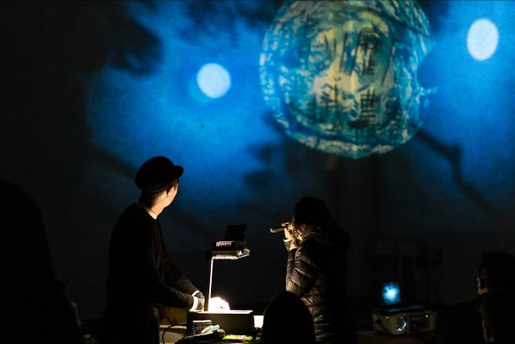
6  「月亮鹽巴：科幻寫作工作坊」。參與者運用第一天的寫作文本，由水、土、大氣等三個面向想像、開發菜單。  Moon Salt, A Sci-Fi Writing Workshop. Participants used the text they wrote to imagine and develop recipes based on water, soil, and atmosphere. Courtesy of Taipei Fine Arts Museum. | 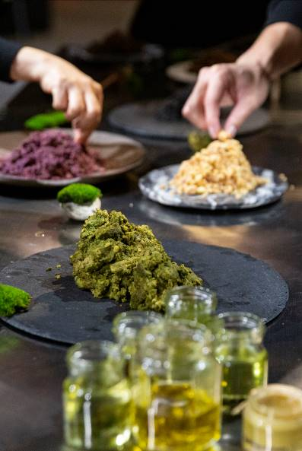
7  「月亮鹽巴：科幻寫作工作坊」。參與者共同體驗結合心智圖和敘事生產的特製桌遊。圖像由臺北市立美術館提供。  Moon Salt, A Sci-Fi Writing Workshop. Participants played a specially designed board game, which combines mind mapping and narrative production. Courtesy of Taipei Fine Arts Museum. | 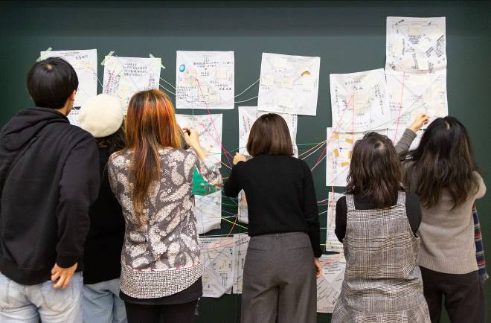
8  「國家所在的遺人遺事」走讀活動。圖像由臺北市立美術館提供。  A walking tour from event series The Relics in Which the Nation Is Situated. Courtesy of Taipei Fine Arts Museum. | 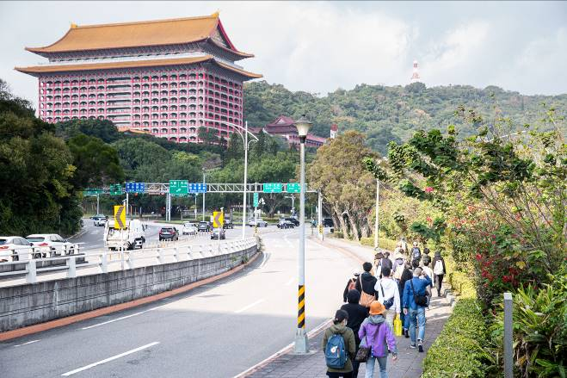
9  「國家所在的遺人遺事」走讀活動。圖像由臺北市立美術館提供。  A walking tour from event series The Relics in Which the Nation Is Situated. Courtesy of Taipei Fine Arts Museum. | 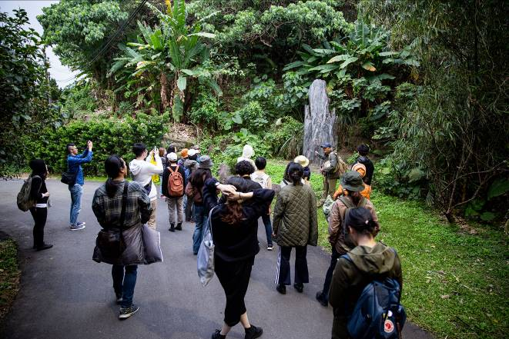
10  「通往世界的獸徑：潛行工作營」路徑1：「萬物夜談-川流治理術」，引路人龔卓軍於鄒族獵人安孝明建造的鄒族傳統家屋中帶領討論。圖像由臺北市立美術館提供。  Path One: Conversation with Things - The Way to Flow With River, The Wild Trail to the World. GONG Jow-Jiun led a discussion in a traditional house of the Tsou tribe. Courtesy of Taipei Fine Arts Museum. | 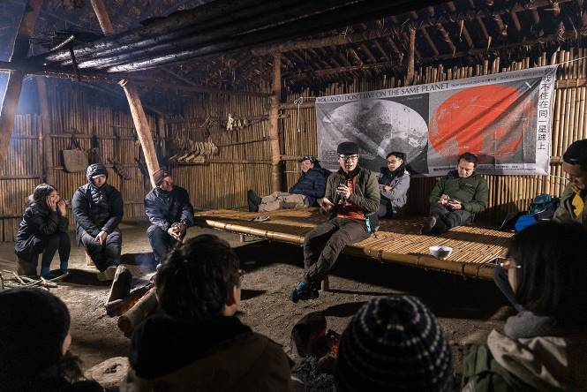
11  「通往世界的獸徑：潛行工作營」路徑1：「萬物夜談-川流治理術」，鄒族獵人安孝明介紹其建造的鄒族傳統家屋。圖像由臺北市立美術館提供。  Path One: Conversation with Things - The Way to Flow With River, The Wild Trail to the World. AN Hsiao-Ming, a Tsou hunter, introduced a traditional house he built. Courtesy of Taipei Fine Arts Museum. | 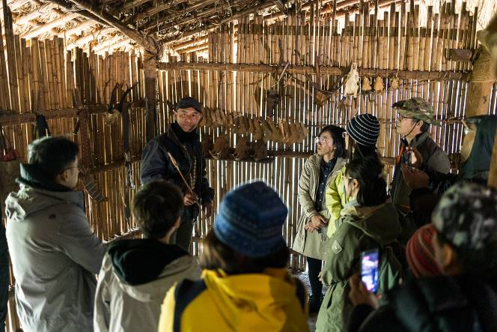
12  「通往世界的獸徑：潛行工作營」路徑1：「萬物夜談-川流治理術」，鄒族獵人安孝明引路上山。圖像由臺北市立美術館提供。  Path One: Conversation with Things - The Way to Flow With River, The Wild Trail to the World. AN Hsiao-Ming, a Tsou hunter, led participants into the mountains. Courtesy of Taipei Fine Arts Museum. | 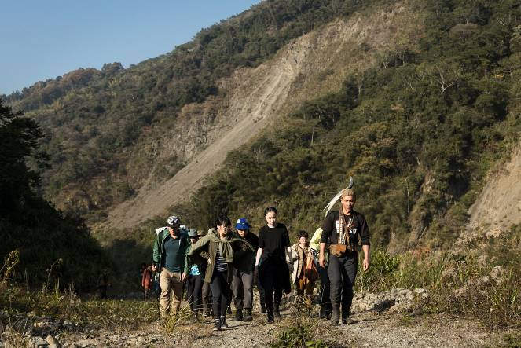
13  「通往世界的獸徑：潛行工作營」路徑1：「萬物夜談-川流治理術」活動參與者合影。圖像由臺北市立美術館提供。  Group photo of participants of Path One: Conversation with Things - The Way to Flow With River, The Wild Trail to the World. Courtesy of Taipei Fine Arts Museum. | 