2020台北雙年展公佈展覽亮點及公眾計畫詳情
Taipei Biennial Announces Further Details of 2020 Presentations and Public Programs

媒體圖說Image Caption
- 2020 台北雙年展「你我不住在同一星球上」  主視覺 ©臺北市立美術館  Taipei Biennial 2020, You and I Don’t Live on the Same Planet ©Taipei Fine Arts Museum  設計理念 | 視覺設計：梁璐  本屆台北雙年展「你我不住在同一星球上」，以具有科學性、功能性和具層次系統的「地圖集」作為主視覺設計概念。  我們所居住的星球，如其他許多星球一般，為一類地行星，主要由矽酸鹽石和金屬組成。從隱喻的角度來看，岩石和石頭使人類著迷，它看似同時處於有生命和無生命、有機和無機、有用和無用等模稜兩可的狀態，因而被賦予詩意的遐想和文化的象徵。而此種持續協商的張力是由兩個毗鄰的岩石星球和一個交疊的引力圖來表示，象徵本屆雙年展不同星球碰撞時的速度和動態，以及彼此之間的交流互動。  Design Concept | Visual Designer: Lu LIANG  The Atlas, as a scientific, functional and layered system has been borrowed as the framework for the key visual of this Taipei Biennial, You and I Don’t Live on the Same Planet.  Our planet—like many others—is a terrestrial planet, composed primarily of silicate rocks or metals. On the metaphorical level, rocks or stones have fascinated the human minds. Its ambiguities, seeming at once animate and inanimate, organic and inorganic, useful and useless are the stuff of poetic reverie and cultural symbolism. The tension of this continuous negotiation is represented by two bordering rocky planets and a superimposed gravitational map. This map symbolizes the interactions between these different planets and emphasizes the velocity and dynamics of the encounters that will be staged during the Biennial. | 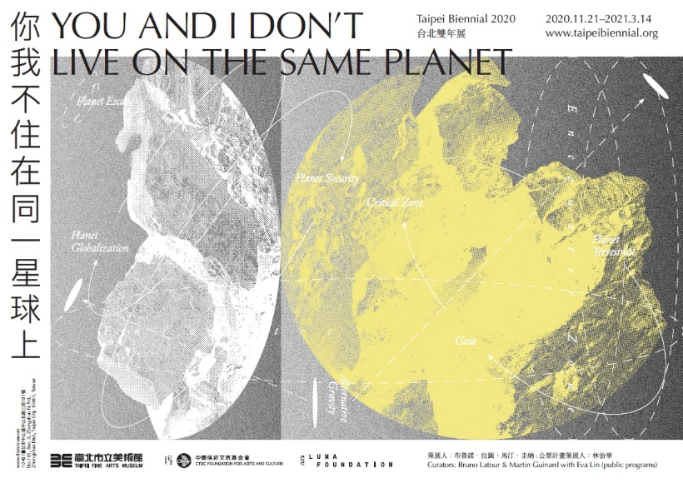  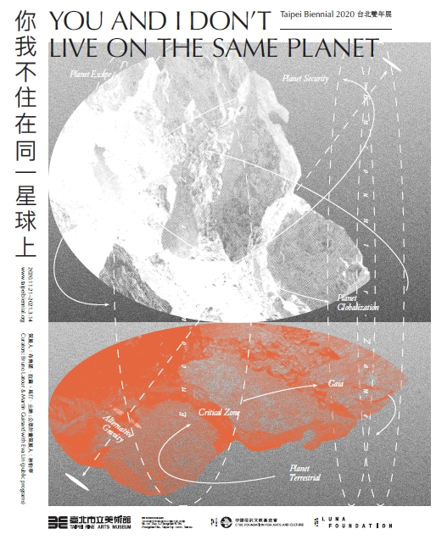
- Milliøns建築工作室（澤娜・柯瑞騰、  約翰・梅）、基爾・莫，《建築的鬼田》，2020，裝置，尺寸視空間而定。  圖像由藝術家提供。  MILLIØNS (Zeina KOREITEM + John MAY), Kiel MOE, The Ghost Acres of Architecture, 2020, installation, dimensions variable.  ©MILLIØNS (Zeina KOREITEM + John MAY), Kiel MOE. | 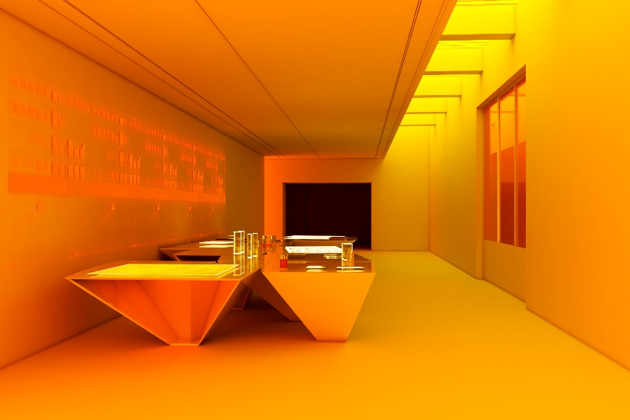
- 蘇郁心，《參照系》(影像截圖)，2020，錄像裝置，尺寸視空間而定。  圖像由藝術家提供。  SU Yu-Hsin, Frame of Reference (Film still), 2020, video installation, dimensions variable.  ©SU Yu-Hsin | 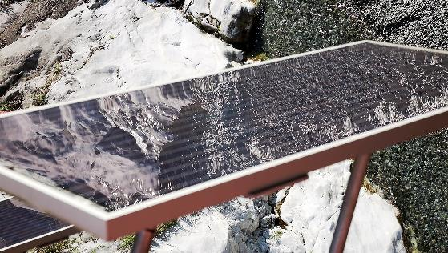
- 瑪利安．莫里，《大地的邊界》，2018，  油彩、麻布，100 x 80 公分。  圖像由藝術家提供。  Marianne MORILD, Limites Terrestres, 2018,  oil on linen, 100 x 80 cm.  ©Marianne MORILD | 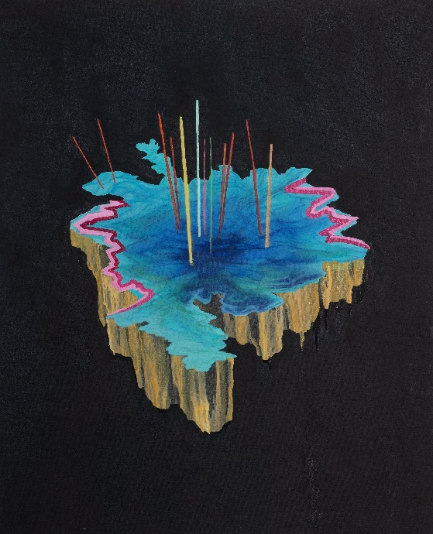
- 峨塞．達給伐歷，《病毒系列》(示意圖)，2020，  素描、壁畫，尺寸視空間而定。  圖像由藝術家提供。  Cemelesai TAKIVALET, Virus Series (Sketch), 2020, drawings and mural, dimensions variable.  ©Cemelesai TAKIVALET | 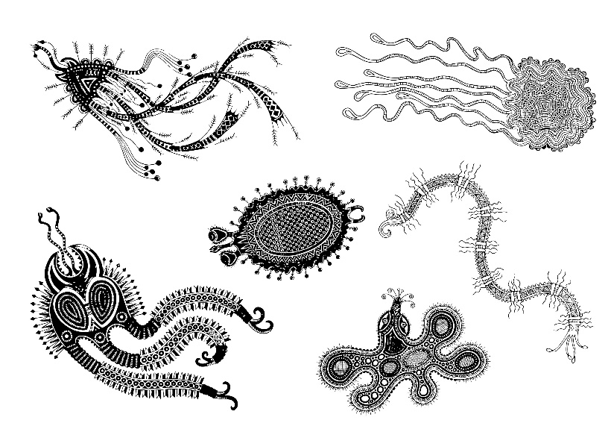
- 皮耶．雨格，《深水》，2017，混凝土模型與蜂巢、蜂群，90 x 54 x 65 公分。  展出版次: 文心藝術基金會收藏。  圖像由藝術家、Taro Nasu東京畫廊、東京國立近代美術館和太宰府天滿宮提供。  Pierre HUYGHE, Exomind (Deep Water), 2017, concrete cast with wax hive and bee colony, 90 x 54 x 65 cm.  Exhibited version: Collection of Winsing Arts Foundation.  ©Pierre HUYGHE; Taro Nasu, Tokyo; The National Museum of Modern Art, Tokyo; and the Dazaifu Tenmangu Shrine. | 