Taipei Fine Arts Museum Press Release  International media contact:  Carol Lo, Sutton  carol@suttoncomms.com  Museum contact：  Yu-Mei Sung  yumei@tfam.gov.tw | Taipei Biennial 2020  You and I Don’t Live on the Same Planet  Date: 21 November 2020 – 14 March 2021  Venue: Taipei Fine Arts Museum
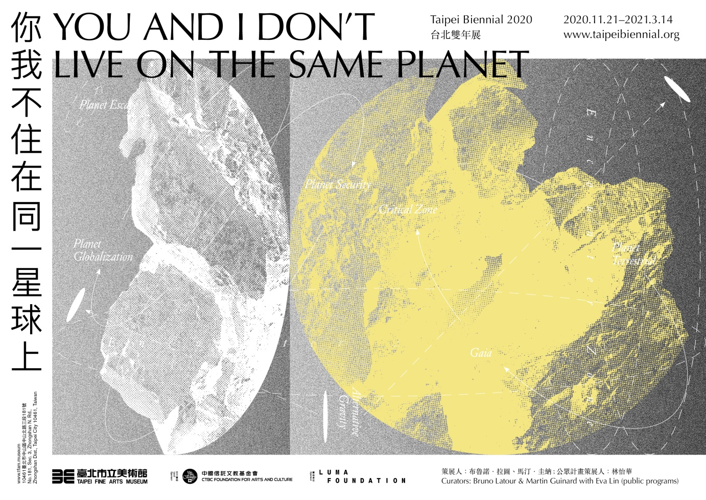

Taipei Biennial Announces Further Details of 2020 Presentations and Public Programs

28 September 2020 – Taipei: Presented by Taipei Fine Arts Museum (TFAM), the 12th edition of Taipei Biennial will take place from 21 November 2020 to 14 March 2021. Co-curated by French philosopher Bruno LATOUR and French independent curator Martin GUINARD, along with Taiwanese independent curator Eva LIN, who has been specially invited to curate the public programs, this year’s biennial will showcase a line-up of works by 58 participants/groups from 25 countries and territories worldwide. Entitled You and I Don’t Live on the Same Planet, the biennial starts from the postulate proposed by Latour and Guinard that “people around the world no longer agree on what it means to live ‘on’ Earth. As we come closer to a series of tipping points, we simultaneously witness a division between those who seem to have abandoned planet Earth, those who try to make it more inhabitable, and those whose cosmology never fitted within the ideals of the globalizing project in the first place”.

This year’s biennial is a call for ideas on how to view and respond to the current environment we are living in. With knowledge across a field of studies encompassing humanities, history, geology, marine science, sociology and political science at the core of the exhibition’s framework, accompanied by dynamic public programs to stimulate thoughts and spark discussions, the biennial aims to question our current ongoing geopolitical tensions and worsening ecological crisis by examining our differences and influences on a planetary perspective. The exhibition will propose a fictional “planetarium” within the museum, wherein the participants will set up the tensions between the gravitational pull of different “planets”. Among the many examples one could name the Planet GLOBALIZATION for those who relentlessly modernize despite planetary boundaries, and the Planet TERRESTRIAL for those who are concerned about the climate situation and trying to reconcile the paradox between development and sustainability.

Highlight works include a newly commissioned work The Ghost Acres of Architecture by Los Angeles-based design practice MILLIØNS (Zeina KOREITEM & John MAY), which presents terrestrial descriptions of the Seagram Building in Manhattan (one of the most iconic examples of 20th century architecture) and aims to explore how to maximize the impact of architecture on its environment in the most positive, generative ways possible. With commissioned video installation Frame of Reference, Taiwanese artist SU Yu-Hsin addresses the question of formatting scalar relations between the field, laboratory and database, and explores the role images play in the field work of the Critical Zone.

Works exploring the relation between the earth surface and the life activities above include Norwegian artist Marianne MORILD’s paintings, which will depict fragments of suspended landscapes “torn” from the ground. Taiwanese artist Cemelesai TAKIVALET from indigenous Paiwan tribe will present a newly commissioned work Virus Series, which depicts imaginary enlarged viruses released from wildlife as a reaction to human intrusion. With this, he subverts the logic of invasive species, in which humans are seen as a main perpetrator of constant disruptions and attacks. French artist Pierre HUYGHE’s installation Exomind (Deep Water) will present a female figure whose head is obscured by a beehive. Giving new heights to this “exomind” ecosystem, the statue grows by pollinating other living symbols and constantly modifying itself in this transitory, porous and entangled environment. For the full list of participants, please see the appendix.

With a specific trajectory in time and space, Taipei Biennial 2020 Public Programs will gather artists and thinkers to tackle critical geo-political and ecological issues at hand, for a series of events produced in parallel with the exhibition. As the exhibition is a simulacrum of various planets, the Public Programs represent a collision between these different astronomical bodies. Eva Lin, curator of the Public Programs stated, “We believe the current imperative is not simply fostering discussions from multiple perspectives; instead, our aim is to explore alternative procedures to reach a point of mediation since we realize the importance of divisions. It is through irreducible boundaries, native philosophies which differ from contemporary mainstream logic, and non-anthropocentric memories out in the field that a turn in the irreversible ending could be possible.”

Through transforming an art space into an experimental field in response to local conditions and the impetus of knowledge, the Public Programs aim to re-establish relations with all the living creatures of the land and to create opportunities for open and mutual exchange and learning. The programs start with Theater of Negotiations, a collaboration between TFAM, researchers and students from the Taiwan Science, Technology and Society Association and five universities. By implementing the concept of “political and diplomatic tactics” into the realm of pressing issues in Taiwan, including climate emergency, nuclear waste, food safety, renewable energy and assisted conception, the discussion engages in realistic exercises in negotiations, debate or public governance to explore new solutions for the current deadlock. The Wild Trail to the World consists of cross-disciplinary panels and interactive workshops, such as science-fiction writing, air detection performance, critical reading and inspection of historical materials. In addition, participants will also be led out of the museum and encouraged to use bodily perceptions to depict spaces that traverse the boundaries of maps and to experience and understand the nature and motherland in a new way.

To kick off the biennial’s dynamic programs, a one-day symposium bringing together renowned international and local curators, artists and scholars to express their perspectives on this year’s theme will be staged on the opening day. speakers in the roundtable include Mali WU, co-curator of Taipei Biennial 2018; Olivia ANANI, independent curator; CHUANG Chun-Mei, Professor at the Department of Sociology, Soochow University; HUANG Chien-Hung, Associate Professor at Taipei National University of the Arts; and Paul JOBIN, Associate Research Fellow, Institute of Sociology, Academia Sinica.

Taipei Biennial 2020 resonates with many given its timely topic and has thus received widespread support, with CTBC Foundation for Arts and Culture as lead sponsor and LUMA Foundation as sponsor. FENG Chi-Tai, chairman of the CTBC Foundation for Arts and Culture, remarks: “In the post-pandemic era, our foundation is committed to eliminating the social barriers between people and art, and contributing to art education by inviting children of underprivileged areas to TFAM to broaden their horizons. We strongly believe that the arts make vital impact in difficult times!”
Notes to editors

Bruno LATOUR
Born in 1947 in Beaune, France, Bruno Latour is now professor emeritus associated with the médialab and the program in political arts (SPEAP) of Sciences Po Paris. Since January 2018 he has been a fellow at the Zentrum für Kunst und Media (ZKM) and professor at the Karlsruhe University of Arts and Design (HfG), both in Karlsruhe, Germany. A member of several academies and recipient of six honorary doctorates, he received the Holberg Prize in 2013. He has written and edited more than twenty books and published more than 150 articles. The major international exhibitions he has curated are: Iconoclash Beyond the Image Wars in Science, Religion and Art with Peter Weibel in 2002, Making Things Public: Atmospheres of Democracy in 2005, and Reset Modernity! in 2016. The catalogs of all three exhibitions are published by MIT Press. He is now a member of curatorial committee at ZKM for the ongoing exhibition Critical Zones, Observatory for Earthly Politics.

Martin GUINARD
Martin Guinard is an independent curator based in Paris, with a background in visual arts and art history. He has worked on several interdisciplinary projects dealing with the topic of ecological mutation. He has collaborated with Bruno Latour on several international projects over the last few years, including Reset Modernity! at ZKM in 2016 as well as a reiteration of the project through two workshop platforms in different geographical contexts: the first in China, Reset Modernity! Shanghai Perspective as part of the 2016 Shanghai Project; the second in Iran, Reset Modernity! Tehran Perspective curated with Reza Haeri at the Pejman Foundation and the Institute of History of Science of Tehran University. He is now a member of curatorial committee at ZKM for the ongoing exhibition Critical Zones, Observatory for Earthly Politics.

IHwa Eva LIN
Eva Lin is an independent curator known for curating at unconventional venues to engage in experiments that constitute her interdisciplinary practice. Lin’s dynamic interests drive her into alternative thinking and response to cultural production in diverse forms in order to extend the agency and force of art. Her recent curatorial projects include Parallax: Damage Control (2017), The Hidden South (2018), The Upcoming Past (2019), Ryoji Ikeda Solo Exhibition (with Jo HSIAO; 2019) and the 7th Taiwan International Video Art Exhibition – ANIMA (with Wei YU; 2020). She is now the art director of mt.project.

Taipei Biennial
The Taipei Biennial is the most important exhibition held by Taipei Fine Arts Museum once every two years since 1998. Dedicated to the development of Taiwan’s contemporary art and international visibility, the Taipei Biennial employs diverse cultural perspectives to place Taipei within the network of Asian and global contemporary art, serving as a driving force for international dialogue. Responding to international art trends with both depth and breadth, it attempts to build direct connections between local and international art communities. Over the past two decades, it has grown rapidly and amassed great energy to become a major mechanism of dialogue between Taiwan and the world.

CTBC Foundation for Arts and Culture
Established in 1996, the CTBC Foundation for Arts and Culture upholds the philosophy of “Learning through the Arts, Nurturing Creativity through Culture”. It is committed to enhancing social care through public welfare initiatives and building a platform where people of urban and rural areas can approach arts and culture. The Foundation recognizes Taipei Biennial as a significant occasion connecting Taiwan and the international arts community, as well as the resonance of its theme and content on society. CTBC Foundation for Arts and Culture is the lead sponsor for this year’s Taipei Biennial, You and I Don’t Live on the Same Planet.

