「藍天之下：我們時代的精神狀況」媒體用圖圖說對照表
Image Sheet _ Between Earth and the Sky: The Spiritual State of Our Times

圖說 | 圖像
01  FAMEME，〈榴槤製藥廠〉，2020，互動裝置、現場表演，複合媒材，尺寸依展場空間而定。  臺北市立美術館提供。  FAMEME, DURIAN Pharmaceutical, 2020, interactive installation, performance, Dimensions variable. Courtesy of Taipei Fine Arts Museum. | 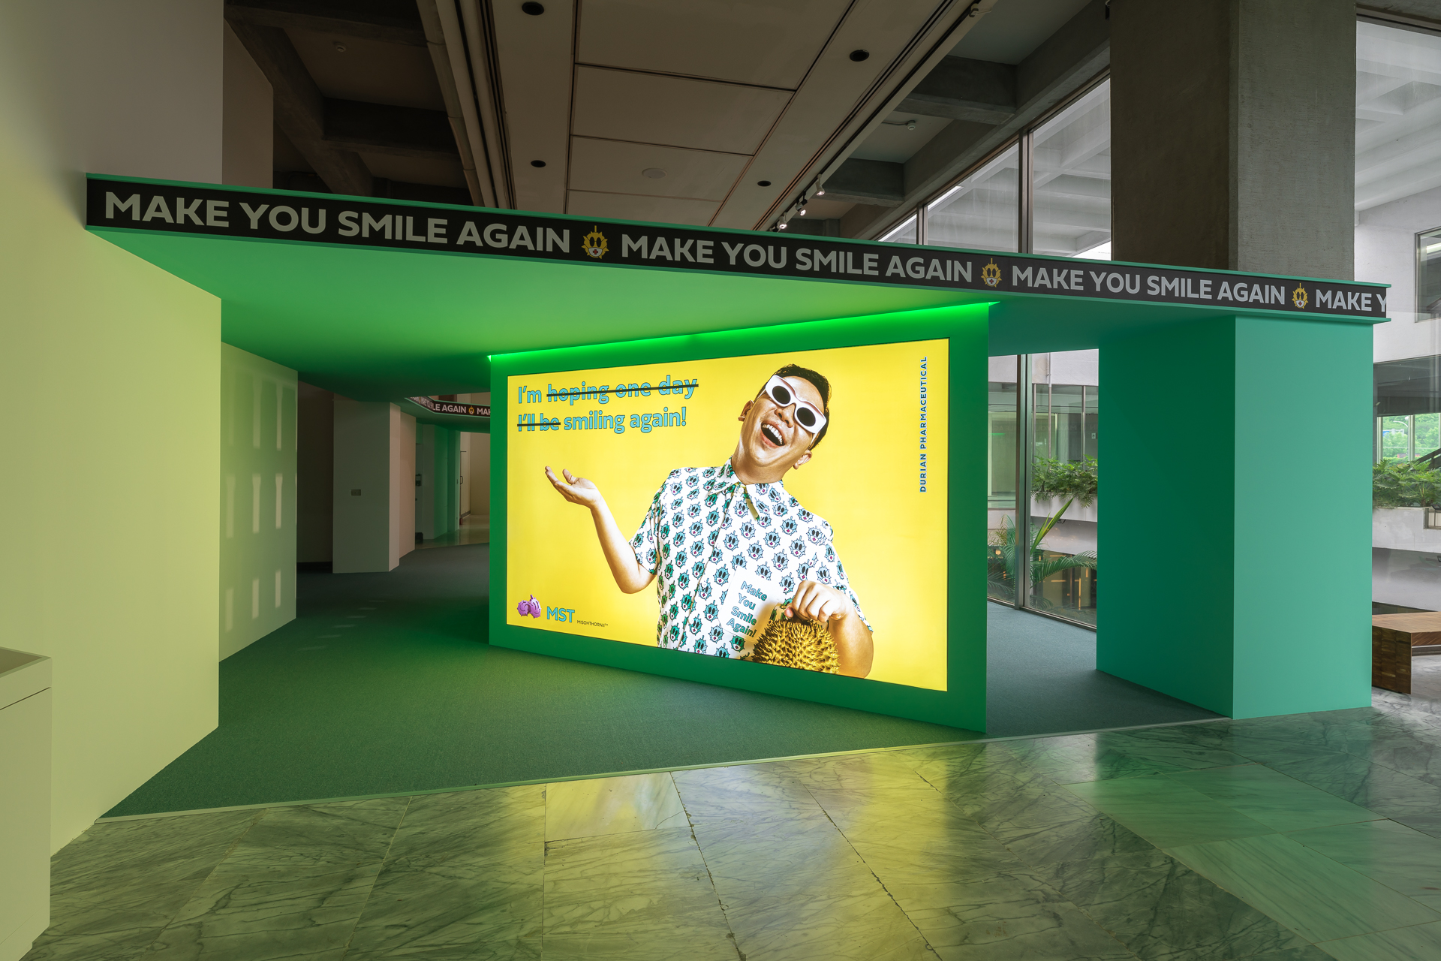
02  張嘉穎，〈HA.HA〉，2020，繪畫、裝置，複合媒材，尺寸依展場空間而定。臺北市立美術館提供。  Chia-Ying Chang, HA.HA., 2020, acrylic on canvas, installation, mixed media, dimensions variable. Courtesy of Taipei Fine Arts Museum. | 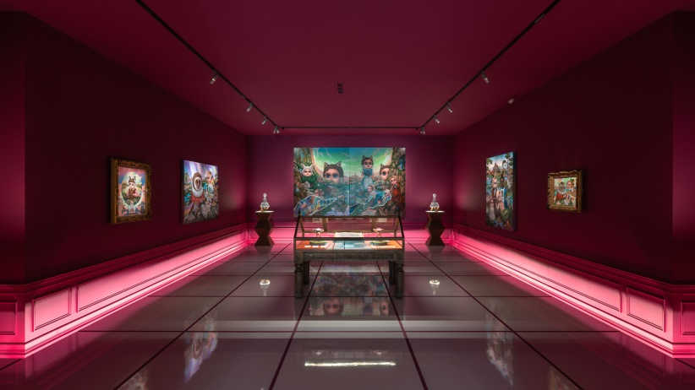
03  Baboo ，<新!王冠度假村>，2020，裝置、網路直播、互動式演出，複合媒材，尺寸依現場空間。演出執行：莎妹工作室。臺北市立美術館提供。  Baboo , Corona Villa , 2020, installation, live streaming, interactive performance, mixed media, dimensions variable. Performance execution: Shakespeare’s Wild Sisters Group Courtesy of Taipei Fine Arts Museum. | 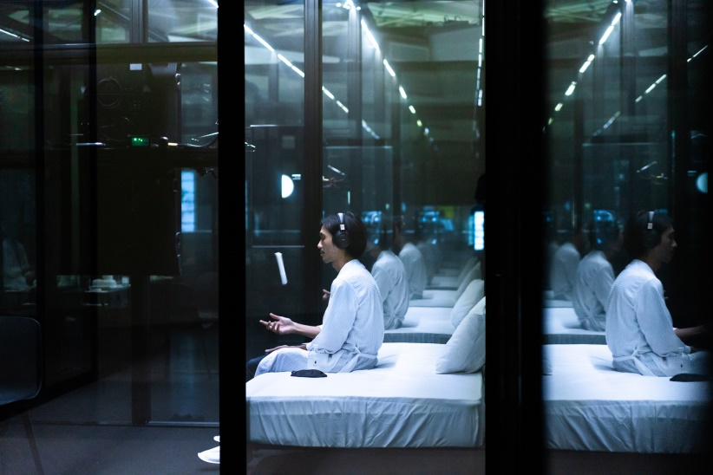
04  陳亮璇 & 致穎，〈手勢II 〉，2020，裝置、影像、現場表演，複合媒材，尺寸依展場空間而定。臺北市立美術館提供。  Liang-Hsuan Chen & Musquiqui Chihying, The Gesture II, 2020, installation , HD video, live performance, dimensions variable. Courtesy of Taipei Fine Arts Museum. | 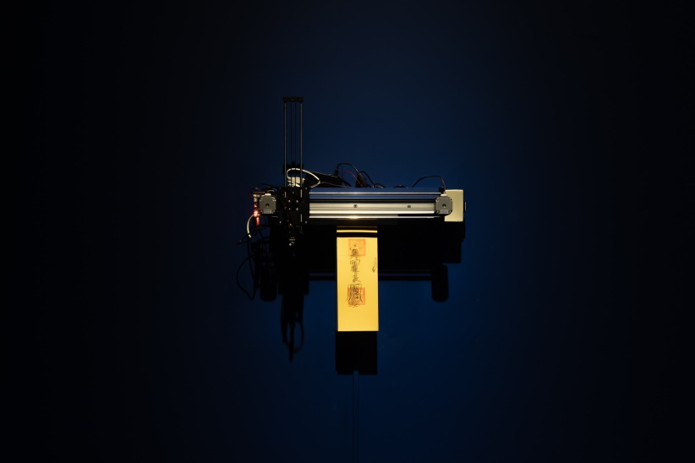
05  李貞葳，<14種承擔的練習>，2020，4頻道舞蹈影像裝置，Full HD、彩色、有聲、循環播放，尺寸依展場空間而定。臺北市立美術館提供。  Chen-Wei Lee, 14 Kinds of Exercise with Endurance, 2020, 4-channel dance video installation, , Full HD, coloured, sound, looped, dimensions variable. Courtesy of the Taipei Fine Arts Museum. | 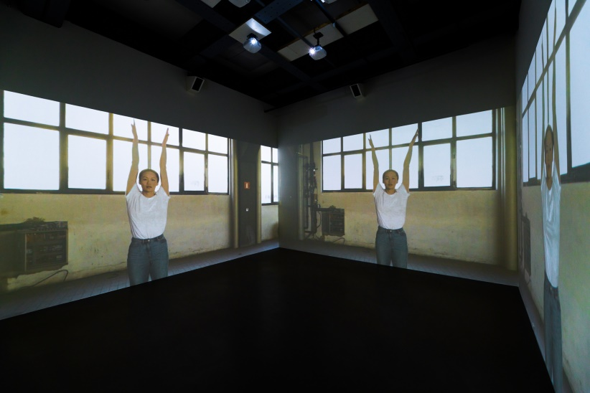
06  阮慶岳 ，〈山徑躊躇─我的小說拯救計畫〉，2020，裝置、影片、文字、行動，尺寸依現場空間。臺北市立美術館提供。  Ching-Yueh Roan, Wavering on a Mountain Path—A Rescue Plan for My Novel, 2020, mixed media installation, film, text, performance , dimensions variable. Courtesy of Taipei Fine Arts Museum. | 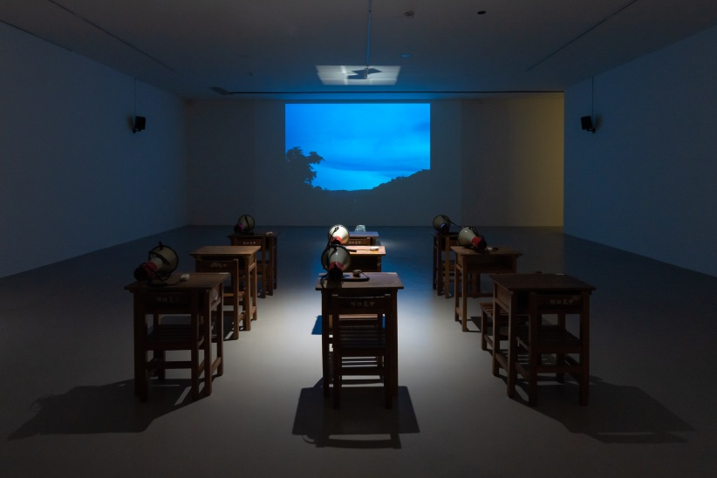
07  許悔之，〈字，療。〉，2020，裝置、現場表演，複合媒材，尺寸依現場空間。臺北市立美術館提供。  Hui-Chih Hsu, Words that Heal , 2020, installation, performance, mixed media, dimensions variable. Courtesy of Taipei Fine Arts Museum. | 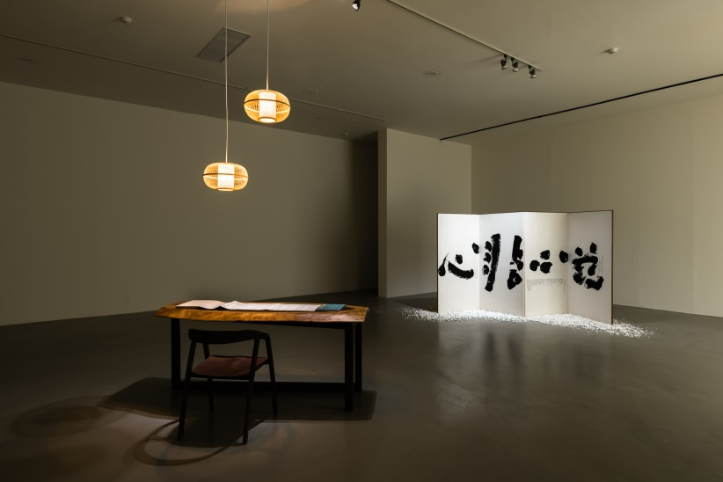
08  李明學，〈後─調味群島風情〉，2020，裝置，胡椒、肉桂、肉豆蔻、丁香、沙灘球、沙灘椅、沙灘傘、仿真樹、風水球、瓶裝水、窗簾、壁紙、鏡子，尺寸依展場空間而定。臺北市立美術館提供。  James Ming–Hsueh Lee, Post—Beach of Spices, 2020, installation, pepper, cinnamon, nutmeg, cloves, beach ball, beach chairs, beach umbrella, artificial coconut trees, fengshui balls, mineral water, curtains, wallpaper, mirrors, dimensions variable. Courtesy of Taipei Fine Arts Museum. | 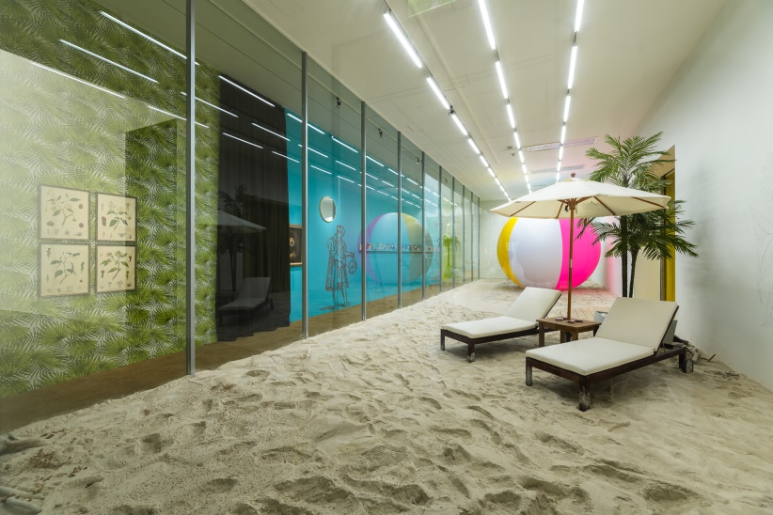
09  發條鼻子，〈howwwwwww〉，2020，影像、網路直播、裝置、複合媒材，尺寸依展場空間而定。臺北市立美術館提供。  Clockwork Noses, howwwwwww , 2020, video, live streaming, installation, mixed media, dimensions variable. Courtesy of Taipei Fine Arts Museum. | 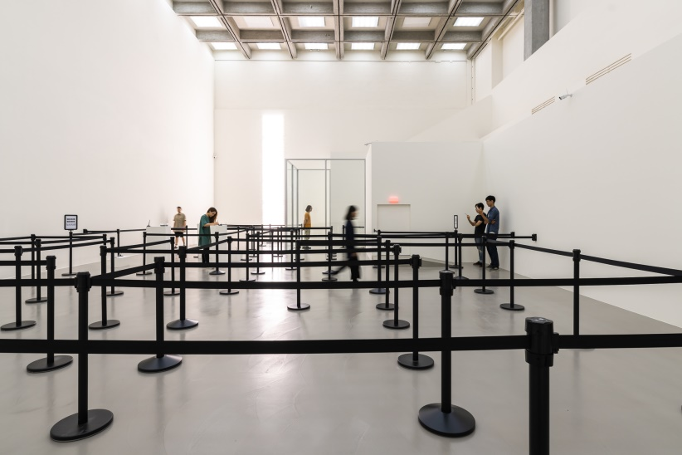
10  張致中，〈海錯〉，2020，裝置，平面繪畫、影像、聲音、印刷品，尺寸依展場空間而定。臺北市立美術館提供。  Chih-Chung Chang, The Mistake on the Sea, 2020, installation, drawings, images, sound, printed materials, dimensions variable. Courtesy of Taipei Fine Arts Museum. | 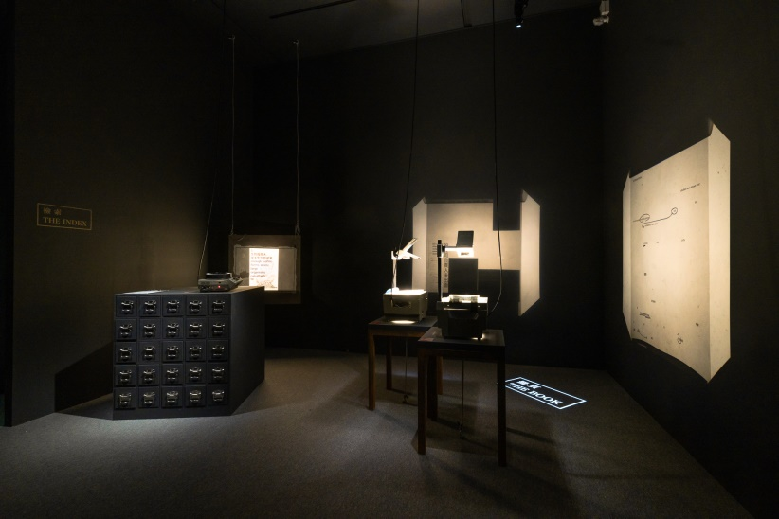
11  太研設計吳書原、耿寧，〈異托邦─花園〉，2020，裝置，植物，尺寸依現場空間。臺北市立美術館提供。  Motif Planning & Design Consultants, Shu Yuan Wu, Slow Geng, Heterotopia Garden , 2020, installation, plants, dimensions variable. Courtesy of Taipei Fine Arts Museum. | 