Taipei Fine Arts Museum Press Release
FOR IMMEDIATE RELEASE
Media Contact | Hui-Ping Liu (hpliu@tfam.gov.tw)  Tzu-chin Kao (tckao@tfam.gov.tw)

The Secret South: From Cold War Perspective to Global South in Museum Collection
July 25 to October 25,2020
Galleries 2A & 2B, Taipei Fine Arts Museum, Taiwan.

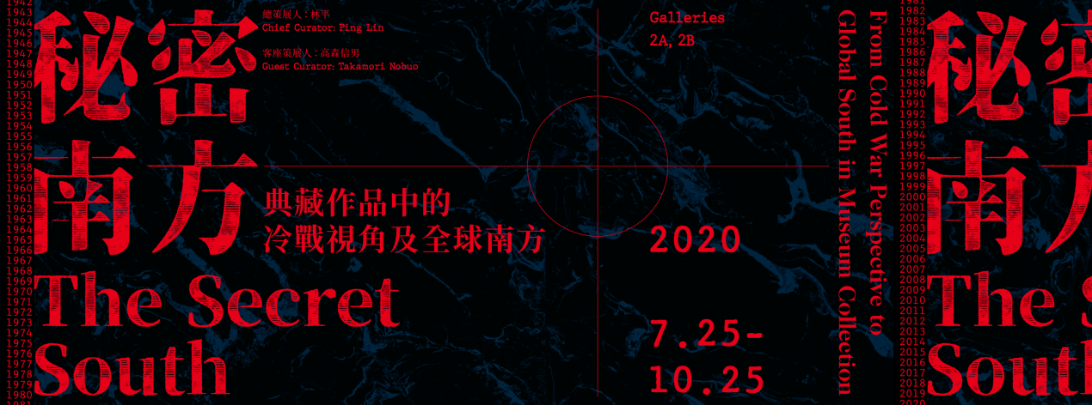

The Secret South: From Cold War Perspective to Global South in Museum Collection
An Experimental Collection Exhibition Reconnecting Artworks and Society

“The Secret South: From Cold War Perspective to Global South in Museum Collection,” considers the relationship between Taiwan and Southeast Asia, Latin America and Africa, and attempts to redefine Taiwan’s historical blueprint for international political, economic and cultural exchanges. For this research exhibition, TFAM director Ping Lin serves as chief curator, inviting guest curator Nobuo Takamori to take a fresh look at rarely seen works from the Taipei Fine Arts Museum, from the perspective of his long-term research of visual culture. While centered on the TFAM collection, the exhibition also integrates collection, historical articles and documentation of the anthropology of art from other public institutions. Tracing history from the Cold War to the present day, it interweaves a narrative from the museum’s collection system, gradually conveying the interaction between Taiwan and the Global South.

Ever since the Japanese colonial era, Taiwan has been incorporated into the system of the “Global South.” Used as the base for Japan’s southward expansion, it once served as the center of Japanese academic research on a wide range of subjects related to Southeast Asia and the South Pacific. Following World War II, political power shifted hands, and the island became swept up in the Cold War rivalry between the Kuomintang and the Chinese Communist Party. In order to strengthen ties with the anti-communist countries of Southeast Asia, Taiwan developed close cultural exchanges with Southeast Asia’s enthical Chinese community. Beginning in the 1960s, Taiwan’s international position started to change, and in response to the shrinking number of allies, many exchanges began to focus on Latin America, Africa, and Oceania. Today, nearly all the countries who still maintain formal diplomatic ties with Taiwan come from the “Global South.”

“Although Taiwan is geographically situated in the Northern Hemisphere, the historical center of gravity for civilization, it has always been viewed as bordering on the South,” remarks TFAM director Ping Lin. “Taiwan’s ambiguous circumstances are also alluded to within the subject this exhibition ponders. ‘The South’ is a specific projection of the imagination that is continually changing. It no longer signifies a geographical direction or spatial dimension, but implies a certain value and charm. It is an exotic realm separate from the mainstream, a place waiting to be explored and developed. But from the point of view of a museum director, this terminology breaks through the encirclement of rationality and physical placement and becomes a metaphor for the ‘dark place’ of the collection storage facilities. It is a curatorial plan, but it also attempts to reference Taiwan’s economy, culture and society, as well as the everyday ‘secret south’ of the museum.”

The exhibition includes World War II era paintings from the TFAM collection: Refugees in Tarla, painted by Ishihara Shisan in 1943, depicts refugees taking a rest with common tropical plants such as cacao trees and hibiscus flowers in the background. The picture’s exotic scenery forms a contrast with the theme of war. Also featured are realistic paintings by such major Taiwanese artists as Kuo Hsueh Hu, Ma Pai Sui, Liu Max C.W., and Shiy De Jinn, who all traveled to Southeast Asia during the Cold War era. Also on display will be numerous contemporary artworks from “the South,” along with related documentation, acquired by TFAM on a variety of occasions – either through the close artistic exchanges it pursued with Taiwan’s Latin American allies from 1985 to 2008; through the Taipei Biennial, which it has held since 1998; or through the occasional acceptance of diplomatic gifts. Moreover, after promoting exchanges with international ethnic-Chinese artists for many years, the National Museum of History has acquired several important works by top-tier Southeast Asian artists, including Ang Kiukok of the Philippines and Cheong Soo Pieng, Liu Kang and Chen Wen Hsi of Singapore, which will be exhibited for the first time at Taipei Fine Arts Museum.

Furthermore, the exhibition seeks to leverage the interpretations of contemporary artists to construct a new narrative of the land of Taiwan in the art history of the Global South. For example, in I-DEN-TI-TY (1996, 2020) the artist Mei Dean E made either gold plates or pennants for all the countries that formed relations or broke relations with Taiwan, and he continued to produce new versions of the work as time progressed. In his video Ruins of the Intelligence Bureau (2015), Hsu Chia Wei invited veterans of Thailand’s Intelligence Bureau to act out the local fable of Hanuman the monkey god, exploring the KMT intelligence network left behind in northern Thailand. Yao Jui Chung of Taiwan and Au Sow Yee of Malaysia have both developed completely new projects for this exhibition, both unique elaborations of historical events: images of ruins and a story of a fictional time and place, respectively.

In addition, the organization and presentation of historical documents also form an important process of interpreting this exhibition. Singaporean artist/researcher Koh Nguang How, independent curator Chen Hsiang Wen, independent rechercher Huang Yi Hsiung, and NML Residency & Nusantara Archive Project director Rikey Tenn Bun Ki present their own projects reflecting the texture of interactions between Taiwan and the South, generating a space for discussion in a form somewhere between art and literature.

The final theme of this exhibition, “The Local South,” attempts to create a close connection with contemporary Taiwanese society. Through the works of artists such as Wong Hoy Cheong of Malaysia, Su Yu Hsien and Chang En Man, visitors can glimpse the history of contemporary relations between Taiwan and Southeast Asia through cultural exchanges and immigration, thus comparing the interactions of contemporary art spaces and organizations with countries of the South in recent years, and gaining a realization of how present-day Taiwan has inherited the legacy of the Cold War yet still portends a different future.

