「董陽孜：行墨」展覽開幕新聞稿 媒體用圖圖說對照表
Tong Yang Tze—Moving Ink, Image Sheet

圖說 | 影像
01  董陽孜，《油畫》，1968。  油彩畫布，116.8 x 116.8 公分，藝術家自藏。  Tong Yang Tze , Oil Painting, 1968  Oil on canvas, 116.8 x 116.8 cm, artist collection | 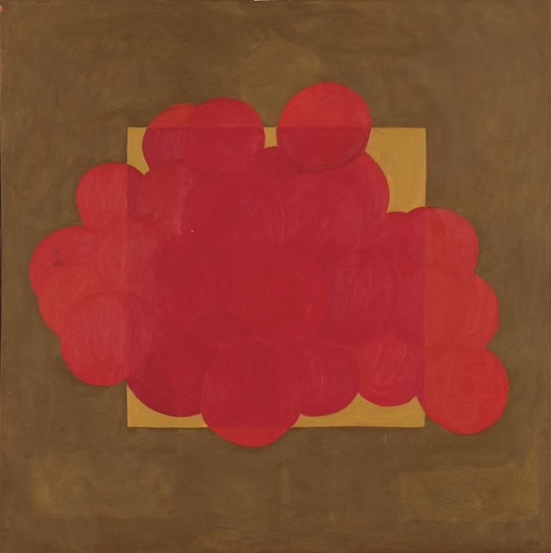
02  董陽孜，《滄海之滉漾浥勺水 不足以削其廣》，1973。  墨、紙，81 x 86.5 公分，藝術家自藏。  Tong Yang Tze , Taking a spoonful of water from the surging sea cannot reduce its immensity, 1973  Ink on paper, 81 x 86.5 cm, artist collection | 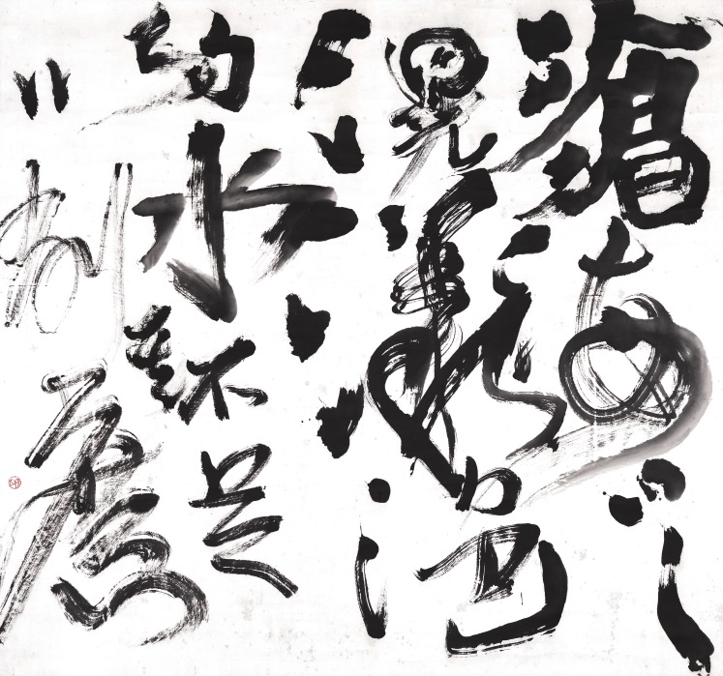
03  董陽孜，《養拙》，1978。  墨、紙，92 x 198公分，誠品畫廊收藏。  Tong Yang Tze , Conceal your competency, bear modesty, 1978  Ink on paper, 92 x 198 cm, collection of ESLITE GALLERY | 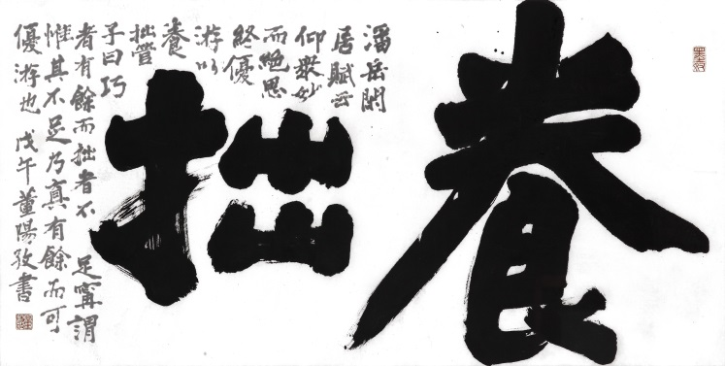
04  董陽孜，《知其白守其黑》，1990。  墨、紙，132.6 x 247.5公分，臺北市立美術館典藏。  Tong Yang-Tze, Know It's White, Keep Silent When It's Black,1990  Ink on paper, 132.6 x 247.5 cm, collection of Taipei Fine Arts Museum | 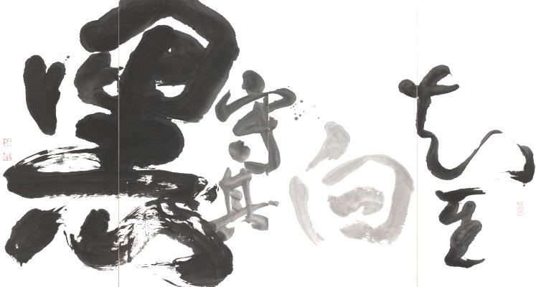
05

董陽孜，《九歌》，1993。墨、紙，52 x 1415公分，臺北市立美術館典藏。
Tong Yang-Tze, Nine Songs,1990. Ink on paper, 52 x 1415 cm, collection of Taipei Fine Arts Museum
06  董陽孜，《別有天》，2000。  墨、紙，137.5 x 250.7 公分，藝術家自藏。  出處：唐．李白〈山中問答〉  Tong Yang Tze , There is another world, 2000  Ink on paper, 137.5 x 250.7 cm, artist collection  Reference: Questions and Answers in the Mountains, Li Bai, Tang dynasty | 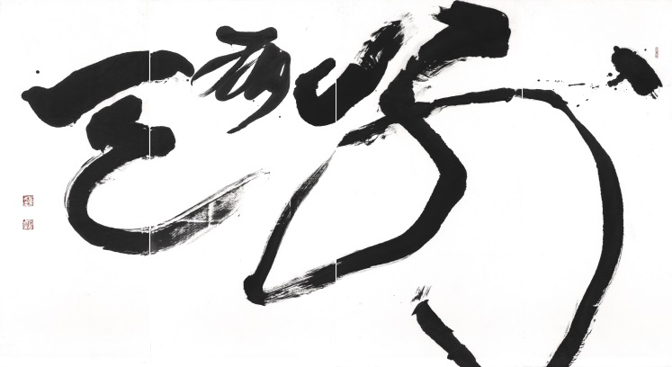
07  董陽孜，《臥遊》，2002。  墨、紙，69 x 69公分，藝術家自藏。  出處：〈宋史．宗炳傳〉  Tong Yang Tze , To wander while lying down, 2002  Ink on paper, 69 x 69 cm, artist collection  Reference: Biography of Zong Bing, History of the Song | 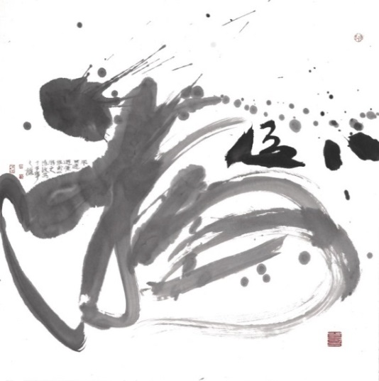
08  董陽孜，《大象無形》，2006。  墨、紙，179 x 776公分，藝術家自藏。  Tong Yang Tze , The great form is without shape, 2006  Ink on paper, 179 x 776 cm, artist collection | 