「阿比查邦．韋拉斯塔古：狂中之靜」展覽開幕新聞稿 媒體用圖圖說對照表
Apichatpong Weerasethakul ─ The Serenity of Madness, Image Sheet

圖說 | 影像
01  阿比查邦．韋拉斯塔古，2014。Kick the Machine Films提供，攝影：Chai Siris。  Apichatpong Weerasethakul, 2014. Courtesy of Kick the Machine Films, Photograph by Chai Siris. | 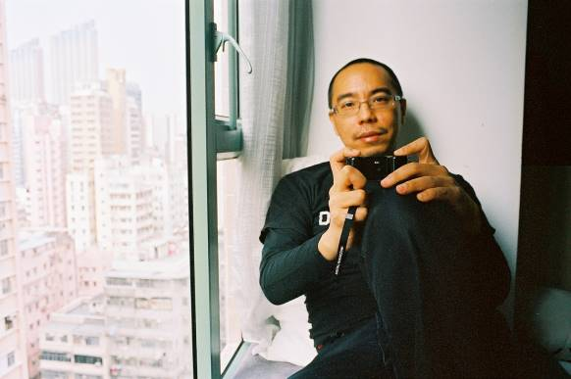
02  阿比查邦．韋拉斯塔古，《子彈》，1994。單頻錄像。藝術家與臺北市立美術館提供。  Apichatpong Weerasethakul, Bullet, 1994. Single-channel video. Courtesy of the artist and Taipei Fine Arts Museum. | 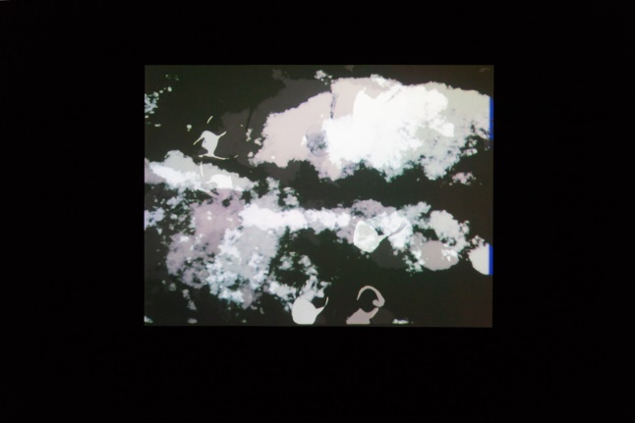
03  阿比查邦．韋拉斯塔古，《備忘：海邊的男孩》，2017。單頻錄像裝置、圓形投影。藝術家與臺北市立美術館提供。  Apichatpong Weerasethakul, Memoria, Boy at Sea, 2017. Single-channel video installation, circular projection. Courtesy of the artist and Taipei Fine Arts Museum. | 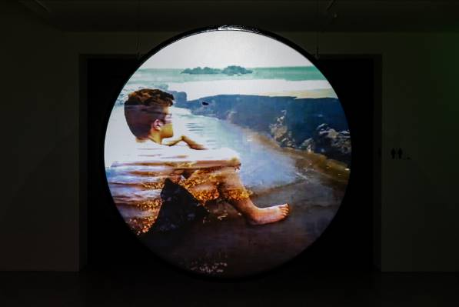
04  阿比查邦．韋拉斯塔古，《虛構》，2018。單頻錄像裝置、玻璃。藝術家與臺北市立美術館提供。  Apichatpong Weerasethakul, Fiction, 2018. Single-channel video installation on glass. Courtesy of the artist and Taipei Fine Arts Museum. | 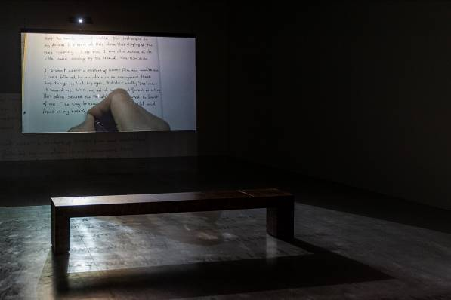
05  阿比查邦．韋拉斯塔古，《煙火（檔案）》，2014。錄像截圖。Kick the Machine Films提供。  Apichatpong Weerasethakul, Fireworks (Archives), 2014. Video still. Courtesy of Kick the Machine Films. | 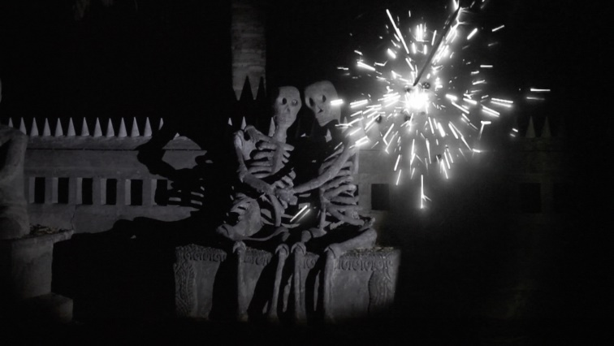
06  阿比查邦．韋拉斯塔古，《煙火（檔案）》，2014。單頻錄像裝置、玻璃。藝術家與臺北市立美術館提供。  Apichatpong Weerasethakul, Fireworks (Archives), 2014. Single-channel video installation on glass. Courtesy of the artist and Taipei Fine Arts Museum. | 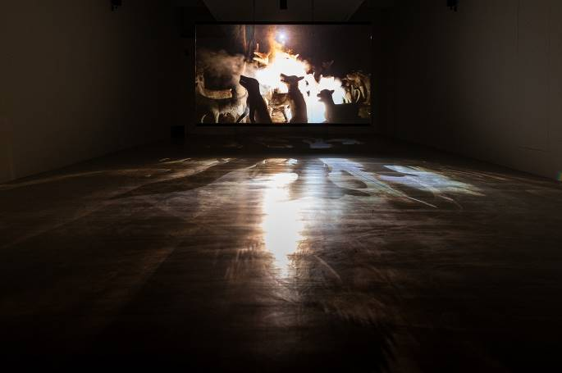
07  阿比查邦．韋拉斯塔古，《無名的力量》，2007。四屏錄像裝置。藝術家與臺北市立美術館提供。  Apichatpong Weerasethakul, Unknown Forces, 2007. 4-channel installation. Courtesy of the artist and Taipei Fine Arts Museum. | 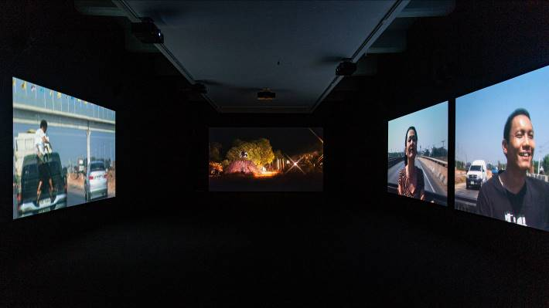
08  阿比查邦．韋拉斯塔古，《俳句》，2009。錄像截圖。Kick the Machine Films提供。  Apichatpong Weerasethakul, Haiku, 2009. Video still. Courtesy of Kick the Machine Films. | 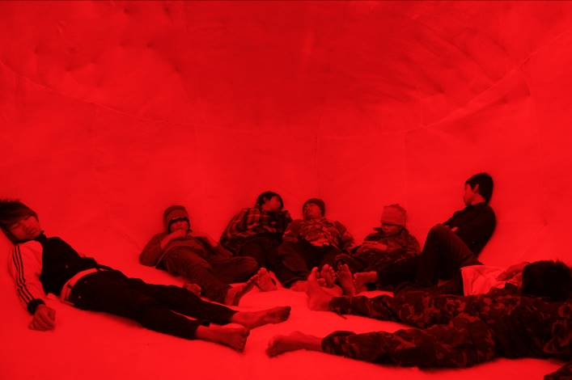
09  阿比查邦．韋拉斯塔古，《灰燼》，2012。錄像截圖。Kick the Machine Films提供。  Apichatpong Weerasethakul, Ashes, 2012. Video still. Courtesy of Kick the Machine Films. | 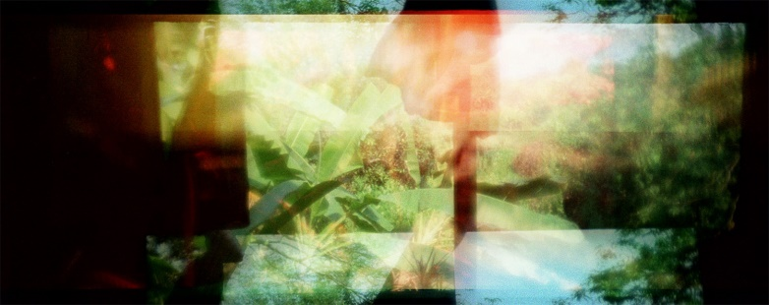
10  阿比查邦．韋拉斯塔古，《灰燼》，2012。錄像截圖。Kick the Machine Films提供。  Apichatpong Weerasethakul, Ashes, 2012. Video still. Courtesy of Kick the Machine Films. | 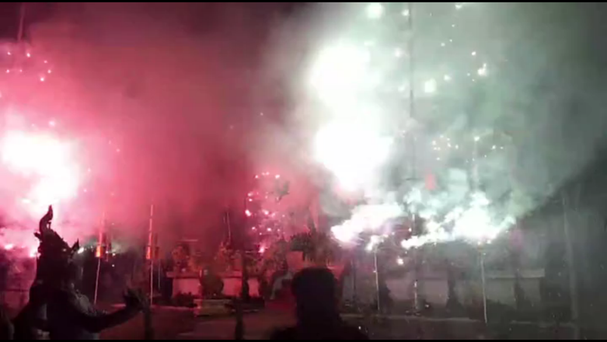
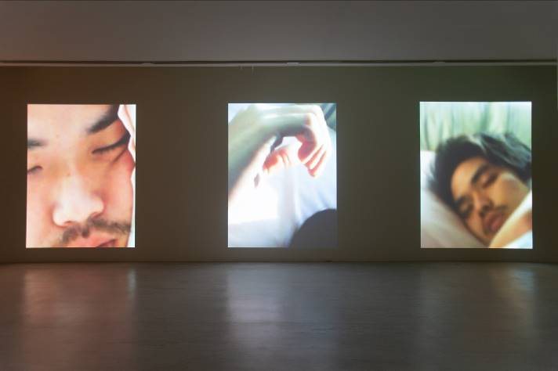11

阿比查邦．韋拉斯塔古，《提牧》，2007。三頻錄像裝置。藝術家與臺北市立美術館提供。

Apichatpong Weerasethakul, TEEM, 2007. 3-channel video installation. Courtesy of the artist and Taipei Fine Arts Museum.
12  阿比查邦．韋拉斯塔古，《薩克達（盧梭）》，2012。錄像截圖。Kick the Machine Films提供。  Apichatpong Weerasethakul, Sakada (Rousseau), 2012. Video still. Courtesy of Kick the Machine Films. | 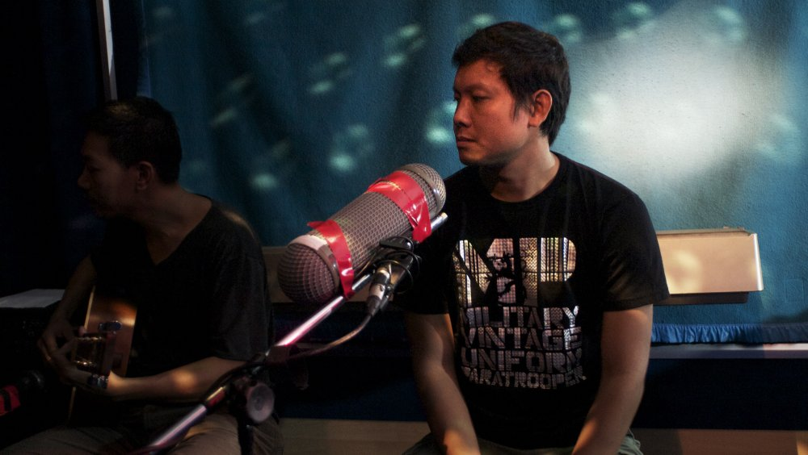
13  阿比查邦．韋拉斯塔古，《納布亞魅影》，2009。錄像截圖。Kick the Machine Films提供。  Apichatpong Weerasethakul, Phantoms of Nabua, 2009. Video still. Courtesy of Kick the Machine Films. | 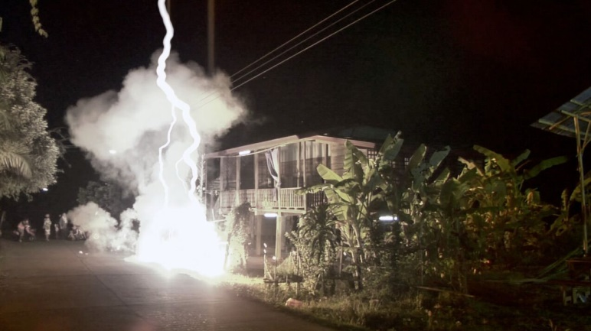
14  阿比查邦．韋拉斯塔古，《納布亞魅影》，2009。錄像截圖。Kick the Machine Films提供。  Apichatpong Weerasethakul, Phantoms of Nabua, 2009. Video still. Courtesy of Kick the Machine Films. | 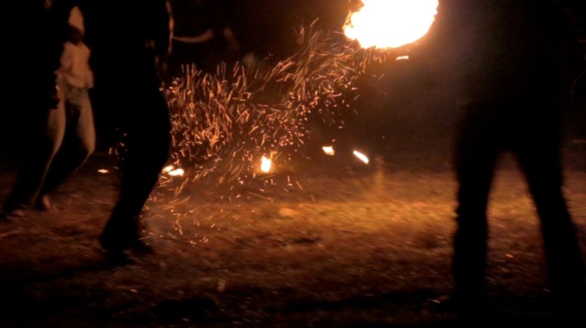
15  阿比查邦．韋拉斯塔古，《隱身 》，2016。雙頻同步錄像裝置。藝術家與臺北市立美術館提供。  Apichatpong Weerasethakul, Invisibility, 2016. 2-channel synchronized video installation. Courtesy of the artist and Taipei Fine Arts Museum. | 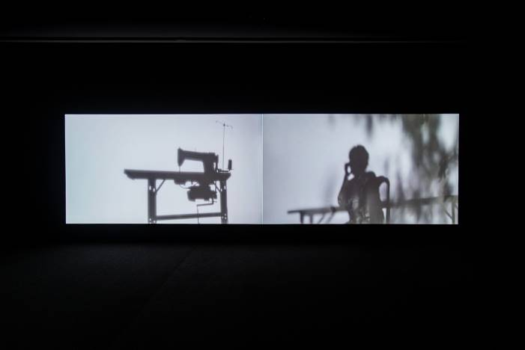
16  阿比查邦．韋拉斯塔古，《僅限猴子》，2014。錄像截圖。Kick the Machine Films提供。  Apichatpong Weerasethakul, For Monkeys Only, 2014. Video still. Courtesy of Kick the Machine Films. | 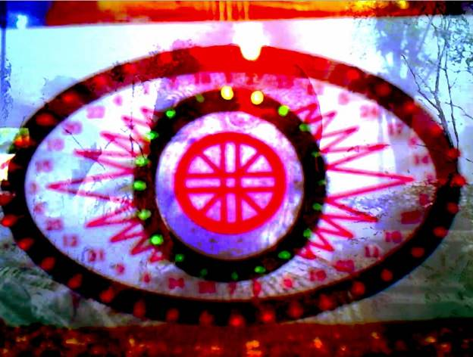
17  阿比查邦．韋拉斯塔古，《鬼魂青年》，2009。噴墨輸出。藝術家與臺北市立美術館提供。  Apichatpong Weerasethakul, Ghost Teen, 2009. Inkjet print. Courtesy of the artist and Taipei Fine Arts Museum. | 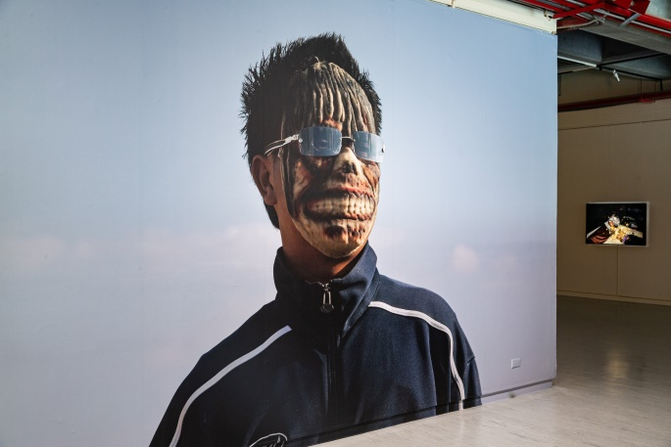
18  阿比查邦．韋拉斯塔古，《電力先生（致雷·布萊伯利）》，2014。燈片輸出。藝術家提供。  Apichatpong Weerasethakul, Mr. Electrico (For Ray Bradbury), 2014. Lightjet print. Courtesy of the artist. | 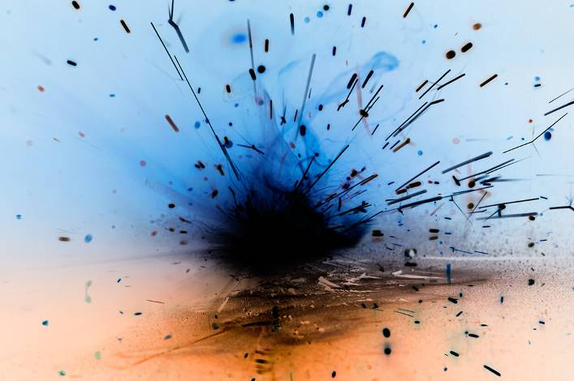
19  阿比查邦．韋拉斯塔古，《原始記憶》，2014。燈片輸出。藝術家提供。  Apichatpong Weerasethakul, Primates’ Memories, 2014. Lightjet print. Courtesy of the artist. | 