Taipei Fine Arts Museum Press Release
Released From: TFAM Marketing and Public Relations Department
Date: November 15, 2019
Media Contacts: Johnny Ho 02-25967656 ext.112 johnny@tfam.gov.tw
Tzu-Chin Kao 02-25967656 ext.110 tckao@tfam.gov.tw

Island Tales: Taiwan and Australia｜Taipei←→Perth
Dates: 2019.11.16-2020.03.01
Venue: Gallery 2A, Taipei Fine Arts Museum
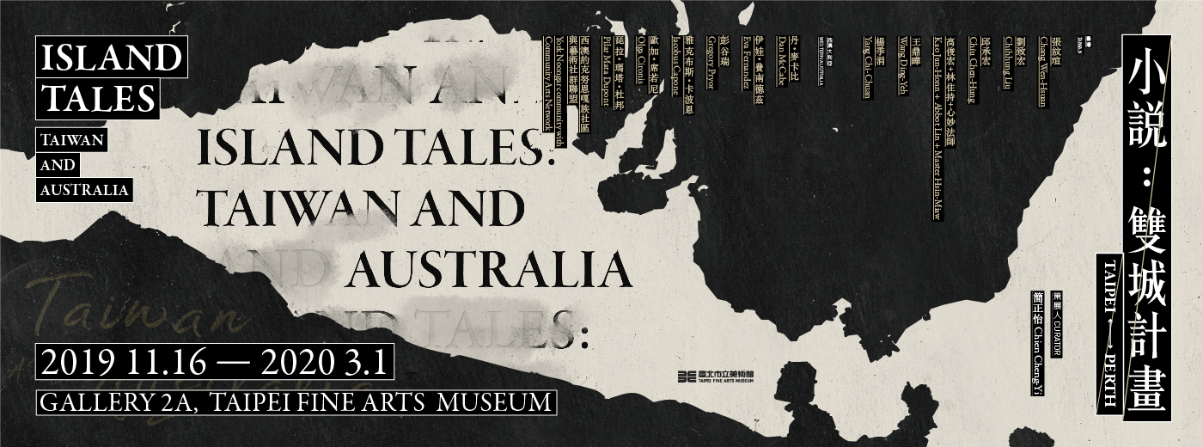

“Island Tales: Taiwan and Australia” Opens at Taipei Fine Arts Museum
Celebrating 20th Anniversary of Taipei and Perth Sister City Relationship

In 1999 Taipei and Perth, the capital of Western Australia, officially became sister cities, and in 2019 they are celebrating the 20th anniversary of this relationship. To celebrate this major milestone, Taipei Fine Arts Museum (TFAM) and the Perth Institute of Contemporary Arts (PICA) are jointly organizing a series of events centered on Taiwan-Australia exchanges, including “Island Tales: Taiwan and Australia｜Taipei←→Perth” at Taipei Fine Arts Museum.

The exhibition kicked off today with a grand opening celebration and news conference. Taipei City Mayor Ko Wen-je, Australian Representative Gary Cowan, and Director of PICA Amy Barrett-Lennard were all in attendance to witness the rich achievements of the two cities in their commitment to cultural diplomacy. Speaking at the opening ceremony, Taipei mayor Ko Wen-je affirmed, “This exhibition is an important milestone in Taipei City’s endeavors to expand cultural diplomacy, and a great example of international exchanges in the arts, which Taipei City has promoted for many years.”

In July of this year, Taipei City Commissioner of Cultural Affairs Tsai Tsung-hsiung traveled to Perth, where the two cities signed a memorandum of understanding for cooperation on culture and the arts. The MOU covers such fields as visual arts, performing arts, and cinema. Its aim is to promote professional exchanges in the arts and to open a new chapter in cooperation between Australia and Taiwan.

“Island Tales” came about from a creative exchange process between Taipei and Perth. The collaboration broke from the conventional model of two museums organizing separate exhibitions and then exchanging artworks. Instead, curators from both museums changed places, engaged in research in their counterpart institutions, and then returned home to organize an exhibition. This innovation has altered the mode of one-way communication commonly seen in exhibitions, giving the curators greater room to observe and converse.

"Collaborations between cultural institutions practically achieve friendly relations between cities,” said Ping Lin, director of Taipei Fine Arts Museum. “They are extremely meaningful, because they can delve deep into history, shed light on the current situation, and find common resonance with the times." PICA Director Amy Barrett-Lennard also said that this cooperative effort highlights the many aspects that the two cultures share in common.

“Island Tales: Taiwan and Australia” is curated by Chien Cheng-Yi of Taipei Fine Arts Museum. When visiting Perth to do research, the curator was inspired by her experiences of local culture and chose the concepts of “tales” and “storytelling” as the exhibition’s core themes. She aims to build a domain where imagination and reality intermingle through the subjective narratives of the artworks. The exhibition features 13 contemporary artists and art collectives from Taiwan and Australia, exploring the distinctive perspectives of both lands through tales, false histories, anecdotes and personal memories.

The cultures of Australia and Taiwan share many things in common, such as indigenous cultures, the languages of Oceania, maritime traditions, and colonial histories. Though they are geographically distant from each other, the cultural connections are surprisingly strong. The exhibition will be presented in the second-floor History Gallery, serving as a historical anchor commemorating the friendship between the two cities and endowing this curatorial theme of cultural dialogue with an interpretive milieu for an array of discussions.

“Island Tales: Taiwan and Australia” features six Taiwanese artists/groups: Chang Wen-Hsuan, Chihhung Liu, Chiu Chen-Hung, Kao Jun-Honn + Abbot Lin + Master Hsin-Miaw, Wang Ding-Yeh, and Yang Chi-Chuan​. Their artworks revolve around the narrative axis of history, cities and memories, deconstructing and reconstructing stories from Taiwanese memory that seem familiar, as if they have already happened to us.

The exhibition also presents works by seven artists/groups from Western Australia: Dan McCabe, Eva Fernandez, Gregory Pryor, Jacobus Capone, Olga Cironis, Pilar Mata Dupont, and York Noongar Community with Community Arts Network. Their art is similarly centered on history, memory, and connections to the land. Highlighting distinctive elements of Western Australian culture, such as native animals and aboriginal symbols, their works take visitors on a cultural journey to the far reaches of the South Pacific.

Taipei Fine Arts Museum will follow up with events of indigenous cultural sharing, to enhance cultural participation and artistic interaction between the two countries. On the first day of the exhibition (Nov. 16), the museum presents “Storytelling Sessions.” Hailing from York in Western Australia, Audrey Narkle Nettle and Tracey Kickett are storytellers of the Balardong people, who will share their creation myths and the history of their homeland. The Storytelling Sessions began as part of the art project “Welcome to Balardong,” showcasing the indigenous culture of Western Australia and relating the native tales and collective memories of the Balardong.

On the second day of the exhibition, the Aboriginal participants will visit the community of Xizhou, home to members of the Amis people. They will be accompanied by Chun-Bin Chen, an associate professor at Taipei National University of the Arts and an expert on indigenous music. Located in the Xindian area of Taipei, Xizhou formed in the 1970s and 1980s, developing its own unique culture as indigenous people moved into the city during the process of urbanization. As community residents, their Australian guests, and ordinary citizens share different perspectives, they will come to understand each other’s contemporary cultures and historical heritages, deepening the friendship of Perth and Taipei.

In October of this year, the exhibition “Unfolding Acts: New Art from Taipei and Perth” officially launched at the Perth Institute of Contemporary Arts. Co-curated by Charlotte Hickson and guest curator Ashley Chang, an Australian of Taiwanese descent, the exhibition featured four Taiwanese artists – Dondon Houmwm, Chou Yu-Cheng, Yi Chun Lo, and Chia-En Jao – alongside seven artists/groups from Australia and New Zealand. “Unfolding Acts” initiates a conversation on the social, economic, cultural, geographical and environmental contrasts and connections between Perth and Taipei. The two exhibitions “Island Tales” and “Unfolding Acts” facilitate a dialogue between the artists of Taiwan and Australia, and write a compelling new chapter in cultural diplomacy between Taipei and Perth.

###

Island Tales: Taiwan and Australia
Taipei←→Perth
Dates: 2019.11.16-2020.03.01
Venue: Gallery 2A, Taipei Fine Arts Museum
Participating Artists: Dan McCabe, Eva Fernandez, Gregory Pryor, Jacobus Capone, Olga Cironis, Pilar Mata Dupont, York Noongar community with Community Arts Network, Chang Wen-Hsuan, Chihhung Liu, Chiu Chen-Hung, Kao Jun-Honn + Abbot Lin + Master Hsin-Miaw, Wang Ding-Yeh, Yang Chi-Chuan​

Storytelling Session
Time: Nov. 16, 2019, 14:00-14:30
Venue: Taipei Fine Arts Museum, 2nd Floor Gallery 2A
Storytellers: Audrey Narkle Nettle, Tracey Kickett
The Storytelling Sessions began as part of the art project “Welcome to Balardong.” Two storytellers of the Balardong people of Western Australia will expand on the work’s theme of indigenous tales, sharing with the audience their people’s creation accounts, legends, and oral histories. These spirited narratives are the perfect introduction to their home.

UNFOLDING ACTS
NEW ART FROM TAIPEI & PERTH
Dates: 2019.10.19–2019.12.22
Venue: Ground Floor Gallery, Perth Institute of Contemporary Arts
Participating Artists: Yu-Cheng Chou, Sharyn Egan, Dondon Hounwn, Chia-En Jao, Yi-Chun Lo, Pilar Mata Dupont, pvi collective, York Noongar community members with Community Arts Network

