「小說：雙城計畫」展覽開幕新聞稿，媒體用圖圖說對照表
Island Tales: Taiwan and Australia Taipei←→Perth, Image Sheet
編號 |  | 圖說 | 影像
01 |  | 開幕合影，左起北美館策展人簡正怡、北美館館長林平、臺北市文化局長蔡宗雄、臺北市長柯文哲、澳洲辦事處代表高戈銳、伯斯當代藝術中心館長艾米．巴蕾特．蓮娜德、伯斯當代藝術中心客座策展人張怡馨  Opening Ceremony, Taipei Fine Arts Museum (TFAM) curator Cheng-Yi Chien, TFAM Director Ping Lin, Commissioner of Taipei City’s Department of Cultural Affairs Tsung-Hsiung Tsai, Taipei City Mayor Wen-Je Ko, Australian Office Representative Mr. Gary Cowan, Australian Office Deputy Representative Ms. Susan Moore, Perth Institute of Contemporary Arts (PICA) Director Amy Barett-Lennard, PICA guest curator Ashley Chang (from left to right) | 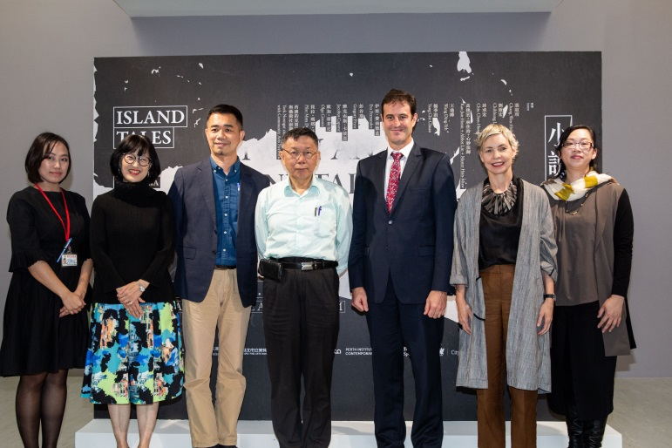
02 |  | 開幕合影，左起北美館策展人簡正怡、北美館館長林平、臺北市文化局長蔡宗雄、臺北市長柯文哲、澳洲辦事處代表高戈銳、伯斯當代藝術中心館長艾米．巴蕾特．蓮娜德、伯斯當代藝術中心客座策展人張怡馨（後排右二），與藝術家合影  Opening Ceremony, Taipei Fine Arts Museum (TFAM) curator Cheng-Yi Chien, TFAM Director Ping Lin, Commissioner of Taipei City’s Department of Cultural Affairs Tsung-Hsiung Tsai, Taipei City Mayor Wen-Je Ko, Australian Office Representative Mr. Gary Cowan, Australian Office Deputy Representative Ms. Susan Moore, Perth Institute of Contemporary Arts (PICA) Director Amy Barett-Lennard (front row from left to right), PICA guest curator Ashley Chang (back row second from the right), group photo with participating artists | 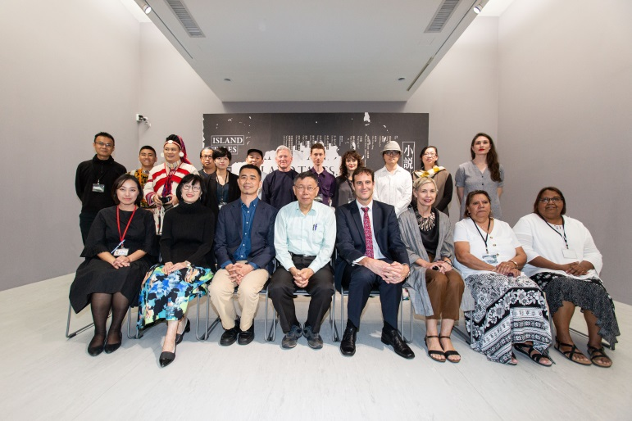
03 |  | 開幕合影，參展藝術家與臺北市立美術館館長林平、策展人簡正怡合影  Opening Ceremony, participating artists with Taipei Fine Arts Museum Director Ping Lin and curator Cheng-Yi Chien | 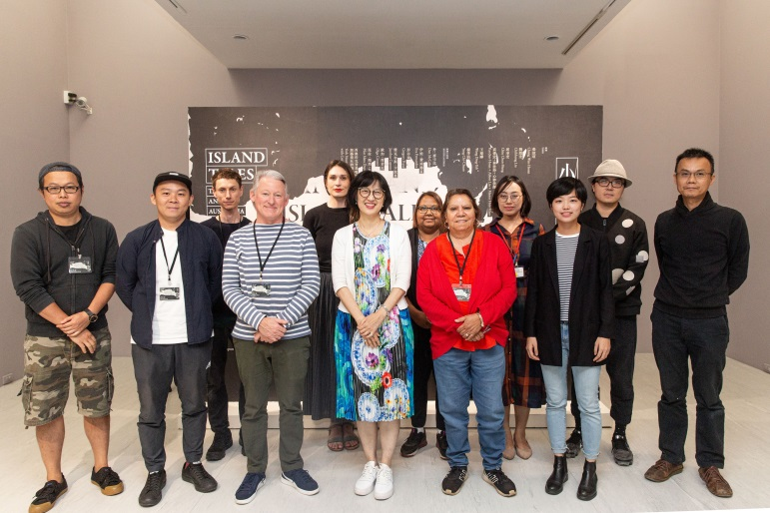
04 |  | 張紋瑄，《自傳大系》，2016  Chang Wen-Hsuan, The Compendium of Autobiographies, 2016  影像由藝術家提供 Courtesy of the artist | 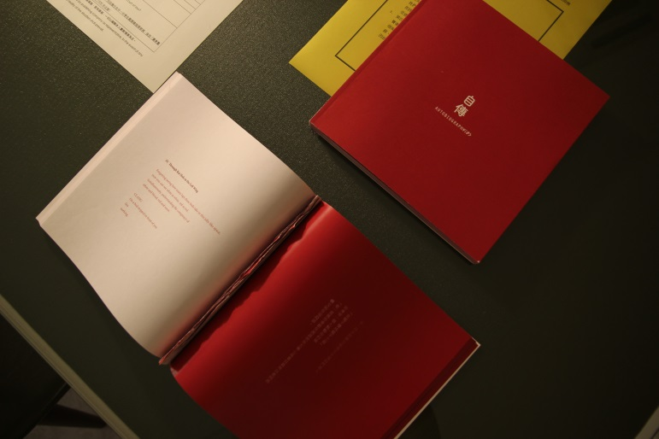
05 |  | 劉致宏，《聲音地誌》，2015-2018  Liu Chih-Hung, Sound Geography, 2015-2018  影像由藝術家提供 Courtesy of the artist | 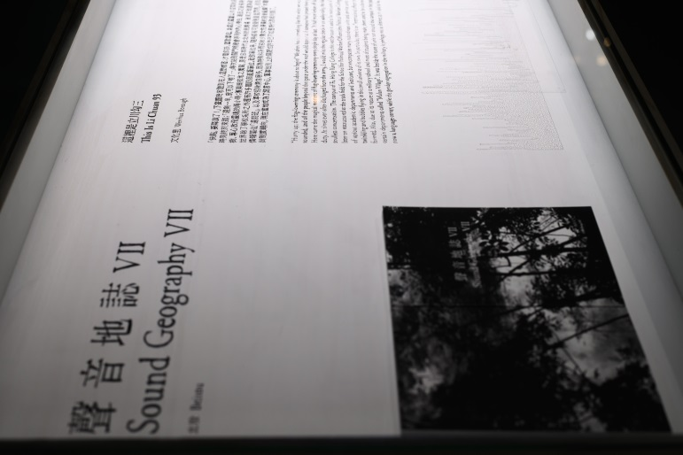
06 |  | 邱承宏，《時間的灰燼─小花蔓澤蘭》，2017-2019  Chiu Chen-Hung, The Dust of Time: Mikania Micrantha, 2017-2019  影像由藝術家提供 Courtesy of the artist | 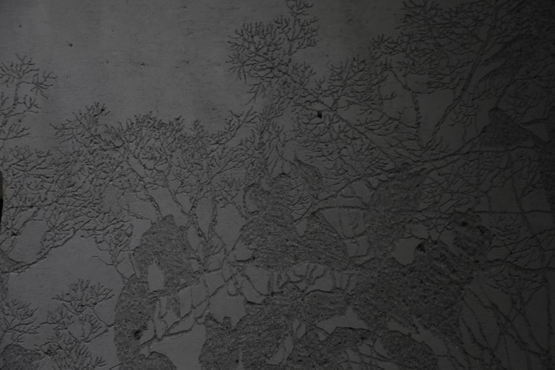
07 |  | 高俊宏+林住持+心妙法師，《出海口─重返小  說》，2019  Kao Jun-Honn + Abbot Lin + Master Hsin-Miaw, Estuary: Return to the Novel, 2019  影像由藝術家提供 Courtesy of the artist | 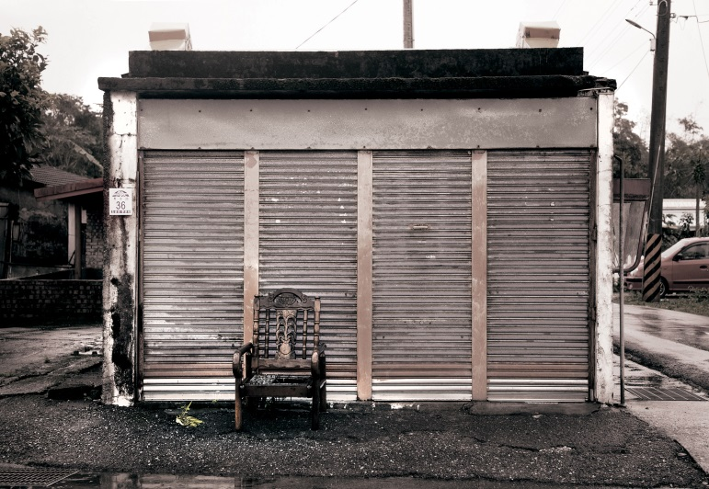
08 |  | 王鼎曄，《勇為》，2018  Wang Ding-Yeh, Confronting Memories, 2018  影像由藝術家提供 Courtesy of the artist
09 |  | 楊季涓，《九條線》，2018  Yang Chi-Chuan, Nine Lines, 2018  影像由藝術家提供 Courtesy of the artist | 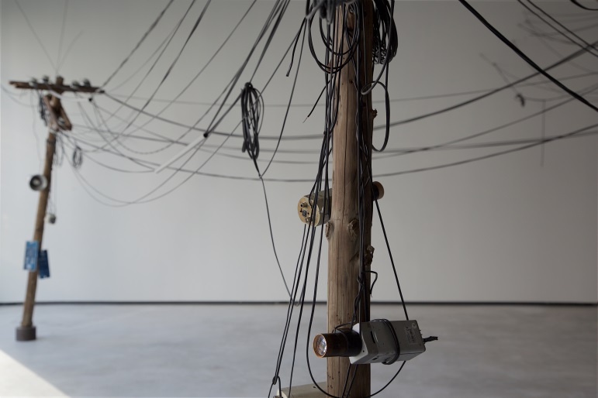
10 |  | 丹．麥卡比，《座標系列》，2018  Dan McCabe, Joiner Series, 2018  澳洲伯斯梅鐸大學典藏 Courtesy of Murdoch University Art Collection, Wst Australia | 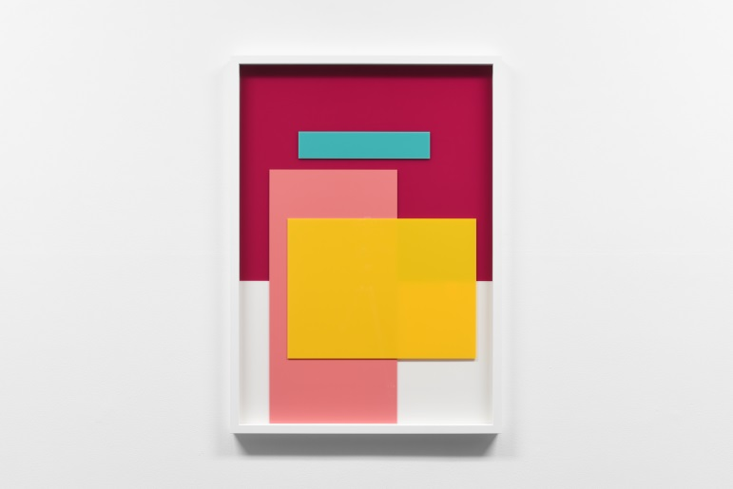
11 |  | 伊娃．斐迪南，《世間罕見之鳥》，2018  Eva Fernandez, A Rare Bird in the Lands, 2018  影像由藝術家提供 Courtesy of the artist | 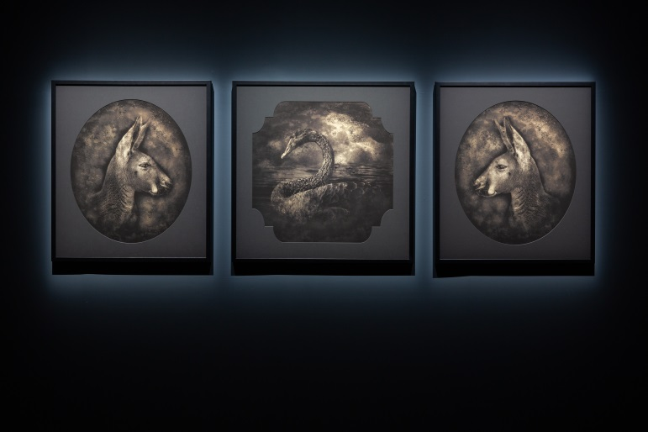
12 | 彭谷瑞，《從2002年10月23日至2007年9月15日的清單》，2002-2019  Gregory Pryor, List From 231002 – 150907, 2002-2019  影像由藝術家提供 Courtesy of the artist |  | 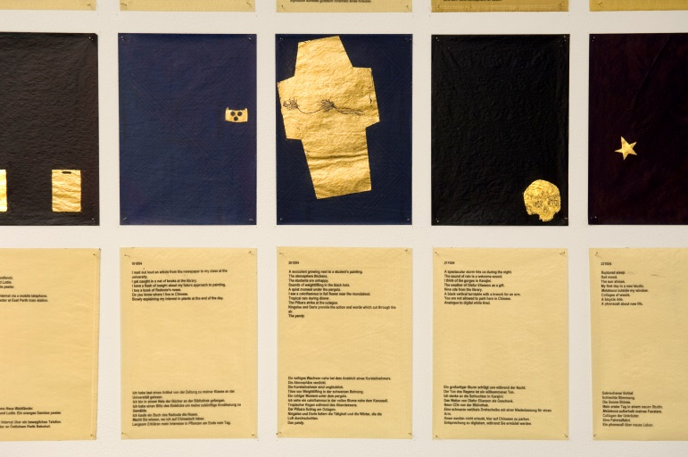
13 | 雅克布斯．卡波恩，《雙重謎團》，2018  Jacobus Capone, Double Enigma, 2018  影像由藝術家提供 Courtesy of the artist |  | 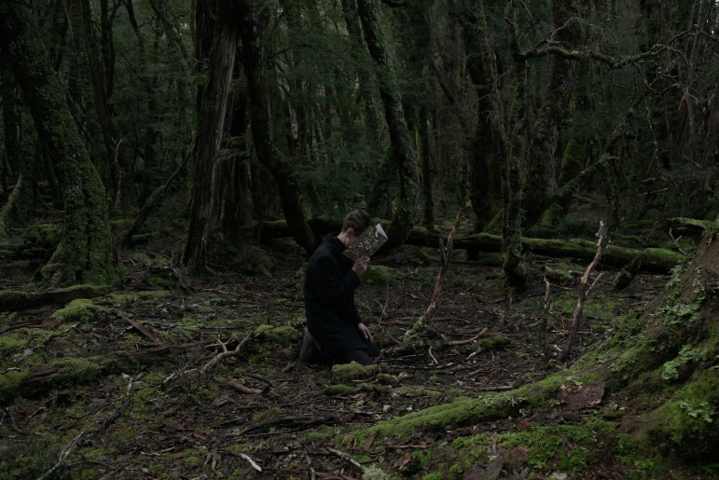
14 | 歐加．席若尼，《當我第一次遇見你》，2013  Olga Cironis, I knew the First Time I Saw You, 2013  影像由藝術家提供 Courtesy of the artist |  | 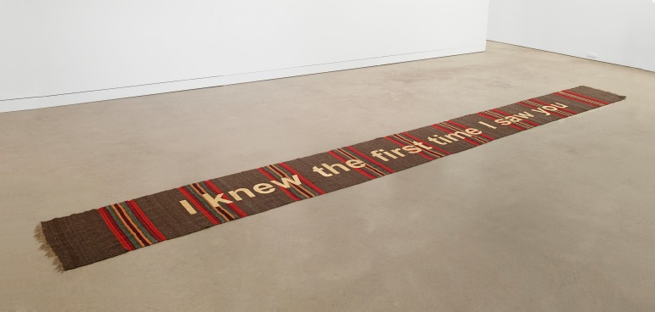
15 | 琵拉．瑪塔．杜邦，《煉獄》，2014  Pilar Mata Dupont, Purgatorio,2014  藝術家與摩爾當代藝廊典藏 Courtesy of the Artist and MOORE CONTEMPORARY |  | 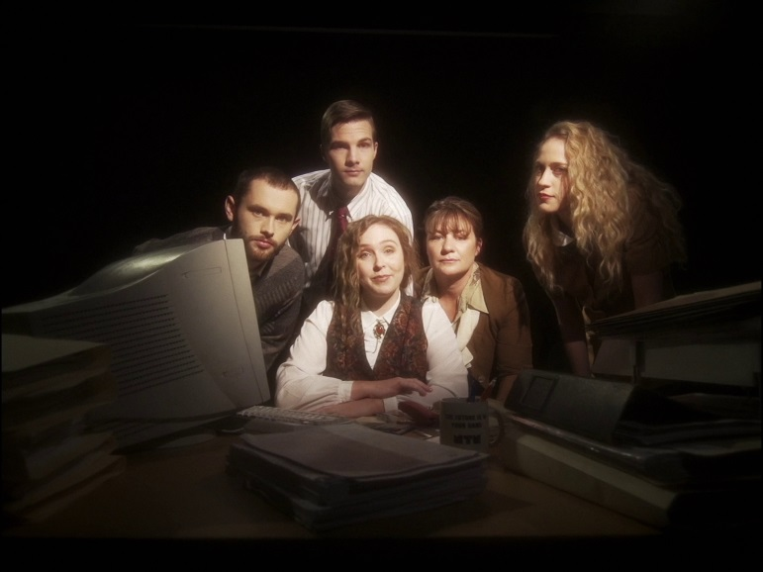
16 | 西澳約克鎮努恩嘎族社區與社群藝術網絡，《歡迎來到巴拉東》，2019  York Noongar Community with Community Arts Network, Welcome to Balardong, 2019  影像由藝術家提供 Courtesy of the artist |  | 