Old Man．Fairy．and a Ｂit of Everything—TANG Jo-Hung, Image Sheet
「老男 ‧ 雜匯 ‧ 小神仙—黨若洪個展」媒體用圖及圖說

1 | 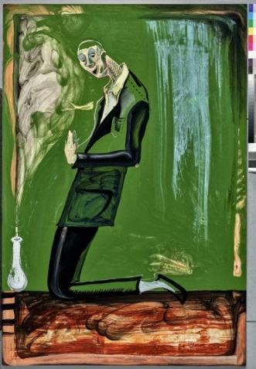 | 黨若洪  《求仙》  Seek Divine Guidance  2019  油彩、纖維板  Oil on masonite  184x124.5cm
2 | 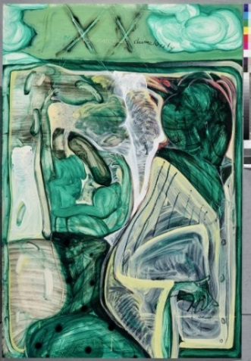 | 黨若洪  《中年男子恥辱的觀看》  A Disgraceful Peek of the Middle-age Male  2019  油彩、纖維板  Oil on masonite  185x125
3 | 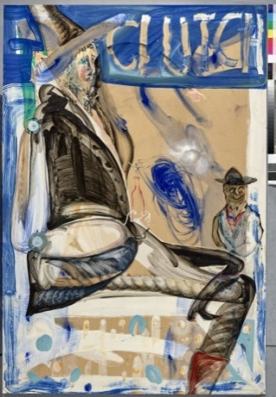 | 黨若洪  《男巫·Soda·Clutch》  Sorcerer·Soda·Clutch  2019  油彩、纖維板  Oil on masonite  220x122cm
4 | 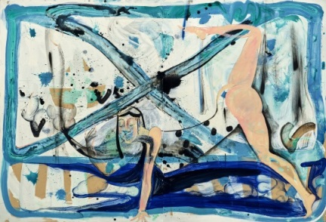 | 黨若洪  《攬鏡自照的下犬式（瑜伽）女神》  The Goddness in Downward-Facing Dog is Looking in the Mirror at Herself  2019  油彩、纖維板  Oil on masonite  150x220cm
5 | 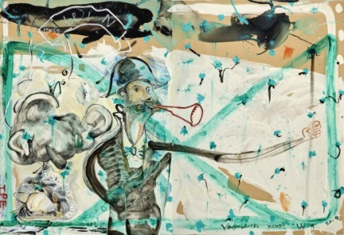 | 黨若洪  《拿破崙必須贏》  Napoleon Must Win  2019  油彩、纖維板  Oil on masonite  150x220cm
6 | 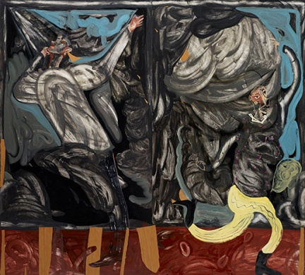 | 黨若洪  《雙開》  Double Dealing  2018  油彩、纖維板  Oil on masonite  220x245 cm(220x122.5 cm x2)
7 | 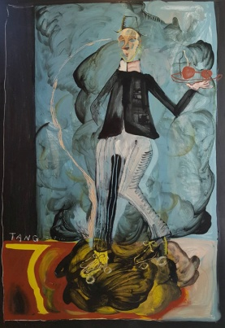 | 黨若洪  《滾輪Waiter》  Waiter on Roller Skates  2018  油彩、纖維板  Oil on masonite  184x 122 cm
8 | 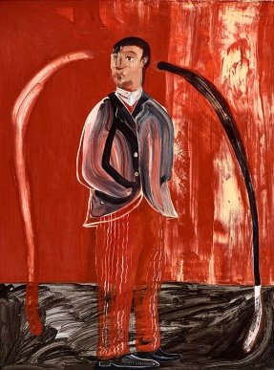 | 黨若洪  《紅色印度青年》  A Red Indian Young Man  2018  油彩、纖維板  Oil on masonite  178x 120 cm
9 | 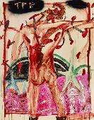 | 黨若洪  《穿靴子的基督》  Christ in Boots  2016  油彩、纖維板  Oil on masonite  180 x 122 cm
10 | 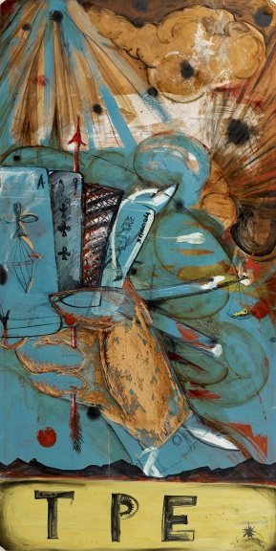 | 黨若洪  《TPE上空的賭局》  A Gambling Game above Taipei Sky  2014  油彩、纖維板  Oil on masonite  244 x 122 cm (140F)

