2019年「第58屆威尼斯國際美術雙年展」台灣館公布展名「3x3x6」
藝術家鄭淑麗展開探討監控與解放的創作計劃
Taiwan’s Representation at the 58th Venice Biennale 2019 Announces 3x3x6 as Title
Artist Shu Lea Cheang Creates Site-Specific Work to Explore Confinement and Liberation

媒體圖說Image Description

01  2019「第58屆威尼斯國際美術雙年展」台灣館「3x3x6」  Taiwan’s Representation at the 58th Venice Biennale 2019, 3x3x6 © TFAM | 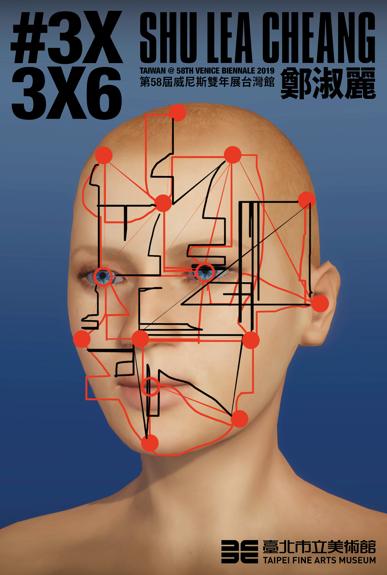
02  鄭淑麗  Shu Lea Cheang  ©TFAM | 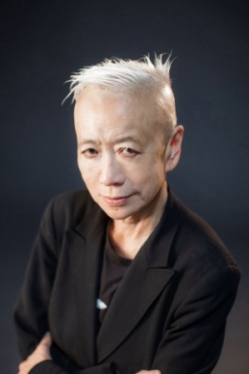
03  保羅．普雷西亞多  Paul B. Preciado  ©TFAM | 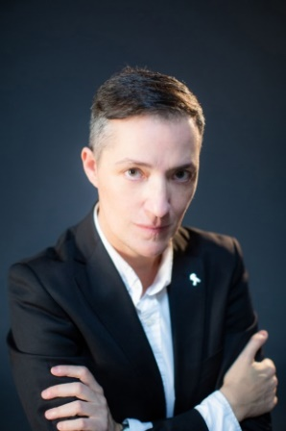
04  鄭淑麗與保羅．普雷西亞多  Shu Lea Cheang & Paul B. Preciado  ©TFAM | 