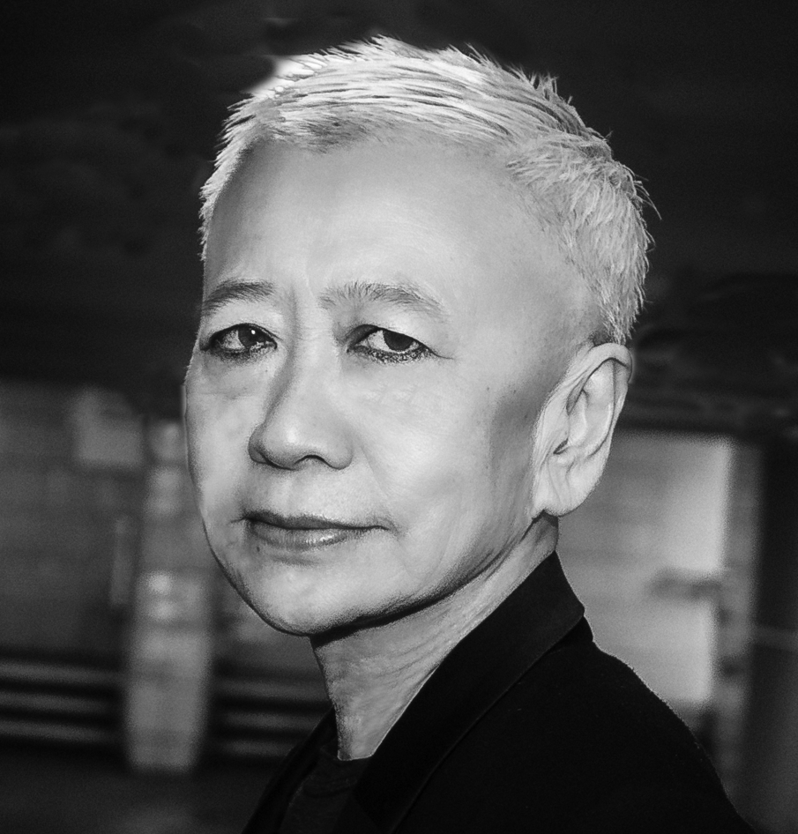
©Jackie Baier

Shu Lea Cheang

Shu Lea Cheang is an artist and filmmaker working with various art mediums and film formats, including installation, performance, net art, public art, video installation, feature length film and mobile web serial. Her artistic pursuits demonstrates an imagination and desire to cross the boundaries of society, geography, politics, and economic structure, thus redefining genders, roles, mechanisms, etc. As a net art pioneer, her BRANDON (1998-1999) was the first web art commissioned and collected by the Solomon R. Guggenheim Museum in New York. Her network installations, including Bowling Alley (1995, Walker Art Center, USA), Baby Love (2015, Palais de Tokyo, Paris), often employ electronic interactive devices to construct open networks that permit public participation. Her multi-player participatory networked performance, including Moving Forest (2008, transmediale, Berlin), UKI (2009-2016) with transgressive plots are realized in collective impromptu mode. She drafts sci-fi narratives in her film scenario and artwork imagination, crafting her own “science” fiction genre of new queer cinema, terming them eco-cybernoia (FRESH KILL, 1994), scifi cyberpunk (I.K.U., 2000), scifi cypherpunk (Fluidø, 2017). From homesteading cyberspace in the 90s to her current retreat to post-netcrash BioNet zone, Cheang takes on viral love, bio hack in her current cycle of works. Born in Taiwan, lived in New York City for two decades, Cheang is currently residing in Paris. (http://mauvaiscontact.info)

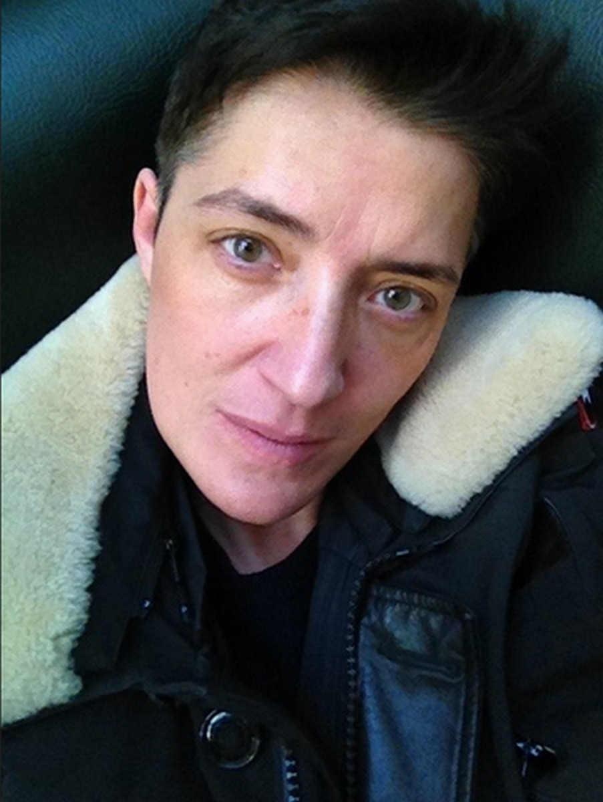
©Leo Freemann

Paul B. Preciado

Paul B. Preciado is a writer, philosopher, curator, and one of the leading thinkers in the study of gender and sexual politics. An Honors Graduate and Fulbright Fellow, he earned a M.A. in Philosophy and Gender Theory at the New School for Social Research in New York where he studied with Agnes Heller and Jacques Derrida. He holds a Ph.D. in Philosophy and Theory of Architecture from Princeton University. His first book, Counter-Sexual Manifesto (Columbia University Press) was acclaimed by French critics as “the red book of queer theory” and became a key reference for European queer and trans activism. He is the author of Testo Junkie. Sex, Drugs and Biopolitics (The Feminist Press) and Pornotopia (Zone Books) for which he was awarded the Sade Price in France. He has been Head of Research of the Museum of Contemporary Art of Barcelona (MACBA) and Director of the Independent Studies Program (PEI) from 2011 to 2014. He has taught Philosophy of the Body and Transfeminist Theory at Université Paris VIII-Saint Denis and at New York University. From 2014 to 2017 he was Curator of Public Programs of documenta 14 (Kassel/Athens). He is a writer in residency at the LUMA Foundation, Arlès, France. He lives between Athens, Paris, and Barcelona.

