2018台北雙年展策展人媒體見面會
Taipei Biennial 2018 Press Conference

媒體圖說Image Description

- 2018台北雙年展策展人吳瑪悧(中)、范切斯科．馬納克達(左)與臺北市立美術館館長林平(右)合影©臺北市立美術館，陳泳任攝  2018 Taipei Biennial Curators, Mali Wu (M) and Francesco Manacorda (L) with Director of TFAM, Ping Lin (R)  ©Taipei Fine Arts Museum | 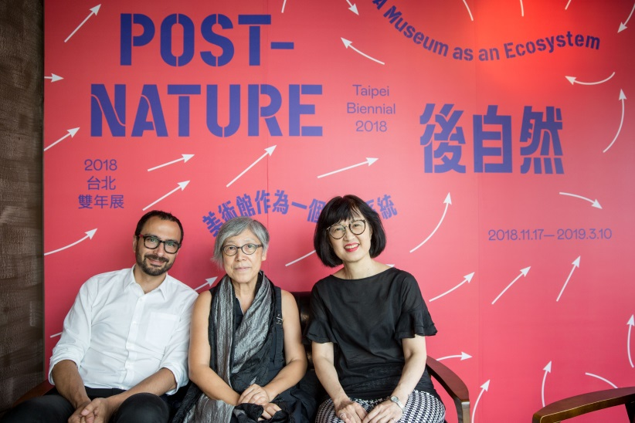
- 2018台北雙年展策展人吳瑪悧(中)、范切斯科．馬納克達(左)與臺北市立美術館館長林平(右)合影©臺北市立美術館，陳泳任攝  2018 Taipei Biennial Curators, Mali Wu (M) and Francesco Manacorda (L) with Director of TFAM, Ping Lin (R)  ©Taipei Fine Arts Museum | 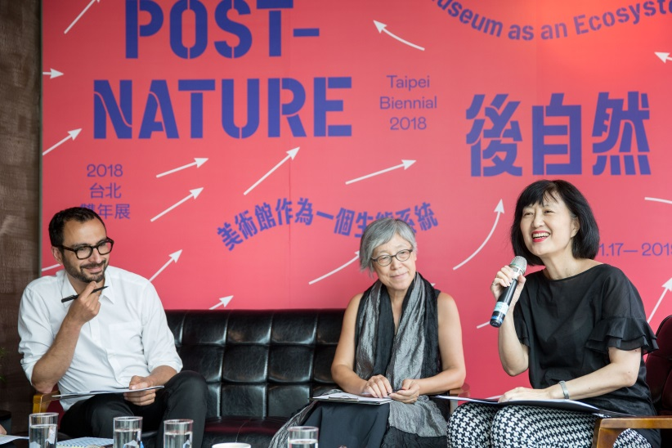
- 策展人吳瑪悧  Curator of Taipei Biennial 2018, Mali Wu  ©Taipei Fine Arts Museum | 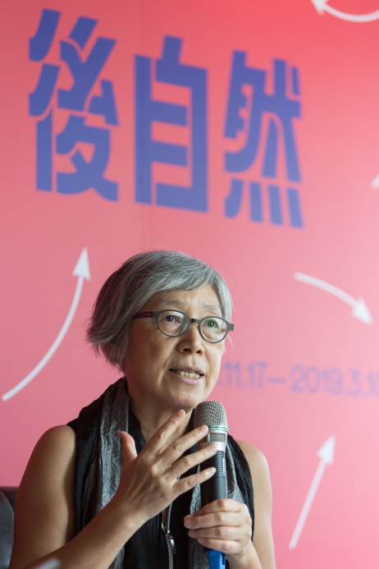
- 策展人范切斯科．馬納克達  Curator of Taipei Biennial 2018, Francesco Manacorda  ©Taipei Fine Arts Museum | 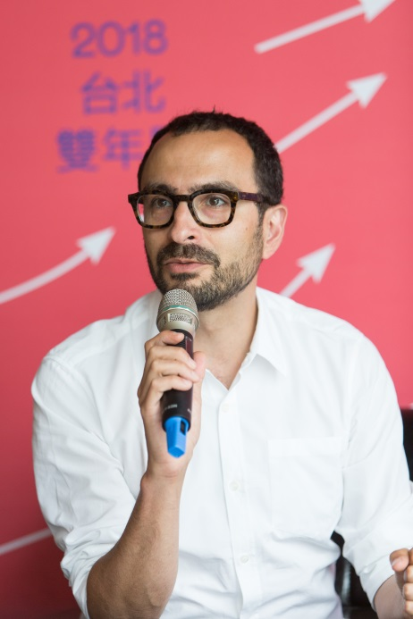
- 臺北市立美術館館長林平  Director of TFAM, Ping Lin  ©Taipei Fine Arts Museum | 