FOR IMMEDIATE RELEASE
Taipei Fine Arts Museum Press Release
International & Public Relations Office at TFAM
Media Contact: Johnny Ho (johnny@tfam.gov.tw)

Taipei Biennial 2018
Post-Nature—A Museum as an Ecosystem
Dates: 2018.11.17 – 2019.03.10
Venue: Taipei Fine Arts Museum

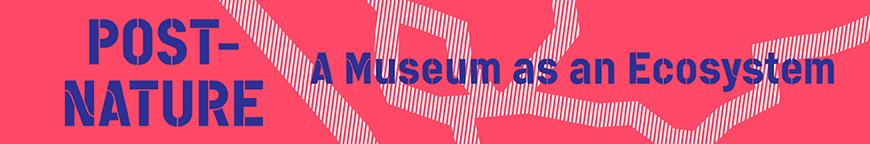

An Embodiment of Ecological Issues:
Curators Discuss the Theme of Taipei Biennial 2018

June 27, 2018. Taipei Fine Arts Museum (TFAM) held a media gathering today for Mali Wu and Francesco Manacorda, the curators of the Taipei Biennial 2018. Together with the director of TFAM, Ping Lin, they described the curatorial strategy for the upcoming biennial.

For Taipei Biennial 2018, titled Post-Nature—A Museum as an Ecosystem, the curators will attempt to transform TFAM into a platform for multi-disciplinary discussions of ecology, and to shed light on environmental issues through international artists’ perspectives. As global environmental problems become increasingly complex and severe, issues of ecology are no longer the responsibility of one single discipline. Instead, in the same way that many natural systems are closely connected and even interdependent, the disciplines can also become mutually influential.

As Francesco Manacorda explains, this biennial is not just concerned with addressing ecological issues inside a museum - rather it is a fresh attempt to further ecological consciousness as a way of thinking. One approach Manacorda cites is to consider ecology on an extended timeline, taking the welfare of future generations into account. With natural resources in short supply, and environmental crises fast developing, issues of ecology should be commonly and publicly considered at the present time - as debate at a later stage may not be possible. Through works by diverse practitioners, this biennial attempts to project into future timeframes.

The list of biennial participants has now entered the stage of final confirmation, and the curators have included not only visual artists, but also NGOs, activists, film and documentary makers, architects and other non-visual artists, in a network of interdependent and cross-pollinating positions. By presenting non-traditional creatives in the TFAM galleries, instead of programming these as exterior satellite events, the curators will attempt to break the conventional boundaries between artists and non-artists, with the aim of enhancing discussion and knowledge exchange. Curator Mali Wu notes that the exhibition spaces will be divided according to the concept of an “eco-lab,” aiming to highlight the interactivity of information, encourage the participatory model and to redefine the roles and functions of the exhibition spaces. The labs will develop organically as the exhibition unfolds, becoming interdisciplinary hubs of knowledge.

Manacorda has remarked that he appreciates the support of TFAM, which has given the curators considerable freedom to develop their ideas. In the process of determining the theme of this year’s Taipei Biennial, both the curators and the museum sought to expand the functions and the definition of the museum to the greatest possible extent. By exploring ecology issues in-depth, they hope to practice commitment to society, culture and the world.

The theme of A Museum as an Ecosystem, TFAM director Ping Lin stressed, highlights the museum’s function of “knowledge production.” By conveying information in the museum and leading the transformation of viewers from awareness to identification, the ultimate goal is for many people to put environmental values into practice in their lives. In the Taipei Biennial 2018, the museum hopes to serve as an active platform of discourse, forming connections among issues and forging bridges among disciplines.

