2018台北雙年展宣布策展命題與策展理念
Taipei Biennial Announces the Title and Curatorial Statement for 2018 Edition

媒體圖說Image Description

- 柯金源，《1993臺北八里海岸嚴重侵蝕，碉堡地標變遷》，1993。攝影。©影像權利為藝術家柯金源所有，臺北市立美術館提供。  KE Chin-Yuan, 1993 Sever Coastal Erosion Causing the Collapse of a Seaside Fortress at Bali Coast, Taipei, 1993. Photograph. ©KE Chin-Yuan. Courtesy of the artist and Taipei Fine Arts Museum. | 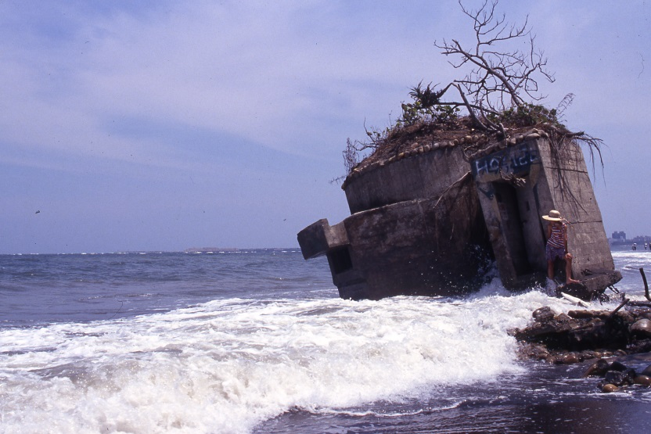
- 黃信堯，《印樣白冷圳》，2018。單頻道錄像。©影像權利為藝術家黃信堯所有，臺北市立美術館提供。  HUANG Hsin-Yao, Contact Prints of Pai-leng Canal, 2018. Single channel video. ©HUANG Hsin-Yao. Courtesy of the artist and Taipei Fine Arts Museum. | 