2018第十一屆台北雙年展宣佈由吳瑪悧與范切斯科•馬納克達共同擔任策展人
Taipei Biennial Announces Mali Wu and Francesco Manacorda
as 2018 Co-Curators

媒體圖說Image Description

- 2018台北雙年展策展人吳瑪悧(左)、范切斯科．馬納克達(右)合影  2018 Taipei Biennial Co-Curators, Mali Wu (L) and Francesco Manacorda (R)  ©Taipei Fine Arts Museum | 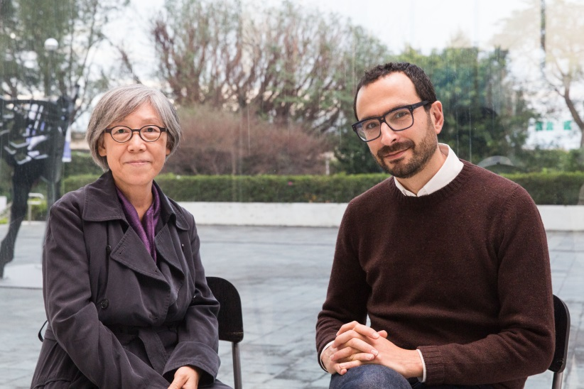
- 策展人吳瑪悧  Mali Wu  ©Taipei Fine Arts Museum | 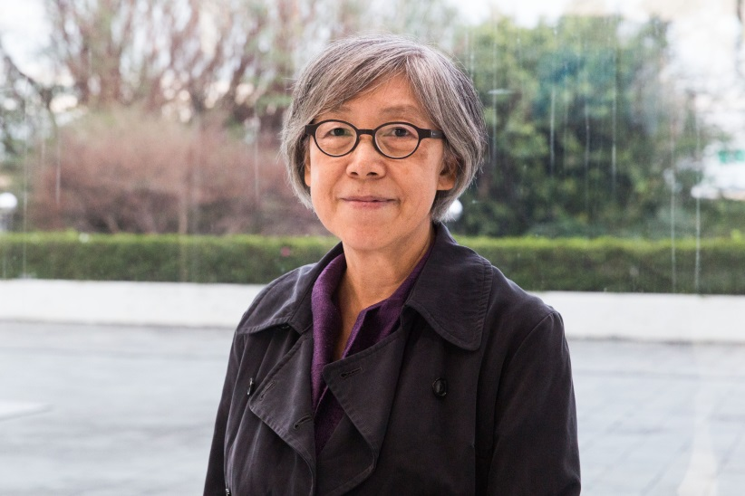
- 策展人范切斯科．馬納克達  Francesco Manacorda  ©Taipei Fine Arts Museum | 